The impact of the introduction of the 10-valent pneumococcal conjugate vaccine into the Icelandic pediatric vaccination program on clinical disease and healthcare utilization

Elías Eyþórsson

Thesis for the degree of Philosophiae Doctor

Supervisor:

Ásgeir Haraldsson

Advisor:

Doctoral committee:



January 2019

Áhrif innleiðingar 10-gilds samtengds pneumókokka bóluefnis í ungbarnabólusetningar á Íslandi á sjúkdómabyrði og notkun heilbrigðiskerfisins

Elías Eyþórsson

Ritgerð til doktorsgráðu

Umsjónarkennari:

Ásgeir Haraldsson

Leiðbeinandi:

Doktorsnefnd:

Janúar 2019



Thesis for a doctoral degree at the University of Iceland. All right reserved. No part of this publication may be reproduced in any form without the prior permission of the copyright holder.

© Elías Eyþórsson 2019

ISBN (apply at <http://www.landsbokasafn.is/>)

Printing by Háskólaprent

Reykjavik, Iceland 2018

Ágrip

**Lykilorð:**

Abstract

**Keywords:**

Acknowledgements

Table of Contents

1 Preamble 3

2 Introduction 3

2.1 Clinical manifestations of *Streptococcus pneumoniae* 6

2.1.1 Acute otitis media 7

2.1.1.1 Pathogens implicated in acute otitis media 8

2.1.1.2 Healthcare burden of otitis media 8

2.1.1.3 Tympanostomy tube procedures 10

2.1.1.4 Acute otitis media in Iceland 11

2.1.2 Pneumonia 11

2.1.2.1 Pathogens causing pneumonia 12

2.1.2.2 Healthcare burden of pneumonia 13

2.1.3 Invasive pneumococcal disease 14

2.2 Pneumococcal vaccines 14

2.2.1 A brief history of pneumococcal vaccination 15

2.2.2 The impact of pneumococcal conjugate vaccines on otitis media 16

2.2.2.1 Randomized controlled trials evaluting the efficacy of pneumococcal conjugate vaccines for otitis media 17

2.2.2.2 Observational studies evaluting the impact of pneumococcal conjugate vaccines for otitis media. 21

2.2.3 The impact of pneumococcal conjugate vaccines on pneumonia 22

2.2.4 The impact of pneumococcal conjugate vaccines on invasive pneumococcal disease 24

2.3 Cost-effectiveness in the context of pneumococcal conjugate vaccination 25

2.3.1 Vaccine efficacy assumptions in economic analyses of pneumococcal conjugate vaccines 29

2.3.2 Assumptions regarding costs and utilities in economic analyses of pneumococcal vaccines 33

3 Aims 35

4 Materials and methods 35

4.1 Data collection and sources 35

4.1.1 Statistics Iceland 36

4.1.2 Landspitali University Hospital patient registry 36

4.1.3 The Primary Care Registry 40

4.1.4 The National Vaccine Registry 40

4.1.5 The National Drug Prescription Registry 40

4.1.6 Reimbursement database of Icelandic Health Insurance 41

4.2 Impact on otitis media with treatment failure (Paper I) 42

4.3 Impact on primary care visits for acute otitis media (Paper II) 43

4.4 Impact on outpatient antimicrobial prescriptions (Paper III) 44

4.5 Impact on tympanostomy tube procedures (Paper IV) 46

4.6 Impact on respiratory associated hospitalizations (Paper V) 47

4.7 Impact and cost-effectiveness analysis (Paper VI) 48

4.7.1 Data sources 49

4.7.2 Statistical analysis 49

5 Results 50

5.1 Data collection and sources 50

5.1.1 Statistics Iceland 51

5.1.2 Landspitali University Hospital patient registry 51

5.1.3 The Primary Care Registry 56

5.1.4 The National Vaccine Registry 56

5.1.5 The National Drug Prescription Registry 58

5.1.6 Reimbursement database of Icelandic Health Insurance 60

5.2 Impact on otitis media with treatment failure (Paper I) 61

5.3 Impact on primary care visits for acute otitis media (Paper II) 65

5.4 Impact on outpatient antimicrobial prescriptions (Paper III) 69

5.5 Impact on tympanostomy tube procedures (Paper IV) 76

5.6 Impact on respiratory associated hospitalizations (Paper V) 81

6 Discussion 85

6.1 Main findings 85

6.2 Data collection and sources 86

6.3 Epidemiology and impact of PHiD-CV10 on otitis media in Iceland (Papers I, II, III, V and VI) 87

6.3.1 Epidemiology of acute otitis media in Iceland (Papers II and V) 87

6.3.2 Impact on primary care visits for otitis media (Papers II and VI) 88

6.3.3 Impact on pediatric emergency department visits for acute otitis media (Paper I) 90

6.3.4 Impact on outpatient antimicrobial prescriptions for otitis media (Paper III) 90

6.3.5 Evidence of herd-effect of PHiD-CV10 on the incidence of otitis media in the unvaccinated population (Papers II and VI) 91

6.3.6 Impact on acute otitis media with treatment failure (Paper I) 92

6.4 Impact of PHiD-CV10 on tympanostomy tube placements (Paper IV) 93

6.4.1 Impact on hospital admissions for otitis media (Paper V) 93

6.5 Impact of PHiD-CV10 on pneumonia hospitalizations in Iceland (Papers V and VI) 94

6.5.1 Evidence of herd-effect of PHiD-CV10 on pneumonia hospitalization in the unvaccinated population (Papers V and VI) 95

6.6 Impact of PHiD-CV10 on invasive pneumococcal disease (Papers V and VI) 95

6.7 Cost-effectiveness of introduction of PHiD-CV10 into the Icelandic pediatric vaccination program (Paper VI) 95

7 Conclusions 95

# Preamble

I am currently writing my PhD thesis on the impact of pneumococcal vaccination in Iceland. I am writing the thesis in Rstudio using the [bookdown](https://bookdown.org/yihui/bookdown/) package and hosting the thesis on Github. Writing the thesis in Rstudio confers many advantages. Tables and Figures can be created directly within Rstudio, which minimizes additional work associated with manually moving them into a separate writing program – a process both error-prone and labor intensive. All aspects of the writing, typesetting and data analysis are documented and version controlled. The bookdown packages automates the process of exporting the thesis to word, pdf and html formats. The thesis will be open access during the writing process. I believe I will be more motivated if my productiveness – or lack thereof, is held accountable to anyone who wishes to check. I would be grateful for any and all comments on any aspect of the thesis under construction.

# Introduction

Table 1 List of abbreviations

|  |  |
| --- | --- |
| Term | Abbreviation |
| 10-valent pneumococcal conjugate vaccine | PCV10 |
| 11-valent pneumococcal conjugate vaccine | PCV11 |
| 13-valent pneumococcal conjugate vaccine | PCV13 |
| 23-valent pneumococcal polysaccharide vaccine | PPV-23 |
| 7-valent pneumococcal conjugate vaccine | PCV7 |
| Acute otitis media | AOM |
| Anatomical-Therapeutic-Chemical | ATC |
| Case-fatality ratio | CFR |
| Community-acquired pneumonia | CAP |
| Confidence intervals | CI |
| Cost-benefit analysis | CBA |
| Cost-effectiveness acceptability curve | CEAC |
| Cost-effectiveness analysis | CEA |
| Cost-utility analysis | CUA |
| Enzyme-linked immunosorbent assay | ELISA |
| Hazard ratio | HR |
| Hospital-aquired pneumonia | HAP |
| Icelandic krona | ISK |
| Incidence rate | IR |
| Incidence rate ratio | IRR |
| Intensive care unit | ICU |
| International Classification of Diseases, 10th revision | ICD-10 |
| International Society for Pharmacoeconomics and Outcome Research | ISPOR |
| Invasive pneumococcal disease | IPD |
| Leave-one-out cross-validation | LOOCV |
| Lower respiratory tract infection | LRTI |
| Meningococcal outer membrane protein complex | MOMPC |
| National Drug Prescription Registry | NDPR |
| National Vaccine Registry | NVR |
| NOMESCO Classification of Surgical Procedures | NCSP |
| non-typable Haemophilus influenzae | NTHi |
| Organisation for Economic Co-operation and Development | OECD |
| Pneumococcal conjugate vaccine | PCV |
| Principal component analysis | PCA |
| Probabilistic sensitivity analysis | PSA |
| Quality-adjusted life-years | QALY |
| Respiratory syncytial virus | RSV |
| Seasonal and trend decompisition using LOESS | STL |
| Tympanostomy tube placement | TTP |
| Upper respiratory tract infection | URTI |
| Vaccine eligible cohorts | VEC |
| Vaccine non-eligible cohorts | VNEC |

*Streptococcus pneumoniae* is a commensal bacterium found in the nasopharynx of humans where it plays an integral role in normal upper respiratory flora. It is also a common pathogen, and one of the most common bacterial causes of disease in humans. In classical medical texts, pneumococcus is described as a Gram-positive lancet-shaped coccus, usually found in pairs. In fact, pneumococcus is *the* Gram-positive coccus, being the first bacteria noted by Christian Gram that retained the dark aniline-gentian violet stain that now bears his name (Gram 1884). Pneumococcus was first isolated in 1881 by two microbiologist, George M. Sternberg in the United States and Louis Pasteur in France (Pasteur 1881; Sternberg 1882; Watson et al. 1993). The causal association between this newly discovered bacterium and pneumonia was firmly established only five years later (Weichselbaum 1886), and in the following decade, all clinical presentations of pneumococcal infection had been described (Austrian 1981).

The infectious manifestations of pneumococcal disease are, broadly speaking, local infections of the respiratory tract and infections of previously sterile tissue. They range from common to uncommon, and from benign to serious. The most common infectious manifestation of pneumococcus is acute otitis media (AOM) – an infection of the middle ear (Coker et al. 2010; Ngo et al. 2016). The disease course is benign and rarely results in permanent disability (Vergison et al. 2010). On the other hand, AOM is the most common reason for physician visit and for antimicrobial prescription in the paediatric population (Grijalva, Nuorti, and Griffin 2009; Todberg et al. 2014). Antimicrobial consumption is causally related to antimicrobial resistance, a major threat to public health (Arason et al. 1996; Austin, Kristinsson, and Anderson 1999).  
Recurrent or persistent otitis media is sometimes treated with the surgical placement of tympanic tubes, rendering it the most common surgical procedure requiring general anesthesia in children (Cullen, Hall, and Golosinskiy 2009). Thus, while AOM is a benign disease, it is associated with a large healthcare burden (Arguedas et al. 2010; Monasta et al. 2012). A potentially more serious manifestation of penumococcal disease is pneumonia, the disease from which pneumococcus gets its name. Pneumonia often requires hospitalization and intravenous antimicrobial treatment, and can lead to permanent disability and death (Troeger et al. 2017). Pneumococcus can cause invasive infections if it gains access to normally sterile tissue. These includes bacteremia, an infection of the blood, and meningitis, an infection of the meninges. These infectious manifestations are grouped together as invasive pneumococcal disease (IPD). Whilst IPD is extremely uncommon, the consequences can be disastrous (Feikin et al. 2000; Ricketson et al. 2013; Tsigrelis et al. 2008). The case-fatality ratio (CFR) from pneumococcal meningitis in Icelandic children and adults is estimated at 13% and 8% respectively (Þórðardóttir et al. 2014; Snaebjarnardóttir et al. 2013). Pneumococcal infections are responsible for a large healthcare burden that spans the range from outpatient to inpatient treatment (Backhaus et al. 2016; Pulido and Sorvillo 2010).

For over a century, scientists have attempted to prevent pneumococcal disease using vaccines with varying results. Pneumococcal vaccine development is complicated by the polysaccharide coating that protects pneumococcus from environmental factors. The polysaccharide capsule acts as an “invisibility cloak” to the human immune system, rendering it unable to detect pneumococcus except through defined patterns in the oligosaccharides contained within the capsule (Tuomanen, Austrian, and Masure 1995). Based on these patterns, pneumococcus has been classified into over 97 different serotypes to date (Habib, Porter, and Satzke 2014). As the capsule contains only polysaccharides and not proteins, the immune response is T-cell independent and therefore poorly immunogenic, especially in children, even after being identified by the immune system (Geno et al. 2015). The epidemiology of pneumococcus is dominated by person-to-person transmission of asymptomatic carriage (BEUTELS et al. 2006). Because children have no previous immunity to any serotype, they are colonized by pneumococcus more frequently, and each colonization lasts longer (MELEGARO, GAY, and MEDLEY 2004). This phenomenon is further augmented when multiple immune-naive children congregate, such as in daycare centers and pre-schools (Yagupsky et al. 1998). Thus children act as a pneumococcal reservoir for the population, often without having any clinical disease (Hoshino et al. 2002; Le Polain de Waroux et al. 2014; Mosser et al. 2014). Vaccinating children against certain serotypes may therefore lead to a decrease in pneumococcal disease caused by those serotypes in adults. In vaccine epidemiology, this is referred to as herd-effect and is an important consideration for pneumococcal vaccine development (Halloran, Longini, and Struchiner 2010; Tsaban and Ben-Shimol 2017). Serotype replacement can also occur, where previously rare serotypes appear and fill the ecological niche vacated by the vaccine serotypes (Weinberger, Malley, and Lipsitch 2011).

Health systems operate under constraints on budgets and resources. Demonstrating vaccine benefit for individuals is essential, but not the only factor to consider when making health policy decisions. Cost and resource allocation are also of great importance. The diseases prevented by an intervention have associated expenses which must be accounted for when the expenditures for the intervention are evaluated. This is especially complicated in the case of vaccines, because benefits are not seen immediately but rather over time and occur in both vaccinated and unvaccinated members of the population (Isaacman et al. 2008; Kim and Goldie 2008). Cost-effectiveness analysis and cost-benefit analysis are methods developed to measure the ratio between expenditure and benefit, and are used as a tool in making health policy decisions (Gray et al. 2011). To adequately perform such an analyses, detailed data on disease incidence and associated costs for the whole population must be available.

Iceland is an independent island nation, isolated in the mid-Atlantic, with a relatively homogeneous population of roughly 350,000 individuals. The first systematic program of vaccination against pneumococcus in Iceland began in April 2011, when the 10-valent pneumococcal *Haemophilus influnzae* protein-D conjugate vaccine (Synflorix, PHiD-CV10) was introduced into the national paediatric vaccination program. The vaccine program entailed two primary doses given at three and five months of age, and a booster dose at 12 months. No catch-up program was undertaken. Prior to the introduction, no systematic vaccination effort had been undertaken in Iceland. As the other Nordic countries, Iceland has a rich legacy of national health-related registers. Detailed individual-level information on vaccine status, outpatient primary care visits, antimicrobial consumption, tympanic tube procedures and hospitalizations are accessible, and can be linked between the registries using national identification numbers. All healthcare costs are available on the individual-level from Icelandic Health Insurance, which is the insurer of all permanent Icelandic residents. This wealth of medical documentation enabled a unique whole-population ecological study examining the impact of systematic pneumococcal vaccination.

## Clinical manifestations of *Streptococcus pneumoniae*

In this chapter the clinical manifestations of pneumococcal disease will be reviewed. The mechanism by which individuals acquire pneumococcus into their normal upper respiratory flora will be discussed, and the association between pneumococcal carriage and disease will be described. Throughout this thesis, attention will be focused on three common clinical presentations of pneumococcal infections; otitis media, pneumonia and invasive pneumococcal disease, including the pathophysiology, natural disease course, and healthcare burden of each of the presentations.

Pneumococcus has gone by many names since it was first isolated in 1881. It was originally named *Micrococcus pasteuri* by Sternberg (Sternberg 1882), but by 1920, a scientific consensus was reached that the official name should be *Diplococcus pneumoniae* (Winslow et al. 1920). It was not until 1974 that pneumococcus received its current name, *Streptococcus pneumoniae* (Deibel and Seeley 1974). Because pneumococcus is both a commensal bacterium and a pathogen, its relationship with humans is complex. Most children are colonized by pneumococcus within the first months of life (Leino et al. 2001). Over the course of the their lifetime, a child will be colonized by many different serotypes (HUSSAIN et al. 2005; Le Polain de Waroux et al. 2014). Their immune system will learn to recognize newly acquired serotypes and will either clear the colonization or maintain an equilibrium in which the serotype is kept within a certain limit of reproduction (Dowling, Sheehe, and Feldman 1971; MELEGARO, GAY, and MEDLEY 2004). In this manner, the contribution of pneumococcus to the human upper respiratory flora is in a state of constant flux (Devine et al. 2015). New serotypes enter while the old exit, and the relative density of serotypes changes.

In some cases, the equilibrium between pneumococcus and the host is destabilized, triggering a rapid growth of pneumococcus and resulting in clinical manifestations (Bergenfelz and Hakansson 2017). It is thought that this is most likely to occur directly following the acquisition of new serotype into the nasopharyngeal flora (Casey, Adlowitz, and Pichichero 2009). Because pneumococcus is carried in the nasopharynx, this overgrowth results in infections of adjacent tissue; the sinuses, middle ear and conjunctiva (Syrjänen et al. 2005). The pathogenesis of pneumococcal pneumonia is thought to occur through micro-aspiration of upper respiratory secretions, provoking a subsequent rapid proliferation of pneumococcus in the lower respiratory tract (Cilloniz et al. 2016) Invasive disease occurs when pneumococcus penetrates the host’s immunological defenses and proliferates in normally sterile tissue (Song, Nahm, and Moseley 2013). This can occur as a primary event, or can be secondary to infections of the upper or lower respiratory tract. Generally, IPD is considered to encompass bacteremic pneumonia, septicemia and meningitis (Song, Nahm, and Moseley 2013). While some may argue that the middle ear is normally sterile, AOM is not considered invasive disease.

### Acute otitis media

Otitis media is an inflammatory state of the middle ear that is most often caused by a viral or bacterial infection (Bergenfelz and Hakansson 2017; Heikkinen and Chonmaitree 2003). The clinical presentation of otitis media is variable. Its onset ranges from abrupt to gradual, and its duration from short to protracted (Thornton et al. 2011). Several categories have been defined to facilitate communication concerning this variability. They are not mutually exclusive, but rather represent a continuum of the disease process. Otitis media can manifest as a acute inflammatory event. This is the classical acute otitis media with which most parents are familiar. AOM can be recurrent, which is defined as AOM occurring three times over a six month period, or four or more times over a 12 month period (Pichichero et al. 2008; Venekamp et al. 2018). Conversely, it can take the form of a chronic low-grade process. The later phenotype includes otitis media with effusion and chronic suppurative otitis media (Chen et al. 2013; Rosenfeld et al. 2016)

#### Pathogens implicated in acute otitis media

Any pathogen that is able to gain access to the middle ear, disrupt the normal function of the Eustachian tube and replicate within the resulting fluid, has the potential to cause otitis media. Though most studies focus on bacterial pathogens, the most common cause of AOM is Eustachian tube dysfunction caused by viral infection (Heikkinen and Chonmaitree 2003). Even when bacteria are cultured from middle ear fluid of children experiencing AOM, the causative agent may still be a virus, and the bacteria an innocent bystander that was trapped in the middle ear following acute closure of the Eustachian tube (Chonmaitree et al. 2016). In upwards of 90% of otitis media cases with a positive bacterial culture, the bacteria aspirated from the middle ear fluid will also be found in the nasopharynx (Casey, Adlowitz, and Pichichero 2009). The most common bacterial causes of otitis media are non-typable *Haemophilus influenzae* (NTHi), *Streptococcus pneumoniae* and *Moraxella catarrhalis* (Bluestone, Stephenson, and Martin 1992; Casey and Pichichero 2004; Casey, Adlowitz, and Pichichero 2009; Ngo et al. 2016; Pumarola et al. 2013). The relative contribution of these three pathogens is remarkably stable between countries and over time (Ngo et al. 2016). This is likely a consequence of how common they are in the nasopharyngeal flora of children.

A systematic review of studies from 1970-2014 which reported the etiology of otitis media, found that *Streptococcus pneumoniae* caused 30% of acute otitis media in Europe (Ngo et al. 2016). In countries that have introduced systematic pneumococcal vaccination, there is evidence to suggest that the microbiology of otitis media has shifted from being predominantly due to pneumococcus to predominantly NTHi (Block et al. 2004; Van Dyke et al. 2017). Of the pneumococcal AOM, the prevalence of vaccine serotypes has decreased and non-vaccine serotypes now predominate. Children with otitis media who experience spontaneous rupture of the tympanic membrane have a slightly different distribution of pathogens, with a higher proportion of *Streptococcus pyogenes* and *Staphylococcus aureus* (Chen et al. 2013; Sonsuwan, Watcharinyanon, and Sawanyawisuth 2016). This could be explained by these pathogens causing a more aggressive infection, or possibly by contamination by bacteria located in the external ear canal. Similarly, coagulase negative staphylococci and *Staphylococcus aureus* are more common in otitis media with effusion (Kim et al. 2013).

#### Healthcare burden of otitis media

The healthcare burden caused by otitis media is disproportionate to its severity (Ahmed, Shapiro, and Bhattacharyya 2014). Acute otitis media is the most common reason for physician visit among children, a fact which has been frequently documented in multiple countries (Arguedas et al. 2010; Marchisio et al. 2012; Monasta et al. 2012). Only focusing on physician visits underestimates the impact of AOM, as some episodes are not reported to physicians but still result in distressing symptoms in children and parental missed days of work (Blank et al. 2014). A Dutch study which surveyed parents of children younger than one year of age repeatedly for 12 consecutive months found that the incidence of parentally reported acute otitis media episodes was 624 per 1,000 person-years, and that only half resulted in physician visits (Fortanier et al. 2015). By a child’s third birthday, 60% to 80% will have experienced at least one episode of AOM (Kaur, Morris, and Pichichero 2017; Teele, Klein, and Rosner 1989). The incidence of outpatient AOM in children is reviewed in Table 2.

Table 2 A review of observed incidence rates of acute otitis media in high-income countries prior to the introduction of paediatric pneumococcal conjugate vaccination. Countries are displayed in alphabetical order. The studies report incidence for different age-groups. The incidence is provided per 100 person-years. When applicable, the cumulative incidence of children who had experienced at least one episode of otitis media by a certain age are displayed. Only two studies were designed to capture this measure of incidence. Missing information is indicated with a hyphen (-)

|  |  |  |  |  |  |
| --- | --- | --- | --- | --- | --- |
| Study | Country | Observation year | Age (years) | Incidence (per 100 person-years) | Cumulative incidence |
| (De Wals et al. 2009) | Canada | 2000 | 0-5 | 59 | - |
| (Todberg et al. 2014) | Denmark | 2010 | 0-7 | - | 60% by seven |
| (Usonis et al. 2016) | Estonia | 2013 | 0-5 | 14 | - |
| (Adam and Fehnle 2008) | Germany | 2007 | 0-2 | 29 | - |
| (Liese et al. 2014) | Germany | 2010 | 0-5 | 26 | - |
| (Esposito et al. 2007) | Italy | 2002 | 0-2.5 | 47 | - |
| (Marchisio et al. 2012) | Italy | 2004 | 0-6 | 16 | - |
| (Liese et al. 2014) | Italy | 2010 | 0-5 | 20 | - |
| (Usonis et al. 2016) | Lithuania | 2013 | 0-5 | 18 | - |
| (Gribben et al. 2012) | New Zealand | 2009 | 0-4 | 27 | 74% by five |
| (Usonis et al. 2016) | Poland | 2013 | 0-5 | 12 | - |
| (Usonis et al. 2016) | Romania | 2013 | 0-5 | 14 | - |
| (Usonis et al. 2016) | Slovenia | 2013 | 0-5 | 34 | - |
| (Liese et al. 2014) | Spain | 2010 | 0-5 | 33 | - |
| (Gisselsson-Solen 2017) | Sweden | 2009 | 0-4 | 47 | - |
| (Liese et al. 2014) | Sweden | 2010 | 0-5 | 26 | - |
| (Lau et al. 2015) | United Kingdom | 2005 | 0-10 | 13 | - |
| (Liese et al. 2014) | United Kingdom | 2010 | 0-5 | 23 | - |
| (Grijalva, Nuorti, and Griffin 2009) | United States | 1996 | 0-5 | 95 | - |
| (Grijalva et al. 2006) | United States | 1999 | 0-2 | 142 | - |
| (Zhou et al. 2008) | United States | 1999 | 0-2 | 207 | - |
| (Poehling 2004) | United States | 2000 | 0-2 | 178-225 | - |

Likewise, otitis media is also responsible for the majority of antimicrobial prescriptions, and thus contributes significantly to antimicrobial resistance (Austin, Kristinsson, and Anderson 1999; Grijalva, Nuorti, and Griffin 2009). Though often benign and self-limiting, AOM can progress to recurrent or chronic infection and require more invasive treatment (Cullen, Hall, and Golosinskiy 2009; Vlastarakos et al. 2007). Mastoiditis is a rare but serious complication of AOM that invariably requires hospital admission and administration of intravenous antimicrobials (Finnbogadóttir et al. 2009; Groth et al. 2011).

#### Tympanostomy tube procedures

For various reasons, parents and clinicians may opt to treat recurrent or chronic otitis media with the placement of a tympanic tube. Tympanic tube procedures are consequently the most common surgical procedure requiring general anesthesia in the paediatric population (Black 1984; Cullen, Hall, and Golosinskiy 2009). Despite their popularity, there is little evidence for the use of tympanostomy tubes for their two most common indications; recurrent otitis media and hearing loss associated with otitis media with effusion (Venekamp et al. 2018; Browning et al. 2010). Inconsistent evidence regarding the efficacy of tympanostomy tube procedures is mirrored in the large variation in incidence that is seen both within and between different countries (Table 3).

Table 3 A review of observed incidence rates of tympanostomy tube placements in high-income countries prior to the introduction of paediatric of pneumococcal conjugate vaccination. Countries are displayed in alphabetical order. The studies report incidence for different age-groups. The incidence is provided per 100 person-years. When applicable, the cumulative incidence of children who had undergone at least one procedure by a certain age are displayed. Missing information is indicated with a hyphen (-)

|  |  |  |  |  |  |
| --- | --- | --- | --- | --- | --- |
| Study | Country | Observation year | Age (years) | Incidence (per 100 person-years) | Cumulative incidence |
| (Spilsbury et al. 2006) | Australia | 2005 | 0-14 | 6 | 8% by 15 |
| (Falster et al. 2013) | Australia | 2007 | 0-8 | 6 | 4% by eight |
| (Coyte et al. 2001) | Canada | 1999 | 0-14 | 8 | - |
| (Desai, Kellner, and Drummond 2002) | Canada | 2000 | 0-15 | 11 | 7% by three |
| (Howitz et al. 2017) | Denmark | 2007 | 0-15 | 38 | - |
| (Djurhuus et al. 2014) | Denmark | 2007 | 0-15 | 32 | 29% by five |
| (Groth, Thomsen, and Ovesen 2015) | Denmark | 2007 | 0-2 | 76 | 1% by 10 |
| (Pedersen et al. 2016) | Denmark | 2007 | 0-3 | 101 | 24% by three |
| (Haapkylä et al. 2008) | Finland | 2005 | 0-7 | 15 | - |
| (Sarasoja et al. 2013) | Finland | 2008 | 2-13 | - | 15% by 13 |
| (Palmu et al. 2017) | Finland | 2009 | 0-5 | 5 | - |
| (Palmu et al. 2015) | Finland | 2010 | 0-2 | 8 | 13% by two |
| (Arason et al. 2002) | Iceland | 1998 | 0-5 | - | 30% by six |
| (Arason et al. 2005) | Iceland | 2003 | 0-5 | - | 34% by six |
| (Kvaerner, Nafstad, and Jaakkola 2002) | Norway | 1996 | 0-4 | - | 9% by five |
| (Haapkylä et al. 2008) | Norway | 2005 | 0-7 | 12 | - |
| (Florentzson and Finizia 2012) | Sweden | 2006 | 0-10 | - | - |
| (Gisselsson-Solen 2017) | Sweden | 2007 | 0-4 | 8 | - |
| (Black 1984) | United Kingdom | 1982 | 0-9 | 9 | - |
| (Bright et al. 1993) | United States | 1988 | 0-17 | - | 13% by 18 |
| (Kogan et al. 2000) | United States | 1991 | 0-3 | - | 7% by three |
| (Cullen, Hall, and Golosinskiy 2009) | United States | 2006 | 0-14 | 11 | - |

The variation can possibly be explained by different thresholds for performing the procedure. By carefully examining the medical records of all children who underwent tympanic tube procedures in five hospitals in New York, Keyhani et al. were able to show that 92% of the procedures would not have been recommended according to the guidelines in force at the time of surgery (Keyhani et al. 2008).

#### Acute otitis media in Iceland

The incidence AOM, its microbiology, treatment and complications have been evaluated in Iceland. In 1990, a retrospective analysis of two birth-cohorts in a small village in Iceland showed a 66% cumulative incidence of AOM by 24 months of age (Bjarnason, Friðriksson, and Benediktsson 1991). A larger study conducted in 1998 used parental questionnaires to estimate the incidence of upper respiratory infections that resulted in antimicrobial treatment and tympanic tube placements among children ages one to six years old (Arason et al. 2002). A total of 1030 children were randomly sampled from four geographically separated areas of Iceland and the study achieved a 78% response rate. The study demonstrated high incidence rates of antimicrobially treated AOM for all age-groups, ranging from 1.79 treatment episodes among children one year of age to 0.25 treatment episodes in children six years of age. In this random sample, 58% of all antimicrobial prescriptions were due to AOM. The cumulative incidence of tympanic tube placements was alarmingly high. By one year of age, 23% (95%CI 16%-31%) had already received at least one tympanostomy tube. This proportion exceeded 30% by age two and remained fairly stable thereafter. The study was repeated by the same investigators in 2003 using the exact same cross-sectional random sampling (Arason et al. 2005). The proportion of all antimicrobial prescriptions that were due to AOM was almost exactly the same, 57%. Surprisingly, the cumulative incidence of tympanostomy tube placement had slightly increased and was now estimated to be 34%,

### Pneumonia

Pneumonia is defined as the infectious infiltration of the lung parenchyma. Several different classification systems have been proposed to aid in the treatment of pneumonia. Some are based on the anatomical distribution of infectious infiltrates on radiographs, others on the symptomotology and still others on the distribution of risk factors in those being diagnosed with the disease (Mackenzie 2016). Each attempts to utilize readily available information to assist in selecting among treatment options and in predicting prognosis. While the ideal classification system would be based on the antimicrobial susceptibility of the causative pathogen, this information is rarely available when treatment decisions are being made. Most commonly, pneumonia is classified by assigning cases based upon the circumstances under which it was diagnosed. Pneumonia is classified as community acquired pneumonia if it is detected in people with limited contact with the healthcare system in the weeks prior to diagnosis. This is the most common type of pneumonia. Remaining pneumonia cases are classified as healthcare associated pneumonia, or hospital-acquired pneumonia if diagnosed during a hospital admission. This simple classification system is remarkably good at predicting antimicrobial resistance in the causative pathogen, and informs the choice of antimicrobial agents (Mackenzie 2016).

#### Pathogens causing pneumonia

Any pathogen that is able to gain access to the lung and replicate there, has the potential to cause pneumonia. As is the case of otitis media, the most common bacterial pathogens causing community acquired pneumonia are *Streptococcus pneumoniae*, *Haemophilus influnzae* and *Moraxella catarrhalis* (Rodrigues and Groves 2017). Here again, this is most likely to be a function of how common these pathogens are in the upper respiratory flora. Unlike otitis media however, it is exceedingly difficult to determine the causative pathogen in the case of pneumonia (Cilloniz et al. 2016; Feikin et al. 2017). Ideally, a sample would be taken from the lung itself, but the dangers of such procedures which moreover require highly trained personnel and technical resources, render this option unfeasible. Most studies, therefore, use proxy measures such as sputum, blood cultures and nasopharyngeal swabs. In addition, the inability of children to produce a quality sputum sample exacerbates the difficulties of elucidating the causative pathogen (Rodrigues and Groves 2017).

The relative contribution of pathogens varies greatly with the age and risk factor profile. Only a few studies in developed countries have evaluated the distribution of pathogens which cause pneumonia in children, but they consistently demonstrate the importance of viruses in paediatric pneumonia (Berg et al. 2016; Jain et al. 2015; Rudan et al. 2013). These results may either indicate that viruses are the primary etiological factor, or that viruses weaken the respiratory defenses and allow bacterial disease to develop (Feikin et al. 2017). The considerable heterogeneity in the proportion of pneumonias found to be caused by various pathogens, underscores the importance of study population, time-period and, most importantly, the methods used in determining the causative pathogen (Feikin et al. 2017). A large multicenter study, The Pneumonia Etiology Research for Child Health (PERCH), is underway to clarify the etiology of paediatric pneumonia (Levine et al. 2012). Its results have not yet been published.

One of the first prospective studies of paediatric pneumonia was undertaken in Chapel Hill, North Carolina, from 1963 to 1971. The study investigated all lower respiratory infections in children, and found most to be caused by respiratory syncytial virus (RSV), parainfluenza virus and *Mycoplasma pneumoniae* (Glezen and Denny 1973). The predominance of causative viruses is likely due to the methods, current at the time, used to detect etiology. Following the advent of pneumococcal antibody testing, the recognition of pneumococcus as an important pathogen increased. Using pneumococcal antigens, PAISLEY et al. (1984). found pneumococcus to be a contributor to 19% of paediatric pneumonias from 1978-1979. In a study conducted in Göteborg, Sweden from 1982-1983, a primitive enzyme-linked immunosorbent assay was used to determine etiology, and found that 13% of paediatric pneumonias were due to *Streptococcus pneumoniae* (CLAESSON et al. 1989). In that study, however, antibody testing for pneumococcus was only performed on those who were found to be pneumococcal carriers by nasopharyngeal swap. A few years later, in 1989, a prospective study of paediatric pneumonia in Turku, Finland demonstrated pneumococcus to be a causative pathogen in 38% of cases (Ruuskanen et al. 1992). Another etiological study in Paris in 1992-1994, enrolled 104 consecutive children who presented with pneumonia to a single hospital. Of those, 14% were found to have pneumococcal pneumonia (Gendrel et al. 1997).

In populations where pneumococcal vaccination is universal, two studies on the etiology of paediatric pneumonia have been published. One of these, conducted in the United Kingdom in 2009-2011, found pneumococcus to be causative in 17.4% of cases (Elemraid et al. 2013). Another is a large prospective study of 2,358 children conducted in 2011-2012 in the United states, which utilized a variety of sampling methods, and detected pneumococcus in only 4% of cases, a result considerably different than all other etiological studies of paediatric pneumonia (Jain et al. 2015). The authors’ discussion of possible reasons for this included speculation that low proportion of pneumococcal pneumonia might be due to universal pneumococcal vaccination.

All of the above studies identified respiratory syncytial virus to be the most common causative pathogen. Of the bacterial pneumonias, all but one found pneumococcus to be the most common. Their interpretation in complicated by the lack of direct sampling from the lungs. In studies that used strict radiological inclusion criteria and lung aspiration to determine the etiology, pneumococcus was found to cause from 20% to 40% of pneumonias (Gilani et al. 2012; World Health Organization Pneumonia Vaccine Trial Investigators’ Group 2001).

While the etiology of adult pneumonia has been more extensively studied, the same challenges are encountered as in the study of children. The estimated proportion of pneumonia cases caused by different pathogens varies between studies. This may represent a true difference in the underlying study populations or may be a result of different study design and methodology. A recent meta-analysis evaluated all published studies of pneumonia etiology in Europe from 1990-2011 (Rozenbaum et al. 2013). Seventy-seven studies were included, and inclusion criteria were strict, considering only radiologically confirmed pneumonia. The crude estimate of the proportion of pneumonia caused by *Streptococcus pneumoniae* was 19.3%. After adjusting for several variables using a fixed-effects meta-regression model, the estimated proportion of pneumococcal pneumonia in the average Northern European country was 15%. Another meta-analysis estimated pneumococcus to be the etiology of 24.8% of community acquired pneumonia (Said et al. 2013). In a prospective population based study in Iceland, 373 consecutive patients admitted to Landspitali University Hospital for pneumonia were recruited and systematically test for etiology (Bjarnason et al. 2015). Pneumococcus was found to be the causative agent in 28% of community acquired pneumonias, and 41% of healthcare-associated pneumonias.

#### Healthcare burden of pneumonia

Lower respiratory infections were, in 2016, estimated to cause 2,38 million deaths worldwide and were the sixth leading cause of death (Troeger et al. 2018). Of those deaths, 652,572 (95%CI 586,475 to 720,612) were estimated to occur among children under five years of age, making lower respiratory infections the leading cause of death in this age-group. Large variations exist in the incidence, morbidity and mortality of pneumonia between countries. Pneumonia disproportionately affects developing countries, which experience over half of the pneumonia associated mortality. Yet pneumonia is still a large healthcare burden in developed countries, and accounts for 3%-18% of all childhood hospital admissions (Madhi et al. 2012). In developed countries, the incidence of pneumonia in children under five years of age is 34-40 cases per 1,000 person-years.

The burden of pneumonia is not isolated to mortality. Studies have shown a large impact on health-related quality of life that lasts for months after hospitalization for pneumonia (Andrade et al. 2018; Mangen et al. 2017), and in detailed cost analyses, hospitalized cases of pneumonia are associated with large direct and indirect monetary costs (Birnbaum et al. 2002; Keitel et al. 2014).

### Invasive pneumococcal disease

Invasive pneumococcal disease represents the most serious infectious presentation of *Streptococcus pneumoniae*. It occurs when pneumococcus gains access to normally sterile tissue. AUSTRIAN (1964) reported the case-fatality ratio (CFR) of hospitalized pneumococcal bacteremia to be 24.8% between 1952 and 1962. Most patients died within five days of hospital admission despite antimicrobial treatment. Though the CFR has improved in the modern era, most patients still die within five days of hospitalization (Drijkoningen and Rohde 2014; Harboe et al. 2010; Mufson and Stanek 1999; Ladhani et al. 2013; Ricketson et al. 2013; Tsigrelis et al. 2008). The improvement in case-fatality is best demonstrated by a Swedish study which reports the incidence, case-fatality and mortality of hospitalized IPD from 1964 to 2008 (Backhaus et al. 2016). The overall CFR was 20% from 1964-1980, 15% from 1981-1995 and 9% from 1996-2008 (Backhaus et al. 2016). A report from an enhanced surveillance database of IPD in 26 European countries, documented CFR of 2.4% in children under five years of age, 9.1% in individuals 5-64 years of age, and 18.6% in adults 65 years of age and older (Torné et al. 2014). Pneumococcal serotypes have a variable propensity to cause death (Harboe et al. 2009; Hoek, Andrews, et al. 2012; Weinberger et al. 2010), and interactions between IPD CFR and seasonal influenza epidemics have been reported (Weinberger et al. 2013). However, a review of this is beyond the scope of this thesis.

Even with invasive pneumococcal disease, there are large variations in case-fatality. IPD is an umbrella term that compromises empyema, septic arthritis, bacteremia and meningitis. Of those, meningitis is associated with the highest CFR. The CFR of paediatric pneumococcal meningitis in Europe and the United States is estimated to be 38% and 8.4% respectively (O’Brien et al. 2009; Hsu et al. 2009) From 1995-2005, the CFR of adult pneumococcal meningitis in Iceland was 8% (Þórðardóttir et al. 2014), and a CFR of 13% was documented for pediatric meningitis between 1975-2010 (Snaebjarnardóttir et al. 2013). Of those that survive, morbidity is common. In a single-center case series of pneumococcal meningitis, only 48% of patients were discharged from hospital with good neurological outcome (Kastenbauer and Pfister 2003). Another such study demonstrated long-term neurological sequelae in 30% of survivors (Weisfelt et al. 2006). The proportion of surviving children experiencing morbidity is even higher, with 49% having one or more long-term sequelae (Chandran et al. 2011). The effect of these conditions on health-related quality of life is devastating (Oostenbrink, A Moll, and Essink-Bot 2002).

## Pneumococcal vaccines

In this chapter the history of pneumococcal vaccination is reviewed to better understand the current vaccine climate. Special attention is paid to the scientific discourse that led to the recognition of the need for conjugating pneumococcal polysaccharides to a protein carrier. The scientific literature on the impact of pneumococcal conjugate vaccines on acute otitis media, pneumonia and invasive pneumococcal disease is reviewed and discussed.

### A brief history of pneumococcal vaccination

The history of pneumococcal vaccination can be roughly divided into three phases; the inactivated (killed) whole-cell vaccines; the polysaccharide vaccines and the conjugated vaccines. In George Sternberg’s original description of pneumococcus in 1881, he observed that rabbits who were injected with saliva mixed with alcohol and quinine died less frequently than those injected with saliva alone, and were later resistant to re-injection with saliva (Austrian 1999; Sternberg 1882). Sternberg had inadvertently immunized the laboratory animals against subsequent infection by injecting killed pneumococci, thus proving the concept of pneumococcal vaccination 30 years before it was first attempted in 1911. In 1911, Wright and colleagues attempted to use an inoculation of heat-killed pneumococcus to vaccinate South African miners against pneumococcal pneumonia (Wright et al. 1914). The trial failed to demonstrate efficacy because the significance of serotypes and serotype specific immunogenicity was not known. In the following two decades, several trials using inactivated whole-cell pneumococcal vaccines were published (Cecil 1918; Lister 1916; Lister and Ordman 1936; Maynard 1913) Due to inconsistencies in study design, the efficacy of whole bacteria pneumococcal vaccines remained fiercely debated at the time, despite some evidence of benefit (Austrian 1999).

Following discoveries of the immunogenicity of the polysaccharide capsule in the 1920s and 1930 (Dochez and Avery 1917; Finland 1931; Francis and Tillett 1930; Heidelberger and Avery 1923; Schiemann and Casper 1927), inactivated whole-cell pneumococcal vaccines were soon replaced with polysaccharide vaccines. The first clinical trial of a pneumococcal polysaccharide vaccine was conducted in the 1930s on 29,000 adult males in the American Civilian Conservation Corps using a bivalent vaccine (Ekwurzel et al. 1938). With similar methodological problems of previous trials of the inactivated vaccines, the results were debated. A second large trial was conducted in the late 1930s, using a tetravalent polysaccharide vaccine (Macleod et al. 1945). This trial built upon the experience of the previous trials, and was able to show convincing efficacy against pneumococcal pneumonia, leading to the licensure of two hexavalent polysaccharide pneumococcal vaccines in the 1940s. One was formulated for adults and the other for children, each optimized to the serotype distribution within the respective age-group. Unfortunately, these early vaccines fell victim to unfavorable timing; in 1944, Tillet and colleagues showed that bacteraemic pneumococcal pneumonia could be cured by parenteral administration of benzylpenicillin (Tillett, Cambier, and McCormack 1944). With this discovery, the medical community became complacent. The mortality rate of pneumococcal disease decreased sufficiently that there was no longer a perceived need for preventative vaccination. The licenses for the polysaccharide vaccines were withdrawn by the manufacturer due to lack of use (Austrian 1999). Interest in pneumococcal vaccination re-emerged in the 1950s when it was noted that the mortality benefit of penicillin was not ubiquitous. The elderly and those who had underlying disease did not experience a decrease in their case fatality ratio (AUSTRIAN 1964). This led to a redoubled effort to create a new polysaccharide vaccine. Several large randomized controlled trials were conducted in South Africa in the 1970s (Austrian et al. 1976, Smit (1977)) and, on the basis of these, a 14-valent pneumococcal vaccine was licensed in the United States in 1977. Its valency was increased to 23 polysaccharides in 1983 (Austrian 1999).

Early in the development of pneumococcal vaccines, there was an interested in vaccinating children. Two trials were conducted in the early 1980s which tested the use of polysaccharide vaccines in young children. Neither showed benefit (Mäkelä et al. 1981; Sloyer, Ploussard, and Howie 1981). This result was not entirely unexpected. In 1937, The first polysaccharide trial conducted in children failed to detect any immunological response (Davies 1937). Laboratory studies in the 1930s and 1940s revealed that the reason for this lack of efficacy was due to the thymus independent immune response to purely sacharide antigens. These same studies showed that this could be remedied by adding a protein adjuvant, thus inducing a T-cell response. The strategy of protein conjugation saw its first success in the development of the *Haemophilus influenzae* type b vaccine. Subsequently, several different pneumococcal conjugate vaccines entered phase II and phase III clinical trials in the late 1990s (Austrian 1999). The first of these to receive licensure was the seven valent pneumococcal conjugate vaccine, licensed in 2000 in the United States. It included the purified polysaccharides of seven serotypes of pneumococcus (4, 9V, 14, 19F, 23F, 18C and 6B) conjugated to CRM197 (PCV7CRM197), a nontoxic variant of the diphtheria toxin. It was shown to be efficacious for IPD, pneumococcal pneumonia and AOM in several randomized trials (Black et al. 2000; Black et al. 2002; Eskola et al. 2001; Fireman et al. 2003; O’Brien et al. 2003; O’Brien et al. 2008). In the 2000s, higher valency conjugated vaccines were developed and received licensure, based on the randomized trials conducted for the heptavalent conjugated vaccine. They have however been shown to be effective in several cluster randomized trials and observational studies.

### The impact of pneumococcal conjugate vaccines on otitis media

Acute otitis media is still most often caused by *Streptococcus pneumoniae* and *Haemophilus influenzae* despite changes in otopathogens (Ngo et al. 2016). Prevention of invasive pneumococcal disease in children and the associated morbidity and mortality was the driving force in the development of pneumococcal conjugate vaccines. However, the public often associates pneumococcal conjugate vaccines with AOM. Most children experience AOM and the dramatic decrease in incidence following pneumococcal conjugate vaccination is what families noticed.

Despite this, AOM is a difficult outcome for trialist as it exists on a continuum. It does not have universally adhered to diagnostic criteria and its signs and symptoms greatly overlap with those of other common diseases (Lieberthal et al. 2013). Because AOM is benign and most often self-limited, the probability that a child with AOM is even seen by a physician varies greatly with parental health seeking behavior (Fortanier et al. 2015). Even when AOM is accurately diagnosed it is not possible to ascertain the causative pathogen without invasive sampling, which is not warranted given the benign nature of the disease (Coker et al. 2010). This precludes measuring the serotype specific effect of vaccination for most studies - and more importantly, it precludes measuring the effect on pneumococcal AOM. Thus any estimation of an effect of pneumococcal vaccination will necessarily by diluted by the subjectiveness of AOM diagnosis and the continued lack of protection against other otopathogens.

Despite these difficulties, AOM has been associated with pneumococcal vaccination in children from the beginning. It was used as an outcome measure in the earliest trials of the pneumococcal polysaccharide vaccines (Mäkelä et al. 1981; Sloyer, Ploussard, and Howie 1981). In the following sub-chapters, the evidence regarding the efficacy and impact of PCV on the otitis media will be reviewed. Randomized controlled trials will be reviewed in greater depth, as they represented the highest quality of evidence of true efficacy. Observational studies will be reviewed more generally.

#### Randomized controlled trials evaluting the efficacy of pneumococcal conjugate vaccines for otitis media

Eight randomized controlled trials have examined the efficacy of pneumococcal conjugate vaccines on acute otitis media (Black et al. 2000; Dagan et al. 2001; Eskola et al. 2001; Fireman et al. 2003; Kilpi et al. 2003; O’Brien et al. 2008; Palmu et al. 2015; Prymula et al. 2006; Tregnaghi et al. 2014; Vesikari et al. 2016). All those that report efficacy against vaccine-type pneumococcal AOM and pneumococcal AOM show large vaccine efficacies. All but two demonstrated a moderate efficacy against all-cause AOM, but only three reach statistical significance. The studies are summarized in Table 4.

The first published randomized controlled trial of a pneumococcal conjugate vaccine reported, among other outcomes, the efficacy against AOM (Black et al. 2000). The study recruited 37,868 children between October 1995 and August 1998 and randomized them to the either PCV7CRM197 or the meningococcus C CRM197 conjugate vaccine. A separate publication from the same trial was published in 2003, and examined the effect of PCV7CRM197 on AOM in more detail using the full data until study completion in April 1999 (Fireman et al. 2003). Both the Andersen-Gill extension of the Cox proportional hazards model with robust variance estimation and the binomial test with Klopper-Pearson confidence intervals were used. The estimated vaccine efficacy against otitis media visits was 7.8% (95%CI 5.4% to 10.2%). Slightly higher point estimates were found for otitis media episodes, frequent otitis media and ventilatory tube placements (Black et al. 2000; Fireman et al. 2003)

The following year the results of two more randomized controlled trials were published (Dagan et al. 2001; Eskola et al. 2001). Dagan et al. (2001) enrolled 264 children ages 12-35 months of age attending eight daycare centers in Beer-Sheva, Isreal. The study employed a block randomized design which stratified the children according to daycare center and age-group. The study examined a nine-valent pneumococcal CRM197 conjugate vaccine produced by Wyeth-Lederle Vaccines. The study’s primary endpoint was vaccine-type nasopharyngeal carriage and the secondary endpoint was parent reported respiratory infections. Monthly questionnaires were submitted to parents for one year starting one month after the last per-protocol vaccine dose, and bimonthly thereafter for a total of 18 encounters. Respiratory infections were split into four different categories (Upper respiratory infections, lower respiratory problems, otitis media and other illnesses) and the results were measured in two different ways; episodes per 100 child-months and the proportion of antimicrobial days during the study period. Finally, each category and measurement was compared in children <36 months of age, 36 months of age and older, and overall, resulting in $4 * 2 * 3=16$ comparisons between the intervention and control. The statistical analysis used $χ^{2}$ and Fischer’s exact contingency table methods but did not account for multiple testing. The study reported an efficacy of 17% (95%CI -2% to 33%) for otitis media episodes and 20% (95%CI 14% to 26%) for antimicrobial treated otitis media, as measured by days spent on antimicrobials. This remains statistically significant when the result has been corrected for multiple testing using any standard method.

The later study published in 2001 compared two heptavalent pneumococcal vaccines to a hepatitis B vaccine control (Eskola et al. 2001). The two heptavalent pneumococcal vaccines differed in their use of carrier protein. One was the same vaccine as in the Black et al. (2000) study (PCV7CRM197), and the other was a conjugated to meningococcal outer membrane protein complex (PCV7MOMPC). The Eskola et al. (2001) paper reported comparison of the PCV7CRM197 to the hepatitis B vaccine. The analogous comparison of the PCV7MOMPC was reported in a separate publication (Kilpi et al. 2003). No head-to-head comparison of the two heptavalent vaccines was ever reported. The study methodology was identical between the two publications as they report different arms of the same study (Eskola et al. 2001; Kilpi et al. 2003).

The study was specifically designed to address the difficulties associated with estimating the effect of pneumococcal vaccination on AOM. A total of 2,497 children were enrolled between December 1995 and April 1997, of which 835 received the PCV7MOMPC vaccine and were therefore not reported in the Eskola et al. (2001) paper. Children were followed until their last visit at 24 months of age. The study defined beforehand the criteria for what constituted AOM and employed a trained study nurse and physician at each study site. Children were seen at enrollment at two months of age, and periodically assessed thereafter at four, six, seven, 12, 13 and 24 months of age. If AOM was diagnosed as defined by the study criteria, myringotomy and aspiration of middle-ear fluid were performed and samples sent for culture. In this way, the study was able to deduce the causative otopathogen. Episodes of AOM were classified as all-cause AOM; culture-confirmed and otopathogen specific AOM; and AOM due to serotypes included in the vaccine. The statistical analysis was again conducted using the Andersen-Gill extension of the Cox proportional hazards model with robust variance estimates and efficacy was reported as $(1-hazard ratio)*100\%$. The results were most consistent with a 6% efficacy against all-cause AOM with 95% confidence limits of -4% and 16%. In this case the negative lower confidence limit indicates the data could be consistent with the possibility of a 4% increase in all-cause AOM, given the specified model.

The PCVCRM197 efficacy against culture-confirmed pneumococcal AOM was 35% (95%CI 21% to 45%) and was 57% (95%CI 44% to 67%) for the seven serotypes included in the vaccine. Similarly, the study demonstrated 57% (95%CI 27% to 76%) efficacy against AOM caused by serotype 6A, which is considered a cross-reactive pneumococcal serotype. The study was also one of the first to demonstrate clinically relevant serotype replacement, showing a 33% (95%CI -1%-80%) increase in pneumococcal AOM caused by serotypes not included in the vaccine.

Children who completed the Eskola et al. (2001) trial and were still living in the study area were invited for a follow-up interview when they were four to five years of age (Palmu et al. 2004). In the extended follow-up trial, the vaccine effectiveness against all tympanostomy tube placements was estimated to be 39% (95%CI 4% to 61%). However, this study was unblinded following unmasking and there was differential recruitment between the placebo and PCV7CRM197 arms. There was therefore a substantial risk of bias in the study, and its results are therefore not included in Table 4.

The effect estimates for the PCV7MOMPC against culture-confirmed pneumococcal AOM was 25% (95%CI 11%-37%) and was 56% (95%CI 44%-66%) for the seven serotypes included in the vaccine (Kilpi et al. 2003). However, unlike PCVCRM197, it did not seem to confer protection against cross-reactive serotypes. Interestingly, virtually no effect was seen on all-cause AOM with this vaccine preparation. The effect estimate was -1% (95%CI -12% to 10%). These surprising results were not presented in the main text and no explanation was given in the discussion chapter of the paper.

Table 4 Randomized controlled trials evaluating the efficacy of pneumococcal conjugate vaccines for acute otitis media (AOM) and tympanostomy procedures. The specific pneumococcal conjugate vaccine used in the study is presented. The seven-valent pneumococcal conjugate vaccine (PCV7) was conjugate to either meningococcal outer membrane protein complex (MOMPC) or CRM197. The 10- and 11-valent vaccines were conjugated to Haemophilus influenzae protein D (HiD). The enrollment period may be considered the start of the study. Dagan et al. (2001) did not present sufficient information to ascertain the exact enrollment period. Vaccine efficacy is presented along with 95% confidence intervals. Information that was not reported in a particular trial is indicated with a hyphen (-). Some studies did not present intention to treat estimates. In those cases, per-protocol efficacy estimates are presented and indicated with an asterix (*)

|  |  |  |  |  |  |  |  |  |  |
| --- | --- | --- | --- | --- | --- | --- | --- | --- | --- |
| Study | Vaccine | Enrollment period | Country | No. of children | Vaccine-type AOM | Pneumococcal AOM | All-cause AOM | Recurrent AOM | Tympanostomy tube placement |
| (Black et al. 2000; Fireman et al. 2003) | PCV7 (CRM197) | Oct 1995-Aug 1998 | United States | 37,868 | 65% (not specified) | - | 7.8% (5.4% to 10.2%) | 9% (3% to 15% | 20% (2% to 35% |
| (Dagan et al. 2001) | PCV9 (CRM197) | Unclear | Isreal | 264 | - | - | 17% (-2% to 33%) | - | - |
| (Eskola et al. 2001) | PCV7 (CRM197) | Dec 1995-Apr 1997 | Finland | 1,662 | 54% (41% to 64%) | 34% (21% to 45%) | 6% (-4% to 16%) | 16% (-6% to 35%) | 4% (-19% to 23%) |
| (Kilpi et al. 2003) | PCV7 (MOMPC) | Dec 1995-Apr 1997 | Finland | 1,666 | 56% (44% to 66%)* | 25% (11% to 37%) | -1% (-12% to 10%) | - | - |
| (Prymula et al. 2006) | PCV11 (HiD) | Oct 2000-Sep 2002 | Czech Republic & Slovakia | 4,968 | 53% (35% to 66%) | 52% (37% to 63%) | 33.6% (20.8% to 44.3%)* | 56% (-2% to 81%) | 60% (-27% to %88) |
| (O’Brien et al. 2008) | PCV7 (CRM197) | Apr 1997-Aug 2000 | United States | 856 | 64% (-34% to 90%)* | - | -0.4% (-19.4% to 15.6%) | 5% (-52% to 41%) | 28% (-225% to 84%) |
| (Tregnaghi et al. 2014) | PHiD-CV10 | Jun 2007-July 2011 | Argentina, Panama and Colombia | 23,821 | 69.9% (29.8% to 87.1% | 55.7% (21.5% to 75%) | 19% (4.4% to 31.4%) | - | - |
| (Palmu et al. 2015; Vesikari et al. 2016) | PHiD-CV10 | Feb 2009-Dec 2011 | Finland | 6,178 | - | - | 6.4% (-5.5% to 17.2% | - | 13% (-2% to 26%) |

In 2006, Prymula et al. (2006) reported a randomized study of an 11-valent pneumococcal conjugate vaccine in 4,968 children recruited from paediatric centers in the Czech Republic and Slovakia (Prymula et al. 2006). The 11-valent vaccine was conjugated to *Haemophilus influenzae* protein D, and of the study aims was to estimate the efficacy against AOM caused by non-typable *Haemophilus influenzae*. A strict case definition of otitis media was used and all cases were reviewed by an otolaryngologist. If confirmed, a middle ear fluid sample was obtained by aspiration and sent for culturing. Statistical analysis was completed using Cox proportional hazards models and the Anderson-Gill extension for repeated events. An interim-analysis was done and the alpha for subsequent statistical comparisons was appropriately adjusted. In the intention to treat analysis, the vaccine efficacy for the first occurrence of AOM caused by pneumococcus was 52.6% (95%CI 36.1% to 65.5%) and was 32.7% (95%CI 0.77% to 54.3%) for the first occurrence of AOM caused by non-typable *Haemophilus influenzae*. Only per-protocol efficacy was presented for all-cause AOM, which was estimated to be 33.6% (20.8% to 44.3%). It is unclear why the intention to treat estimates were not presented.

In 2003, the first paper from a cluster randomized controlled trial of PCV7CRM197 among the Navajo and White Mountain Apache infants was published (O’Brien et al. 2003). In 2008, a retrospective chart review of AOM visits among the participating children was published (O’Brien et al. 2008). The study population was defined as children who had adhered to the study protocol, i.e. a per-protocol analysis. From this population, 944 of the 4,476 eligible children were randomly sampled for chart review. The sample size was restricted for logistical reasons. A rough power analysis which assumed 1.5 years of follow-up time per chart and a baseline incidence of one AOM visit per person-year suggested that a sample of 1,000 children would give 80% power to detect a 15% reduction in the incidence of AOM visits. It is unclear why only 944 children were sampled, given that the power calculation assumed 1,000. Furthermore, it should be noted that the investigators performing the chart review were not blinded to vaccine allocation. This becomes significant when considering that the reviewers had significant leeway in deciding what constituted an AOM visit, and how to categorize the multitude of subjective subgroups considered in the study. Of the 944 children reviewed, only 803 were included for various reasons further limiting the study’s sample. A Poisson regression model was used to estimate the incidence rate ratio between the study arms, and sandwich variance estimates were used to account for the block-randomized design. No difference was found between the PCV7CRM197 arm and the control, with an estimated vaccine efficacy of -0.4% (95%CI -19.4%-15.6%). It is debatable whether this should be considered a randomized controlled trial in light of the methodological flaws discussed above. Even if the study were to be considered randomized, it is unclear how to interpret a study that does not even have 80% power to detect a difference twice as large as the the estimates presented by previous randomized controlled trials.

Tregnaghi et al. (2014) reported a randomized controlled trial of PHiD-CV10 conducted in Argentina, Panama and Colombia with an enrollment period from 2007-2011. The study design is complex, and considers a multitude of secondary outcomes. The primary outcome was bacterial community acquired pneumonia in the per-protocol cohort, and the first secondary outcome was clinically diagnosed AOM. An interim-analysis was conducted in which the primary endpoint was considered to be met, but following this, an error was discovered in the randomization process of children in Panama. The publications indicates that this error did not effect the secondary outcomes, however, it is unclear why this is the case as the secondary outcome of clinically diagnosed AOM is only evaluated in Panamese children. AOM by physicians who were trained in the beginning of the study to standardize the assessment. In the beginning of the study, cases were only brought to the attention of the study physicians at the discretion of the child’s parents. This was changed to active surveillance approximately two years into the study’s progression due to a lower than expected rate of AOM. It is unclear if and how this could affect the study’s results. All clinically suspected cases of AOM were subsequently referred to otolaryngologists associated with the study, who confirmed the diagnosis and performed tympanocentesis if middle ear fluid was present. The study reported a 19% (95%CI 4.4% to 31.4%) vaccine efficacy for clinically diagnosed AOM in the intention to treat analysis. The estimated efficacy for pneumococcal AOM was 55.7% (95%CI 21.5% to 75%) and the estimated efficacy for vaccine-type AOM was 69.9% (95%CI 29.8% to 87.1%). Unlike Prymula et al. (2006), the study did not find a statistically significant efficacy against AOM caused by non-typable *Haemophilus influenzae*, though the point estimate was similar 21.5% (95%CI -43.4% to 57.0%) (Tregnaghi et al. 2014).

Finally, the results of a cluster-randomized controlled trial on AOM and tympanostomy tube placements conducted in Finland in 2009 was reported in two publications (Palmu et al. 2015; Vesikari et al. 2016). The details of the trial are reviewed in Chapter 2.2.4, in which the efficacy of PCV for invasive pneumococcal disease is reviewed. Tympanic tube placements were evaluated in the main trial, while the efficacy against AOM was evaluated in a smaller trial, nested within the main trial. The vaccine efficacy for tympanic tube placements was 13% (955CI -2% to 26%) (Palmu et al. 2015). The efficacy of parental reported, physician diagnosed AOM was assessed with active surveillance through means of text messaging, and was estimated as 6.4% (95%CI -5.5% to 17.2%) (Vesikari et al. 2016).

#### Observational studies evaluting the impact of pneumococcal conjugate vaccines for otitis media.

The observational studies reviewed in this chapter are obtained from two systematic reviews of the impact of pneumococcal conjugate vaccines on otitis media (Taylor et al. 2012; Vojtek, Nordgren, and Hoet 2017). The review focuses on if and how the studies accounted for secular trends in the incidence of AOM prior to the introduction of PCV, and whether population based data were used.

Eight of nine included studies acknowledged an observed decreasing trend of AOM prior to vaccine introduction (Grijalva et al. 2006; Grijalva, Nuorti, and Griffin 2009; Poehling 2004; Poehling et al. 2007; Lau et al. 2015; Magnus et al. 2012; Marom et al. 2014; Singleton et al. 2009). Only three studies attempted to correct for the observed secular trend. Grijalva et al. (2006) employed a crude difference-in-differences approach, in which the relative risk ratio between young vaccine eligible children and older vaccine non-eligible children in the pre- and post-vaccine periods were compared. This approach assumes that secular trends in AOM are identical in children under the age of three, and between three and six years of age and that no other changes than vaccination occurred that could upset this balance. This resulted in an estimated impact of 0.80 (95%CI 0.66 to 0.96).

Lau et al. (2015) and Marom et al. (2014) used a variations of linear interrupted time-series analysis. Interrupted time-series analysis is a segmented regression, which fits a linear trend in a defined pre-intervention period and compares this to a linear trend in a defined post-intervention period (Penfold and Zhang 2013; Wagner et al. 2002). The major threats to validity of such analyses are few pre- and post-intervention observations, the existence of other possible changes that correlate with the intervention and inappropriate use of linear trends (Jandoc et al. 2015). Lau et al. (2015) demonstrated a roughly 20% sequential decrease in the incidence of otitis media among children younger than 10 years of age following the introduction of PCV7 and PCV13. There do not seem to be obvious threats to the validity of this study. In Marom et al. (2014), a version of segmented linear regression was performed on 11 annual incidence estimates of otitis media to estimate the added benefit of PCV13 over PCV7. A linear trend was constructed from eight of these estimates, which was then projected without any uncertainty over the last two years of the study period. Any difference between the observed incidence of otitis media and the projected line is assumed to be due to the effect of PCV13. Projected trends are subject to uncertainty and should not be used as a baseline truth. Furthermore, the number of observations used in the regression was extremely few, rendering segmented regression inappropriate (Jandoc et al. 2015).

Ben-Shimol et al. (2014) did not specifically discuss whether a trend was occurring in the pre-vaccine period. They report a detailed prospective population based study of pathogen specific otitis media. which included a four year period prior to vaccine introduction. Visual inspection of the included figures seems to reveal an abrupt decrease in pneumococcal AOM one year prior to the introduction of PCV7. This is said to be due to the private market availability one year prior to the general introduction into the pediatric vaccination program. However, only 18% of children younger than one year of age had received two or more vaccine doses when the decrease was visually underway. It is also not clear from the publication whether the rate of tympanocentesis among children presenting with AOM decreased disproportionately following vaccine introduction. This could independently explain the observed decrease in pneumococcal AOM, but would not confound the substantial decrease in vaccine-type pneumococcal AOM. Of the included studies, only Ben-Shimol et al. (2014) used population based data.

### The impact of pneumococcal conjugate vaccines on pneumonia

Like acute otitis media, pneumonia can be a tricky end-point for trailists. Clinically diagnosed pneumonia is a subjective diagnosis, which spans a range of likelihood and severity. Though radiographically confirmed pneumonia is less subjective, radiological interpretations still vary. In 2005, the World Health Organization published a consensus statement defining WHO criteria for pneumonia (Cherian et al. 2004).

Four randomized controlled trials have evaluated the efficacy of pneumococcal conjugate vaccines for pneumonia (Black et al. 2002; Cutts et al. 2005; Kilpi et al. 2018; Tregnaghi et al. 2014). Black et al. (2002), Tregnaghi et al. (2014) and Kilpi et al. (2018) are publications from randomized controlled trials that are extensively reviewed in Chapters 2.2.2.1 and 2.2.4. Black et al. (2002) reported the intention to treat efficacy estimate of the secondary end-point of clinically diagnosed pneumonia to be 6% (95%CI -1.5% to 11%). Following the development of the WHO-criteria (Cherian et al. 2004), the data was re-analyzed and the efficacy against WHO-criteria radiographically confirmed pneumonia was 25.5% (95%CI 6.5% to 40.7%) (Hansen et al. 2006). Tregnaghi et al. (2014) reported the intention to treat analysis efficacy estimate of the primary outcome of bacterial community acquired pneumonia as 18.2% (95% 5.5% to 29.1%), and secondary end-points included clinically suspected pneumonia, 7.3% (95%CI 2.1% to 12.3%). Finally, Kilpi et al. (2018) reported efficacy estimates for hospital-diagnosed pneumonia to be 27% (95%CI 14% to 38%) and radiographically confirmed pneumonia as 28% (95%CI 5% to 46%).

Cutts et al. (2005) reported the results of a randomized controlled trial of 17,437 children recruited in the Gambia from 2000 to 2003, who received either a nine-valent pneumococcal vaccine conjugated to CRM197, or the diphtheria-pertussis-tetanus vaccine. The randomization procedure was provided in detail. The primary outcome was originally all-cause mortality, but was changed to radiographically confirmed pneumonia in February 2002. Several secondary end-points were evaluated, and only invasive pneumococcal disease and mortality were specified a priori. At the time of publication, the WHO consensus statement on radiographically confirmed pneumonia had not yet been published. However, the study did employ WHO trained radiologists. The study only published the per protocol analysis for any of the end-points. The efficacy for clinically and radiographically diagnosed pneumonia was 7% (95%CI 1% to 12%) and 37% (95%CI 25% to 48%) respectively. The results of the randomized controlled trials are summarized in Table 5.

Table 5 Randomized controlled trials evaluating the efficacy of pneumococcal conjugate vaccines for pneumonia. The specific pneumococcal conjugate vaccine used in the study is presented. The seven and nine-valent pneumococcal conjugate vaccine (PCV7, PCV9) were conjugate to CRM197. The 10-valent vaccine was conjugated to Haemophilus influenzae protein D (PHiD-CV10). The enrollment period may be considered the start of the study. Vaccine efficacy is presented along with 95% confidence intervals. Radiographically confirmed pneumonia is based on WHO-criteria (Cherian et al. 2004). Cutts et al. (2005) did not report intention to treat estimates and did not report WHO-criteria radiographically confirmed pneumonia. The per-protocol radiographically confirmed pneumonia estimates using the study’s criteria are presented. These are indicated with an asterix (*). Kilpi et al. (2018) only reported hospital-diagnosed pneumonia, not clinically suspected pneumonia (**)

|  |  |  |  |  |  |  |
| --- | --- | --- | --- | --- | --- | --- |
| Study | Vaccine | Enrollment period | Country | No. of children | Clinically suspected pneumonia | Radiographically confirmed pneumonia |
| (Black et al. 2002; Hansen et al. 2006) | PCV7 (CRM197) | Oct 1995-Aug 1998 | United States | 37,868 | 6 (-1.5 to 11) | 25.5% (6.5% to 40.7%) |
| (Cutts et al. 2005) | PCV9 (CRM197) | Aug 2000-Feb 2003 | The Gambia | 17,437 | 7% (1% to 12%)* | 37% (25% to 48%)* |
| (Tregnaghi et al. 2014) | PHiD-CV10 | Jun 2007-July 2011 | Argentina, Panama and Colombia | 23,821 | 7.3% (2.1% to 12.3%) | 18.2% (5.5% to 29.1%) |
| (Kilpi et al. 2018) | PHiD-CV10 | Feb 2009-Dec 2011 | Finland | 6,178 | 27% (14% to 38%)** | 28% (5% to 46%) |

Over a multitude of observational studies evaluating the effect of the introduction of pneumococcal conjugate vaccines on pneumonia have been published. They use different case definitions and design and their review is beyond the scope of this thesis. A systematic review of pneumonia impact studies identified 60 publications and found robust evidence, with 60% of studies finding significant reductions in clinically diagnosed pneumonia and 55% showing reductions in radiographically confirmed pneumonia (Jennifer D. Loo et al. 2014). Most of the included studies did not use controls or correct for pre-vaccine time-trends, however no attempt was made to summarize the studies with regards to methodological factors. Another systematic review and meta-analysis of the impact of PCV10 and PCV13 on pneumonia systematically reviewed the studies quality and used a random-effect model to summarize the results (Alicino et al. 2017). The review included 12 studies, of which only six corrected for secular trends and five used some form of control – most often total hospital admissions. The meta-analysis concluded that in children aged 24 months and younger, the introduction of the higher valency conjugate vaccines resulted in a 17% (95%CI 11% to 22%) reduction in clinical pneumonia and a 31% (95%CI 26% to 35%) in radiographically confirmed pneumonia (Alicino et al. 2017).

### The impact of pneumococcal conjugate vaccines on invasive pneumococcal disease

Invasive pneumococcal disease represents an optimal outcome for trialists to evaluate with randomized controlled trials. It is diagnosed when *Streptococcus pnemoniae* is cultured from normally sterile bodily fluids – there is little risk of subjectivity bias in the outcome. Five randomized controlled trials evaluated the efficacy of PCV for IPD, of which four have been extensively reviewed in Chapters 2.2.2.1 and 2.2.3 (Black et al. 2000; Cutts et al. 2005; O’Brien et al. 2003; Palmu et al. 2013; Tregnaghi et al. 2014). Black et al. (2000) reported the efficacy of PCV7 for vaccine-type IPD to be 93.9% (95%CI 79.6% to 98.5%). One fully vaccinated child was diagnosed with IPD caused by 19F. The vaccine-efficacy against IPD regardless of serotype was 89.1% (73.7% to 95.85%). Cutts et al. (2005) only reported the per-protocol estimates of vaccine efficacy, which were 77% (95%CI 51% to 90%) and 50% (95%CI 21% to 69%) for vaccine-type and all-cause IPD respectively. The only randomized controlled trial to report statistically non-significant results of PCV on all-cause IPD was O’Brien et al. (2003), 46.3% (95%CI -16.5% to 75.3%) in the intention to treat analysis. The efficacy against vaccine-type IPD was 86.4% (95%CI 40.3% to 96.9%). Tregnaghi et al. (2014) did not include IPD as the primary or first secondary outcome measure. They reported a 100% (95%CI 77.3% to 100%) efficacy for vaccine-type IPD and a 66.7% (95%CI 21.8% to 85.9%) efficacy for all-cause IPD.

Palmu et al. (2013) reports a cluster-randomized controlled trial in Finland, in which 47,366 children were randomized to either PHiD-CV10 or Hepatitis A vaccine from February 2009. The trial was pre-registered, and the randomization procedure was provided in detail and extensive power calculations were undertaken prior to the randomization. The primary outcome was vaccine-type IPD among children who received at least one dose of PHiD-CV10 before seven months of age, in the three primary dose + one booster dose schedule. A statistical analysis plan was specified a priori. A negative binomial model was used to estimate the vaccine efficacy accounting for the cluster-randomization procedure. The efficacy for vaccine-type IPD among children who were randomized to the 3+1 schedule and received at least one dose before seven months of age, was 100% (95%CI 83% to 100%). The efficacy for children randomized to the 2+1 schedule was 92% (95%CI 58% to 100%). The intention to treat estimate of the vaccine efficacy for the combined 2+1 and 3+1 group was not reported – the per-protocol estimate was 100% (95%CI 91% to 100%) Finally, the efficacy for IPD regardless of serotype in the combined 2+1 and 3+1 schedules was 93% (95%CI 75% to 99%). The results of the randomized controlled trials are summarized in Table 6.

Table 6 Randomized controlled trials evaluating the efficacy of pneumococcal conjugate vaccines for invasive pneumococcal disease (IPD). The specific pneumococcal conjugate vaccine used in the study is presented. The seven and nine-valent pneumococcal conjugate vaccine (PCV7, PCV9) were conjugate to CRM197. The 10-valent vaccine was conjugated to Haemophilus influenzae protein D (PHiD-CV10). The enrollment period may be considered the start of the study. Vaccine efficacy for vaccine-type IPD, and IPD regardless of serotype are presented along with 95% confidence intervals. Some studies did not present intention to treat estimates. In those cases, per-protocol efficacy estimates are presented and indicated with an asterix (*)

|  |  |  |  |  |  |  |
| --- | --- | --- | --- | --- | --- | --- |
| Study | Vaccine | Enrollment period | Country | No. of children | Vaccine-type IPD | IPD regardless of serotype |
| (Black et al. 2000) | PCV7 (CRM197) | Oct 1995-Aug 1998 | United States | 37,868 | 93.9% (79.6% to 98.5%) | 89.1% (73.7% to 95.85%) |
| (Cutts et al. 2005) | PCV9 (CRM197) | Aug 2000-Feb 2003 | The Gambia | 17,437 | 77% (51% to 90%)* | 50% (21% to 69%)* |
| (O’Brien et al. 2003) | PCV7 (CRM197) | Apr 1997-Aug 2000 | United States | 856 | 86.4% (40.3% to 96.9%) | 46.3% (-16.5% to 75.3%) |
| (Tregnaghi et al. 2014) | PHiD-CV10 | Jun 2007-July 2011 | Argentina, Panama and Colombia | 23,821 | 100% (77.3% to 100%) | 66.7% (21.8% to 85.9%) |
| (Palmu et al. 2013) | PHiD-CV10 | Feb 2009-Dec 2011 | Finland | 47,366 | 100% (91% to 100%)* | 93% (77% to 99%) |

Too many observational studies of the impact of pneumococcal conjugate vaccines on invasive pneumococcal disease have been published for them to be individually reviewed in this thesis (Myint et al. 2013). A systematic review and meta-analysis of all published studies in high-income countries from 1994-2010 identified 242 publications and summarized the results with a Bayesian random-effect model (Shiri et al. 2017). The model was used to predict the time in years from the introduction of a PCV into a country’s pediatric vaccination program, until a 50% and 90% reduction in vaccine-type IPD had occurred in the whole country’s population. The average time until a 50% reduction in vaccine-type IPD was observed was 2.3 years (95% credible intervals 1.9 to 2.7), and the average time to 90% reduction was 8.9 years (95% credible intervals 7.8 to 10.3) (Shiri et al. 2017).

## Cost-effectiveness in the context of pneumococcal conjugate vaccination

Healthcare operates under resource constraints. In this setting of scarcity, the decision to fund one project inevitably results in another project remaining unfunded. Economic analyses are one of many tools to aid decision-makers in allocating resources optimally. Interventions are compared to two or more alternatives, and costs and benefits are systematically scrutinzed. Economic analyses require data on the efficacy of the interventions being evaluated, the burden of disease and the subgroups of the population which are affected (Gray et al. 2011).

All methods of economic analysis measure the monetary costs associated with the relevant interventions, but differ in how they measure the resultant benefits. Cost-benefit analysis translates the effect of an intervention into a monetary value, and calculates the total cost associated with the intervention once any potential savings have been accounted. In cost-effectiveness analysis, the effect of the intervention is measured in units of the condition being intervened upon, e.g. deaths prevented, life-years gained. The results of such an analysis are commonly presented as an incremental cost-effectiveness ratio, which represents the cost associated with one unit change in the effect measure. Cost-effectiveness analyses are preferred over cost-benefit analyses in the healthcare context, as placing a monetary value on a health-effect is both controversial and impractical. One drawback however, is difficulty in comparing cost-effectiveness ratios between studies that use different measurements of effect. Cost-utility analyses remedy this by standardizing a combined effect that measures the quality and quantity of life gained. This combined effect is most often measured in units of quality-adjusted life-years (QALY) (Gray et al. 2011).

Quality-adjusted life-years are constructed by dividing each persons life into units of time. A unit of time lived in perfect health is assigned a value of one, while death is assigned a value of zero. Each disease is assigned a utility, which represents the health-related quality of life an individual is expected to have while suffering from the disease. Three methods are generally used to obtain utility values for a given health state. These are the rating scale method, time trade-off and standard gamble. Each method is intended to capture the preferences of the population in which the economic analysis is meant to inform, and they are not meant to be generalized to other populations except with extreme caution (Petrou and Kupek 2009). Even then, some external criteria must be used for the results to be interpretable. Decision-makers must specify the threshold incremental cost-effectiveness ratio, below which an intervention is deemed cost-effective.

Measuring costs associated with an intervention is deceptively simple. The costs associated with an intervention depend on from what perspective the intervention is evaluated (Byford and Raftery 1998). When examined from the societal perspective, an expensive medication may be cost-saving, if it allows individuals who would have otherwise required disability benefits to participate in the workforce . The same medication may be considered prohibitively costly when examined from the healthcare sector perspective. The choice of perspective should reflect the purpose of the analysis and the intended audience. For the health-economic analysis of vaccines, the general consensus is to choose the societal perspective but also include an analysis from the perspective of the healthcare sector (Sanders et al. 2016).

Interventions are compared at a single point in time but accrue costs and benefits over a variably long time period. The time horizon is the term used for the time period over which an intervention is evaluated. In general, the time horizon should be chosen to reflect the duration of the effect of the intervention. In the context of cost-effectiveness analyses of vaccines, the consensus is to use a lifetime horizon, unless there are compelling reasons otherwise (Mauskopf et al. 2018; Wilkinson et al. 2016). To accurately compare interventions with differential distributions in the timing of costs and benefits, it has become standard practice to discount future cost and benefit. The rationale is grounded in both the psychology of human behavior and economic principles (Severens and Milne 2004). Society tends to value current costs and benefits higher than those that occur in the future. The exact discount rate, whether it should be constant and whether costs and benefits should be discounted at the same rate are debated (Claxton et al. 2011). However, the general consensus is to use a constant 3% discount rate for both costs and benefits (Mauskopf et al. 2018; Sanders et al. 2016; Wilkinson et al. 2016).

Economic analyses are built upon a set of assumptions that may influence the outcome. In the case of pneumococcal conjugate vaccines, the assumptions include the incidence of disease in the target population, the proportion caused by *Streptococcus pneumoniae*, the serotype distribution, the degree of vaccine uptake, the vaccine efficacy in vaccinated and unvaccinated members of the population, costs and utilities associated with disease states, cost of the vaccine, perspective, time horizon and discounting (Wasserman et al. 2018). These assumptions are combined together in mathematical model which describes the result, given the input parameters. Decision analysis models are static scenario based models in which individuals are independently assumed to progress through a decision tree. The tree has one branch for each intervention being evaluated, and each branch contains an identical set of nodes that represent the health outcomes being considered. However, the nodes on each branch are associated with a different set of costs, consequences and probabilities of occurring, The model is run and the number of individuals in each node are tallied along with the associated cost and consequence to produce the final result. This generally means that the model cannot incorporate different probabilities depending on age or time from the start of the intervention (Gray et al. 2011). For example, a decision analysis model would assume that the difference in invasive pneumococcal disease with and without the vaccine were constant, regardless of how many years had passed since the vaccine introduction. Markov models expand upon this framework, by removing the tree structure and allowing individuals to transition between nodes (which are termed health states in Markov models) in any direction. The transitions between health states occur in Markov cycles. At the end of each cycle, the costs and consequences associated with the current health state are recorded, before the next cycle begins. Thus an individual accumulates cost and benefit over time and may transition in and out of health states – an improvement over the static once-only decision analysis models. The transition probabilities may be either constant or time-dependent. However, the Markovian assumption requires that all individuals within a given health state should be homogeneous, regardless of their previous health states or the length of time that they have been in their current state. Thus the transition between health states may depend on the time that has elapsed from the start of the model but cannot depend on what has happened in a prior cycle (Gray et al. 2011). A Markov model would assume that an individual who has previously been hospitalized twice for pneumonia, has the same probability of being hospitalized again as someone who has never been hospitalized. Transmission dynamic models expand upon the Markov process by using a set of differential equations to remove the need for the Markovian assumption (Pitman et al. 2012).

Because of the subjective nature of many of the modeling assumptions, a sensitivity analysis that explores the cost-effectiveness outcome over a plausible range of each of the assumptions is necessary. Consensus statements from the World Health Organization and the International Society for Pharmacoeconomics and Outcome Research (ISPOR) require at minimum, a one-way sensitivity analysis of each of the assumptions (Mauskopf et al. 2018; Walker, Hutubessy, and Beutels 2010). One-way sensitivity analysis imply that each parameter is individually varied across its probability distribution, while other parameters are held constant. The results are often presented as a tornado plot. Scenario analyses show the result of specific combinations of parameter values, which are often based on common situations that Both consensus statements strongly recommend the inclusion of a probabilistic sensitivity analysis, in which the analysis is repeatedly run and the assumptions simultaneously varied across their respective probability distributions (Gray et al. 2011). The resulting spread of cost-effectiveness estimates reflects the uncertainty of the analysis. This can be paired with threshold analysis, which shows the proportion of the resulting spread that is above a stated cost-effectiveness threshold, or a generalization of a threshold analysis called the cost-effectiveness acceptability curve (CEAC) (Gray et al. 2011).

A large number of cost-effectiveness analyses of pneumococcal conjugate vaccines have been published (Saokaew et al. 2016; Vooren et al. 2014; Wu et al. 2015). They display great variation in their results, underlying assumptions and modeling choices. In this thesis, cost-effectiveness analyses of pneumococcal conjugate vaccines in high-income countries will be reviewed. The studies included in this review are summarized in Table 7. This review focuses on studies published in 2009 and later, after the introduction of the higher-valent pneumococcal conjugate vaccines. Other published reviews have examined cost-effectiveness studies prior to 2006 (Beutels, Thiry, and Van Damme 2007) and studies in low- and middle income countries (Saokaew et al. 2016). All of the included studies found pneumococcal conjugate vaccines to be cost-effective compared to no vaccine, but varied as to whether PCV7, PCV10 or PCV13 dominated as compared to the others. The aim of this review is to explore the studies’ design and underlying assumptions, rather than the results.

Table 7 A summary of the economic analyses of pneumococcal conjugate vaccines in high-income countries from 2009-2018. All analyses are either a cost-effectiveness analysis (CEA) or cost-utility analysis (CUA). Costs and benefit are either considered from the societal or health sector perspective, depending on whether indirect costs such as productivity loss are included in the analyses, The time horizon of the studies er presented in years. A lifetime horizon is based on the life-expectancy of the population, and is most commonly assumed to be 100 years. Discount rates are presented separately for costs and benefits. When the time horizon is one year or less, discount rates are not applicable and are presented with a hyphen (-). Earnshaw et al. (2012) did not publish sufficent information to know what discount rate was used. The table is partially adapted from Wu et al. (2015).

|  |  |  |  |  |  |  |
| --- | --- | --- | --- | --- | --- | --- |
| Study | Country | Study type | Perspective | Time horizon (years) | Discount rate of costs (%) | Discount rate of benefits (%) |
| (M. A. O’Brien et al. 2009) | United States | CUA | Societal | Lifetime | 3 | 3 |
| (Chuck et al. 2010) | Canada | CUA | Health sector | 1 | - | - |
| (Rozenbaum et al. 2010) | Netherlands | CEA, CUA | Health sector, societal | 5 | 4 | 1.5 |
| (Rubin et al. 2010) | United States | CUA | Socital | 10 | 3 | 3 |
| (Talbird et al. 2010) | Canada, Germany, Mexico, Norway | CEA, CUA | Societal | 1 | - | - |
| (Robberstad et al. 2011) | Norway | CEA, CUA | Societal | Lifetime | 4 | 4 |
| (Newall et al. 2011) | Australia | CUA | Health sector | 100 | 5 | 5 |
| (Díez-Domingo et al. 2011) | Spain | CEA, CUA | Health sector | Lifetime | 3 | 3 |
| (Knerer, Ismaila, and Pearce 2012) | Canada, United Kingdom | CEA, CUA | Health sector, societal | Lifetime | 3, 3.5 | 3, 3.5 |
| (Earnshaw et al. 2012) | Canada | CUA | Health sector | Lifetime | Not specified | Not specified |
| (By et al. 2012) | Sweden | CUA | Societal | Lifetime | 3 | 3 |
| (Strutton et al. 2012) | Germany, Greece, Netherlands | CEA, CUA | Health sector | 1 | - | - |
| (Blank and Szucs 2012) | Switzerland | CEA, CUA | Health sector | 10 | 3 | 3 |
| (Hoek, Choi, et al. 2012) | England | CUA | Health sector | 30 | 3.5 | 3.5 |
| (Klok et al. 2013) | Denmark, Sweden | CEA, CUA | Health sector | 1 | 3 | 3 |
| (Zhou et al. 2014) | United States | CUA | Health sector, societal | Lifetime | 3 | 3 |
| (Delgleize et al. 2016) | United Kingdom | CUA | Health sector, societal | Lifetime | 3.5 | 3.5 |
| (Newall et al. 2016) | Australia | CUA | Health sector | - | 5 | 5 |
| (Castiglia et al. 2017) | Italy | CUA | Health sector | 18 | 3 | 3 |
| (Gouveia et al. 2017) | Portugual | CEA | Societal | Lifetime | 5 | 5 |
| (Kuhlmann and Schulenburg 2017) | Germany | CUA | Health sector, societal | 50 | 3 | 3 |

### Vaccine efficacy assumptions in economic analyses of pneumococcal conjugate vaccines

Because *Streptococcus pneumoniae* causes a wide range of clinical infections, economic analyses that study the cost-effectiveness of pneumococcal conjugate vaccines must make choices regarding which health outcomes to include in the analysis. Most, but not all, include acute otitis media, pneumonia and invasive pneumococcal disease. The way in which each study measures these health outcomes differs, and the studies assume divergent vaccine efficacies for outcomes. Each of the health outcomes considered may or may not be associated with further healthcare consumption and disease burden. Repeated acute otitis media may lead to a tympanostomy tube procedure, and invasive pneumococcal disease may cause death or long term disability. If and how disease sequlae are taken into account is variable between studies. Finally, the studies differ in whether they consider health outcomes in unvaccinated members of the population (Holubar et al. 2017; Isaacman et al. 2008).

Most of the cost-effectiveness analyses that were reviewed based their vaccine efficacy estimates for acute otitis media on the results of the Northern California Kaiser Permente trial (Black et al. 2000; Fireman et al. 2003). Others, (Castiglia et al. 2017; Delgleize et al. 2016; Klok et al. 2013; Knerer, Ismaila, and Pearce 2012; Robberstad et al. 2011; Strutton et al. 2012; Talbird et al. 2010) based the efficacy of PCV7 and PCV13 on Eskola et al. (2001), and justified a higher vaccine efficacy estimate for PHiD-CV10 based on Prymula et al. (2006) or Tregnaghi et al. (2014), by also assuming efficacy against otitis media caused by non-typable *Haemophilus influenzae*. The validity of this assumption has been called into question (Wasserman et al. 2018). Few studies did not base their efficacy estimates on data from randomized clinical trials. Gouveia et al. (2017) based their otitis media efficacy estimates on observational data from the United Kingdom, which used a crude interrupted time series analysis to ascertain impact (Lau et al. 2015). Hoek, Choi, et al. (2012) assumed the otitis media efficacy to be a linear ratio of their estimated efficacy for invasive pneumococcal disease, which they based on a complex transmission dynamic model. Chuck et al. (2010) also based the efficacy for otitis media on invasive pneumococcal disease, but used the observed change in invasive disease before and after vaccine introduction without any adjustments for secular trends in the pre-vaccine period. Similarly, Zhou et al. (2014) did not use any efficacy estimates, but instead directly compared published incidence rates of otitis media before and after vaccine introduction and assumed any difference was due to the vaccine.

The vaccine efficacy estimates for hospitalized and non-hospitalized pneumonia were generally based on Black and Shinefield (2002). As with otitis media, Delgleize et al. (2016) and Castiglia et al. (2017) based their estimates on Tregnaghi et al. (2014). Newall et al. (2016) based the efficacy against outpatient pneumonia on Black and Shinefield (2002), as did other studies. However, the efficacy estimates for inpatient pneumonia and invasive disease was estimated using a novel time-series methodology. They projected the rate of disease in the pre-vaccine period to the post-vaccine period using a Poisson regression, and corrected for changes in population demographics using an offset term. Because they only had access to three years of annual pre-vaccine incidence rates, they were unfortunately only able to correct for an intercept term and they acknowledge this in their discussion section (Newall et al. 2016). Nevertheless, the methodology is interesting. In the case of pneumonia, a larger proportion of studies based their estimates on either unadjusted observational studies from other populations or did not provide sufficient information to ascertain what estimates was used. Chuck et al. (2010) and Hoek, Choi, et al. (2012) again assumed the efficacy for pneumonia to be a fixed ratio of their invasive pneumococcal disease efficacy estimate. Talbird et al. (2010) and Gouveia et al. (2017) never explicitly state what their assumed vaccine efficacy is, and no rationale is provided. The estimate cannot be deduced from tables and references. Díez-Domingo et al. (2011) assumed a 42% efficacy against hospitalized pneumonia cases but did not provide any rationale or reference for this assumption. Zhou et al. (2014) directly compared published incidence rates for pneumonia in the pre- and post-vaccine periods, and assumed any difference to be a direct result of vaccination. Finally, M. A. O’Brien et al. (2009) did not consider pneumonia or invasive pneumococcal disease as health outcomes.

Invasive pneumococcal disease vaccine efficacy estimates were most often based on Black et al. (2000), and Kuhlmann and Schulenburg (2017) based their estimate on Palmu et al. (2013). Newall et al. (2016) used a novel regression methodology as previously described, and Chuck et al. (2010) used simple unadjusted pre- and post-vaccine observational data. The remaining studies based their efficacy estimates on non-randomized studies observational studies in different populations. Hoek, Choi, et al. (2012) utilized a complex transmission dynamic model on meticulously collected prospective surveillance data to estimate the effect of PCV13, but did not provide any reference or rationale for the efficacy parameters used in the model.  
Castiglia et al. (2017) assumed that the vaccine efficacy of PCV10 and PCV13 were the average of two observational studies (Palmu et al. 2015; Waight et al. 2015). By et al. (2012), Delgleize et al. (2016), Knerer, Ismaila, and Pearce (2012), Newall et al. (2011) and Robberstad et al. (2011) based their efficacy estimate on a matched case-control study of PCV7, conducted in the United States in 2001-2002 (Whitney et al. 2006). Talbird et al. (2010) failed to provide any reference or rationale for their efficacy estimates.

Critical appraisals of cost-effectiveness assumptions have shown that they can have large effects on the study’s outcomes (Wasserman et al. 2018). The included cost-effectiveness and cost-utility analyses base their efficacy estimates on many different studies. An alarmingly large proportion of studies cite observational data from other time-periods and study populations that used a different formulation of pneumococcal conjugate vaccine. In most cases were randomized controlled trials are utilized, the most commonly referenced studies were conducted ten years prior in a completely vaccine naive population using PCV7. Newall et al. (2016) introduced a thoughtful time-series approach were local pre-vaccine trends in disease were statistically extrapolated to the post-vaccine period to simulate what would have occurred, had the vaccine not been introduced. This was ten subtracted from the observed rates of disease to estimate the true vaccine impact. However, as the authors concede in their discussion, they did not have access to adequate pre-vaccine data and were thus unable to conduct a robust statistical extrapolation (Newall et al. 2016). The care with which these data are incorporated also varies between studies, with only some considering vaccine coverage, waning vaccine protection and adjusting for local serotype distribution and herd effect 8. Additionally, a large variation existed in how the pre-vaccine incidence of disease was defined, with some studies borrowing incidence estimates from other countries. A review of the epidemiological rationale used in each of the studies is beyond the scope of this thesis.

Table 8 A summary of modeling assumptions used in economic analyses of pneumococcal conjugate vaccines in high-income countries from 2009-2018. Several different modeling strategies were used, which are discussed in more detail in chapter 2.3.. Vaccine protection is known to wane over an unknown length of time. The assumed length of protection is presented with a hyphen (-) if the study assumed infinite protection or did not provide sufficient data to ascertain over which period the protection waned. Similarly, a hyphen indicates that assumed vaccine coverage was not specified. When herd effect was included in the model, it was often only included for invasive pneumococcal disease (IPD). Serotype replacement was often only incorporated for indirect effects (herd immunity, herd effect). When models are based on ecological data, they implicitly includ both herd effects and serotype replacement. Only Hoek, Choi, et al. (2012) directly modelled the serotype replacement. Sensitivity analyses are can be either deterministic, such as 1-Way, 2-Way and scenario analyses, or stochastic, such as proabilistic sensitivity analyses (PSA) and cost-effectiveness acceptability curves (CEAC). Sensitivity analyses are discussed in more detail in chapter 2.3.. The table is partially adapted from Wu et al. (2015).

|  |  |  |  |  |  |  |
| --- | --- | --- | --- | --- | --- | --- |
| Study | Model structure | Vaccine protection (years) | Vaccine uptake (%) | Herd effect | Serotype replacement | Sensitivity analyses |
| (M. A. O’Brien et al. 2009) | Markov | - | - | No | No | 1-Way, 2-Way, threshold |
| (Chuck et al. 2010) | Steady-state population | - | 83.8 | Yes, IPD only | No | PSA |
| (Rozenbaum et al. 2010) | Decision analysis | 5 | - | Yes, IPD only | Yes, herd effect only | 1-Way, PSA, threshold, CEAC, scenario |
| (Rubin et al. 2010) | Markov state transition | 5 | 90 | Yes | Yes, ecological data | - |
| (Talbird et al. 2010) | Steady-state population | - | 80-91 | Yes | Yes, herd effect only | 1-Way, threshold |
| (Robberstad et al. 2011) | Markov cohort | 9 | 80-95 | Yes, IPD only | Yes, herd effect only | 1-Way, 2-Way, PSA, CEAC, scenario |
| (Newall et al. 2011) | Markov state transition | 10 | 75-95 | Yes | Yes, increased incidence | 1-Way, PSA, CEAC, scenario |
| (Díez-Domingo et al. 2011) | Markov cohort | 6 | 95 | Yes | Yes, increased incidence | 1-Way, scenario |
| (Knerer, Ismaila, and Pearce 2012) | Markov cohort | 10 | 100 | Yes, IPD only | Yes, herd effect only | 1-Way, PSA |
| (Earnshaw et al. 2012) | Markov cohort | - | - | Yes | No | 1-Way, threshold, scenario |
| (By et al. 2012) | Markov cohort | 10 | 100 | Yes, IPD only | Yes, herd effect only | 1-Way, scenario |
| (Strutton et al. 2012) | Markov cohort | - | 80-95 | Yes | Yes, ecological data | 1-Way, scenario |
| (Blank and Szucs 2012) | Decision analysis | 5 | 83 | No | No | 1-Way |
| (Hoek, Choi, et al. 2012) | Transmission dynamic | 10 | - | Yes | Yes, directly | PSA, threshold, CEAC, scenario |
| (Klok et al. 2013) | Markov state transission | - | - | Yes | Yes, ecological data | 1-Way, scenario |
| (Zhou et al. 2014) | Decision analysis | - | - | No | No | 1-Way, scenario |
| (Delgleize et al. 2016) | Markov cohort | 10 | 100 | Yes, IPD only | Yes, herd effect only | 1-Way, PSA, threshold, CEAC, scenario |
| (Newall et al. 2016) | Markov state transition | 10 | - | Yes, IPD only | Yes, ecological data | PSA, threshold, CEAC, scenario |
| (Castiglia et al. 2017) | Markov cohort | 10 | 87.46 | Yes, IPD only | Yes, herd effect only | 1-Way, PSA, threshold, scenario |
| (Gouveia et al. 2017) | Markov cohort | 25 | 60.8 | Yes, IPD only | No | 1-Way, scenario |
| (Kuhlmann and Schulenburg 2017) | Markov state transition | 8 | 90 | Yes | Yes | 1-Way, PSA, threshold, CEAC, scenario |

### Assumptions regarding costs and utilities in economic analyses of pneumococcal vaccines

Cost-utility analyses present their results as the cost of an intervention per additional quality-adjusted life-year gained. QALYs are a good universal measure of benefit, provided that the quality adjustments for the included health outcomes accurately reflect the true preferences of the population for which the cost-utility analysis is supposed to inform decision making. Otherwise, the resulting cost-utility ratio is at best externally valid in comparison to other studies which use the same utility weights, but has no intrinsic meaning in informing decision-makers. Similarly, the costs associated with each vaccine and health outcome must necessarily be derived from accurate estimates from the population under study. If costs are measured imprecisely or obtained from other countries or time-periods, it becomes difficult to imagine what relevance the economic analysis has to the decision that needs to be made.

To date, only three studies have been published that estimate utility values for pneumococcal diseases in high-income countries by interviewing children or parents of children who have experienced the disease. One study in the United States in 2001 used time trade-off and willingness-to-pay methods to estimate the utility values associated with simple and complex acute otitis media, moderate and severe pneumonia, meningitis and bacteremia (Prosser et al. 2004). Another study from the United Kingdom used the health utility index to estimate utility values for pneumococcal meningitis (Legood et al. 2009). It is unclear from the publication over which time period the study was conducted. Finally, the utility values for adult pneumococcal pneumonia were estimated using the EuroQoL five dimensional questionnaire in France (Andrade et al. 2018). Additionally, Bennett et al. (2000) estimated utility values for meningitis sequlae; deafness and moderate and severe brain damage by interviewing parents of toddlers presenting to urgent care for unrelated illnesses. Oostenbrink, A Moll, and Essink-Bot (2002) surveyed 28 pediatricians in the Netherlands using the health utility index and EuroQoL five dimensional questionnaires to ascertain utility weights for long term sequlae of bacterial meningitis.

With few exceptions, all of the reviewed cost-utility analyses used the same two references for utilities (Bennett et al. 2000; Herdman et al. 2016; Oostenbrink, A Moll, and Essink-Bot 2002). Most (Kuhlmann and Schulenburg 2017; Newall et al. 2011; Newall et al. 2016; Rozenbaum et al. 2010; Rubin et al. 2010; Talbird et al. 2010) did so indirectly, and instead cited a cost-utility analysis by Melegaro and Edmunds (2004), which itself based it’s estimates on the two studies. This is important as Melegaro and Edmunds (2004) incorrectly translated the utility values to QALYs (Herdman et al. 2016). Earnshaw et al. (2012), Knerer, Ismaila, and Pearce (2012) and By et al. (2012) took the extra step of citing Morrow et al. (2007), which itself cites Melegaro and Edmunds (2004). M. A. O’Brien et al. (2009) base their utility values on Prosser et al. (2004). Klok et al. (2013) uses utilities based on a Maddigan, Feeny, and Johnson (2005) which is a study of the quality of life of diabetic adults in Canada, and provides no rationale for the how this could be relevant to pneumococcal disease in Danish and Swedish children. Strutton et al. (2012) claim to use country specific utilities for Germany, Greece and the Netherlands, but provide no reference for the utility values, which are the same for each country and identical to those in Maddigan, Feeny, and Johnson (2005). Chuck et al. (2010) references the Canadian National advisory committee on immunization statement on recommended use of pneumococcal conjugate vaccine, which is not available online. Despite the considerable uncertainty associated with utilities, they were often not examined with sensitivity analyses (Blank and Szucs 2012; Chuck et al. 2010; Earnshaw et al. 2012; Gouveia et al. 2017; Klok et al. 2013; Newall et al. 2016; Strutton et al. 2012; Talbird et al. 2010).

The costs that are included in the economic analyses are divided into direct and indirect costs. Direct costs include the cost of each vaccine dose, cost of hospitalized and outpatient health outcomes, and the cost of long-term sequelae. The reviewed studies invariably used the list price of pneumococcal conjugate vaccines currently available in the respective country during the time the cost-effectiveness analysis was undertaken. This would be considered a conservative estimate, as healthcare systems generally negotiate the purchase price of the vaccine considerably lower than the list price. Studies comparing two higher-valency pneumococcal conjugate vaccines most commonly used the list price of the available vaccine and assumed price parity, which negates the possibility of competition between the two vaccine manufacturers and seems like an unreasonable assumption. Ideally, such an assumption would be examined in sensitivity analyses. Some of the reviewed studies did not perform such an analysis for any of the cost components (Chuck et al. 2010; Earnshaw et al. 2012; Gouveia et al. 2017; Klok et al. 2013; Newall et al. 2016; Strutton et al. 2012; Talbird et al. 2010).

The most common method employed to estimate the direct costs associated with hospitalized health outcomes, was to use official statistics of costs associated with diagnostic related groupings and unit costs from national tariffs. Expert opinion was then used to decide which resources would be used on average for each health outcome, to construct a hypothetical reference case used to calculate the direct cost. Outpatient health outcomes were often solely based on the assumptions of expert opinion, except for the studies conducted in the Netherlands, Germany and the United Kingdom, were official statistics on outpatient unit costs are available. Rationale as to what was considered expert opinion was only stated in one case (Knerer, Ismaila, and Pearce 2012). Sometimes this resulted in suspect estimates, e.g. that each case of outpatient acute otitis media in Greece cost 3861 euros – 30-300 times higher than the estimate for the two other countries included in the study (Strutton et al. 2012). This is particularly unfortunate because costs were not included in the sensitivity analysis. Díez-Domingo et al. (2011) and Hoek, Choi, et al. (2012) obtained average costs and hospital length of stay for each health condition directly from medical records. The direct cost of long-term sequale was with few exceptions based on assumptions and expert opinion.

Indirect costs mainly compromises lost workdays, and were only included in few of the reviewed studies (By et al. 2012; Delgleize et al. 2016; Gouveia et al. 2017; Kuhlmann and Schulenburg 2017; Robberstad et al. 2011; Rozenbaum et al. 2010). M. A. O’Brien et al. (2009) included parental time spent for outpatient visit, but not lost workdays. Generally, average wage and unemployment rates were extracted from official statistics and multiplied by the days of work lost to estimate the indirect cost. The days of work lost were assumed to be equal to the hospital length of stay for hospitalized cases for both adults and parents of admitted children. The days of work lost for outpatient cases were assumed to be half of that of hospitalized cases. In the case of outpatient acute otitis media, parents were assumed to lose from zero to three days depending on the study, and no rationale was provided in most studies.

# Aims

The aims of the thesis were to estimate the impact of PHiD-CV10 on various facets of pneumococcal disease, associated healthcare burden, and cost:

1. The incidence of paediatric emergency department visits for otitis media with treatment failure (Paper I)
2. The incidence of otitis media visits to primary care (Paper II)
3. The incidence of outpatient antimicrobial prescriptions (Paper III)
4. The incidence of tymapnostomy tube procedures (Paper IV)
5. The incidence of hospitalizations for respiratory and invasive infections commonly associated with *Streptococcus pneumoniae* (Paper V)
6. Incidence of pneumococcal disease in all age-groups and cost-effectiveness analysis (Paper VI)

# Materials and methods

## Data collection and sources

During the study period from 1 January 2005 to 31 December 2017, data were collected from multiple whole population registries, and from a single hospital registry. All data were identifiable to individuals by government issued national identification numbers. Each individual receives only one number over the course of their lifetime, and the identification number is permanently retired at the time of death. The Icelandic Directorate of Health processed and anonymized all data from the various registries before releasing it to the study group. A study identifier was created based on the national identification number, which was then removed from the data as part of the anonymization process. The mapping key was kept by the Directorate of Health, and was not accessible to the study group. The study group linked data from the various registries using both the study identifier and dates of events.

The data underlying this study was observational in nature, and its quality was enhanced by several factors. Not only were all medical records in Iceland stored electronically, but the same software, *Saga*, was used by all health care providers and institutions throughout the study period. Likewise, the International Classification of Diseases, 10th revision (ICD-10), was the only diagnostic coding system in use in Iceland during the study period. Furthermore, all medical procedures were coded with the NOMESCO Classification of Surgical Procedures (NCSP), and drugs were classified using the Anatomical-Therapeutic-Chemical (ATC) classification system of the World Health Organization. Continuity between data systems enhanced the quality of results.

In the following sub-chapters, each registry providing study data is reviewed. Statistics Iceland provided data on immigration and emigration, demographic indices and salaries. Diagnostic data were obtained from Landspitali University Hospital’s patient registry and the Primary Care Registry of the Directorate of Health. Pneumococcal vaccination status was collected from the National Vaccine Registry (NVR) and augmented with information on privately purchased vaccine doses obtained from the National Drug Prescription Registry (NDPR). Data regarding antimicrobial prescriptions were also extracted from the NDPR. Finally, reimbursement data for outpatient otolaryngological procedures were obtained from Icelandic Health Insurance.

### Statistics Iceland

Statistics Iceland collects and maintains a large array of economical, social and demographic indices, and provides aggregate data at www.statice.is. For each calendar-year 2005-2017, the number of individuals living in Iceland was collected from Statistics Iceland, stratified by postal-code, gender and age in years. These data were used for the denominator in incidence calculations in all papers. The deciles of salary from 2005-2017 were obtained from Statistics Iceland and used to inform a sensitivity analysis on the cost-effectiveness of PHiD-CV10 ( Paper VI). Costs were adjusted for inflation using the Medical Care Consumer Price Index of Statistics Iceland, and wages adjusted using the National Wage Index. In addition to the aggregate data presented above, individual-level information on the immigration and emigration of children zero to four years of age was obtained, anonymized and linked to the other study data.

### Landspitali University Hospital patient registry

Landspitali University Hospital is the sole tertiary hospital in Iceland, and includes Children’s Hospital Iceland – Iceland’s only pediatric hospital. It provides primary and secondary care for the capital area, approximately 65% of the Icelandic population, and tertiary care for the whole population. In 2017, the total number of non-psychiatric curative care hospital beds in Iceland was 732 (www.statice.is). Of those, 669 (91%) were at Landspitali University Hospital. Landspitali’s patient registry records information on all emergency department and outpatient visits, and all hospital admissions to Landspitali University Hospital. For the period from 1 January 2005 to 31 December 2017, data were extracted on all unplanned acute-care visits and hospital admissions with ICD-10 discharge diagnoses compatible with respiratory infections (Table 9).

Table 9 The International Classification of Diseases, 10th revision (ICD-10) codes used for individual-level data collection from the Primary Care Registry and Landspitali University Hospital’s patient registry. All subgroups of the listed ICD-10 codes were also included.

|  |  |
| --- | --- |
| ICD-10 code | Disease |
| A40 | Streptococcal sepsis |
| A41 | Other sepsis |
| A48 | Other bacterial diseases, not elsewhere classified |
| A49 | Bacterial infection of unspecified site |
| B00 | Herpesviral [herpes simplex] infections |
| B08 | Other viral infections characterized by skin and mucous membrane lesions, not elsewhere classified |
| B33 | Other viral diseases, not elsewhere classified |
| B34 | Viral infection of unspecified site |
| B95 | Streptococcus, Staphylococcus, and Enterococcus as the cause of diseases classified elsewhere |
| B96 | Other bacterial agents as the cause of diseases classified elsewhere |
| G00 | Bacterial meningitis,not elsewhere classified |
| H65 | Nonsuppurative otitis media |
| H66 | Suppurative and unspecified otitis media |
| H70 | Mastoiditis and related conditions |
| H72 | Perforation of tympanic membrane |
| H73 | Other disorders of tympanic membrane |
| J00 | Acute nasopharyngitis [common cold] |
| J01 | Acute sinusitis |
| J02 | Acute pharyngitis |
| J03 | Acute tonsillitis |
| J04 | Acute laryngitis and tracheitis |
| J05 | Acute obstructive laryngitis [croup] and epiglottitis |
| J06 | Acute upper respiratory infections of multiple and unspecified sites |
| J09 | Influenza due to certain identified influenza viruses |
| J10 | Influenza due to other identified influenza virus |
| J11 | Influenza due to unidentified influenza virus |
| J12 | Viral pneumonia, not elsewhere classified |
| J13 | Pneumonia due to Streptococcus pneumoniae |
| J14 | Pneumonia due to Hemophilus influenzae |
| J15 | Bacterial pneumonia, not elsewhere classified |
| J16 | Pneumonia due to other infectious organisms, not elsewhere classified |
| J17 | Pneumonia in diseases classified elsewhere |
| J18 | Pneumonia, unspecified organism |
| J20 | Acute bronchitis |
| J21 | Acute bronchiolitis |
| J22 | Unspecified acute lower respiratory infection |
| J32 | Chronic sinusitis |
| J36 | Peritonsillar abscess |
| J40 | Bronchitis, not specified as acute or chronic |
| J85 | Abscess of lung and mediastinum |
| J86 | Pyothorax |
| J90 | Pleural effusion, not elsewhere classified |
| N30 | Cystitis |
| N39 | Other disorders of urinary system |
| R05 | Cough |
| R50 | Fever of other and unknown origin |

Additionally, any visit or hospital admission associated with NCSP procedural codes in Table 10 were extracted the patient registry.

Table 10 NOMESCO Classification of Surgical Procedures (NCSP) codes used for individual-level data collection from Landspitali University Hospital’s patient registry.

|  |  |
| --- | --- |
| NCSP code | Description |
| EMSB00 | Excision of lesion of tonsil or adenoid |
| EMSB10 | Tonsillectomy |
| EMSB15 | Intracapsular destruction of tonsils |
| EMSB20 | Adenotonsillectomy |
| EMSB30 | Adenotomy |
| EMSB99 | Other excision on tonsils and adenoids |
| EMSW99 | Other operation on tonsil or adenoids |
| DCSA10 | Paracentesis of tympanic membrane |
| DCSA20 | Insertion of ventilating tube through tympanic membrane |
| DCSW00 | Removal of ventilating tube from tympanic membrane |

The data included the date of visit or hospital admission, date of hospital discharge, hospital length of stay, the departments involved (including the intensive care unit), and a detailed breakdown of costs associated with each contact. A separate and unique identification number was provided for each individual visit or hospital admission. All costs were recorded in Icelandic kronas (ISK) and was broken down into specific subsets. Costs associated with diagnostic testing were provided and broken down into costs associated with chemical blood testing; diagnostic radiological testing; anatomical pathology; virological testing; bacteriological cultures; antibody and other immunological testing; and specific tests performed by the blood bank in preparation for the administration of blood products. Costs associated with departmental upkeep, such as heat, electricity, and wages were divided between patients based on hospital length of stay. The costs associated with treatment were broken down into the cost of drugs, surgery and procedures and intensive care unit treatment.

Several smaller independent data-sets pertaining to specific papers were extracted from the patient registry. These data-sets were not linked to the main study data.

In paper I, describing the impact of PHiD-CV10 on acute otitis media with treatment failure, information on all doses of ceftriaxone administered at the Children’s Hospital Iceland between January 2009 and December 2015 was extracted from the hospital’s medication administration system using the ATC code J01DD0. Any ICD-10 diagnostic code associated with a visit or hospital admission in which ceftriaxone was administered, was extracted from the patient registry. Importantly, this included all ICD-10 codes, not only those in Table 9. Also obtained for paper I was the aggregate number of yearly visits to the pediatric emergency department of Children’s Hospital Iceland 2008-2015.

Paper VI – a cost-benefit analysis of PHiD-CV10 introduction into the pediatric vaccination program, required synthetic controls used within a time-series analysis framework. The aggregate monthly number of acute-care visits and hospital admissions for several sub-chapters of the ICD-10 diagnostic coding system (Table 11) were obtained for 22 different age-groups.

Table 11 The International Classification of Diseases, 10th revision subchapters used to define synthetic conrtrols

|  |  |
| --- | --- |
| ICD-10 code | Description |
| A10-B99 | Certain infectious and parasitic diseases |
| C00-D48 | Neoplasms |
| D50-89 | Diseases of the blood and blood-forming organs and certain disorders involving the immune mechanism |
| E00-99 | Endocrine, nutritional and metabolic diseases |
| G00-G99 | Diseases of the nervous system |
| H00-99 | Diseases of the eye and adnexa, Diseases of the ear and mastoid process |
| I00-99 | Diseases of the circulatory system |
| K00-99 | Diseases of the digestive system |
| L00-99 | Diseases of the skin and subcutaneous tissue |
| M00-99 | Diseases of the musculoskeletal system and connective tissue |
| N00-99 | Diseases of the genitourinary system |
| P00-99 | Certain conditions originating in the perinatal period |
| Q00-99 | Congenital malformations, deformations and chromosomal abnormalities |
| R00-99 | Symptoms, signs and abnormal clinical and laboratory findings, not elsewhere classified |
| S00-T99 | Provisional assignment of new diseases of uncertain etiology |
| U00-99 | Injury, poisoning and certain other consequences of external causes |
| V00-Y99 | External causes of morbidity |
| Z00-99 | Factors influencing health status and contact with health services |

Data from the patient registry were used in paper I, paper IV, paper V and paper VI.

### The Primary Care Registry

In the Icelandic healthcare system, primary care is provided by family medicine physicians at 69 neighborhood based centers (*Heilsugæsla*). All primary care centers use the same electronic medical record system, and the same diagnostic coding systems (NCSP, ICD-10) as Landspitali University Hospital and Children’s Hospital Iceland. The Directorate of Health maintains a registry on all primary care visits within the Icelandic healthcare system. From this registry, all physician visits with ICD-10 diagnostic codes compatible with respiratory tract infections were extracted for the period 1 January 2005 to 31 December 2015 (Table 9). From early 2016, extensive maintenance and restructuring of the registry has been ongoing, and no new data have been added since 31 December 2015.

Data from the Primary Care Registry were used in paper II, paper III, paper IV and paper VI.

### The National Vaccine Registry

The Icelandic Directorate of Health also maintains the National Vaccine Registry (NVR). All vaccine doses administered within the healthcare system are systematically recorded in an individual’s electronic health record at the time they are administered. This record is reviewed and updated regularly, and vaccinations given in other healthcare facilities are included. The NVR collects this information from all electronic health records in the country. All administered vaccine doses with ATC codes “J07AL” (Pneumococcal vaccines) were extracted for the period of 1 January 2005 to 31 December 2017.

Data from the NVR were used in all papers.

### The National Drug Prescription Registry

The national drug prescription registry (NDPR) is a whole-population registry, collected and maintained by the Icelandic Directorate of Health since 1 January 2005 It contains information on all filled drug prescriptions in Iceland. All pharmacies are required by law to collect data on each filled prescription and submit them to the NDPR. An important distinction must be made between a written prescription and a filled prescription. The NDPR receives information if and when a prescription is filled. It does not record information on written prescriptions that were never filled by the patient. Therefore, all prescriptions documented within the NDPR were paid for and received by the patient. Extensive validation and error testing have been performed by the Directorate of Health to ensure the robustness of the NDPR. Automated electronic submissions, coupled with tightly controlled processes by which pharmacies dispense drugs, has essentially excluded the possibility of any filled prescriptions escaping registration.

All prescriptions within the ATC therapeutic subgroup “J01” (Antibacterials for Systemic Use), “J07” (Vaccines), “S01” (Opthalmologicals) and “S02” (Otologicals) were extracted for the period from 1 January 2005 to 31 December 2017. The chemical levels used in the study are shown in Table 12

Table 12 Anatomical Therapeutic Chemical (ATC) codes used for individual-level data collection from the National Drug Prescription Registry. The presents ATC codes down to the therapeutic level. All sublevels of the listed ATC codes were also included. ATC codes J07 and sublevels were used to extract data on pneumococcal vaccine doses from the National Vaccine Registry.

|  |  |
| --- | --- |
| ATC chemical subgroup code | Description |
| J01A | Tetracyclines |
| J01B | Amphenicols |
| J01C | Beta-lactam antibacterials, penicillins |
| J01D | Other beta-lactam antibacterials |
| J01E | Sulfonamides and trimethoprim |
| J01F | Macrolides, lincosamides and streptogramins |
| J01G | Aminoglycoside antibacterials |
| J01M | Quinolone antibacterials |
| J01R | Combinations of antibacterials |
| J01X | Other antibacterials |
| J07A | Bacterial vaccines |
| J07B | Viral vaccines |
| J07C | Bacterial and viral vaccines |
| J07X | Other vaccines |
| S01A, S02A | Anti-infectives |
| S01C, S02C | Anti-inflammatory agents and anti-infectives in combination |

Data from the NDPR were used in paper II, paper III and paper IV.

### Reimbursement database of Icelandic Health Insurance

The healthcare system in Iceland is a single-payer system with one government-run health insurance provider, under which all permanent citizens are covered. Most healthcare visits require a nominal out-of-pocket fee, with the rest of the visit covered by the insurance. There are exceptions to this – for example, visits by children under two years of age are completely covered by the insurance. Healthcare providers are either salaried governmental employees, or independent practitioners who are reimbursed on a per case basis, according to pre-determined negotiations with Icelandic Health Insurance. To receive pay for services, physicians must submit a reimbursement form, detailing the nature of the visit and any procedures performed using pre-specified procedural codes. Icelandic Health Insurance maintains a reimbursement database which details the nature and number of procedures performed. Data on all otolaryngological procedures performed on the middle ear and tonsils were extracted from the reimbursement database for the period from 1 January 2005 to 31 December 2017 using the procedural codes in Table 13

Table 13 Reimbursement codes used for individual-level data collection from the Reimbursement database of Icelandic Health Insurance. The codes are specific to Icelandic Health Insurance and do not represent a universal classification system. With one exception (Myringotomy, one or both ears, under local anesthetic), each reimbursable procedure has three associated reimbursement codes. One general (without letters), one specifically for surgeons (Z) and one specifically for anesthesiologists (Q).

|  |  |
| --- | --- |
| Reimbursement code | Description |
| 5500601 | Myringotomy, one or both ears, under local anesthetic |
| 5500602/55Q0602+55Z0602 | Placement of tympanostomy, one ear (local anesthetic/general anesthesia) |
| 5500603/55Q0603+55Z0603 | Placement of tympanostomy tube, one ear, and myringotomy, both ears (local anesthetic/general anesthesia) |
| 5500604/55Q0604+55Z0604 | Removal of tympanostomy tube, one ear (local anesthetic/general anesthesia) |
| 5501001/55Q1001+55Z1001 | Placement of tympanostomy tube, both ears (local anesthetic/general anesthesia) |
| 5501002/55Q1002+55Z1002 | Removal of tympanostomy tube, both ears (local anesthetic/general anesthesia) |
| 5501201/55Q1201+55Z1201 | Adenoidectomy (local anesthetic/general anesthesia) |
| 5501301/55Q1301+55Z1301 | Adenoidectomy and placement of tymponstomy tube or myringotomy, one or both ears (local anesthetic/general anesthesia) |
| 5501801/55Q1801+55Z1801 | Tonsillectomy with or without adenoidectomy (local anesthetic/general anesthesia) |
| 5501802/55Q1802+55Z1802 | Tonsillectomy with or without adenoidectomy - performed with laser (local anesthetic/general anesthesia) |
| 5501901/55Q1901+55Z1901 | Tonsillectomy, with or without adenoidectomy, and tympanostomy or myringotomy (local anesthetic/general anesthesia) |
| 5501902/55Q1902+55Z1902 | Tonsillectomy, with or without adenoidectomy, and tympanostomy or myringotomy - performed with laser (local anesthetic/general anesthesia) |
| 5502002/55Q2002+55Z2002 | Myringoplasty with patch (local anesthetic/general anesthesia) |

Data from the reimbursement database were used in paper IV.

## Impact on otitis media with treatment failure (Paper I)

The objective of Paper I was to evaluate whether the introduction of PHiD-CV10 was associated with a reduction in the incidence of otitis media with treatment failure. Treatment of otitis media with ceftriaxone was used as a proxy for treatment failure. Ceftriaxone use for other diagnoses and in older children was used as a comparator.

All children under 18 years of age who visited Children’s Hospital Iceland between 1 January 2008 and 31 December 2015 were included. Children’s Hospital Iceland’s referral area was defined as a 100 kilometer driving distance from the hospital. Population demographic data for the referral area were obtained from Statistics Iceland (www.statice.is), as previously described in 4.1.1.

Data were extracted from Landspitali University Hospital’s patient registry. A visit was included in the study if an ICD-10 code of Nonsuppurative otitis media (H65) or Suppurative and unspecified otitis media (H66) was documented in the medical record, or if a child received one or more doses of ceftriaxone. All administered doses of ceftriaxone were systematically extracted from the hospital’s medication administration system using the ATC code J01DD04. The ICD-10 diagnoses associated with the ceftriaxone administrations were then obtained from the patient registry. The total number of visits per calendar year and month regardless of diagnosis was provided by the hospital.

Pre-vaccine (2008-2011) and post-vaccine (2012-2015) periods were defined based on the year of vaccine introduction. Because hospital visits for otitis media (OM) are uncommon in older children, the primary analysis was restricted to children under four years of age. Ceftriaxone use was analysed in three separate diagnostic groups; otitis media, pneumonia and other , based on the associated ICD-10 diagnostic codes. Ceftriaxone was considered to be due to OM, if an ICD-10 code of Nonsuppurative otitis media (H65) or Suppurative and unspecified otitis media (H66) were recorded. It was considered due to pneumonia if ICD-10 codes Bacterial pneumonia, not elsewhere classified (J15) or Pneumonia, unspecified organism (J18) were recorded. Visits associated with ceftriaxone administration that did not fall into either of the above categories were classified together as “Other”.

The number of ceftriaxone treatment episodes per diagnostic group was aggregated by calendar month. An episode was considered distinct if no ceftriaxone administration was documented in the previous 14 days. Incidence rates (IR) per 1,000 person-years were calculated by dividing the monthly number of ceftriaxone episodes per diagnostic group by the number of person-years accrued by children in the referral area. The IR of OM visits were similarly defined and calculated. If a decrease were to be observed in the number of ceftriaxone treated OM episodes, it could be due to either a decrease in the number of OM visits or a decrease in the use of ceftriaxone. To evaluate this, the incidence risk of ceftriaxone treated OM episodes was calculated per 1,000 OM episodes presenting to Children’s Hospital Iceland for both the pre- and post-vaccine periods.

Statistical analysis was performed in R version 3.4.4. (R Core Team 2018) using the epiR package (Stevenson et al. 2017). Incidence rate ratios ($IRR$) were calculated between the pre- and post-vaccine periods, and were estimated independently for each age-strata. The stratum-specific estimates were combined (when appropriate) using the Mantel-Haenszel method and 95% confidence intervals (CI) calculated using the delta procedure (Kirkwood and Sterne 2003). The Mantel-Haenszel estimate of the incidence rate ratio ($IRR_{MH}$) is the weighted mean of the $IRR$ in each stratum. The null-hypothesis that $IRR_{MH}=1$ was tested by calculating the Mantel-Haenszel $χ^{2}$ test statistic, from which the *P*-value was derived.

Combining stratum-specific estimates is appropriate when the exposure-outcome association is the same in each of the strata, i.e. $IRR_{age}=IRR_{MH}$ The $χ^{2}$ test of heterogeneity assesses whether the data is congruent with the null hypothesis which predicts no effect modification of the exposure-outcome relationship by strata. The greater the differences is between $IRR_{age}$ and $IRR_{MH}$, the larger the $χ^{2}$ statistic. If the null hypothesis is rejected, the $IRR_{MH}$ is not calculated and only the stratum-specific $IRR$ are presented.

## Impact on primary care visits for acute otitis media (Paper II)

The objective of Paper II was to evaluate the impact of PHiD-CV10 on the incidence of acute otitis media in Icelandic children. Paper II is a population based observational cohort study that followed all children born in Iceland between 1 January 2005 and 31 December 2015, from birth until three years of age, death or end of the study period. All primary care visits in which an ICD-10 diagnostic code of suppurative otitis media (H66) was recorded were included. Any visits occurring within 30 days of a previously documented visit by the same child were excluded from the main analysis. The study therefore represented AOM episodes, rather than AOM visits.

Data were obtained from the [Primary Care Registry](primarycareregistry) of the Icelandic Directorate of Health. In addition to the diagnosis of acute otitis media, the data included all ICD-10 codes associated with the visit, as well as the date of the visit, age and gender of the child, and physician identification number. The study identification number used to identify unique individuals is derived from the national identification numbers issued to individuals by the government. Those who had immigrated to Iceland after birth were excluded. Demographic population data was obtained from Statistics Iceland.

Cohorts were defined based on year of birth or vaccine eligibility. Birth-cohorts 2005–2010 were grouped as vaccine non-eligible cohorts (VNEC) and birth-cohorts 2011–2015 as vaccine eligible cohorts (VEC). Statistical analyses were performed in R version 3.4.4. (R Core Team 2018) using the R packages; survival (Therneau 2018), RMS (Harrell, Jr. 2018) and epiR (Stevenson et al. 2017).

Crude incidence rates of AOM visits were calculated per 100 person-years at risk for each birth cohort, stratified by four-month age brackets. Following each AOM visit, there was a 30 day period in which it was impossible for a visit to be recorded due to the study design. To avoid misclassifying this period, the individual time at-risk was carefully constructed to exclude the 30 days following each recorded otitis media visit. Crude incidence rate ratio between VNEC and VEC were calculated and confidence intervals estimated assuming Poisson variance.

In the subset of children who had full follow-up time, the number of children who cumulatively experienced 0-12 episodes of AOM were tabulated, and the distribution between VNEC and VEC compared using the $χ^{2}$ test of homogeneity, Additionally, the crude risk ratio between the VEC and VNEC of experiencing 0, 1–4, or >5 episodes of AOM before three years of age was calculated.

The Andersen-Gill extension of the Cox regression model for repeated events was used to model data on the individual level and to account for censoring of follow-up time (Andersen and Gill 1982). To correct for successive visits by the same individual, Lin and Wei (1989) sandwich variance estimates were used. From this model, the hazard ratio (HR) of AOM visits between each birth-cohort and the last vaccine non-eligible cohort was calculated. The impact of PHiD-CV10 on AOM visits was defined as 1 – ( $HR$ between the last vaccine-eligible birth cohort and the last vaccine non-eligible cohort) * 100%.

The HR between VNEC and VEC was calculated for each number of previous AOM visits, and the mean number of episodes as a function of age was estimated from the model using the generalized Nelson-Aalen estimator (Cook and Lawless 2007). To determine the number of AOM episodes prevented in the first five years of the vaccination, each child’s follow-up time was multiplied by the Nelson-Aalen estimate of the mean number of episodes. The absolute reduction in the IR was then calculated by dividing the estimated number of prevented episodes with the total person-time of the VEC.

## Impact on outpatient antimicrobial prescriptions (Paper III)

The objective of Paper III was to estimate the impact of PHiD-CV10 on outpatient antimicrobial prescriptions among children in Iceland. Paper III is a population based observational cohort study of antimicrobial prescriptions in children under three years of age in Iceland. Eleven consecutive Icelandic birth-cohorts 2005–2015 were followed from birth until three years of age. Children who immigrated to Iceland after birth were excluded. Follow-up time was censored on death, emigration, or the end of the study period (31 December 2016). Because of shortened follow-up time, the 2016 birth-cohort was not included in the analysis.

Data regarding outpatient antimicrobial prescriptions were obtained from the National Drug Prescription Registry, as previously described in 4.1.5. Data on primary care visits for respiratory tract infections were collected from the Primary Care Registry using the ICD-10 codes in Table 9. Prescriptions filled within three days of a documented physician visit by the same child were linked. Because data from the Primary Care Registry was only available through 31 December 2015, the portion of the analysis pertaining to the linked data was restricted to that date. Demographic population data were acquired from Statistics Iceland (<https://www.statice.is/>).

Data was analysed both descriptively and from a cohort perspective. Descriptive analysis included all Icelandic children under three years of age during the study period. Statistical analyses were performed in R version 3.4.4. (R Core Team 2018) using the R packages survival (Therneau 2018), RMS (Harrell, Jr. 2018) and epiR (Stevenson et al. 2017). Based on a previously published study, all filled antimicrobial prescriptions were classified into one of six categories; first and second line penicillins, first and second generation macrolides, cephalosporins, and finally, others (Youngster et al. 2017). The proportion of prescriptions within each category was calculated by calendar-year. Five diagnostic-groups were defined, based on primary care ICD-10 diagnoses, and the proportion of cases resulting in an antimicrobial prescription was calculated per calendar-year. The five diagnostic-groups were; Acute upper respiratory infections (J00-J06), Influenza and pneumonia (J09-J18), Other acute lower respiratory infections (J20-J22), AOM (H65, H66 and H72) and Other viral infections (B34).

Birth-cohorts were compared either individually, or grouped by vaccine eligibility. In the individual birth-cohort analysis, each birth-cohort was compared to the last vaccine non-eligible cohort, i.e. the 2010 birth-cohort. Birth-cohorts 2011–2015 were grouped as vaccine-eligible cohorts (VEC), and birth-cohorts 2005–2010 as vaccine non-eligible cohorts (VNEC). The incidence rate ($IR$) of antimicrobial prescriptions per 100 person-years was calculated in six-month age-brackets for each birth-cohort. Ninety-five percent confidence intervals were estimated using the Wald method (Kirkwood and Sterne 2003). Incidence rate ratios ($IRR$) between the VNEC and the VEC were estimated, and 95% confidence intervals calculated assuming Poisson variance. The cumulative proportion of children who had filled at least one antimicrobial prescription by three years of age, was calculated and compared between the VEC and VNEC using the $χ^{2}$ test of homogeneity. The cumulative number of prescriptions by three years of age per child, was categorized as <1, 1–4, 5–9, 10–14 and ≥ 15 prescriptions. The ratio between VNEC and VEC was then calculated for each of these categories. The 2014 and 2015-cohorts were excluded from the cumulative analyses, as they did not have the full three-year follow-up time.

The Andersen-Gill time-to-event model was fitted to the individual level data (Andersen and Gill 1982). It was used to estimate the hazard ratio (HR) of antimicrobial prescription between the study birth-cohorts, which were included in the model as a categorical variable. Age was accounted for by defining it as the model’s underlying measurement of time. The model was stratified by gender to allow for independent baseline hazards. The number of previous antimicrobial prescriptions was included in the model, and its effect allowed to be non-linear by means of restricted cubic splines (Cook and Lawless 2007). Lin and Wei (1989) robust sandwich variance estimates were applied to account for the correlation between successive prescriptions filled by the same child.

The impact of PHiD-CV10 on outpatient antimicrobial prescriptions was estimated as 1 – (the hazard ratio between the last vaccine eligible and last vaccine non-eligible cohort) * 100%. The impact on each successive prescription was also estimated. Finally, the generalized Nelson-Aalen estimate of the mean number of antimicrobial prescriptions for each gender and vaccine-cohort was calculated (Cook and Lawless 2007). To estimate the absolute number of prevented antimicrobial prescriptions during the first seven years of the intervention, the following formula was utilized; first, the expected number of prescriptions per child was added together by multiplying each child’s follow-up time with the VNEC estimate of the mean number of prescriptions per child. Next, the expected number of prescriptions per child was estimated using the VEC estimate of the mean. Finally, the absolute number prevented was calculated by subtracting the VEC total from the VNEC total. The absolute rate reduction was then calculated by dividing the absolute number prevented, with the number of person-years at-risk in the VEC.

A sub-analysis was performed to estimate the vaccine impact against OM-associated antimicrobial prescriptions. The above described regression methodology was applied to those antimicrobial prescriptions that were linked to a primary care physician visit resulting in a diagnosis of AOM.

## Impact on tympanostomy tube procedures (Paper IV)

The objective of Paper IV was to estimate the impact of PHiD-CV10 on the incidence of tympanostomy tube placements (TTP) among children in Iceland. Paper IV is an individual level observational cohort study of all outpatient TTP procedures in Iceland. The study period is from January 1, 2005 to December 31, 2016. Eleven consecutive birth-cohorts 2005-2015, were followed from birth until five years of age, or end of the study period. Children who immigrated to Iceland after birth were excluded from the analysis. Those children who emigrated were censored from the study on the date of emigration. This allowed for accurate person-year at risk calculations.

Data on outpatient TTP was obtained from the Icelandic Health Insurance reimbursement database, using reimbursement codes compatible with TTP (Table 13). Information regarding inpatient TTP was extracted from Landspitali University Hospital’s patient registry using NCSP codes (Table 10). These data were linked with data on primary care and emergency department visits for otitis media (OM). Data on primary care visits was obtained from the Primary Care Registry, and information regarding emergency department visits was extracted from the hospital’s patient registry. Primary care data was only available until December 31, 2015. A visit was considered to be due to OM if an ICD-10 diagnostic code of Non-suppurative otitis media (H65), Suppurative otitis media (H66), Mastoiditis (H70) or Perforation of tympanic membrane (H72) was recorded. A repeat visit within 30 days was assumed to represent the same episode, and was excluded. Data regarding filled antimicrobial prescriptions was extracted from the National Drug Prescription Registry using ATC code J01 (antibacterials for systemic use).

Cohorts were defined based on year of birth or vaccine eligibility. Birth-cohorts 2005-2010 were classified as vaccine non-eligible cohorts (VNEC) and birth-cohorts 2011-2015 as vaccine-eligible cohorts (VEC). Statistical analyses were performed in R version 3.4.4. (R Core Team 2018) using the R packages; survival (Therneau 2018), RMS (Harrell, Jr. 2018) and epiR (Stevenson et al. 2017). Crude incidence rates (IR) of TTP per 100 person-years were calculated for each birth-cohort in 6-month age-groups. Crude incidence rate ratios (IRR) between the VEC and VNEC were calculated, and 95% confidence intervals estimated assuming Poisson variance. The Kaplan-Meier product limit estimate was used to calculate the cumulative proportion of TTP procedures for each birth-cohort, and confidence intervals calculated using the log delta method.

The comparison of the risk of TTP between birth-cohorts was adjusted for two confounders; the number of prior OM diagnoses and the number of prior antimicrobial prescriptions. Among children who had undergone TTP and had the full five year follow-up time, the distribution in the number of previous visits and prescriptions was compared between VNEC and VEC using the $χ^{2}$ test of independence. When adjusting for the number of previous visits, four years was considered full follow-up time due to restricted data. If a significant difference was detected, the risk ratio and absolute risk difference between VEC and VNEC were calculated, stratified by the prior number of visits or antimicrobial prescriptions. Confidence intervals were estimated with the $χ^{2}$ of independence.

A Cox regression model was constructed to accurately account for the influence of age and censored follow-up time. Three separate models were estimated. The first did not adjust for prior OM visits or antimicrobial prescriptions, while the later two did. The Cox regression model using the number of previous OM visits was censored at December 31, 2015 due to restricted data. Each Cox model was stratified by gender. Correlation between repeated observations of the same child was adjusted, using Lin and Wei (1989) sandwich variance estimates. The hazard ratio (HR) of TTP was estimated between each of the study’s birth-cohorts. The vaccine impact of PHiD-CV against TTP was estimated as 1 – (the hazard ratio between the last vaccine eligible cohort and the last vaccine non-eligible cohort) * 100%.

## Impact on respiratory associated hospitalizations (Paper V)

The objective of Paper V was to estimate the impact of PHiD-CV10 on the incidence of pediatric hospitalizations due to diseases commonly caused by *Streptococcus pneumonae*. Paper V is a single-center, individual-level, observational cohort study of pediatric hospitalizations. Eleven consecutive Icelandic birth-cohorts 2005-2015 were followed from birth until three years of age. Immigration and emigration data obtained from Statistics Iceland was used to exclude children who had immigrated to Iceland after birth. Included were all hospital admissions to the Children’s Hospital Iceland January 1st, 2005 to December 31st, 2016. The Children’s Hospital Iceland is the primary pediatric hospital for approximately 90% of Iceland’s population (www.statice.is), and serves as a secondary and tertiary pediatric hospital for the entire country. Data on admissions was collected from Landspitali University Hospital’s patient registry. Microbiological data was extracted from a database maintained by the Department of Clinical Microbiology at Landspitali University Hospital.

Seven diagnostic groups were defined in this paper. Five of these represent diseases commonly caused by *Streptococcus pneumoniae*; Invasive pneumococcal disease (IPD), meningitis, sepsis, pneumonia and otitis media. The remaining two groups, upper respiratory tract infections (URTI) and other lower respiratory tract infections (LRTI), were included as comparators. Hospitalization was categorized in a diagnostic group, if the relevant ICD-10 diagnostic code was recorded on the discharge chart, or if the admission was associated with microbiologically-confirmed IPD. Admissions with ICD-10 discharge diagnoses compatible with meningitis (G00) were grouped as meningitis. Those with A40 or A41 diagnoses were grouped as sepsis; with J09-J18, as pneumonia; J20-J22 as LRTI; H65, H66, H70 and H72 as OM; and J01-J06 as URTI (Table 14). A hospitalization was considered to be due to IPD if associated with culture or PCR confirmed *Streptococcus pneumoniae* sampled from joint fluid, bone, cerebrospinal fluid or blood, regardless of ICD-10 discharge diagnosis.

Table 14 Definitions of the Paper V’s diagnostic groupings

|  |  |  |
| --- | --- | --- |
| Diagnostic group | Abbreviation | Definition |
| Meningitis | - | ICD-10 discharge diagnosis of G00 |
| Sepsis | - | ICD-10 discharge diagnosis of A41 or A42 |
| Pneumonia | - | ICD-10 discharge diagnosis of J09-J18 |
| Otitis media and complications | OM | ICD-10 discharge diagnosis of H65, H66, H70 or H72 |
| Acute upper respiratory tract infections | URTI | ICD-10 discharge diagnosis of J00-J06 |
| Acute lower respiratory tract infections | LRTI | ICD-10 discharge diagnosis of J20-J22 |
| Invasive pneumococcal disease | IPD | Microbiologically confirmed pneumococcal infection from normally sterile site, regardless of ICD-10 diagnosis |

Birth-cohorts were compared either individually, or grouped by vaccine eligibility. In the individual birth-cohort analysis, each birth-cohort was compared to the last vaccine non-eligible cohort, i.e. the 2010 birth-cohort. Birth-cohorts 2011–2015 were grouped as vaccine-eligible cohorts (VEC), and birth-cohorts 2005–2010 as vaccine non-eligible cohorts (VNEC). Statistical analyses were performed in R version 3.4.4. (R Core Team 2018) using the R packages; survival (Therneau 2018), RMS (Harrell, Jr. 2018) and epiR (Stevenson et al. 2017).

Mean age at hospitalization was calculated for each birth-cohort and diagnostic group. Analysis of variance was used to test whether significant difference existed between cohorts. If an overall difference was identified, the analysis was followed by Tukey’s honest significant difference procedure. The median hospital length of stay was calculated for each diagnostic group, and compared between cohorts using the Wilcoxon rank sum test. Crude incidence rates ($IR$) of hospital admissions were calculated for each birth-cohort, diagnostic group and age group, and incidence rate ratios ($IRR$) were calculated between the VNEC and VEC assuming Poisson variance. The proportion of hospitalizations which led to admission to the intensive care unit (ICU) was calculated by birth-cohort and diagnostic group.

The Kaplan-Meier product limit estimator was used to calculate both event-free survival, as well as the event-free survival difference of the VNEC compared to the VEC for each of the diagnostic groups. Subsequent hospitalizations of the same child with the same discharge diagnosis were excluded from this portion of the analysis. Follow-up time was censored upon emigration or death. Cox regression was used to estimate the hazard ratio of admission between the VNEC and VEC. To clarify whether potential differences between VNEC and VEC were likely to be due to direct effects of the vaccine, the Cox regression was repeated for two restricted age-ranges; 0-90 days of age and 90 days and older. A sensitivity analysis of potential unmeasured confounding of the hazard ratio was calculated using E-values (VanderWeele and Ding 2017). An E-value represents the minimum association an unmeasured confounder would need to have with both the exposure and the outcome, to completely explain away the observed association.

## Impact and cost-effectiveness analysis (Paper VI)

The objective of Paper VI was estimate the population impact of PHiD-CV10 on several aspects of pneumococcal disease and calculate the cost-effectiveness of PHiD-CV10 introduction. Considered were otitis media visits to primary care among children 0-19 years of age, and hospitalizations due to pneumonia and invasive pneumococcal disease among the whole population. The study period was from 1 January 2005 to 31 December 2017 and the study population included all Icelandic citizens. The data was analysed as a time-series, and incorporated synthetic controls.

### Data sources

Data were extracted from several population based registries. Primary care visits with ICD-10 diagnoses compatible with otitis media (H65, H66, H70, H72) were extracted from the Primary Care Registry. The observation period was restricted to 2005-2015, as the Primary Care Registry has not been updated for 2016 and 2017. Data regarding hospitalized pneumonia and invasive pneumococcal disease were extracted from Landspitali University Hospital’s patient registry. Microbiological data were extracted from a database maintained by the Department of Clinical Microbiology at Landspitali University Hospital and linked to the patient registry. A hospitalization was considered to be due to invasive pneumococcal disease if associated with culture or PCR confirmed *Streptococcus pneumoniae* sampled from joint fluid, bone, cerebrospinal fluid or blood, regardless of ICD-10 discharge diagnosis. Hospitalizations with ICD-10 diagnoses compatible with pneumonia (J09-J18) were obtained directly from the patient registry. The aggregate number of visits and hospitalizations per calendar-month for diagnoses unrelated to *Streptococcus pneumoniae* infections were also extracted from both registries and used as synthetic controls (Table 11).

Data regarding the cost of hospitalization were obtained directly from the patient registry. For each hospitalization, a detailed breakdown of cost was available, which was extracted for each of the hospitalizations included in the study. No cost data is available for primary care visits. Because Children’s Hospital Iceland’s pediatric emergency department serves as a walk-in clinic for the greater capital area, the distribution of costs for otitis media visits to the emergency department was assumed to mirror that of primary care visits. The cost of otitis media visits to Children’s Hospital Iceland was extracted from the patient registry. The consumer price index for medical care obtained from Statistics Iceland was used to convert all direct healthcare costs to constant 2011 ISK.

The deciles of regular total wage for the calendar-year 2011, were obtained from Statistics Iceland. These were optimally fitted to a lognormal distribution to obtain a continoues distribution of wage. The number of days of work lost were calculated using distributional assumptions. For each case of otitis media in primary care, the days of work lost by a parent or guardian were assumed to follow a Poisson distribution with mean equalling one. For each pneumonia or invasive pneumococcal disease hospitalization, the days of work lost was assumed to equal the sum of the hospital length of stay, and a Poisson distribution with mean equalling one.

### Statistical analysis

The cost-effectiveness analysis was completed in two separate steps. First, the impact of PHiD-CV10 introduction into the pediatric vaccination program in Iceland was estimated. This was accomplished using a previously published Bayesian time-series methodology (Bruhn et al. 2017; Shioda et al. 2018). The pre-vaccine period was defined as January 1, 2005 to December 31, 2010, and the post-vaccine period as April 1, 2013 to December 31, 2017. For each disease category and age-group, four models of PHiD-CV10 impact were estimated. All were Bayesian Poisson models with observation specific random intercepts to account for over-dispersion (Dvorzak and Wagner 2016). Each model utilized the pre-vaccine period to predict the monthly occurrence of the outcome of interest in the post-vaccine period, had the vaccination not occurred.

The simplest model was a time-series without an offset term. Calender-month effects were accounted for using dummy variables. The time-series model used the pre-vaccine period to estimate the trend. It predicted the monthly number of cases of the disease category, assuming the pre-vaccine trend would have continued if the vaccination had not occurred. A second, similar time-series model was also estimated, but included an offset term of all non-respiratory visits. This model used the pre-vaccine period to estimate the relationship between the outcome of interest and all non-respiratory visits. It also predicted the occurrence in the post-vaccine period assuming the relationship would not have changed, had the vaccination not occurred. The third model included synthetic controls as covariates and used Bayesian variable selection to choose which of them to include (Bruhn et al. 2017). The prior for each synthetic control was set as a Dirac spike with a point-mass at zero. The pre-vaccine period was used to estimate the relationship between the synthetic controls and the outcome of interest, and to select the optimal controls. This relationship was used to predict the trend in the post-vaccine period, had the vaccination not occurred. Finally, a two-step model was fitted, using a seasonal and trend decomposition (STL) and principal component analysis (PCA) (Shioda et al. 2018). STL was used to extract a smoothed trend for each of the synthetic controls. PCA was then used to extract the first principal component, which was used as a covariate in the final prediction model. Leave-one-out cross-validation (LOOCV) was used to calibrate the models, using data from the pre-vaccine period. The LOOCV was also used to calculate the average point-wise likelihood for each model, diagnostic category and age-group. The average point-wise likelihoods were used as weights in a Bayesian model stacking procedure, which produced the final stacked model used in the analysis.

The stacked model was used to generate a posterior distribution of the number of cases which would have occurred, had the vaccine not been introduced. From this posterior distribution, 10,000 estimates of the number of cases per calendar-month in post-vaccine period were drawn, of which the first 2,000 were discarded for optimal burn-in. The observed number of cases were subtracted from the remaining 8,000 draws, which produced 8,000 draws of the total number of cases prevented by the vaccine introduction. For each draw, the cumulative sum of the number of prevented cases was calculated, and the median and 95% credible intervals extracted.

The direct cumulative cost associated with the vaccination was calculated by bootstraping from the distribution of costs per case, and multiplying by the number of prevented cases. From this the cost of the vaccine was subtracted. This resulted in 8,000 posterior draws of the estimated vaccine cost, from which the median and 95% credible intervals were extracted.

# Results

## Data collection and sources

The data presented in this thesis were collected and analysed over a four year period from 2013-2017. Consequently, the papers that form this thesis were written and published at different times. Therefore, the study period and the populations described in each paper varies slightly. They differ however only marginally from the final data summary described below. The results of papers I-VI are summarized in their respective sub-chapters.

When data from all registries were taken together, individual-level information was available for 375,383 Icelandic citizens, of which 183,544 were female and 181,316 were male. Gender was not registered for 10,523 individuals. The exact date of birth was available for 366,188 and birth-year was registered for the rest. The median birth-year for the whole study population was 1979 (IQR 1958-1997). Death was registered for 12,308 individuals during the study period.

The study often examined the data stratified by birth-cohort. The number of children in each birth-cohort who contributed data to the present study are shown in Table 15.

Table 15 Demographic information regarding birth-cohorts included in the study. The number of children and proportion who are male is presented. The number of children in each cohort who had registered immigration or emigration from Iceland before four years of age is shown.

|  |  |  |  |
| --- | --- | --- | --- |
| Birth-cohort | No. children | Proportion male (%) | No. moved |
| 2005 | 4,803 | 51.5 | 578 |
| 2006 | 4,887 | 51.4 | 572 |
| 2007 | 4,993 | 51.6 | 567 |
| 2008 | 5,153 | 51.7 | 571 |
| 2009 | 5,331 | 51.7 | 553 |
| 2010 | 5,203 | 51.4 | 525 |
| 2011 | 4,849 | 51.7 | 473 |
| 2012 | 4,841 | 51.2 | 430 |
| 2013 | 4,566 | 49.4 | 344 |
| 2014 | 4,527 | 51.1 | 223 |
| 2015 | 4,198 | 51.3 | 144 |
| 2016 | 4,112 | 50.7 | 26 |

### Statistics Iceland

Statistics Iceland (www.statice.is) provided data on the immigration and emigration of all Icelandic children zero to four years of age from 2005-2017. Of the 57,695 Icelandic children born 2005 or later, 5,577 moved to or from the country 6,847 times. The proportion of children in each birth-cohort who moved at least once before five years of age, was consistently 9%-12% of those birth-cohorts with full follow-up time (birth-cohorts 2005-2012).

### Landspitali University Hospital patient registry

All visits and hospitalizations with ICD-10 diagnostic codes compatible with respiratory infections (Table 9) and procedural codes compatible with tympanostomy tube procedures (Table 10), were extracted from Landspitali’s patient registry. The number of visits and hospitalizations corresponding to each of the study’s ICD-10 codes recorded in the first diagnostic field, are shown in Table 16.

Table 16 The number of visits and hospitalizations with International Classification of Diseases, 10th revision (ICD-10) codes listed as the primary diagnosis. Hospital visits and hospitalizations are extracted from Landspitali University Hospital’s patient registry between 1 January 2005 and 31 December 2017. Primary care visits are obtained from the Primary Care Registry of the Icelandic Directorate of Health from 1 January 2005 to 31 December 2015.

|  |  |  |  |  |
| --- | --- | --- | --- | --- |
| ICD-10 code | Disease | Hospital visits | Hospitalizations | Primary care visits |
| A40 | Streptococcal sepsis | 37 | 135 | 68 |
| A41 | Other sepsis | 370 | 777 | 279 |
| A48 | Other bacterial diseases, not elsewhere classified | 5 | 28 | 10 |
| A49 | Bacterial infection of unspecified site | 123 | 26 | 1,861 |
| B00 | Herpesviral [herpes simplex] infections | 497 | 22 | 2,176 |
| B08 | Other viral infections characterized by skin and mucous membrane lesions, not elsewhere classified | 76 | 1 | 655 |
| B33 | Other viral diseases, not elsewhere classified | 32 | 4 | 106 |
| B34 | Viral infection of unspecified site | 25,601 | 528 | 329,179 |
| B95 | Streptococcus, Staphylococcus, and Enterococcus as the cause of diseases classified elsewhere | 12 | 4 | 40 |
| B96 | Other bacterial agents as the cause of diseases classified elsewhere | 5 | 7 | 29 |
| G00 | Bacterial meningitis,not elsewhere classified | 79 | 60 | 3 |
| H65 | Nonsuppurative otitis media | 2,803 | 75 | 38,585 |
| H66 | Suppurative and unspecified otitis media | 11,647 | 244 | 160,086 |
| H70 | Mastoiditis and related conditions | 164 | 86 | 259 |
| H72 | Perforation of tympanic membrane | 1,270 | 233 | 1,947 |
| H73 | Other disorders of tympanic membrane | 67 | 3 | 727 |
| J00 | Acute nasopharyngitis [common cold] | 3,525 | 49 | 124,984 |
| J01 | Acute sinusitis | 4,625 | 113 | 152,076 |
| J02 | Acute pharyngitis | 1,869 | 44 | 124,874 |
| J03 | Acute tonsillitis | 5,019 | 213 | 106,491 |
| J04 | Acute laryngitis and tracheitis | 983 | 38 | 19,288 |
| J05 | Acute obstructive laryngitis [croup] and epiglottitis | 2,738 | 40 | 3,148 |
| J06 | Acute upper respiratory infections of multiple and unspecified sites | 3,649 | 94 | 110,236 |
| J09 | Influenza due to certain identified influenza viruses | 250 | 185 | 9 |
| J10 | Influenza due to other identified influenza virus | 282 | 151 | 699 |
| J11 | Influenza due to unidentified influenza virus | 1,003 | 77 | 34,949 |
| J12 | Viral pneumonia, not elsewhere classified | 206 | 189 | 189 |
| J13 | Pneumonia due to Streptococcus pneumoniae | 129 | 265 | 80 |
| J14 | Pneumonia due to Hemophilus influenzae | 18 | 44 | 34 |
| J15 | Bacterial pneumonia, not elsewhere classified | 2,489 | 1,129 | 1,870 |
| J16 | Pneumonia due to other infectious organisms, not elsewhere classified | 60 | 37 | 62 |
| J17 | Pneumonia in diseases classified elsewhere | 17 | 15 | 38 |
| J18 | Pneumonia, unspecified organism | 8,576 | 4,501 | 66,232 |
| J20 | Acute bronchitis | 2,431 | 297 | 148,963 |
| J21 | Acute bronchiolitis | 2,874 | 707 | 6,178 |
| J22 | Unspecified acute lower respiratory infection | 356 | 55 | 9,425 |
| J32 | Chronic sinusitis | 3,298 | 405 | 52,899 |
| J36 | Peritonsillar abscess | 1,095 | 254 | 1,239 |
| J40 | Bronchitis, not specified as acute or chronic | 893 | 49 | 77,272 |
| J85 | Abscess of lung and mediastinum | 98 | 41 | 24 |
| J86 | Pyothorax | 20 | 62 | 48 |
| J90 | Pleural effusion, not elsewhere classified | 560 | 409 | 599 |
| N30 | Cystitis | 6,112 | 568 | 133,560 |
| N39 | Other disorders of urinary system | 12,901 | 2,868 | 36,154 |
| R05 | Cough | 2,471 | 11 | 83,948 |
| R50 | Fever of other and unknown origin | 3,433 | 557 | 27,121 |

A total of 169,585 records (of 74,740 individuals) were available, of which 135,841 (64,090) were visits to outpatient clinics or emergency departments and 33,744 (20,318) were hospital admissions. The highest recorded number of visits of a single individual was 170 and the most admissions was 31. The number of procedures performed at Landspitali University Hospital is shown in Table 17.

Table 17 The number of NOMESCO Classification of Surgical Procedures (NCSP) performed at Landspitali University Hospital between 1 January 2005 and 31 December 2017. The data is presented for all age-groups

|  |  |  |
| --- | --- | --- |
| NCSP code | Description | Number of procedures |
| EMSB00 | Excision of lesion of tonsil or adenoid | 1 |
| EMSB10 | Tonsillectomy | 88 |
| EMSB15 | Intracapsular destruction of tonsils | 2 |
| EMSB20 | Adenotonsillectomy | 101 |
| EMSB30 | Adenotomy | 170 |
| EMSB99 | Other excision on tonsils and adenoids | 2 |
| EMSW99 | Other operation on tonsil or adenoids | 1 |
| DCSA10 | Paracentesis of tympanic membrane | 289 |
| DCSA20 | Insertion of ventilating tube through tympanic membrane | 340 |
| DCSW00 | Removal of ventilating tube from tympanic membrane | 0 |

The age distribution of visits and hospital admissions are shown in Figure 1. Though children and young adults comprise most of the visits due to study diagnoses, older adults make up the largest number of hospitalizations.

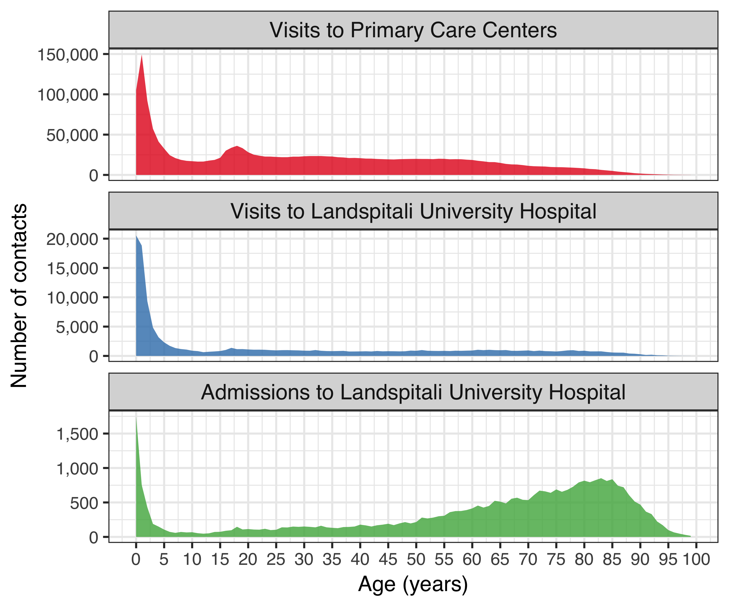

Figure 1 The total number of contacts to Landspitali University Hospital and Primary Care Centers in Iceland associated with International Classification of Diseases, 10th revision (ICD-10) codes compatible with respiratory infections. Data on hospital contacts were extracted from Landspitali University Hospital’s patient registry from 1 January 2005 to 31 December 2017. Primary care contacts were obtained from the Primary Care Registry of the Icelandic Directorate of Health from 1 January 2005 to 31 December 2015. The number of contacts are shown as a function of age. Different Y-axis scales are used for each category. The figure demonstrates disproportionate hospitalizations among older adults, compared to primary care contacts and hospital visits.

In addition to the increased frequency of hospitalization among older adults, the cost associated with each visit and hospitalization is higher (Figure 2).

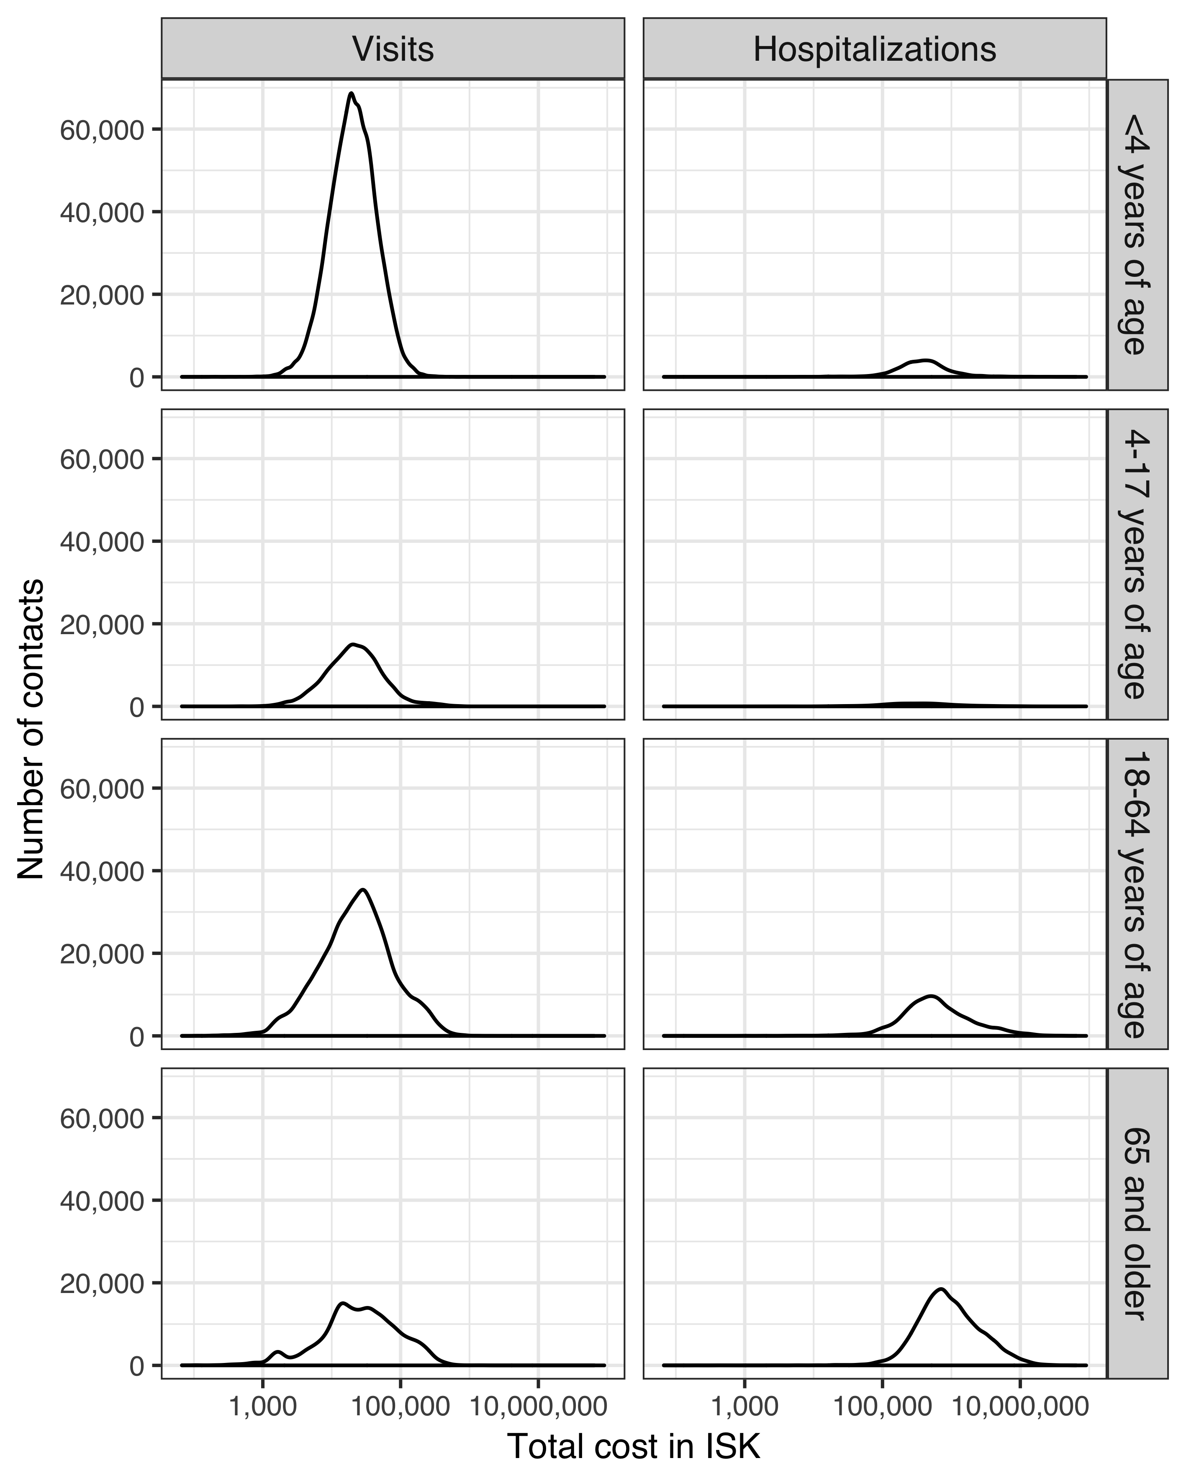

Figure 2 The distribution in the cost associated with contacts to Landspitali University Hospital was extracted from the patient registry for the period of 1 January 2005 to 31 December 2017. Costs are presented in Icelandic Krona (ISK) at the value of the calendar year in which they occurred. Distributions are presented seperately for visits and hospitalizations, and are further divided into age-groups. The X-asis has been logarithmically scaled. The figure shows that costs associated with visits range from 1,000 ISK to 100,000 ISK, while hospitalizations range from 100,000 ISK to 10,000,000 ISK. As age increases, the distribution is shifted towards higher costs.

### The Primary Care Registry

The Primary Care Registry contains information on all primary care health contacts for the period 2005-2015. All contacts associated with the ICD-10 codes listed in Table 9, regardless of age, were extracted. A total of 1,963,439 separate contacts were recorded between 298,307 individual patients and 1,266 different physicians. The most visits recorded for a single individual was 212. The distribution of contacts by age can be seen in Figure 1.

### The National Vaccine Registry

The National Vaccine Registry contains information on all administered vaccine doses for the period 2005-2017. All recorded pneumococcal vaccine doses were extracted using ATC code J07 and sub-levels. A total of 110,712 doses of pneumococcal vaccines were administered to 51,601 individuals during the study period. The monthly number of administered doses per age-group and vaccine is shown in Figure 3.

Different Y-axis scales are used for each category of age. The figure demonstrates the abrupt and sustained increase in the number of administered doses of PCV10 following introduction into the vaccine program. Adult vaccination with 23-PPV does not appear to have increased during the study period.

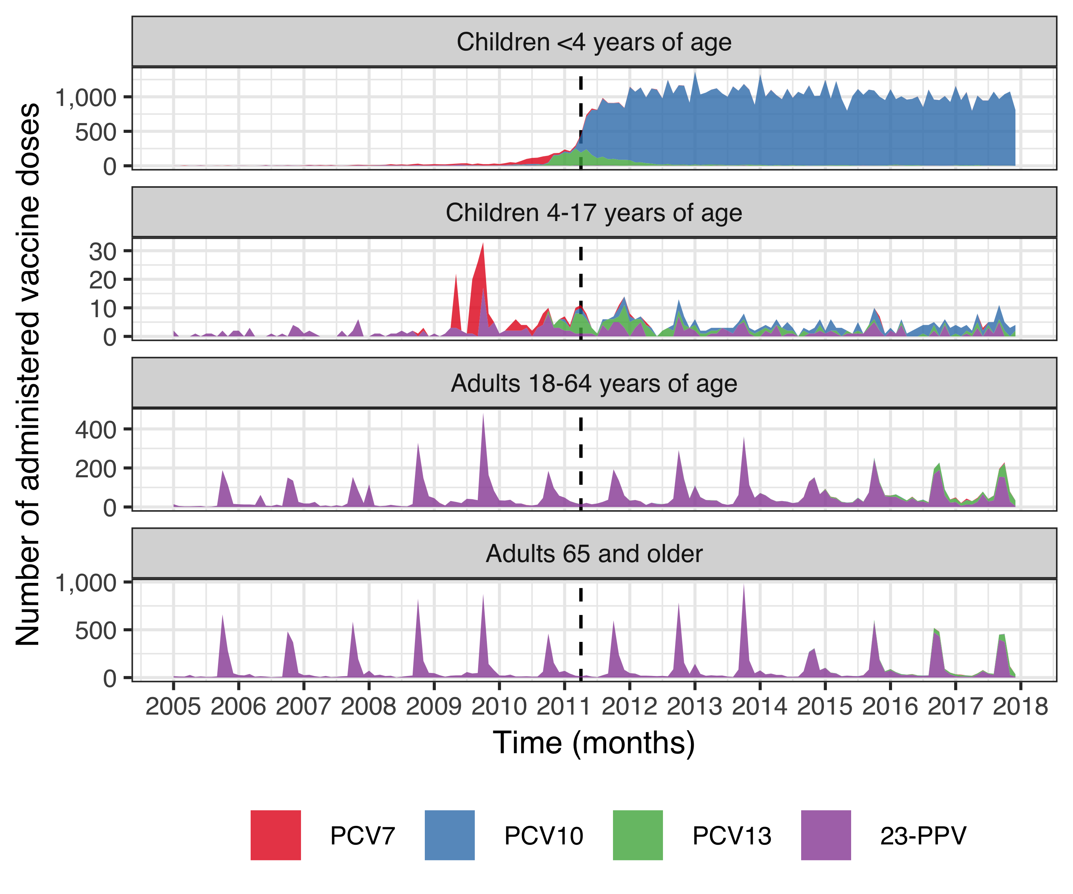

Figure 3 The monthly number of administered doses of pneumococcal vaccines in Iceland from 1 January 2005 to 31 December 2017. Data were extracted from the National Vaccine Registry of the Icelandic Directorate of Health using Anatomical Therapeutic Chemical code J07. Records were available for four different pneumococcal vaccines; the 23-valent pneumococcal polysaccharide vaccine (23-PPV, purple), seven-valent pneumococcal conjugate vaccine (PCV7, red), the 10-valent pneumococcal conjugate vaccine (PCV10, blue) and the 13-valent pneumococcal conjugate vaccine (PCV13, green). The introduction of PCV10 into the Icelandic pediatric vaccination program on 1 April 2011, is shown with a dotted line.

Table 18 shows the number of children in each birth-cohort who had received zero, one, two, or three doses of a pneumococcal conjugate vaccine by four years of age. An abrupt shift is observed in the first vaccine eligible cohort, of which over 90% received three or more doses of a pneumococcal conjugate vaccine. Children who moved to or from the country before four years of age, were excluded from the table.

Table 18 The number of children in each birth-cohort who received zero to three doses of a pneumococcal conjugate vaccine before four years of age are shown. Children who were documented to have immigrated or emigrated from Iceland before four years of where excluded. For the reminaing children, data were obtained from the National Vaccine Registry of the Icelandic Directorate of Health using Anatomical Therapeutic Chemical code J07. Seven-, 10- and 13- valent pneumococcal conjugate vaccines were included.

|  |  |  |  |  |
| --- | --- | --- | --- | --- |
| Birth-cohort | Zero doses | One dose | Two doses | Three doses |
| 2005 | 4,207 | 10 | 5 | 4 |
| 2006 | 4,278 | 26 | 8 | 3 |
| 2007 | 4,345 | 51 | 18 | 13 |
| 2008 | 4,348 | 140 | 62 | 37 |
| 2009 | 4,292 | 166 | 237 | 87 |
| 2010 | 3,660 | 158 | 336 | 549 |
| 2011 | 263 | 44 | 144 | 3,976 |
| 2012 | 199 | 45 | 154 | 4,059 |
| 2013 | 165 | 44 | 122 | 3,940 |
| 2014 | 127 | 54 | 191 | 3,978 |
| 2015 | 70 | 60 | 283 | 3,672 |
| 2016 | 45 | 76 | 466 | 3,514 |

Some children in vaccine non-eligible cohorts received one, two or three doses of pneumococcal conjugate vaccines before four years of age. This generally occurred at an older age than children in the vaccine eligible cohorts Figure 4.

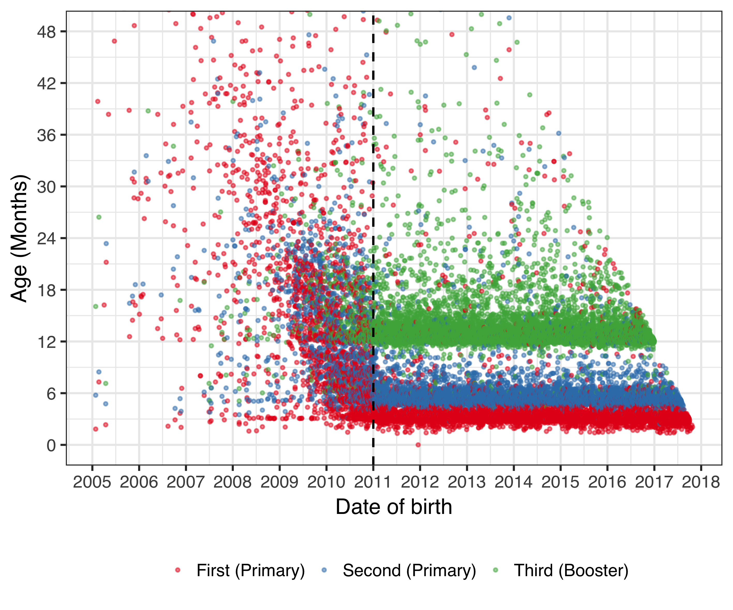

Figure 4 The age at which children receive their first, second and third dose of a pneumococcal conjugate vaccine (PCV) is shown as a function of birth-date. All administered doses of PCV were extracted from the National Vaccine Registry of the Icelandic Directorate of Health from 1 January 2005 to 31 December 2017, using Anatomical Therapeutic Chemical code J07. The age at which each individual child receives a dose of PCV is illustrated with a point. The child’s first documented dose is indicated in red color, their second dose in blue and their third dose in green. The introduction of PCV10 into the Icelandic pediatric vaccination program on 1 April 2011, is shown with a dotted line. Though some children received PCV prior to the vaccine introduction, they did so sporadically and few achieved two or more doses. Those who did were almost invariably born in the later half of 2010. An obvious change occurs after vaccine introduction. The apparent oblique cut-off in points starting for children born in 2014 is explained by censored follow-up time.

### The National Drug Prescription Registry

The National Drug Prescription Registry (NDPR) contains all filled outpatient prescriptions from 2005-2017. From this registry, all antibacterials for systemic use (ATC code J01 and sub-levels), vaccines (J07 and sub-levels), opthalmologicals (S01 and sub-levels) and otologicals (S02 and sub-levels) were extracted. A total of 4,020,624 prescriptions were recorded among 360,560 individuals. The number of prescriptions by the chemical sub-levels of the ATC classification system are shown in Table 19. The highest number of antimicrobial prescriptions filled by a single individual was 336 during the study period.

Table 19 The number of filled outpatient prescriptions by Anatomical Therapeutic Chemical (ATC) is shown for the period from 1 January 2005 to 31 December 2017. Data were extracted from the National Drug Prescription Registry of the Icelandic Directorate of Health.

|  |  |  |
| --- | --- | --- |
| ATC chemical sub-level code | Description | No of prescriptions |
| J01A | Tetracyclines | 357,498 |
| J01B | Amphenicols | 0 |
| J01C | Beta-lactam antibacterials, penicillins | 1,720,661 |
| J01D | Other beta-lactam antibacterials | 106,757 |
| J01E | Sulfonamides and trimethoprim | 168,045 |
| J01F | Macrolides, lincosamides and streptogramins | 344,098 |
| J01G | Aminoglycoside antibacterials | 71 |
| J01M | Quinolone antibacterials | 135,864 |
| J01R | Combinations of antibacterials | 0 |
| J01X | Other antibacterials | 96,318 |
| J07A | Bacterial vaccines | 9,687 |
| J07B | Viral vaccines | 16,703 |
| J07C | Bacterial and viral vaccines | 496 |
| J07X | Other vaccines | 0 |
| S01A | Anti-infective opthalmologicals | 287,904 |
| S02A | Anti-infective otologicals | 1 |
| S01C | Anti-inflammatory agents and anti-infectives opthalmologicals | 40,315 |
| S02C | Anti-inflammatory agents and anti-infectives otologicals | 25,218 |

The distribution in the number of prescriptions for selected chemical sub-levels of the ATC classification system are shown as a function of age in Figure 5.

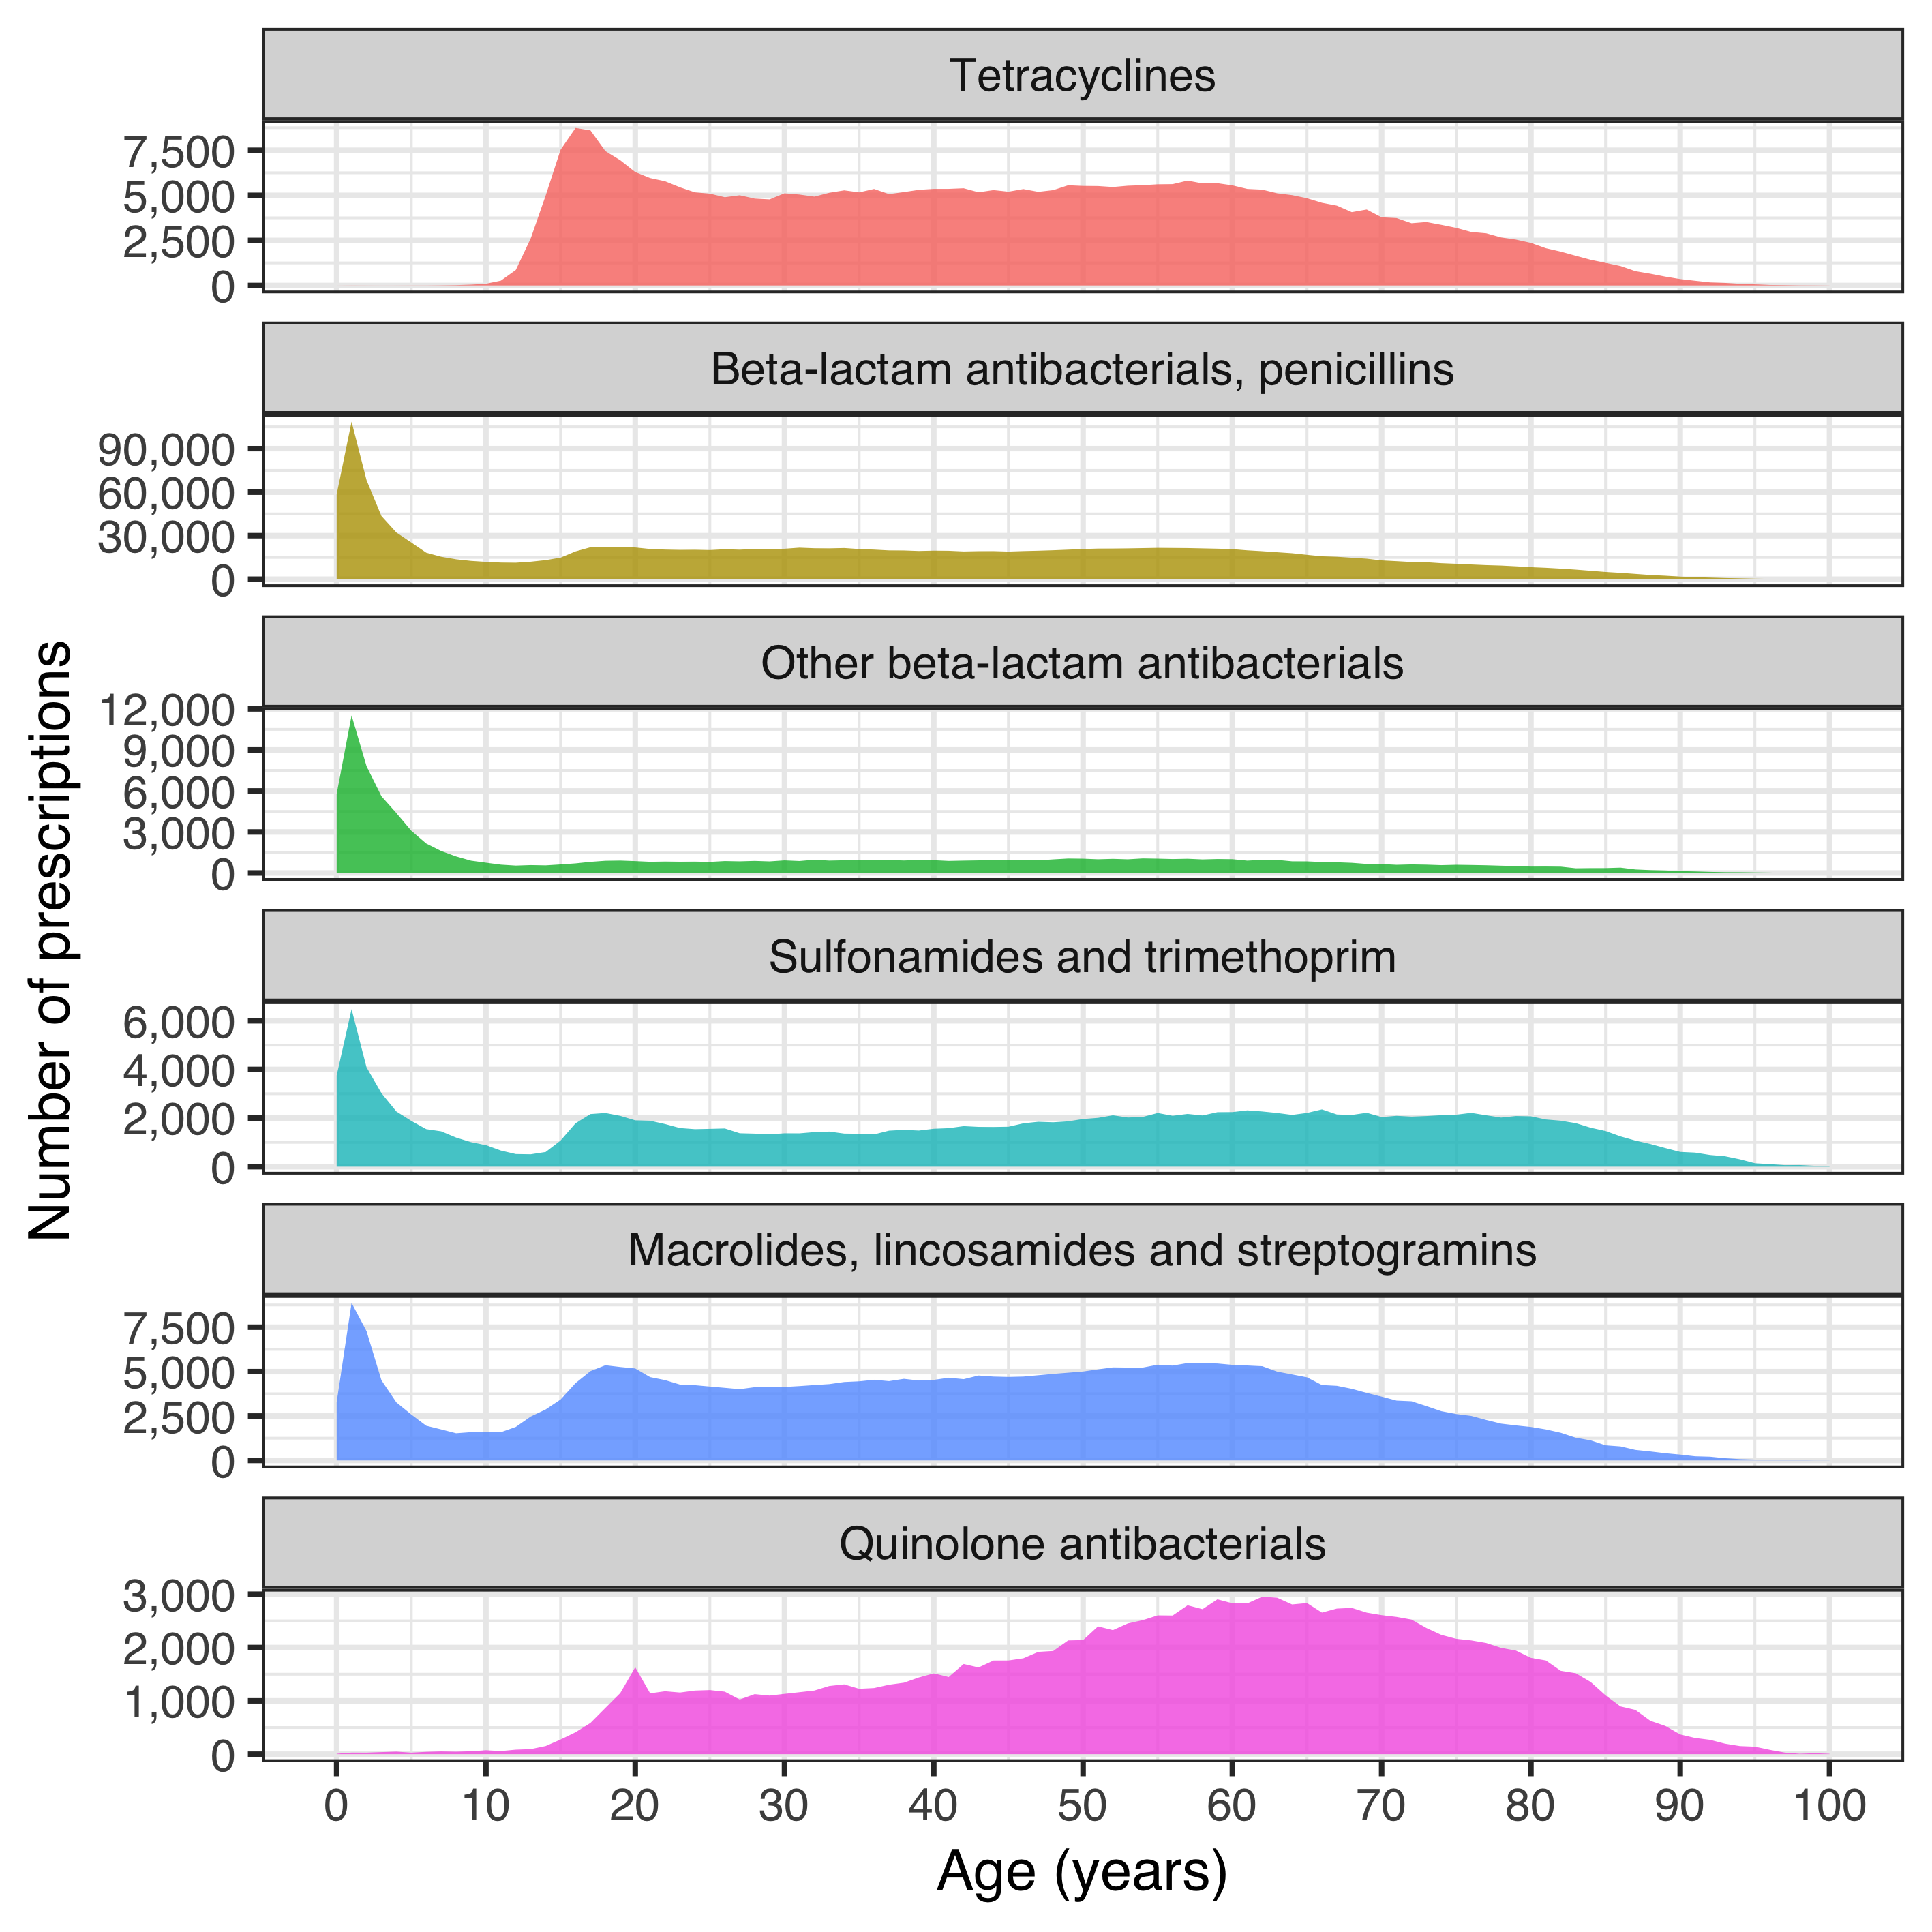

Figure 5 The number of filled antimicrobial prescriptions are shown as a function of age for selected chemical sub-levels of the Anatomical Therapeutic Chemical (ATC) classification system. Data were extracted from the National Drug Prescription Registry of the Icelandic Directorate of Health for the period of 1 January 2005 to 31 December 2017. Different Y-axis scales are used for each category. The figure demonstrates a similar age-distribution for beta-lactam antibacterials, sulfonamides and macrolides, with most prescriptions being filled by young children. Tetracyclines and quinolones are more commonly filled by adults.

### Reimbursement database of Icelandic Health Insurance

All interactions with independent health care practitioners were recorded in Icelandic Health Insurance’s reimbursement database. From this database, all records of otolaryngological procedures were extracted. A total of 51,814 procedures were recorded among 34,084 individuals.

## Impact on otitis media with treatment failure (Paper I)

The total number of children under 18 years of age who lived within Children’s Hospital Iceland’s referral region remained stable during the study period, decreasing from 62,067 in 2008 to 61,798 in 2015. The variation in the number of children under four years of age in the same region was more pronounced, increasing from 13,562 in 2008 to 14,644 in 2011, and then decreasing again to 13,272 in 2015.

During the period 1 January 2008 to 31 December 2015, 103,220 visits were recorded to the emergency department of Children’s Hospital Iceland. The visits varied over the calendar year, spiking in the winter months and troughing in the summer months. The total number of visits increased steadily during the study period, from 12,229 in 2008 to 14,502 in 2015 (Figure 6).

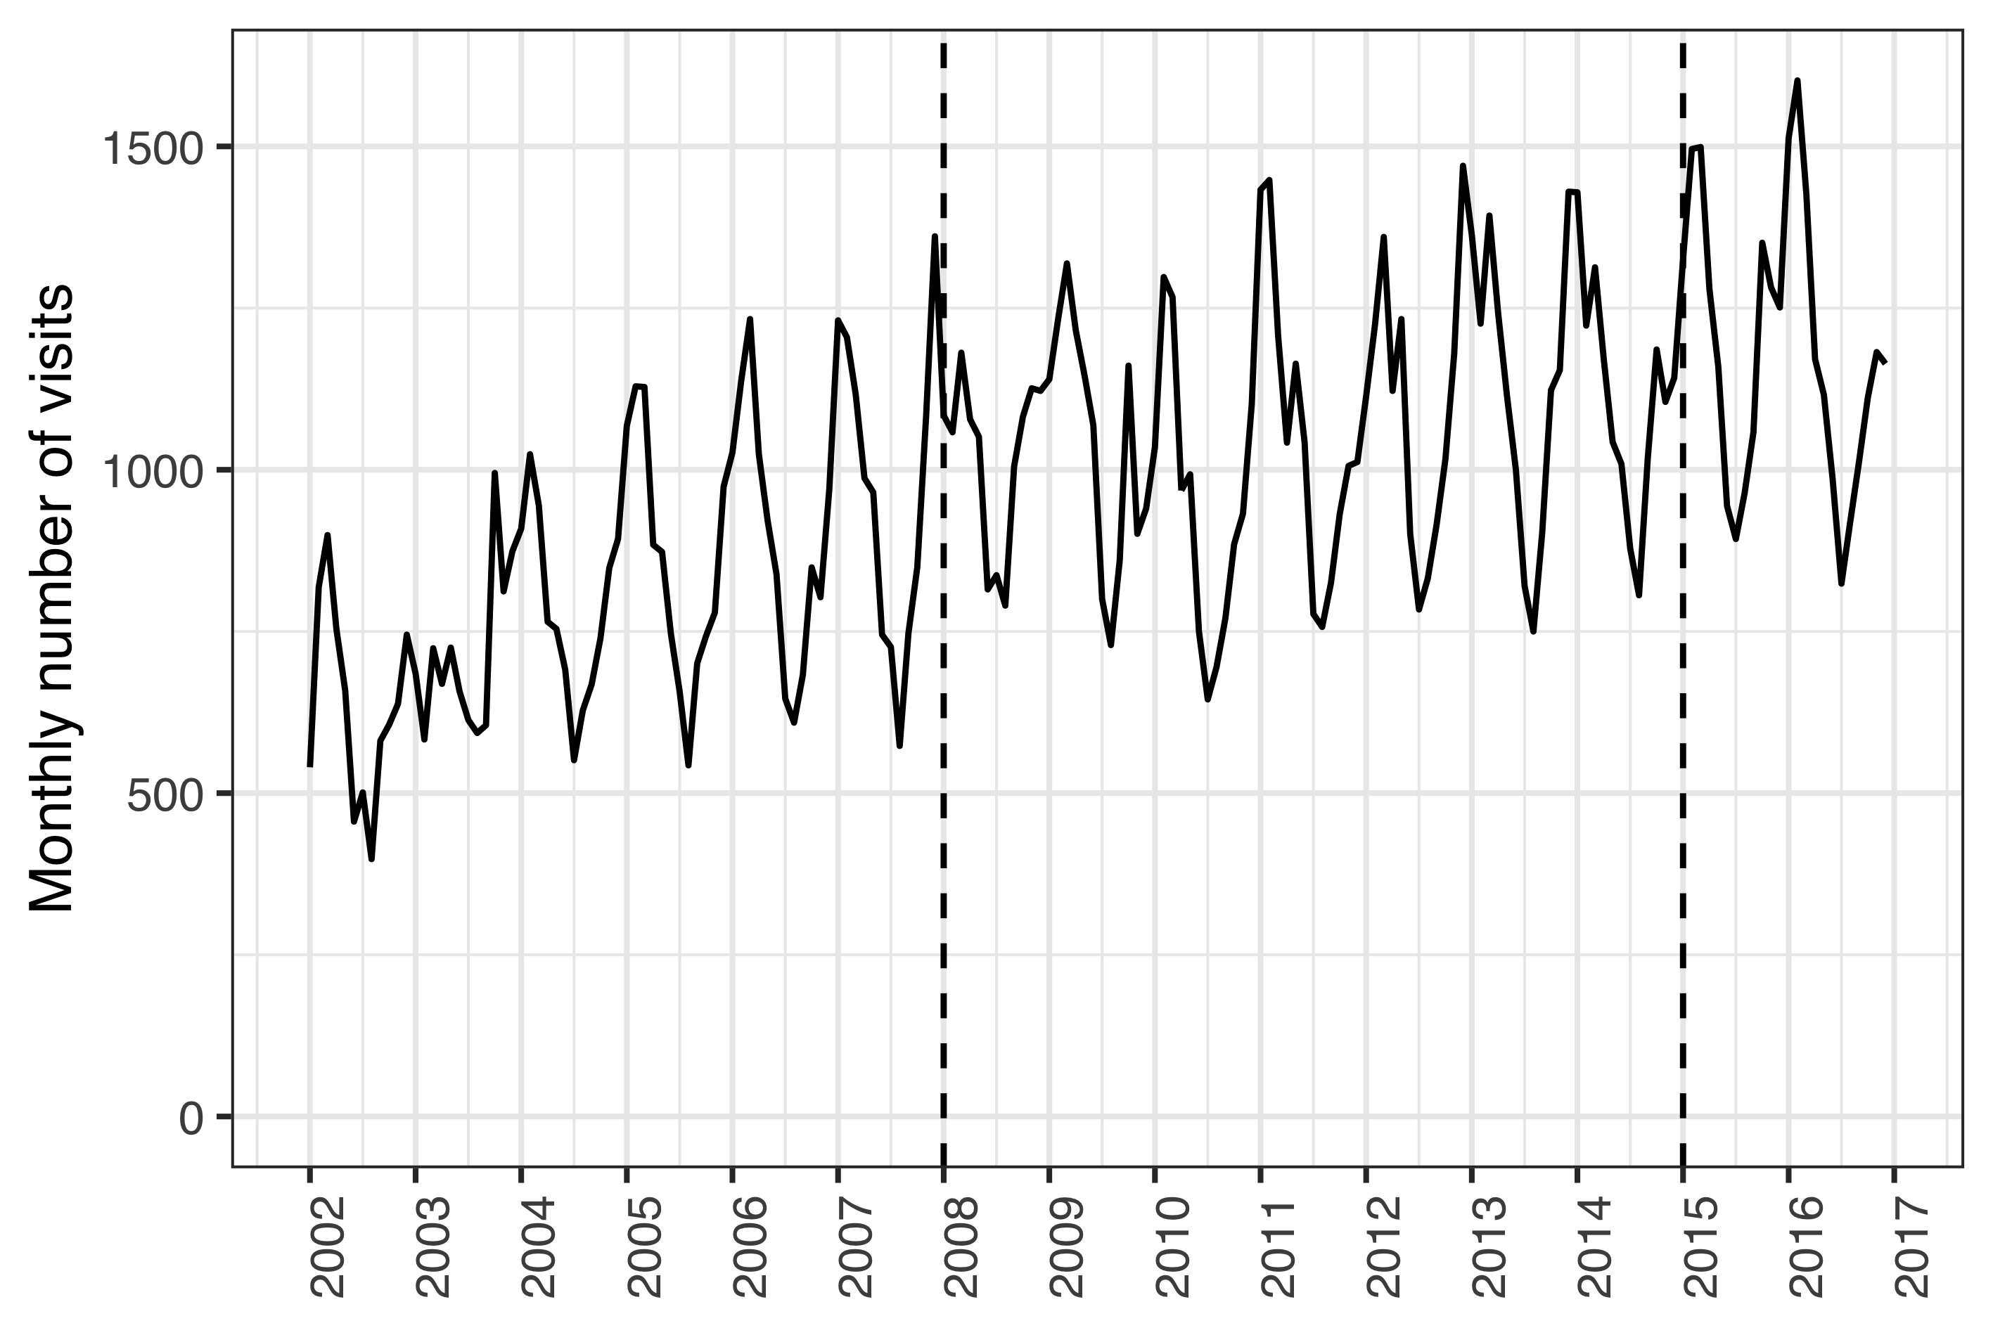

Figure 6 The monthly number of visits of children zero to 18 years of age to Children’s Hospital Iceland’s emergency department for the period from January 2002 to December 2016. All visits are included regardless of International Classification of Diseases, 10th revision (ICD-10) diagnostic codes. The study period was from January 2008 to December 2015, and is delineated with two vertical dashed lines.

During the same period, 6,232 visits to the Children’s Hospital Iceland for acute otitis media were recorded for 4,624 individual children under four years of age, representing 4,994 distinct episodes. Of those episodes, 531 were treated with one or more doses of ceftriaxone. The total number of visits, visits for AOM and ceftriaxone treatment episodes are shown in Table 20,

Table 20 The incidence of visits and parenteral ceftriaxone administrations at Children’s Hospital Iceland by calendar-year. The incidence is both presented for all visits regardless of diagnosis (Total) and visits associated with acute otitis media (AOM). When presented for total visits or administrations, the denominator is children 18 and younger who live within Children’s Hospital Iceland’s referral region and is expressed per 1,000 visits or person-years. The denominator of AOM associated visits are children younger than four years of age in the same region. The incidence rate and incidence risk are shown with the number of events within parentheses

|  |  |  |  |  |  |  |
| --- | --- | --- | --- | --- | --- | --- |
| Year | Total (n) | AOM (n) | Total (n) | AOM (n) | Total (n) | AOM (n) |
| 2008 | 197 (12,229) | 69 (936) | 80.8 (988) | 186 (174) | 15.9 (988) | 72.9 (174) |
| 2009 | 199 (12,514) | 72 (1,012) | 74.8 (936) | 192 (194) | 14.9 (936) | 66.5 (194) |
| 2010 | 181 (11,339) | 64.2 (925) | 81 (918) | 253 (234) | 14.6 (918) | 63.7 (234) |
| 2011 | 201 (12,645) | 60.8 (890) | 63.8 (807) | 178 (158) | 12.8 (807) | 55.1 (158) |
| 2012 | 215 (13,150) | 58.4 (830) | 52.5 (691) | 163 (135) | 11.3 (691) | 48.6 (135) |
| 2013 | 221 (13,518) | 55.2 (772) | 54.7 (739) | 105 (81) | 12.1 (739) | 52.8 (81) |
| 2014 | 216 (13,323) | 52 (708) | 48.9 (652) | 76.3 (54) | 10.6 (652) | 47.9 (54) |
| 2015 | 235 (14,502) | 55.1 (731) | 56.7 (822) | 88.9 (65) | 13.3 (822) | 61.9 (65) |

The incidence rate of AOM visits to Children’s Hospital Iceland decreased significantly in the post-vaccine period as compared to the pre-vaccine period; from 47.4 visits to 41.8 per 1,000 person-years. The crude IRR was 0.88 (95% CI 0.83 to 0.93). Mantel-Haenszel adjustment was not appropriate due to effect heterogeneity ( $χ^{2}$ = 15.2, *P*<0.001). When each age-group was examined separately, a significant decrease in AOM visits was observed among children between one and two years of age (IRR 0.89) and between two and three years of age (IRR 0.79) as shown in Table 21. Children younger than one year of age and children between three and four years of age, visited the Children’s Hospital Iceland because of AOM 471 times and 379 times, respectively.

Table 21 The incidence rate ratios (IRR) of acute otitis media (AOM) associated visits between the pre- and post-vaccine periods are presented for each age with 95% confidence intervals within parentheses. The chi-squared statistic and P-value are also presented.

|  |  |  |  |
| --- | --- | --- | --- |
| Age (years) | IRR (95% CI) | Chi-squared | P-value |
| <1 | 1.10 (0.90-1.30) | 0.80 | 0.370 |
| 1-2 | 0.89 (0.83-0.96) | 8.60 | 0.003 |
| 2-3 | 0.79 (0.71-0.88) | 17.00 | <0.001 |
| 3-4 | 1.00 (0.85-1.30) | 0.22 | 0.639 |

Independent of the decrease in AOM associated visits to the Children’s Hospital, the incidence of ceftriaxone treatment episodes for AOM was also found to decrease significantly in the post-vaccine period compared to the pre-vaccine period. The effect was heterogeneous across age-strata ( $χ^{2}$ = 57, *P*<0.001) and the crude overall IRR was 0.48 (95% CI 0.40 to 0.58). The stratum specific results are shown in Table 22. During the study period, only 17 episodes of AOM were treated with ceftriaxone among children zero to one years of age and 19 episodes were treated among children three to four years of age.

Table 22 The incidence rate ratios (IRR) of ceftriaxone treatment episodes of acute otitis media (AOM) between the pre- and post-vaccine periods are presented for each age with 95% confidence intervals within parentheses. The chi-squared statistic and P-value are also presented.

|  |  |  |  |
| --- | --- | --- | --- |
| Age (years) | IRR (95% CI) | Chi-squared | P-value |
| <1 | 0.61 (0.19-1.80) | 0.96 | 0.326 |
| 1-2 | 0.47 (0.37-0.60) | 41.00 | <0.001 |
| 2-3 | 0.47 (0.32-0.68) | 18.00 | <0.001 |
| 3-4 | 0.85 (0.31-2.30) | 0.12 | 0.732 |

The risk of receiving ceftriaxone treatment if presenting to Children’s Hospital Iceland with AOM was calculated to correct for the possibility that observed decreases in ceftriaxone treatment episodes were due only to a decrease in the number of AOM associated visits. The risk decrease was not homogeneous across age-strata ( $χ^{2}$ = 33.8, *P*<0.001) and the overall relative risk ratio was 0.58 (95% CI 0.48 to 0.69). The stratum specific effects are shown in Table 23.

Table 23 The incidence risk ratio (IRR) of receiving ceftriaxone treatment if presenting to Children’s Hospital Iceland with acute otitis media (AOM) between the pre- and post-vaccine periods is shown along with 95% confidence intervals. The corresponding Chi-squared statistic and P-value are also presented.

|  |  |  |  |
| --- | --- | --- | --- |
| Age (years) | IRR (95% CI) | Chi-squared | P-value |
| <1 | 0.56 (0.17-1.70) | 1.30 | 0.258 |
| 1-2 | 0.53 (0.42-0.67) | 26.00 | <0.001 |
| 2-3 | 0.59 (0.40-0.86) | 7.50 | 0.006 |
| 3-4 | 0.81 (0.29-2.20) | 0.19 | 0.662 |

Thus the study found significant decreases in the incidence of AOM visits, ceftriaxone treatment episodes of AOM and risk of ceftriaxone treatment if presenting to the Children’s Hospital Iceland with AOM. Similar decreases were established in the ceftriaxone treatment episodes for pneumonia. In the pre-vaccine period, 251 treatment episodes were recorded, compared to only 90 in the post-vaccine period. The effect was not consistent across age-strata ( $χ^{2}$ = 72, *P*<0.001). The overall IRR was 0.37 (95% CI 0.29 to 0.47). The stratum specific effects are shown in Table 24.

Table 24 The incidence rate ratio (IRR) of ceftriaxone treatment episodes of pneumonia between the pre- and post-vaccine periods are presented along with 95% confidence intervals. The Chi-squared statistic and P-value are also shown.

|  |  |  |  |
| --- | --- | --- | --- |
| Age (years) | IRR (95% CI) | Chi-squared | P-value |
| <1 | 0.15 (0.017-0.64) | 8.6 | 0.003 |
| 1-2 | 0.34 (0.220-0.51) | 33.0 | <0.001 |
| 2-3 | 0.36 (0.230-0.54) | 28.0 | <0.001 |
| 3-4 | 0.51 (0.290-0.89) | 6.4 | 0.012 |

To ascertain whether a decrease in ceftriaxone use occurred in vaccinated children for non-vaccine related indications, the incidence of ceftriaxone treatment episodes for all other indications was examined. No heterogeneity across age-strata was detected ( $χ^{2}$ = 0.56, *P*=0.455). The Mantel-Haenszel adjusted IRR was 0.96 (95% CI 0.87 to 1.06), and the null hypothesis of no difference in the incidence rate of treatment episodes could not be rejected. The number of treatment episodes by age and vaccine period ranged from 117 to 295. The stratum specific IRR are shown in Table 25.

Table 25 The incidence rate ratios (IRR) of ceftriaxone treatment episodes for indications other than acute otitis media and pneumonia between the pre- and post-vaccine periods are presented for each age with 95% confidence intervals within parentheses. The chi-squared statistic and P-value are also presented.

|  |  |  |  |
| --- | --- | --- | --- |
| Age (years) | IRR (95% CI) | Chi-squared | P-value |
| <1 | 1.30 (1.10-1.50) | 7.60 | 0.006 |
| 1-2 | 0.86 (0.70-1.00) | 2.40 | 0.121 |
| 2-3 | 0.73 (0.58-0.91) | 8.00 | 0.005 |
| 3-4 | 0.90 (0.70-1.20) | 0.62 | 0.432 |

The quarterly incidence of ceftriaxone treatment episodes by indication are shown in Figure 7.

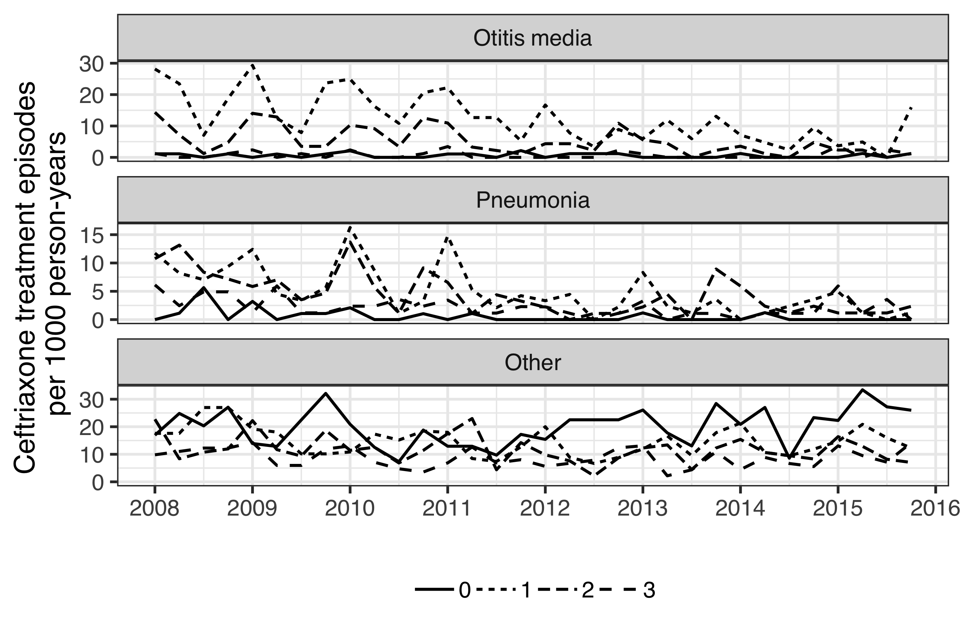

Figure 7 The quarterly incidence rate (IR) of ceftriaxone treatment episodes are shown stratified by age and indication for the period from January 2008 to December 2015. The IR per 1,000 person-years is presented for children one, two, three and four years of age using different line-types. The figure is stratified by indication, and demonstrates a decrease in the IR of ceftriaxone treatment episodes for acute otitis media and pneumonia in the post-vaccine period January 2012 to December 2016. No such decrease is visible for ceftriaxone treatment episodes for all other indications.

To further test whether a general decrease was occurring in the overall use of ceftriaxone, rather than a specific decrease for vaccine-related indications in vaccinated children, an examination of ceftriaxone treatment episodes in all children regardless of age and indication was undertaken. An overall decrease in the IR of ceftriaxone treatment episodes was found among children under 18 years of age regardless of indication. The IR declined from 11.1 to 9.55 treatment episodes per 1,000 person-years, IRR 0.86 (95% CI 0.81-0.91). The effect was not consistent across age-groups ( $χ^{2}$ = 23.6, *P*<0.001). When examined by age-group, the overall decrease proved to be driven by the youngest age-group – i.e the children who were protected by the vaccination. The incidence of ceftriaxone treatment episodes did not decrease significantly in other age groups (Figure 8).

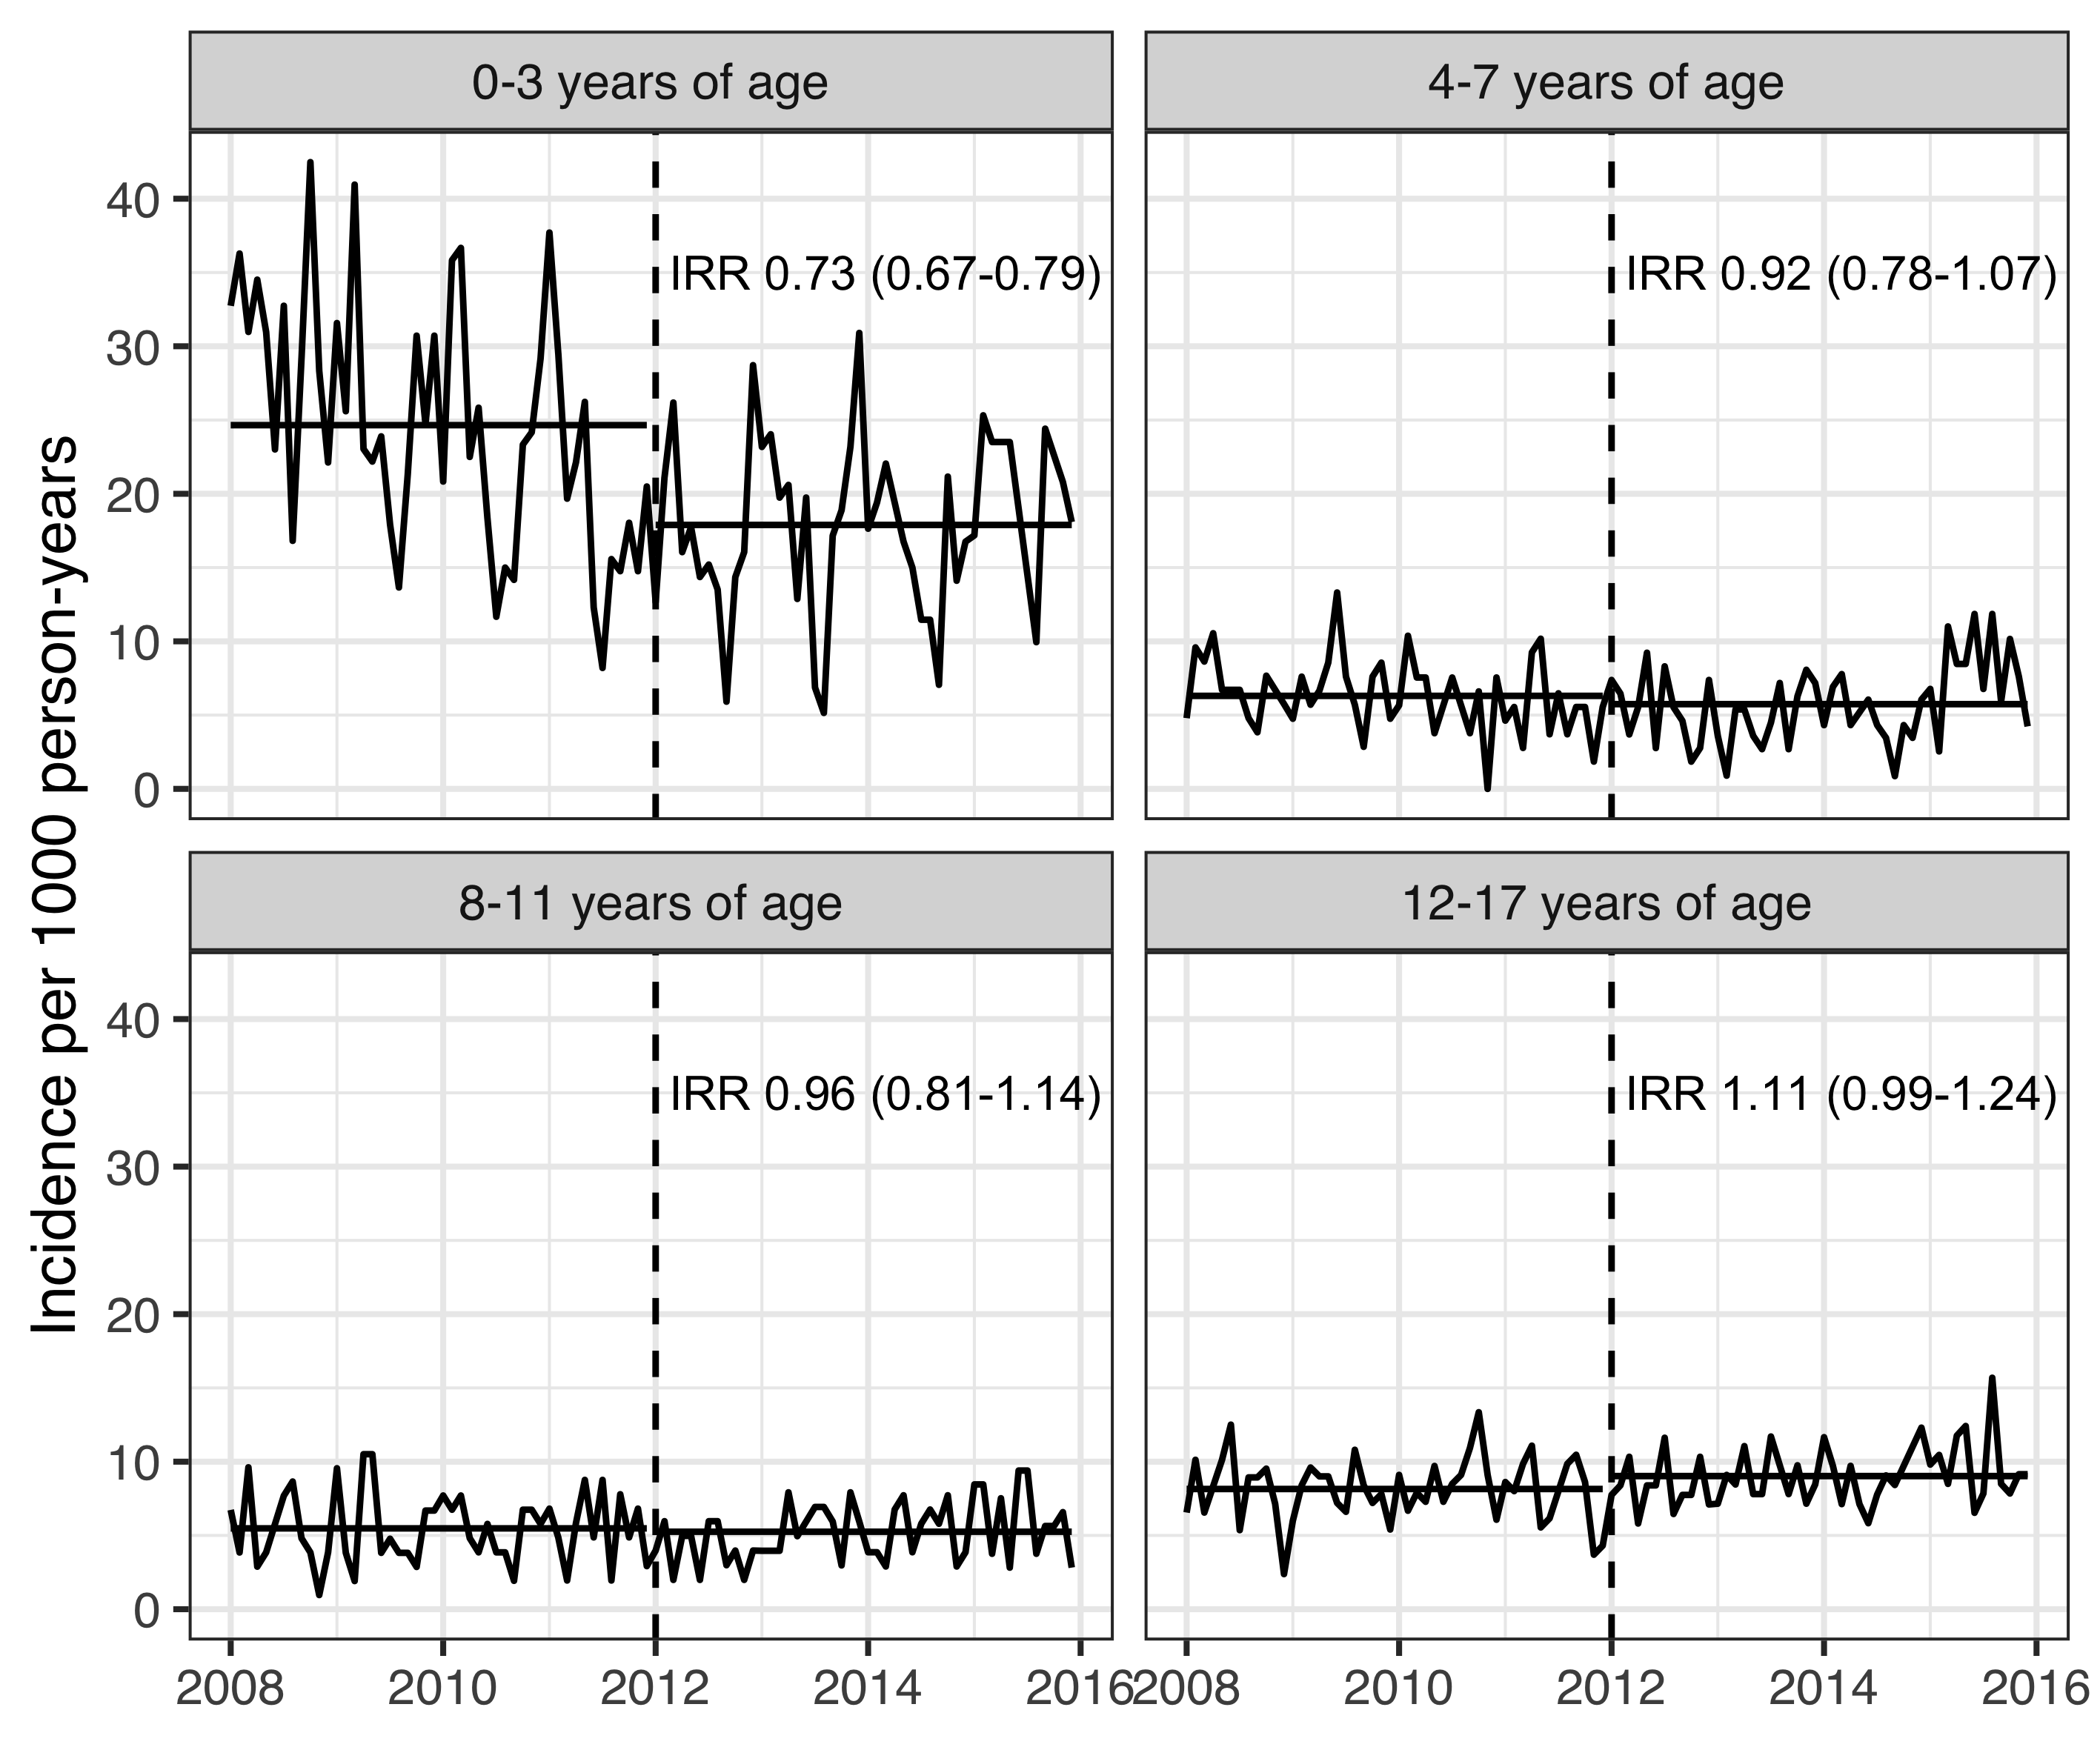

Figure 8 The monthly incidence rates (IR) of ceftriaxone treatment episodes per 1,000 person-years regardless of indication are shown stratified by age-groups for the period from January 2005 to December 2016. The delineation between the pre- and post-vaccine periods on January 2012 is illustrated with a dashed vertical line. For each age-group, the mean IR in the pre- and post-vaccine periods are depicted with a solid horizontal line. The incidence rate ratio (IR) between the two vaccine periods is shown for each age-group along with 95% confidence intervals within parentheses. The figure demonstrates a significant decrease in the IR of ceftriaxone treatment episodes for children zero to three years of age. No change is detectable in other age-groups.

## Impact on primary care visits for acute otitis media (Paper II)

The demographics of the study birth-cohorts are described in chapter 5.1 and Table 15. A total of 92,935 primary care visits for acute otitis media were recorded among birth-cohorts 2005-2015 during the study period. The crude incidence rate of AOM visits to primary care per 100 person-years in the VNEC and VEC was 45.3 and 39.8 respectively. The IR and number of AOM visits by birth-cohort and gender are shown in Table 26.

Table 26 The incidence rate (IR) of acute otitis media visits to primary care physicians is shown for each birth-cohort and gender. The absolute number of visits are presented within parentheses.

|  |  |  |
| --- | --- | --- |
| Birth-cohort | Females | Males |
| 2005 | 41.9 (2,777) | 49.0 (3,439) |
| 2006 | 46.1 (3,096) | 50.9 (3,605) |
| 2007 | 45.7 (3,118) | 50.3 (3,646) |
| 2008 | 46.2 (3,259) | 45.3 (3,419) |
| 2009 | 40.9 (2,981) | 47.0 (3,649) |
| 2010 | 45.0 (3,207) | 47.0 (3,523) |
| 2011 | 39.1 (2,631) | 44.1 (3,164) |
| 2012 | 40.6 (2,760) | 41.8 (2,977) |
| 2013 | 38.0 (2,125) | 42.8 (2,322) |
| 2014 | 37.4 (1,200) | 44.0 (1,465) |
| 2015 | 15.8 (157) | 20.8 (222) |

The lowest incidence was observed in children zero to three months of age, ranging from 3-6 visits per 100 person-years. Thereafter, the incidence increased sharply, and peaked in children eight to eleven and twelve to fifteen months of age, ranging from 50 to 80 visits per 100 person-years. The crude IR decreased significantly in all age-groups, with incidence rate ratios ranging from 0.60 to 0.94. The largest and visually most consistent decrease in incidence was observed among children zero to three months of age, IRR 0.6 (95%CI 0.51 to 0.69), Figure 9.

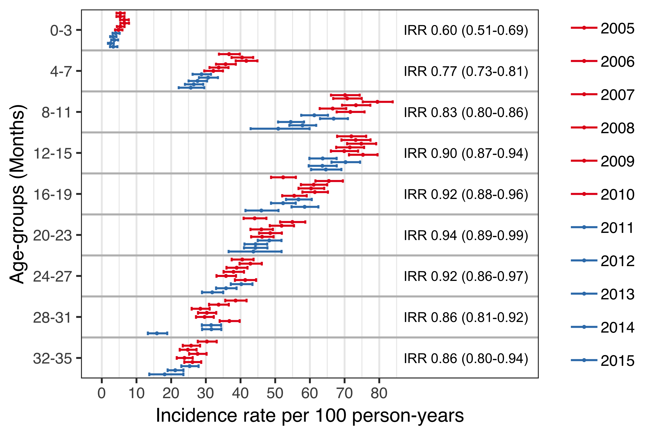

Figure 9 The incidence rate (IR) of acute otitis media (AOM) visits to primary care physicians is shown stratified by birth-cohort and four-month age-groups. The estimated IR is illustrated with a point and 95% confidence intervals are depicted with horizontal error-bars. The vaccine non-eligible birth-cohorts (VNEC) are illustrated in red, and the vaccine eligible birth-cohorts in blue. The incidence rate ratio (IRR) between the VEC and VNEC is shown for each age-group and 95% confidence intervals are presented within parentheses.

When tabulated by the cumulative number of AOM episodes experienced by each child, the proportion of children experiencing zero episodes of AOM increased in the VEC compared to the VNEC, while the proportion experiencing one to four episodes and five or more decreased, as shown in Table 27.

Table 27 The proportion of each vaccine eligibility cohort that experienced zero, one to four and five to twelve cumulative episodes of AOM by 36 months of age. The incidence risk ratio (IRR) between the vaccine eligible cohorts (VEC) and vaccine non-eligible cohorts (VNEC) is presented along with 95% confidence intervals within parentheses.

|  |  |  |  |
| --- | --- | --- | --- |
| No. visits | VNEC (%) | VEC (%) | Incidence risk (95%CI) |
| 0 | 40.0 | 43.2 | 1.14 (1.10-1.18) |
| 1-4 | 55.7 | 53.2 | 0.904 (0.876-0.932) |
| 5-12 | 4.23 | 3.58 | 0.84 (0.744-0.946) |

Discrimination indices for the Andersen-Gill multiple event model were adequate, Nagelkerke’s $R^{2}$ = 0.110 and Somer’s $D_{xy}$ = 0.238. No systematic deviations in Schoenfeld residuals were detected on diagnostic plots indicating that the proportional hazard assumption for each covariate were met. There was little variation in the hazard of AOM between vaccine non-eligible birth-cohorts. Only the 2007 birth-cohort differed significantly, with a hazard ratio of 1.06 (95%CI 1.01 to 1.12) compared to the 2010 birth-cohort. An abrupt and significant decrease in the hazard of AOM was noted in the first vaccine eligible cohort, which continued for all remaining VEC (Figure 10). The estimated impact of PHiD-CV10 on AOM episodes in the primary care setting among children younger than three years of age was 21% (95%CI 11% to 30%).

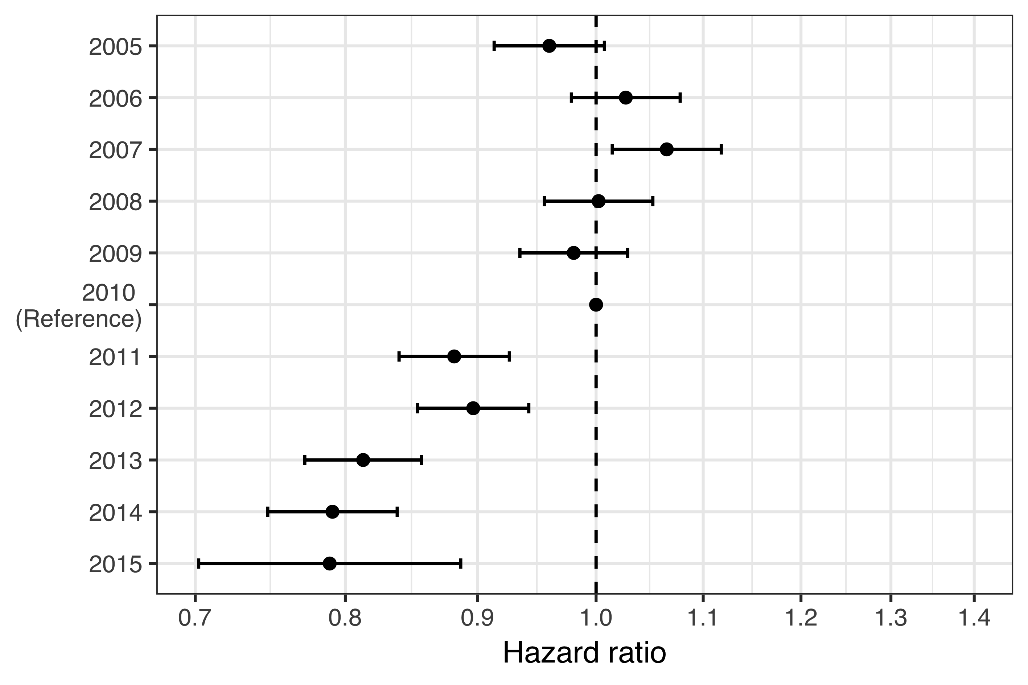

Figure 10 The hazard ratio (HR) of acute otitis media (AOM) between each birth-cohort and the last vaccine non-eligible birth-cohort is shown. The estimated HR is presented with a point, and 95% confidence intervals are illustrated with horizontal error-bars. The 2010 birth-cohort is used as a reference and therefore no confidence intervals are presented. A dashed vertical line is placed on the ratio value of one to assist in visually estimating significance. The X-axis is on the logarithmic scale. The figure demonstrates an abrupt decrease in the hazard of AOM in the first vaccine eligible birth-cohort.

When the hazard ratio of AOM between VEC and VNEC was stratified by the number of previous AOM episodes, the vaccine impact was discernible in children who had experienced either no or only one previous AOM episode. Among children who had more than one previous AOM episode, no effect was found (Figure 11).

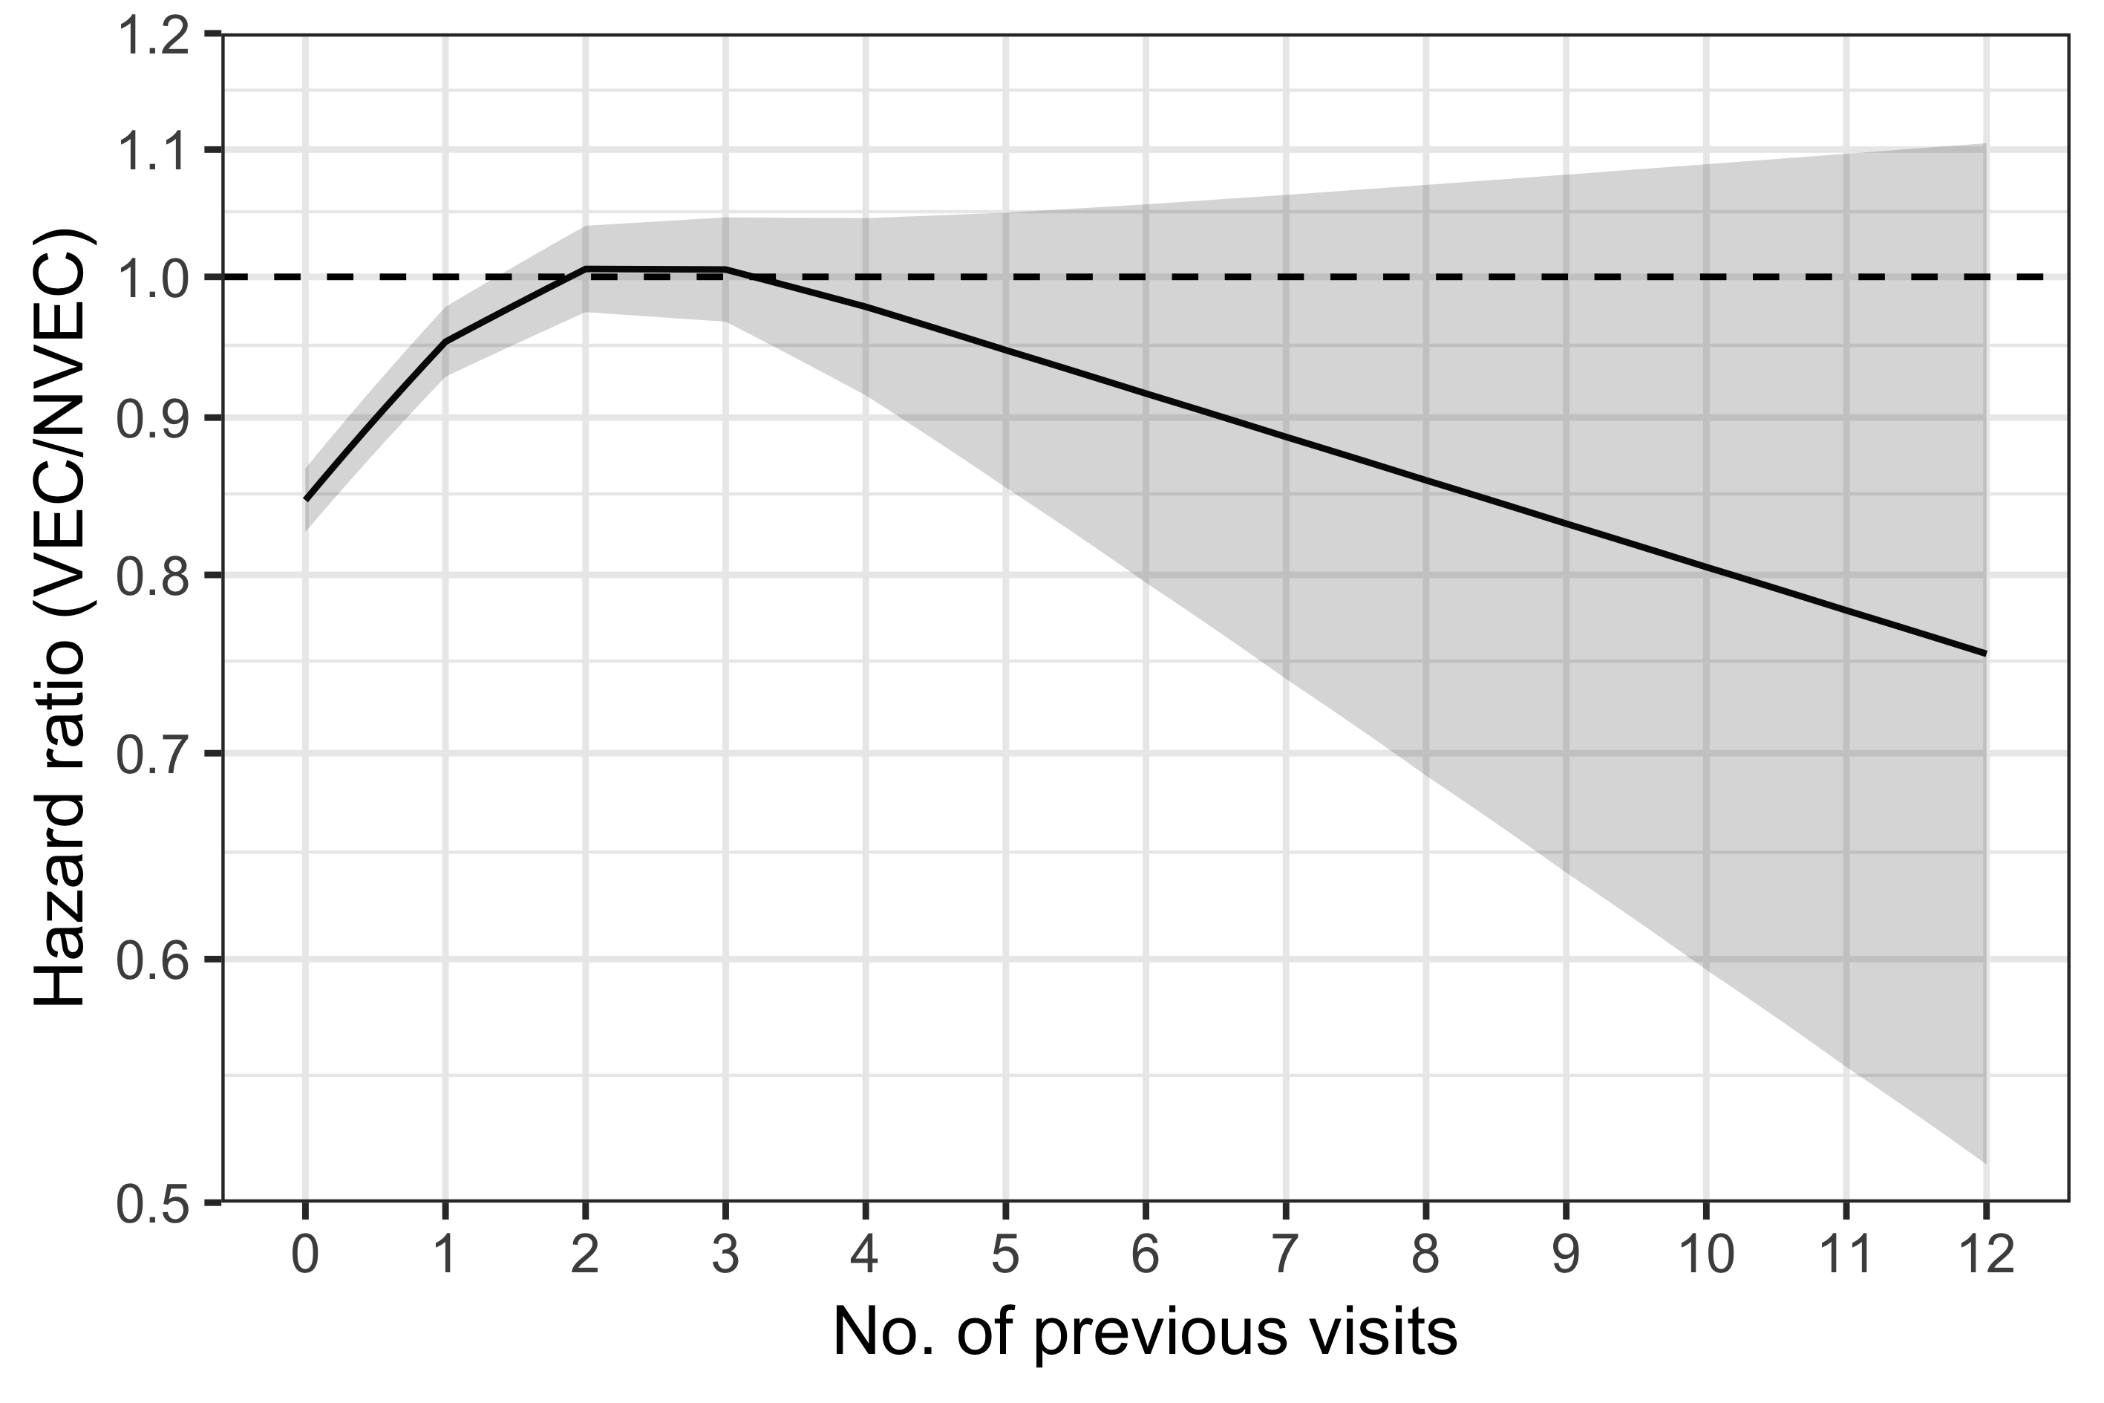

Figure 11 The hazard ratio (HR) of acute otitis media (AOM) between the vaccine eligible (VEC) and vaccine non-eligible cohorts (VNEC) is shown stratified by the number of previous AOM episodes. The estimated HR is illustrated as a solid black line, and 95% confidence intervals are presented as a shaded area. A dashed horizontal line is placed on the ratio value of one to assist in visually assessing significance. The Y-axis is truncated at a HR of 0.5 and is presented on the logarithmic scale. The figure demonstrates a significantly lower hazard of experiencing an additional episode of AOM among vaccine eligible children who have previously experienced zero or one episodes.

The mean number of AOM episodes in primary care was calculated as a function of age using the generalized Nelson-Aalen estimate of the underlying Andersen-Gill model. By their third birthday, the average child in the VNEC had experienced 1.61 episodes of AOM. The average child in the VEC had experienced 1.37. The mean number of AOM episodes by age is shown in Figure 12.

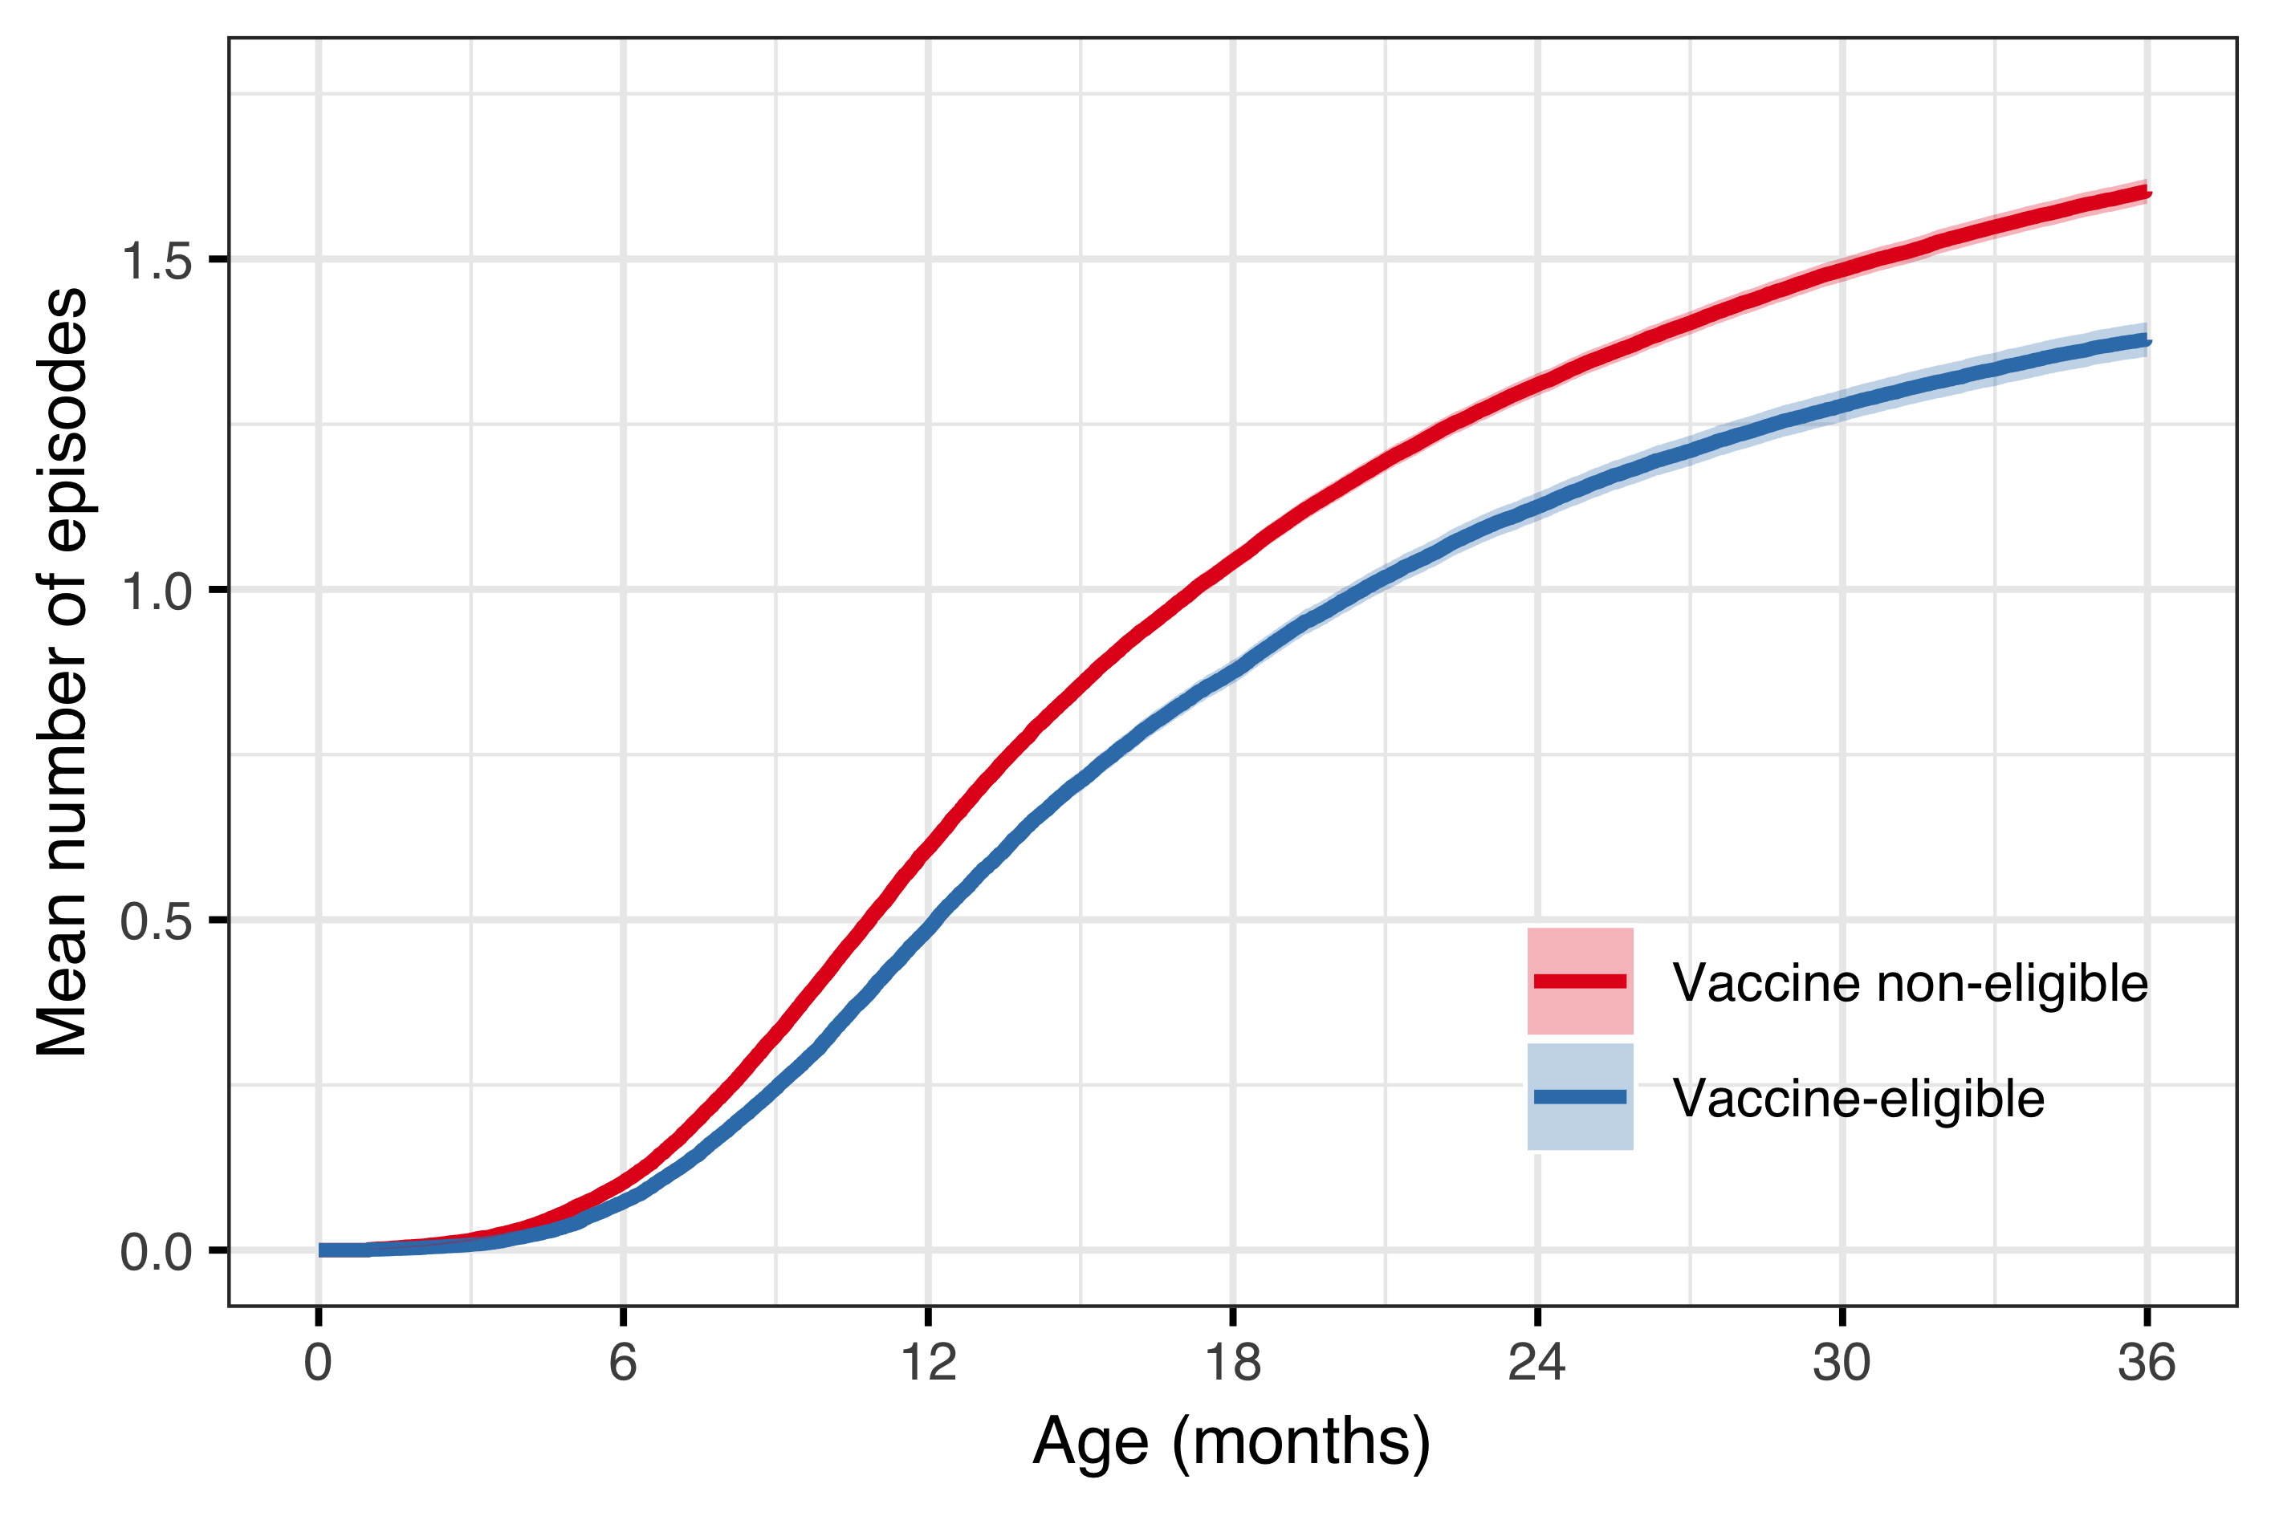

Figure 12 The mean number of acute otitis media (AOM) episodes is shown as a function of age. The estimated mean is presented as a solid red line for the vaccine non-eligible cohorts and a blue line is used for the vaccine eligible cohorts. The 95% confidence intervals are illustrated as shaded areas. The figure demonstrates an early divergence in the mean number of episodes between the two cohorts.

## Impact on outpatient antimicrobial prescriptions (Paper III)

Demographic data regarding the study birth-cohorts are summarized in chapter 5.1 and Table 15.

From 2005-2012, first-line penicillins were the most commonly prescribed antimicrobials and represented between 41% and 47% of all antimicrobial prescriptions in children younger than three years of age. Their use decreased suddenly to 32% in 2013, and represented only 18% of all antimicrobial prescriptions in 2014 and 2015. During this same period, the use of second-line penicillins increased from 35%-40% from 2005-2012, to 48%, 55% and 54% in 2013, 2014 and 2015. Use of cephalosporins followed a similar trend – there use represented between 5.2% and 7.8% of all prescriptions 2005–2012, and increased to 10–15% between 2013–2016. Antimicrobial prescriptions by calendar year are shown in Table 28.

Table 28 The incidence rate (IR) and number of outpatient antimicrobial prescriptions among children younger than three years of age are presented by calendar-year from 2005 to 2016. Antimicrobials were grouped based on a previously published classification system (Youngster et al. 2017).

|  |  |  |  |  |  |  |  |  |
| --- | --- | --- | --- | --- | --- | --- | --- | --- |
| Calendar year | No. prescriptions | Incidence per 100 person-years | First-line penecillin | Second-line penecillin | First-generation macrolide | Second-generation macrolide | Cephalosporin | Other |
| 2005 | 25,649 | 204.0493 | 41.41 | 37.92 | 1.48 | 6.55 | 5.37 | 7.26 |
| 2006 | 26,396 | 205.5123 | 40.34 | 39.57 | 1.27 | 6.22 | 5.36 | 7.24 |
| 2007 | 25,179 | 192.0448 | 44.97 | 36.80 | 1.60 | 6.39 | 5.16 | 5.08 |
| 2008 | 24,046 | 178.4622 | 46.74 | 35.22 | 0.20 | 6.37 | 5.91 | 5.57 |
| 2009 | 22,409 | 159.3586 | 46.41 | 37.16 | 0.05 | 5.51 | 6.33 | 4.55 |
| 2010 | 24,007 | 166.9239 | 43.71 | 38.55 | 0.02 | 5.54 | 7.02 | 5.17 |
| 2011 | 23,866 | 163.6002 | 44.70 | 37.92 | 0.03 | 5.91 | 7.47 | 3.98 |
| 2012 | 22,703 | 159.5993 | 43.45 | 39.01 | 0.01 | 6.92 | 7.77 | 2.83 |
| 2013 | 21,113 | 151.9686 | 32.10 | 48.08 | 0.02 | 6.56 | 10.03 | 3.20 |
| 2014 | 20,325 | 151.7924 | 18.48 | 55.46 | 0.01 | 6.60 | 14.53 | 4.92 |
| 2015 | 19,873 | 149.6010 | 18.49 | 53.91 | 0.06 | 7.25 | 14.95 | 5.34 |
| 2016 | 20,543 | 160.3294 | 35.28 | 41.68 | 0.04 | 5.52 | 12.91 | 4.57 |

The proportion of visits resulting in antimicrobial prescription and the incidence of antimicrobial prescriptions linked to each of the study’s diagnostic groups are shown in Figure 13. The proportion of otitis media visits resulting in an antimicrobial prescription remained stable at between 57% and 64% of visits. The incidence of otitis media associated prescriptions decreased from a high of 54.9 prescriptions per 100 person-years in 2008 to 39.8 prescriptions per 100 person-years in 2015.

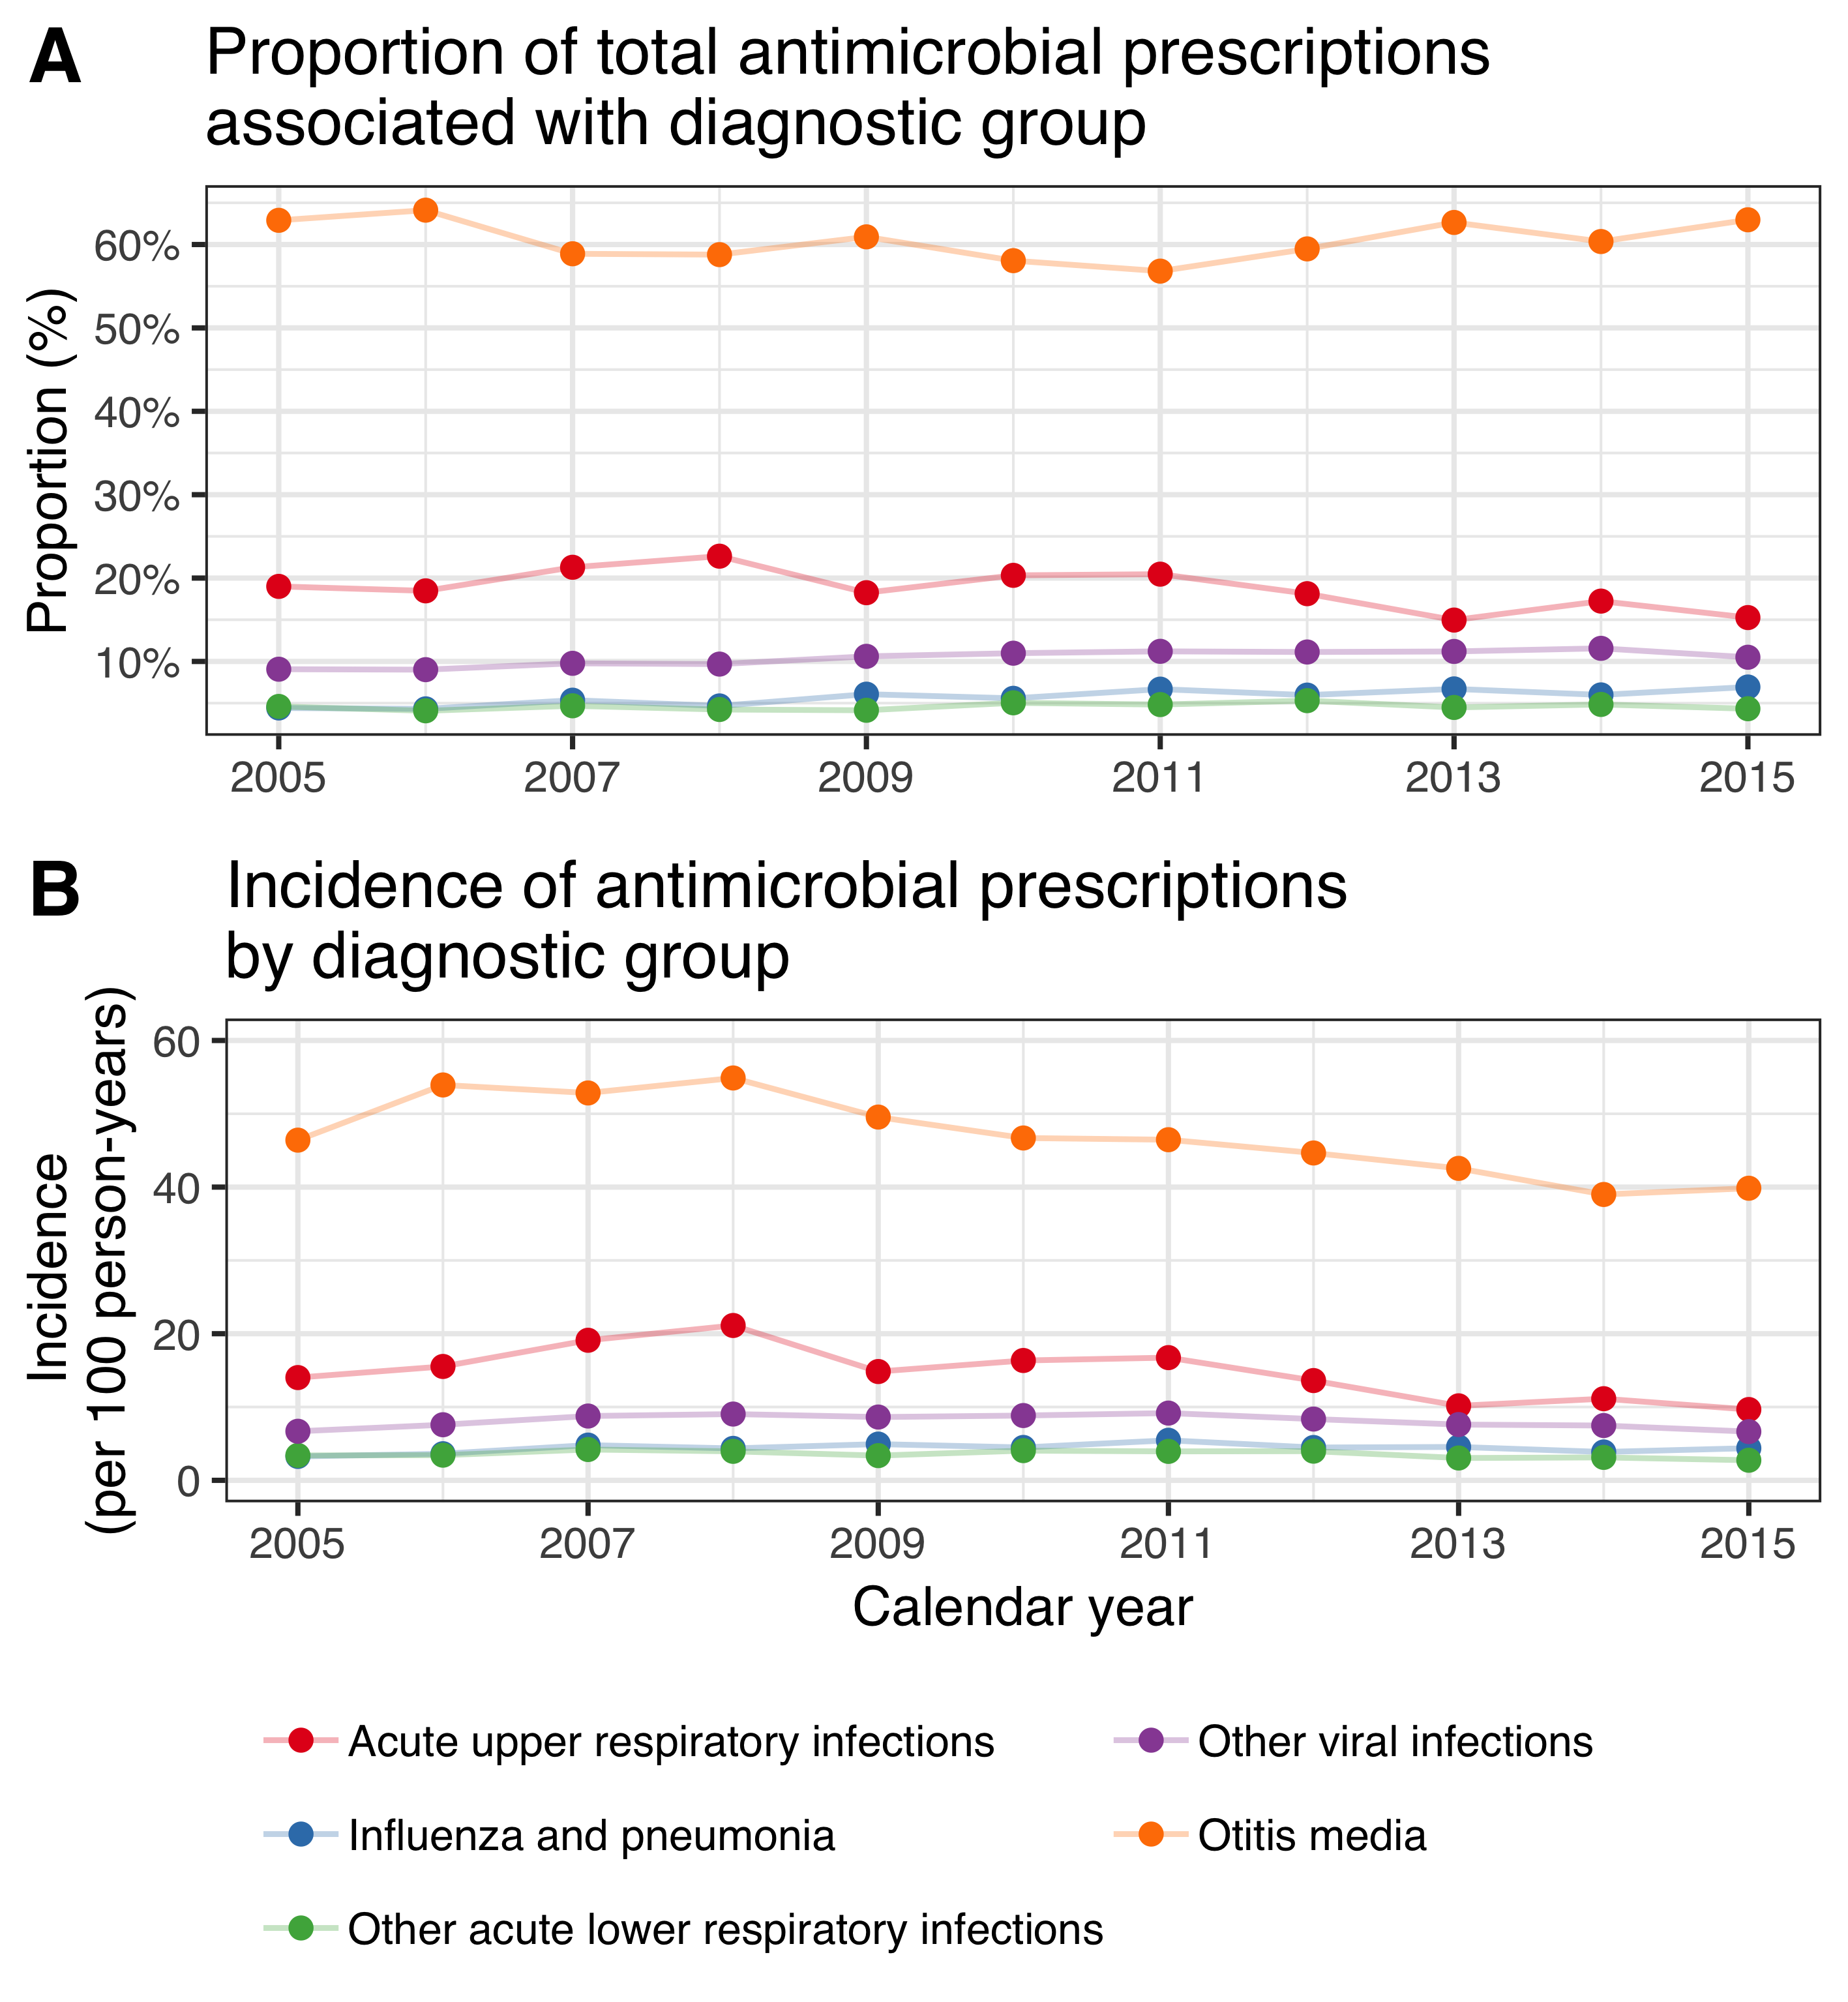

Figure 13 The proportion of visits resulting in antimicrobial prescription and the incidence of prescriptions are depicted for each diagnostic group for the period from 2005 to 2015. The diagnostic groups and their corresponding color are presented in the figure legend. The figure demonstrates that the proportion of visits resulting in antimicrobial prescriptions remains fairly stable for most diagnostic groups, while the incidence is decreasing.

During the study period, a total of 226,084 outpatient antimicrobial prescriptions were recorded among birth-cohorts 2005-2015. The crude incidence rate of outpatient antimicrobial prescriptions per 100 person-years in the VNEC and VEC was 164.6 and 150.2 respectively. The incidence rate and number of outpatient antimicrobial prescriptions by birth-cohort and gender is shown in Table 29.

Table 29 The incidence rate (IR) of outpatient antimicrobial prescriptions is presented by birth-cohort and gender. The absolute number of prescriptions are shown within parentheses.

|  |  |  |
| --- | --- | --- |
| Birth-cohort | Females | Males |
| 2005 | 176.0 (11,178) | 200.0 (13,423) |
| 2006 | 167.0 (10,843) | 190.0 (13,109) |
| 2007 | 153.0 (10,140) | 174.0 (12,339) |
| 2008 | 153.0 (10,543) | 171.0 (12,492) |
| 2009 | 151.0 (10,699) | 169.0 (12,775) |
| 2010 | 150.0 (10,366) | 161.0 (11,854) |
| 2011 | 142.0 ( 9,230) | 156.0 (10,906) |
| 2012 | 142.0 ( 9,447) | 158.0 (11,058) |
| 2013 | 138.0 ( 9,015) | 158.0 (10,180) |
| 2014 | 145.0 (7,726) | 167.0 (9,234) |
| 2015 | 138.0 (4,075) | 173.0 (5,452) |

When stratified by six month age-groups, the lowest incidence was observed in children zero to five months of age and ranged from 30 to 50 prescriptions per 100 person-years. The observed incidence increased sharply thereafter and peaked among children twelve to seventeen months of age, ranging from 225 to 280 prescriptions per 100 person-years. The crude IR decreased significantly in all age-groups, with incidence rate ratios ranging from 0.82 to 0.94 (Figure 14).

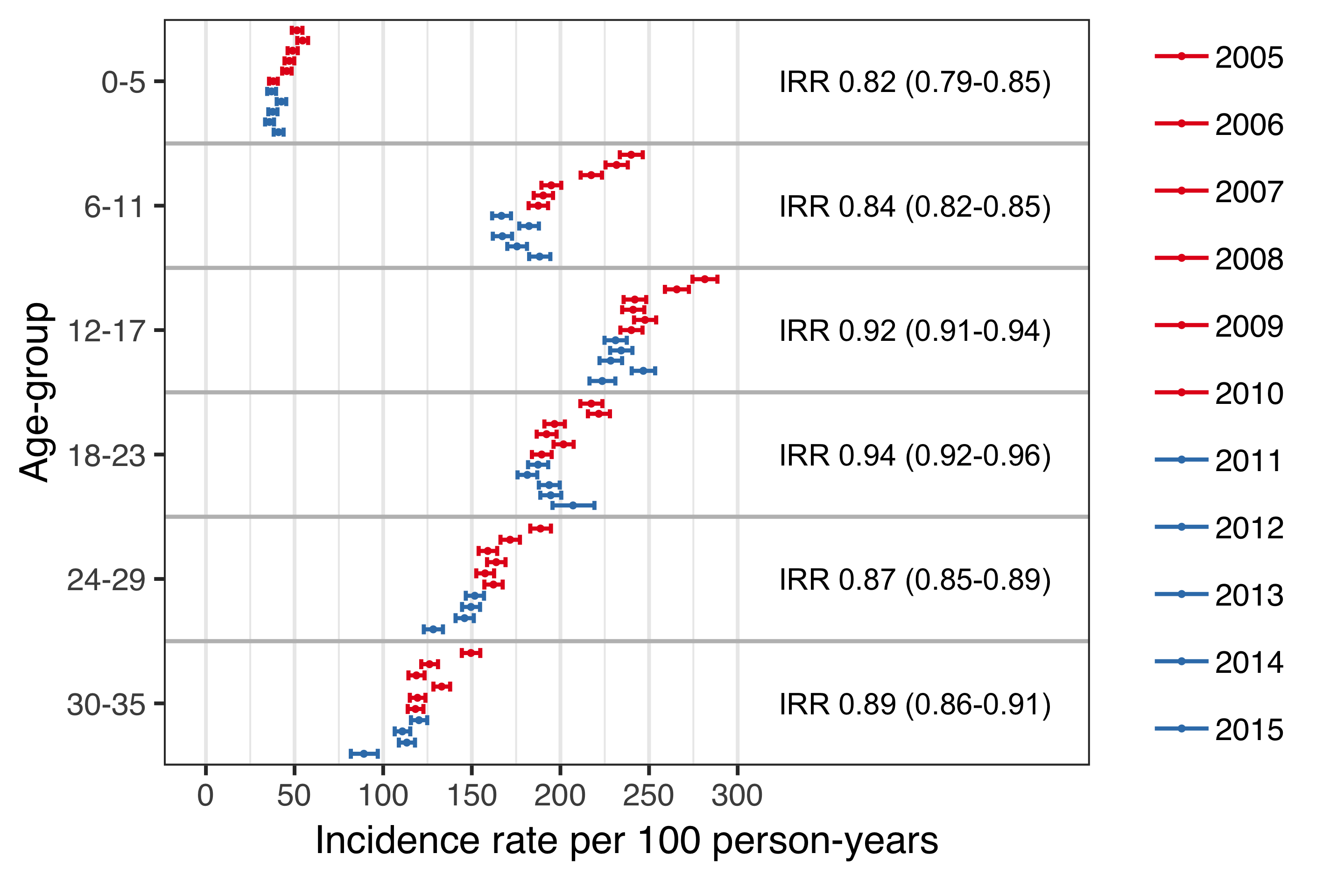

Figure 14 The incidence rate (IR) of outpatient antimicrobial prescriptions is shown stratified by birth-cohort and six-month age-groups. The estimated IR is shown as a point and 95% confidence intervals are illustrated with horizontal error-bars. The vaccine non-eligible cohorts (VNEC) are depicted in red, and the vaccine eligible cohorts (VEC) in blue. The incidence rate ratio (IRR) between the VEC and VNEC is shown for each age-group and 95% confidence intervals are presented within parentheses.

The proportion of children in the VNEC and VEC who filled at least one antimicrobial prescription by three years of age was 88.6% and 86.8 respectively. Children in the VEC were significantly more likely than children in the VNEC not to have filled an antimicrobial prescription (incidence risk ratio 1.16, 95%CI 1.10 to 1.23) or to have filled only between one and four antimicrobial prescriptions (incidence risk ratio 1.08, 95%CI 1.06 to 1.11). The cumulative number of prescriptions by vaccine eligibility cohort in shown in Table 30.

Table 30 The proportion of children in the vaccine non-eligible cohorts (VNEC, 2005–2010) and vaccine eligible cohorts (VEC, 2011–2013) who filled 0, 1–4, 5–9, 10–14 and ≥15 antimicrobial prescriptions by 36 months of age.

|  |  |  |  |
| --- | --- | --- | --- |
| No. prescriptions | VNEC (%) | VEC (%) | Incidence risk (95%CI) |
| 0 | 11.4 | 13.2 | 1.16 (1.10-1.23) |
| 1-4 | 43.7 | 47.3 | 1.08 (1.06-1.11) |
| 5-9 | 31.6 | 29.0 | 0.918 (0.889-0.947) |
| 10-14 | 9.79 | 7.52 | 0.768 (0.716-0.823) |
| ≥15 | 3.51 | 2.91 | 0.831 (0.74-0.934) |

Discrimination indices for the Andersen-Gill multiple event model were adequate, Nagelkerke’s $R^{2}$ = 0.212 and Somer’s $D_{xy}$ = 0.295, and no significant deviations from the model assumptions were visible on diagnostic plots. The model was used to estimate the hazard ratio of outpatient antimicrobial prescriptions between each of the study’s birth-cohorts and the last vaccine non-eligible cohort, 2010. Visually, there seemed to be a decreasing trend in hazard of prescription among the vaccine non-eligible birth-cohorts (Figure 15). The hazard did not change significantly between the last vaccine non-eligible birth-cohort and the preceding two cohorts, but did decrease significantly thereafter, with each vaccine eligible cohort having a significantly lower hazard of outpatient antimicrobial prescription. The estimated impact of PHiD-CV10 on outpatient antimicrobial prescriptions among children younger than three years of age was 8% (95%CI 4% to 12%).

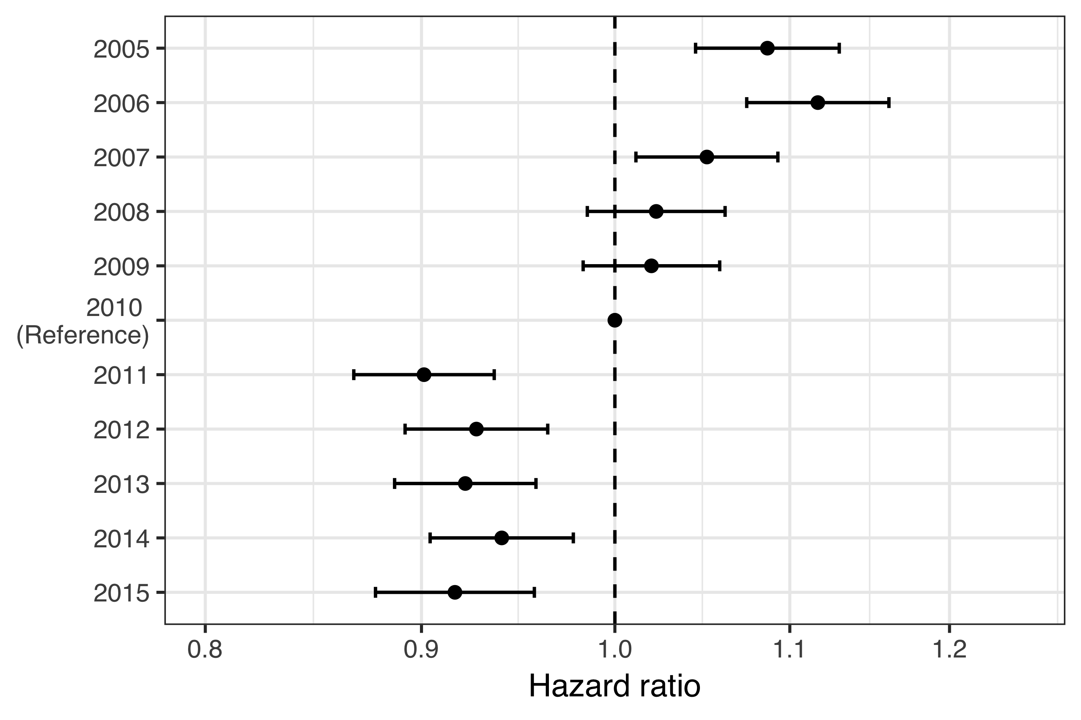

Figure 15 The hazard ratio (HR) of outpatient antimicrobial prescription between each birth-cohort and the last vaccine non-eligible birth-cohort is shown. The estimated HR is depicted as a point, and 95% confidence intervals are illustrated with horizontal error-bars. The 2010 birth-cohort is used as a reference and by definition, no uncertainty is present. Therefore, no confidence intervals are presented. A dashed vertical line is placed on the ratio value of one to assist in visually estimating significance. The X-axis is on the logarithmic scale. The figure demonstrates a decreasing trend in the hazard of outpatient antimicrobial prescription in the vaccine non-eligible cohorts. An abrupt decrease in the hazard is observed in the first vaccine eligible birth-cohort.

When stratified by the number of previous prescriptions, an independent vaccine impact on subsequent prescriptions was still discernible in children who had received up to three prior antimicrobial prescriptions. Among children who had received more than three prior prescriptions, no effect was found (Figure 16).

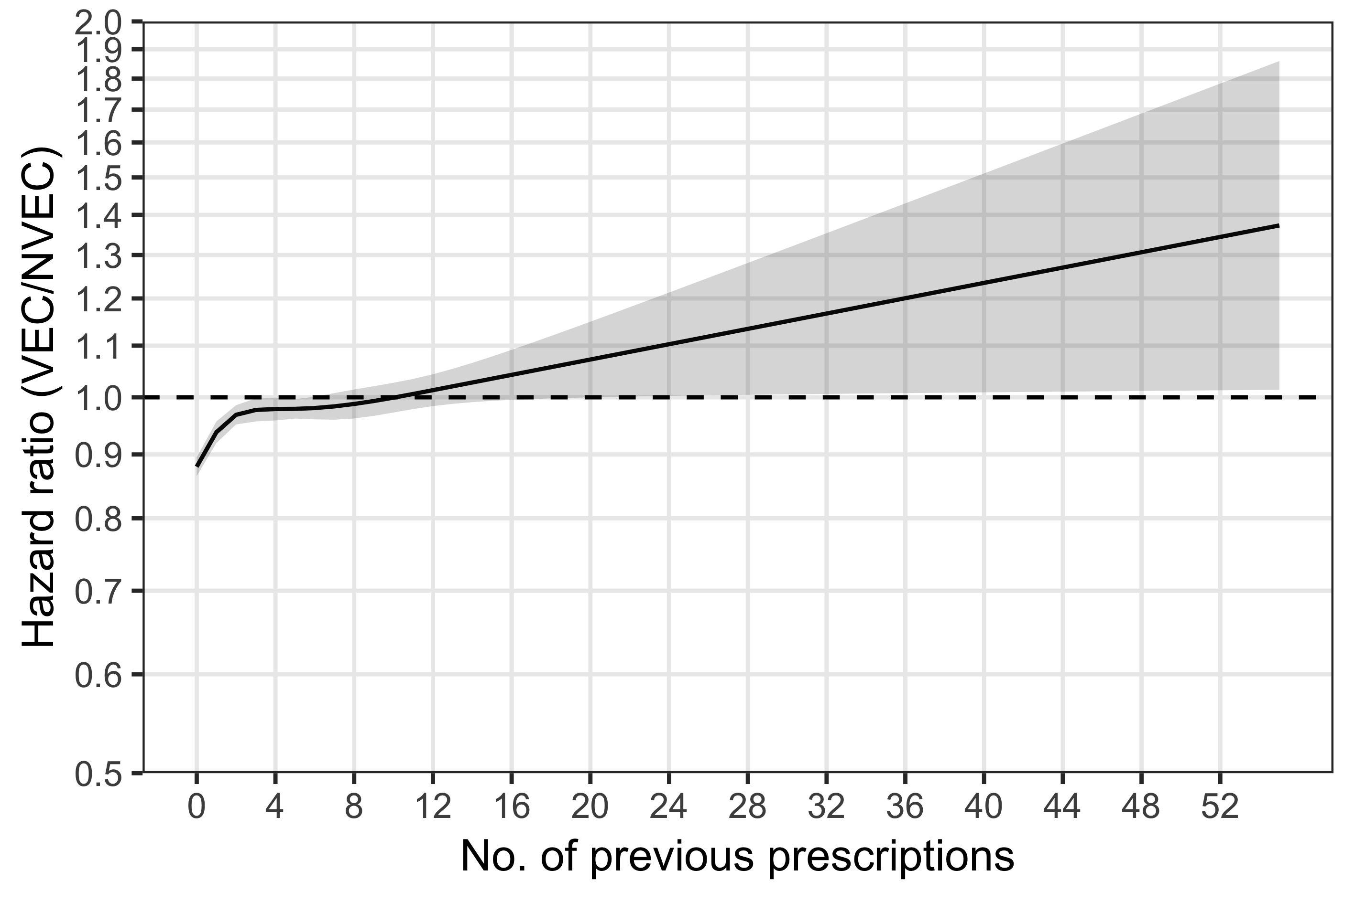

Figure 16 The hazard ratio (HR) of outpatient antimicrobial prescriptions between the vaccine eligible (VEC) and vaccine non-eligible cohorts (VNEC) is shown stratified by the number of previous prescriptions. The estimated HR is depicted as a solid black line, and 95% confidence intervals are illustrated as a shaded area. A dashed horizontal line is placed on the ratio value of one to assist in visually assessing significance. The Y-axis is truncated at a HR of 0.5 and is presented on the logarithmic scale. The figure demonstrates a significantly lower hazard of filling additional outpatient antimicrobial prescriptions among vaccine eligible children who had previously filled fewer than four prescriptions.

The mean number of outpatient antimicrobial prescriptions as a function of age was calculated using the generalized Nelson-Aalen estimate of the underlying Andersen-Gill model. The average male child in the VNEC had filled 6.48 antimicrobial prescriptions by his fourth birthday, and the average female child had filled 6.07. The average male and female children in the VEC had filled 5.84 and 5.46 prescriptions respectively. The mean number of antimicrobial prescriptions by age and gender is shown in Figure 17.

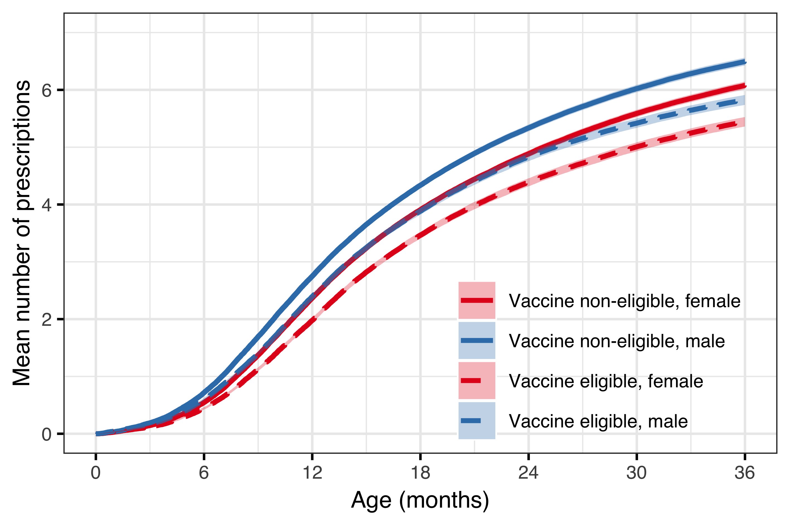

Figure 17 The mean number of outpatient antimicrobial prescriptions are shown as a function of age, and stratified by vaccine eligibility cohort and gender. The figure deviates from the color schema used in other figures that compromise this thesis. Here, the estimates for females are illustrated in red and males in blue. Vaccine non-eligible cohorts are represented with solid lines and vaccine eligible cohorts with dashed lines. The 95% confidence intervals are illustrated as shaded areas. The figure demonstrates an early divergence in the mean number of prescriptions, and a consistent difference between genders.

## Impact on tympanostomy tube procedures (Paper IV)

Demographic data regarding the study birth-cohorts are summarized in chapter 5.1. In total, during the study period, 14,351 children underwent 20,373 tympanostomy tube placements, 57% of whom were male. The median age of children undergoing their first tympanostomy procedure was 17 months (IQR 13-24). In the subset of children who underwent a TTP during the study period, 10,248 (71%) underwent only one procedure, 2,902 (20%) underwent two, and 1201 (8%) underwent three or more. Almost all (98%) of the procedures were performed in private outpatient clinics. The number of otolaryngologists performing outpatient TTP increased from 15 in 2005 to 23 in 2016. Each surgeon performed a median of 123 (IQR: 56.5-196) procedures each year. The study’s population is summarized in Table 31.

Table 31 An overview of the birth-cohorts included in paper IV. The number of observed tympanostomy tube placements (TTP) in each cohort is presented, with the number of children undergoing the procedures within parentheses. The median age in months at the time of a childs first procedure is shown. The observational period is 1 January 2005 to 31 December 2016. Birth-cohorts 2012-2015 do not attain full follow-up time, as indicated by fewer person-years included in the study. Thus, the decrease in the number of procedures and and median age is not indicative of a true decrease.

|  |  |  |  |  |
| --- | --- | --- | --- | --- |
| Birth-cohort | Number of children | Person-years | Number of procedures (n children) | Median age (months) |
| 2005 | 4,541 | 21,409 | 1,946 (1,280) | 17 (12-25) |
| 2006 | 4,665 | 21,988 | 1,931 (1,303) | 18 (13-27) |
| 2007 | 4,770 | 22,500 | 1,974 (1,335) | 18 (13-27) |
| 2008 | 4,949 | 23,313 | 2,140 (1,428) | 18 (13-26) |
| 2009 | 5,128 | 24,141 | 2,145 (1,514) | 18 (13-25) |
| 2010 | 4,984 | 23,580 | 2,203 (1,547) | 18 (13-26) |
| 2011 | 4,642 | 22,056 | 1,997 (1,382) | 18 (13-24) |
| 2012 | 4,668 | 20,195 | 2,057 (1,419) | 16 (12-23) |
| 2013 | 4,442 | 14,964 | 1,642 (1,200) | 16 (13-23) |
| 2014 | 4,444 | 10,744 | 1,582 (1,251) | 16 (13-20) |
| 2015 | 4,136 | 5,983 | 756 (692) | 13 (11-15) |

The crude incidence rate of TTP in the vaccine eligible cohorts was 10.6 procedures per 100 person-years. This was significantly higher than the crude incidence rate in the vaccine non-eligible cohorts, 8.7 procedures per 100 person-years (IRR 1.20, 95%CI 1.17 to 1.24). When stratified by age-groups, the crude incidence rate was highest among 12-17 month old children, ranging from 19 to 27 procedures per 100 person-years (Figure 18).

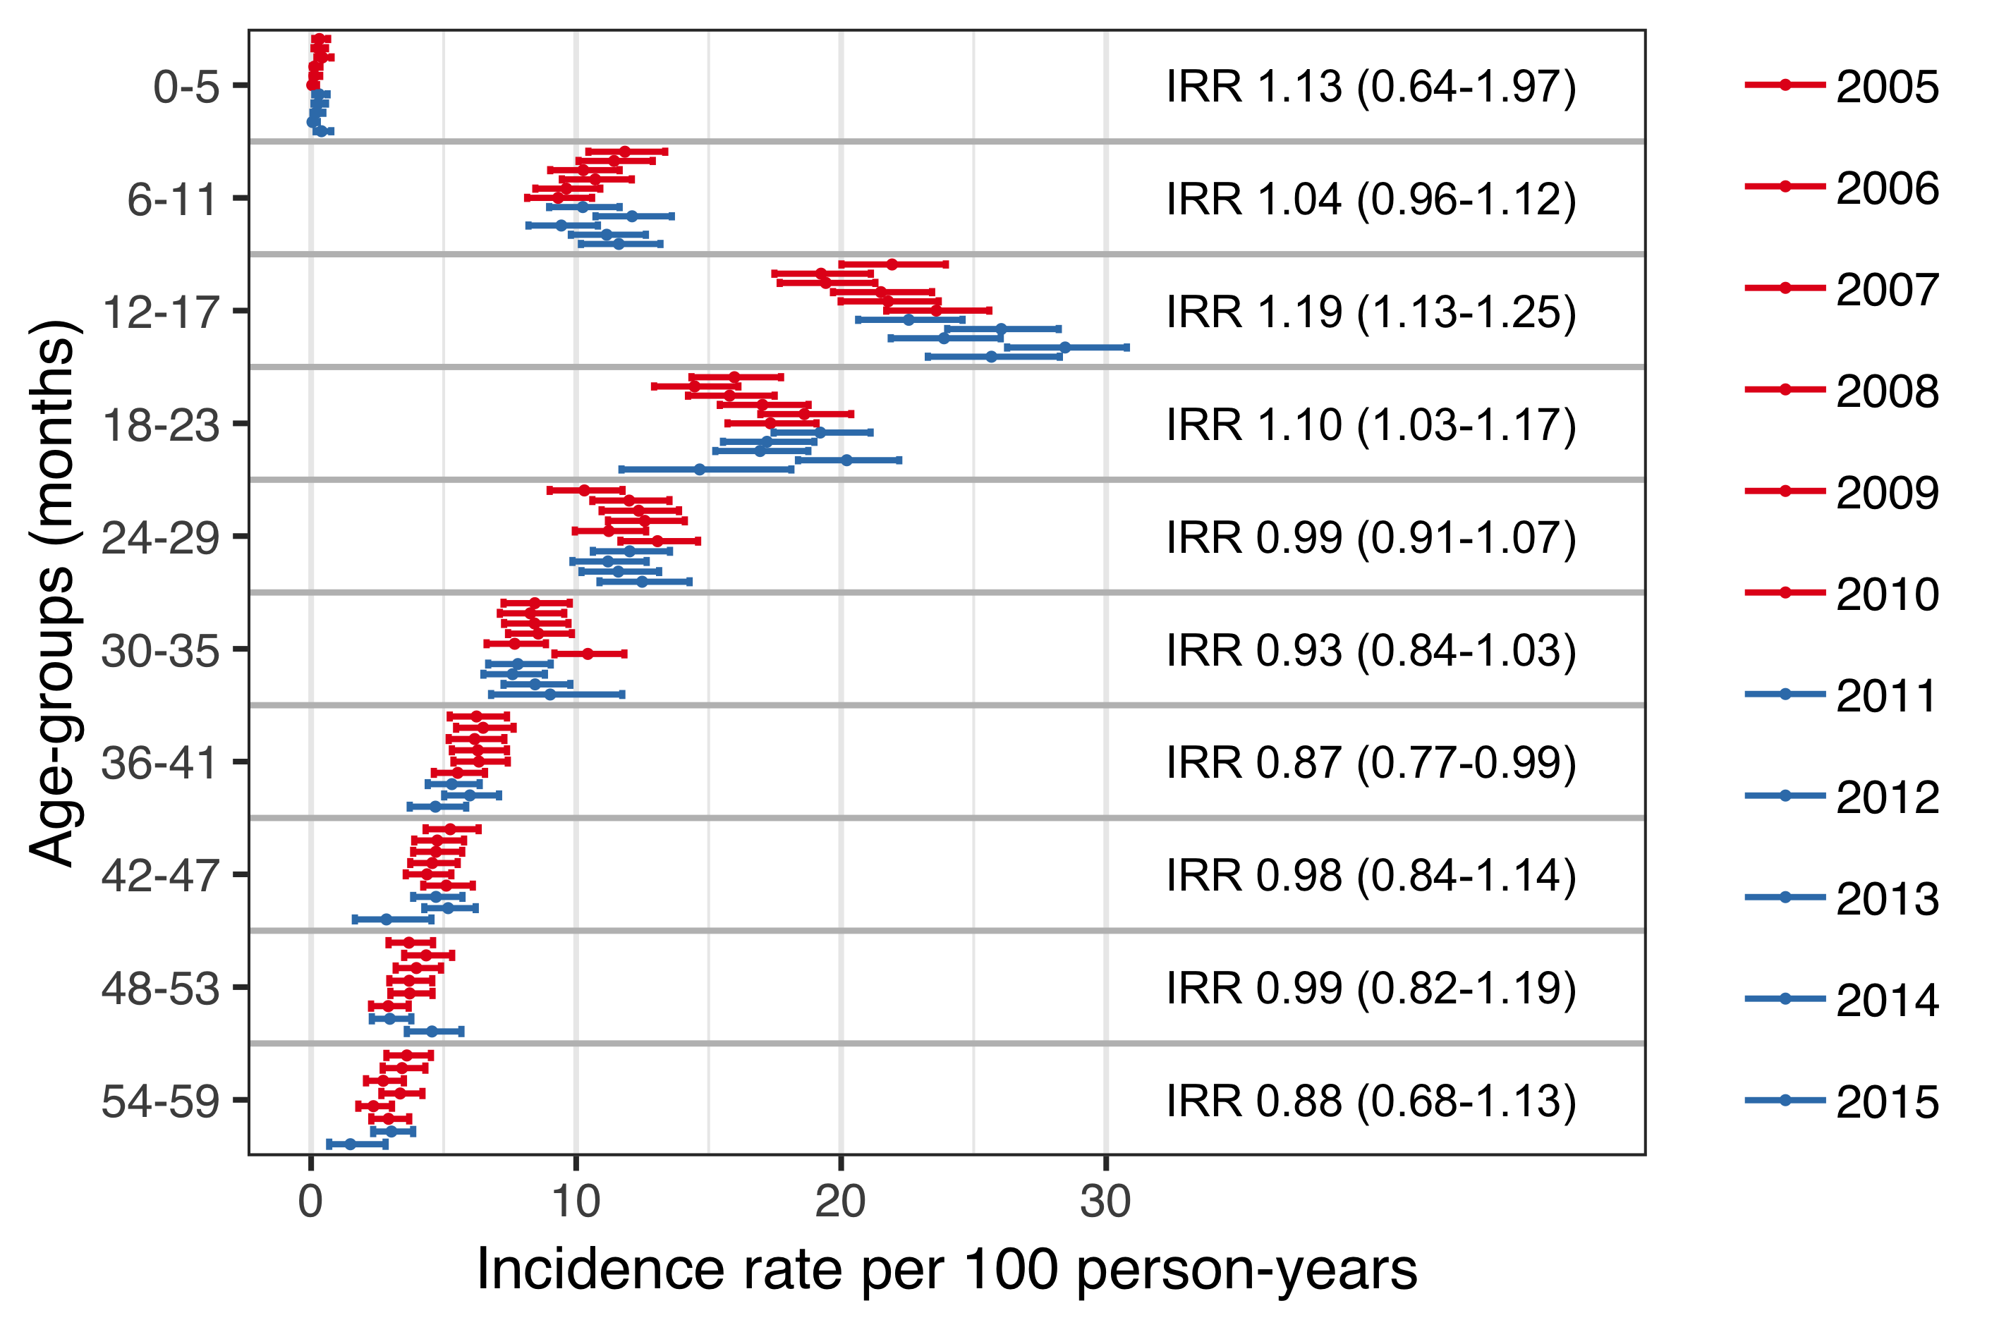

Figure 18 The incidence rate (IR) of tympanostomy tube placements (TTP) is shown stratified by birth-cohort and six-month age-groups. The estimated IR is represented with a point, and 95% confidence intervals are illustrated with horizontal error-bars. The vaccine non-eligible cohorts (VNEC) are depicted in red, and the vaccine eligible cohorts (VEC) in blue. The incidence rate ratio (IRR) between the VEC and VNEC is shown for each age-group and 95% confidence intervals are presented within parentheses.

The cumulative incidence of children who had undergone at least one TTP by five years of age was highest in birth-cohort 2010 (31.7%) and lowest in birth-cohort 2006 (28.6%), Table 32. The cumulative incidence of tympanostomy procedures was significantly higher in the VEC compared to VNEC regardless of age (Figure 19).

Table 32 The cumulative incidence of having undergone at least one tympanostomy tube placement (TTP) at six-month age intervals is presented for each birth-cohort. The cumulative incidence is presented as a percentage (%) of all children in the respective cohort. Birth-cohorts 2012-2015 do not attain full follow-up time. Lack of information due to censoring is indicated with a hyphen (-).

|  |  |  |  |  |  |  |  |  |  |  |  |
| --- | --- | --- | --- | --- | --- | --- | --- | --- | --- | --- | --- |
| Age (months) | 2005 | 2006 | 2007 | 2008 | 2009 | 2010 | 2011 | 2012 | 2013 | 2014 | 2015 |
| 6 | 0.4 | 0.3 | 0.4 | 0.2 | 0.3 | 0.1 | 0.4 | 0.2 | 0.3 | 0.2 | 0.5 |
| 12 | 7.2 | 7.1 | 6.6 | 7.2 | 6.5 | 6.6 | 6.6 | 7.8 | 6.5 | 6.9 | 7.6 |
| 18 | 16.4 | 14.8 | 14.9 | 15.9 | 15.7 | 16.5 | 16.3 | 18.3 | 16.3 | 19.1 | 18.4 |
| 24 | 21.1 | 19.5 | 19.7 | 21.0 | 22.0 | 22.4 | 23.3 | 23.9 | 21.7 | 26.1 | - |
| 30 | 23.7 | 22.9 | 23.4 | 24.5 | 25.1 | 26.3 | 26.3 | 26.7 | 24.9 | 29.0 | - |
| 36 | 25.8 | 24.8 | 25.3 | 26.5 | 27.2 | 28.8 | 27.9 | 28.3 | 26.9 | - | - |
| 42 | 26.9 | 26.5 | 26.7 | 27.7 | 28.5 | 30.1 | 28.7 | 29.5 | 27.5 | - | - |
| 48 | 27.8 | 27.4 | 27.8 | 28.5 | 29.1 | 31.0 | 29.4 | 30.4 | - | - | - |
| 54 | 28.4 | 28.3 | 28.4 | 29.1 | 29.9 | 31.4 | 30.1 | 30.9 | - | - | - |
| 59 | 28.8 | 28.6 | 28.6 | 29.5 | 30.2 | 31.7 | 30.4 | 31.3 | - | - | - |

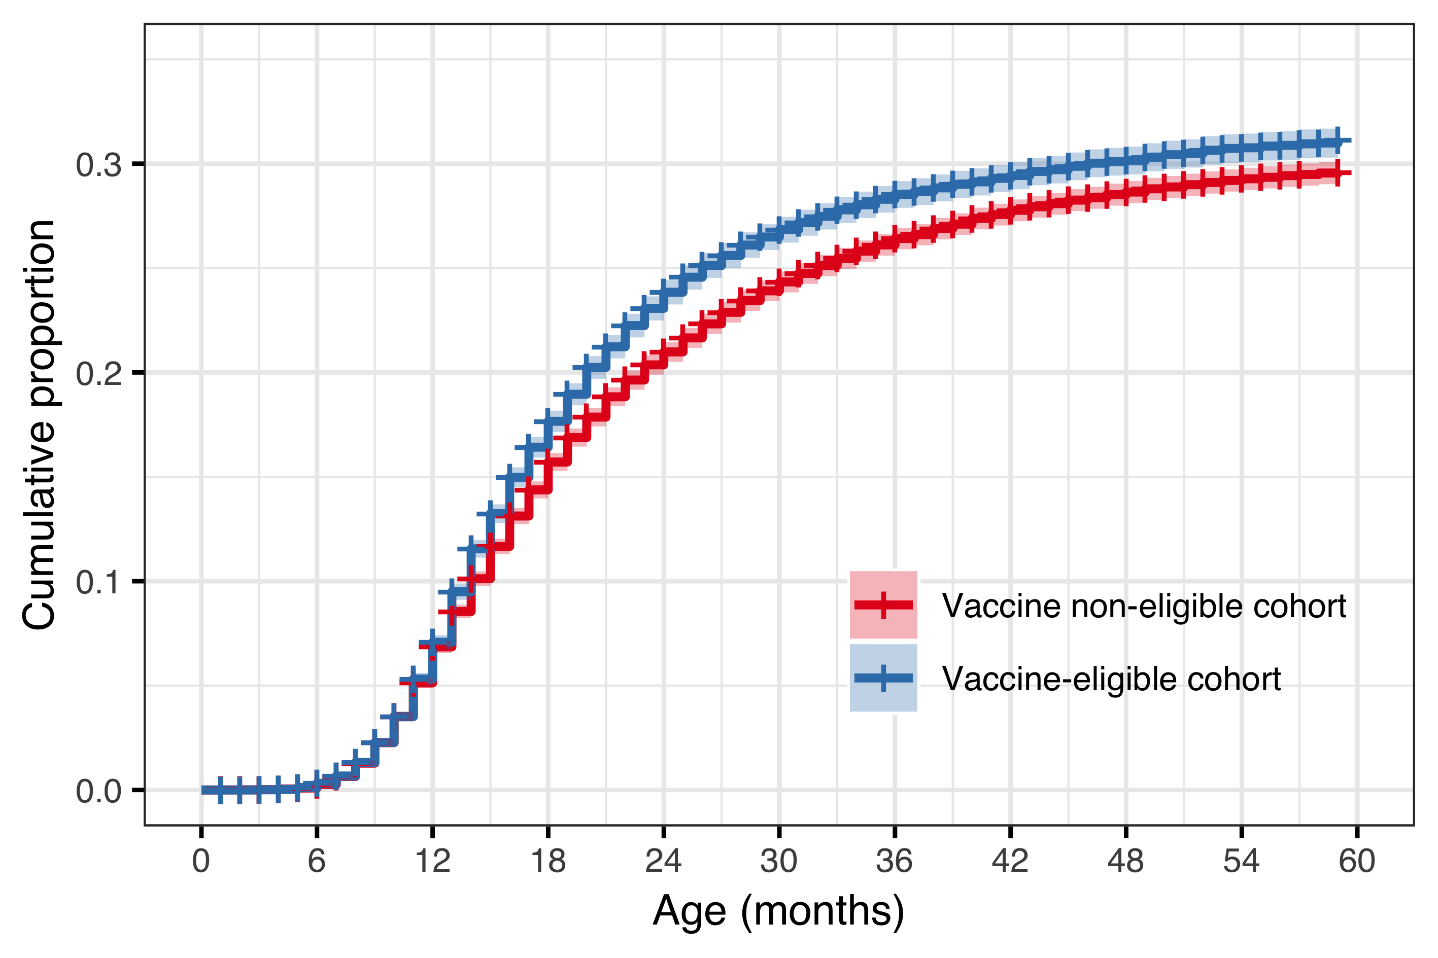

Figure 19 The cumulative incidence of tympanostomy tube placements (TTP) is shown for the vaccine eligible (VEC) and vaccine non-eligible cohorts (VNEC) as a continuous function of age. Cumulative incidence is presented as a proportion of all children in the respective vaccine eligibility cohort. The estimated cumulative incidence is illustrated with a solid red line for the VNEC, and a solid blue line for the VEC, and 95% confidence intervals are depicted with a shaded area.

In the subset of children who underwent TTP, the mean (median) number of otitis media associated visits to primary care or to the pediatric emergency department was 2.05 (2) visits in the vaccine non-eligible cohorts, compared to 1.72 (1) visits in the vaccine eligible cohorts. The distribution in the number of previous visits was significantly different between the VNEC and VEC (Chi-Squared test statistic 63.8, P<.001). The proportion of children who did not have a single recorded visit prior to undergoing the procedure increased from 20.6% in the VNEC to 28.9% in the VEC, RR 1.40 (95%CI 1.28-1.54). Children in the vaccine eligible cohorts had received significantly fewer antimicrobial prescriptions prior to undergoing the procedure (Chi-Squared test statistic 53.6, P<.001). The mean (median) number of previous antimicrobial prescriptions was 3.19 (4) in the vaccine eligible cohorts compared to 3.62 (4) in the vaccine non-eligible cohorts. Children in the VEC were more likely to have never been prescribed antimicrobials prior to undergoing tympanostomy placement, RR 1.52, 95%CI 1.18-1.96). The comparison between VEC and VNEC is summarized in Table 33.

Table 33 The cumulative number of previous antimicrobial prescriptions and otitis media visits are shown for those children in the vaccine non-eligible (VNEC) and vaccine eligible cohorts (VEC) who underwent at least one tympanostomy tube placement. The proportion of each cohort who had the corresponding number of prior visits or prescriptions is shown with the absolute number of children within parentheses. The relative risk (RR) and absolute risk difference (ARD) of having each number of previous visits or prescriptions between the VEC and VNEC is shown with 95% confidence intervals.

|  |  |  |  |  |  |  |  |  |
| --- | --- | --- | --- | --- | --- | --- | --- | --- |
| Cumulative number | VNEC % (n) | VEC % (n) | RR (95%CI) | ARD (95%CI | VNEC % (n) | VEC % (n) | RR (95%CI) | ARD (95%CI |
| 0 | 3.43 (286) | 5.22 (72) | 1.18 (1.52 to 1.96) | 1.79 (0.51 to 3.07) | 20.60 (1,720) | 28.90 (398) | 1.28 (1.40 to 1.54) | 8.29 (5.70 to 10.900) |
| 1 | 11.60 (966) | 12.80 (177) | 0.95 (1.11 to 1.29) | 1.26 (-0.68 to 3.19) | 24.90 (2,080) | 24.40 (337) | 0.89 (0.98 to 1.09) | -0.45 (-2.94 to 2.040) |
| 2 | 19.30 (1,610) | 22.60 (311) | 1.05 (1.17 to 1.30) | 3.28 (0.87 to 5.68) | 20.40 (1,700) | 19.60 (270) | 0.85 (0.96 to 1.07) | -0.86 (-3.17 to 1.450) |
| 3-4 | 37.80 (3,150) | 37.40 (516) | 0.92 (0.99 to 1.07) | -0.39 (-3.19 to 2.41) | 24.90 (2,080) | 20.20 (279) | 0.73 (0.81 to 0.91) | -4.64 (-7.00 to -2.290) |
| 5-7 | 22.30 (1,860) | 19.30 (266) | 0.77 (0.86 to 0.97) | -3.01 (-5.32 to -0.70) | 7.98 (666) | 6.45 (89) | 0.65 (0.81 to 1.00) | -1.53 (-2.99 to -0.066) |
| 8+ | 5.61 (468) | 2.68 (37) | 0.34 (0.48 to 0.67) | -2.93 (-3.95 to -1.90) | 1.25 (104) | 0.43 (6) | 0.15 (0.35 to 0.79) | -0.81 (-1.28 to -0.348) |

A diagnostic plot of Schoenfeld residuals did not reveal deviations from the proportional hazards assumption. The hazard of undergoing TTP was considerably higher in children who had previously visited a physician for otitis media or received an antimicrobial prescription. Children who had one prior documented visit were considerably more likely to undergo the procedure than children who had no documented visits, HR of 3.12 (95%CI 2.93 to 3.32). Likewise, children who had previously filled one antimicrobial prescription were more likely to receive a tympanostomy tube than children who had received no prescription, 6.98 (95%CI 6.13 to 7.95). The hazard of tympanostomy tube placement increased gradually from birth-cohort 2005 to 2015 (Figure 20).

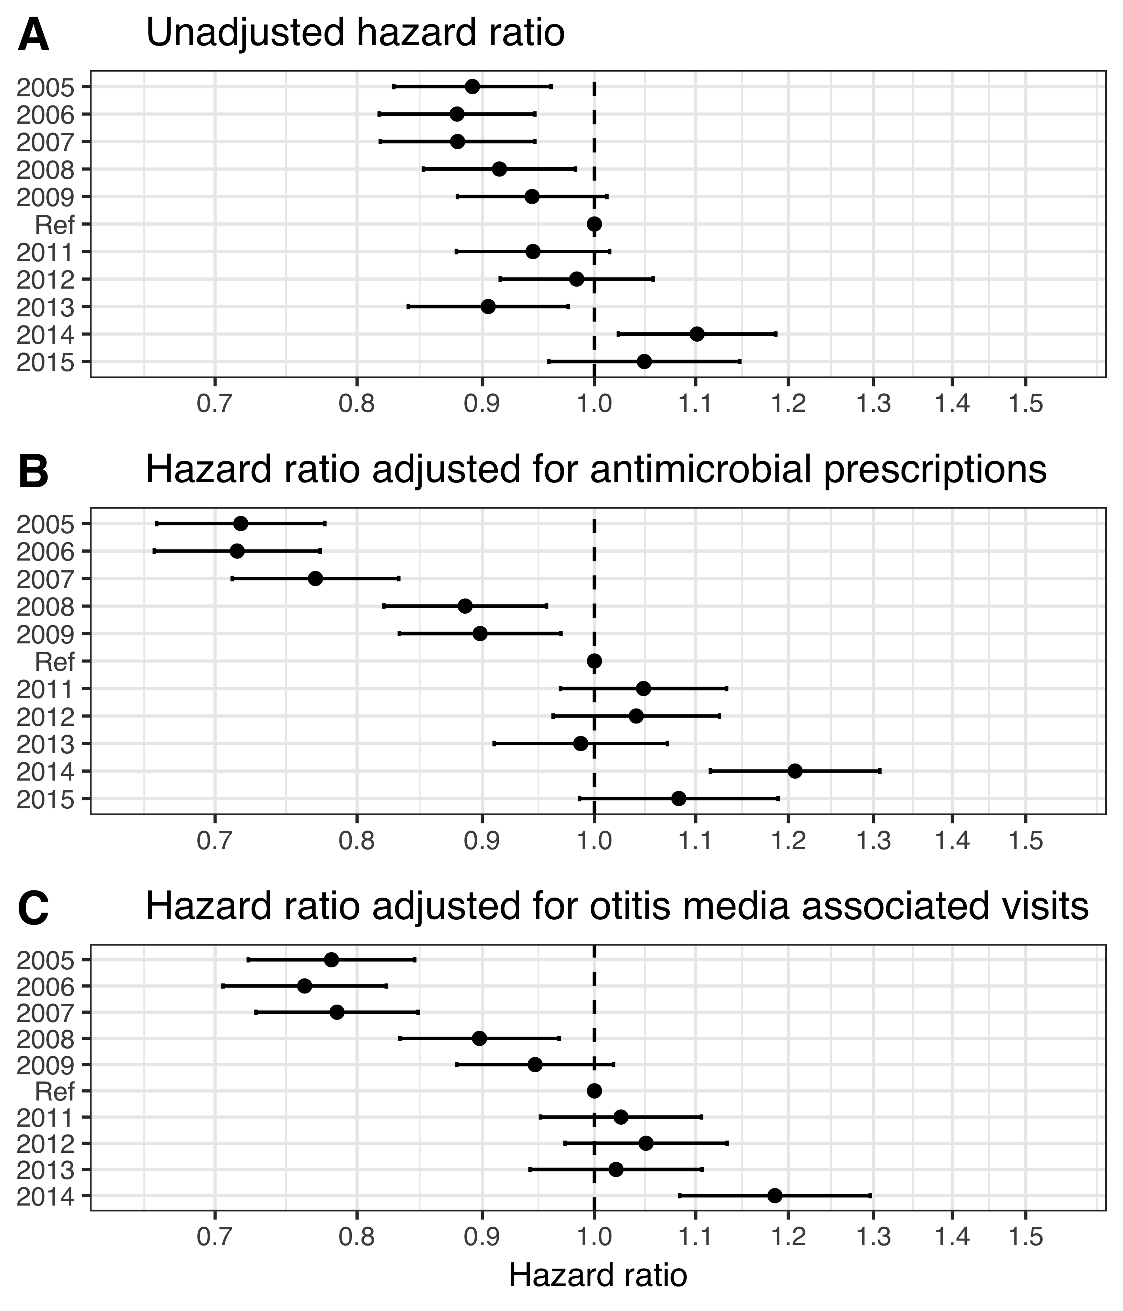

Figure 20 The hazard ratio (HR) of tympanostomy tube placements (TTP) is depicted between each birth-cohort and the last vaccine non-eligible birth-cohort are depicted, as estimated by three Cox regression models. In panel A, the unadjusted HR estimates are shown. Panel B shows HR estimates adjusted for antimicrobial prescriptions, and panel C illustrates the HR estimates adjusted for otitis media associated visits. Primary care visits are obtained from the Primary Care Registry of the Directorate of Health, and the observation period is restricted to December 2015. Because of this the data presented in panel C is restricted to birth-cohorts 2005-2014. The figure demonstrates an increasing hazard of TTP with each successive birth-cohort. The effect is more pronounced when adjustment is made for antimicrobial prescriptions and visits.

## Impact on respiratory associated hospitalizations (Paper V)

Demographic data regarding the study birth-cohorts are summarized in chapter 5.1. In total, 51,264 children were followed for a median of 1,096 days (range 6-1,096) resulting in 142,315 person-years of follow-up time. Of those, 1,414 children were admitted to hospital 1,703 times with diagnoses compatible with the study’s diagnostic groups. The total number of hospital admissions regardless of indication was 4,842. An overview of the demographic data is presented in Table 34.

Table 34 An overview of the birth-cohorts included in paper V. The total number of hospitalizations, hospital admissions due to the study’s diagnoses, and admissions to the intensive care unit (ICU) are presented. The number of children is presented within parentheses. The proportion of all hospital admissions that were due to the study’s diagnoses is shown. The observational period is 1 January 2005 to 31 December 2017. Birth-cohorts 2014 and 2015 do not attain full follow-up time, as indicated by fewer person-years included in the study.

|  |  |  |  |  |  |  |
| --- | --- | --- | --- | --- | --- | --- |
| Birth-cohort | Number of children | Person-years | All cause admissions, *n* | Study admissions, *n* (children, *n*) | Proportion due to study diagnosis, *%* | ICU admissions, *n* (children, *n*) |
| 2005 | 4,541 | 13,277 | 446 | 219 (160) | 49.1 | 7 (7) |
| 2006 | 4,668 | 13,658 | 415 | 176 (140) | 42.4 | 10 (8) |
| 2007 | 4,770 | 13,985 | 423 | 186 (160) | 44.0 | 6 (5) |
| 2008 | 4,953 | 14,472 | 442 | 117 (101) | 26.5 | 5 (4) |
| 2009 | 5,130 | 14,965 | 484 | 124 (109) | 25.6 | 7 (6) |
| 2010 | 4,988 | 14,592 | 384 | 158 (138) | 41.1 | 7 (7) |
| 2011 | 4,644 | 13,640 | 392 | 129 (112) | 32.9 | 4 (4) |
| 2012 | 4,668 | 13,753 | 576 | 196 (155) | 34.0 | 0 (0) |
| 2013 | 4,442 | 13,044 | 472 | 149 (119) | 31.6 | 9 (8) |
| 2014 | 4,446 | 10,930 | 431 | 144 (122) | 33.4 | 6 (5) |
| 2015 | 4,136 | 6,140 | 377 | 105 (98) | 27.9 | 3 (3) |

Of the children in the study birth-cohorts, 550 were hospitalized 660 times with ICD-10 discharge diagnoses consistent with pneumonia. In the same cohorts, 508 children were admitted 550 times with diagnoses consistent with acute lower respiratory tract infections. In the vaccine non-eligible cohorts, the crude incidence rate of pneumonia requiring hospital admission was 4.94 per 1,000 person-years, which decreased to 4.18 per 1,000 in the vaccine eligible cohorts. The analogous crude incidence rate of hospitalizations for acute lower respiratory tract infections was 2.94 and 5.23 per 1,00 person-years. Though the absolute number of admissions was similar between these two groups, the distribution of cases was different. The crude incidence rate of hospital admissions for pneumonia was highest in children 12-17 months of age, while the incidence rate of hospitalizations for lower respiratory tract infections was highest in children <6 months of age (Figure 21). Children admitted for acute lower respiratory tract infections were significantly younger than children admitted for pneumonia (mean age 8.0 months and 13.6 months respectively, P<.001). Using crude age-group stratified incidence rate ratios between the vaccine eligible and non-eligible cohorts, the incidence rate of pneumonia hospitalizations was found to have decreased significantly only among children 12-17 months of age, crude incidence rate ratio 0.52 (95%CI: 0.35-0.77). Using the same method, the incidence rate of hospital admissions for acute lower respiratory tract infections admissions was found to have increased significantly among children 0-5 months of age, crude incidence rate ratio 1.50 (95%CI 1.23-1.84).

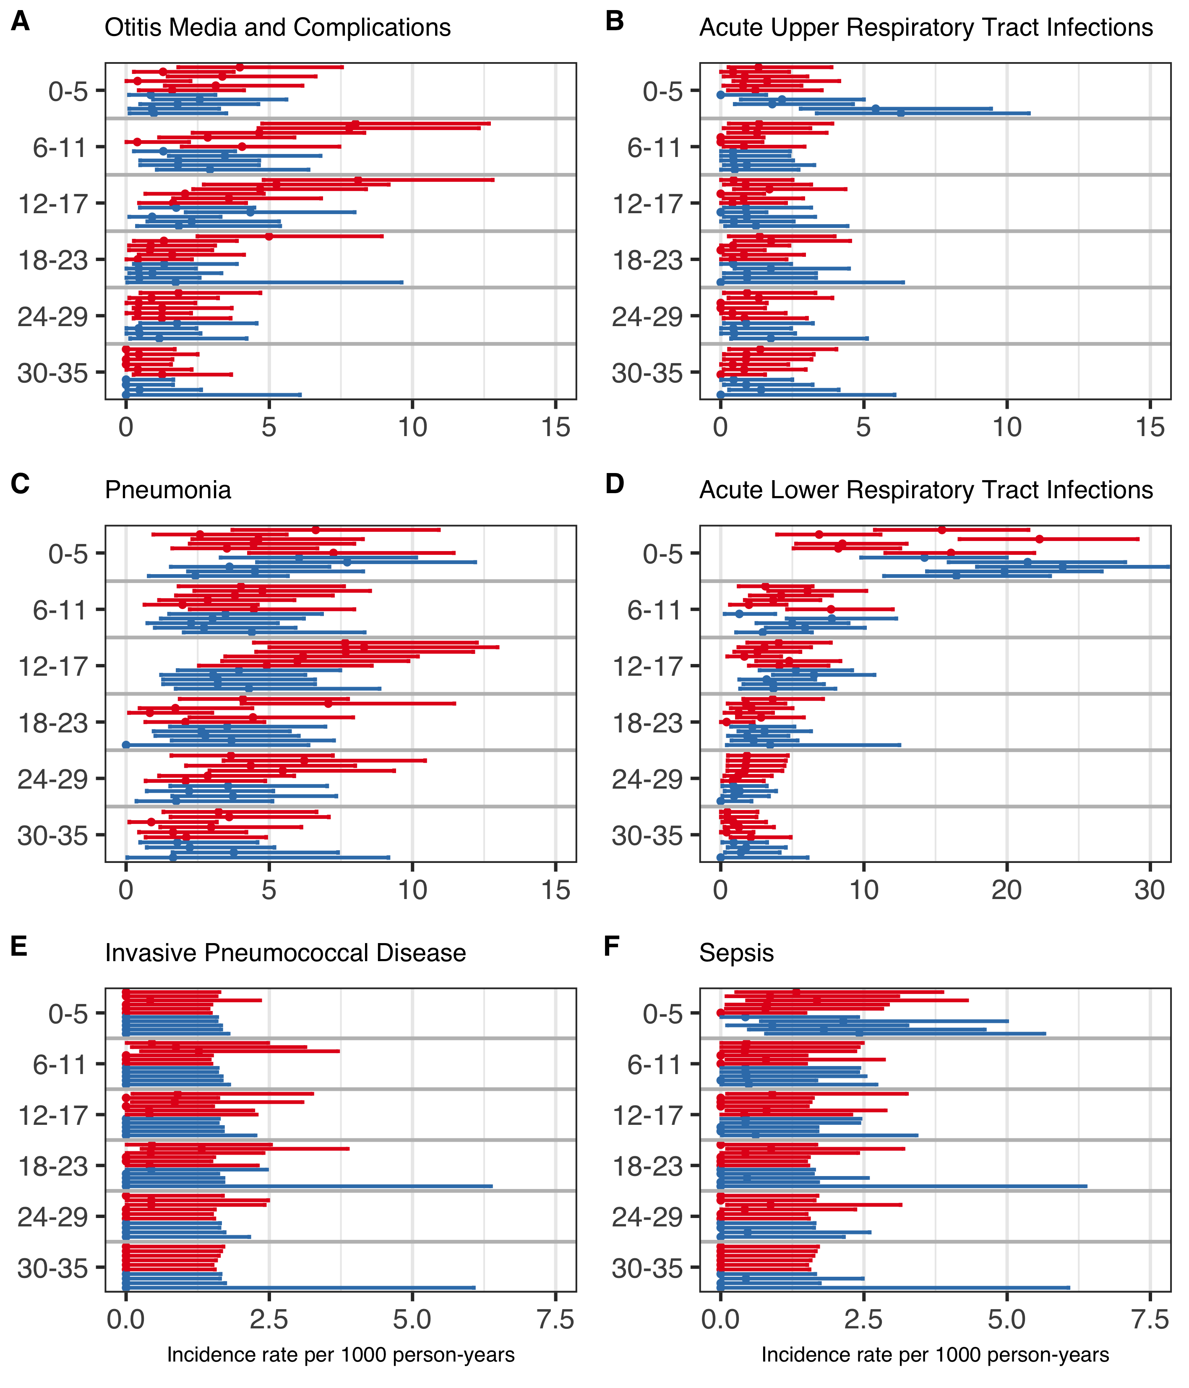

Figure 21 Crude incidence rates (IR) of the six diagnostic groups (A-F) per 1,000 person-years for each of the birth-cohorts. Panels A-D and F depict the IR of admissions based on the International Classification of Diseases, 10th revision (ICD-10) discharge diagnoses, while panel E depicts the IR of admissions with culture confirmed invasive pneumococcal disease (IPD), regardless of ICD-10 diagnosis. Birth-cohorts are compared in six-month age-groups which are illustrated on the Y-axis. The vaccine non-eligible cohorts (VNEC) are illustrated in red and the vaccine eligible cohorts (VEC) in blue.

A significant difference was detected in the cumulative rate of hospital admissions for both pneumonia and acute lower respiratory tract infections between the vaccine eligible and non-eligible cohorts (Figure 22). The hazard ratio of hospital admission for pneumonia was 0.80 (95%CI:0.67-0.95), with an E-value of 1.81 and a lower bound of 1.29. When the risk-set was restricted to children younger than 90 days and 90 days and older, respectively, the hazard ratio was 1.22 (95%CI 0.81-1.85) and 0.73 (95%CI 0.60-0.89) respectively. The hazard ratio for hospital admission due to acute lower respiratory tract infection was 1.32 (95%CI:1.14-1.53), with an E-value of 1.97 and a lower bound of 1.54. The hazard ratio was augmented when children younger than 90 days were analysed separately, HR 1.54 (95%CI 1.23-1.94). It was not significant in children 90 days and older, HR 1.18 (95%CI 0.97-1.44).

A total of 131 hospitalizations for acute upper respiratory tract infections were recorded for 123 children. During the same period, 256 children were admitted to hospital 280 times for otitis media and complications. The crude incidence rate of hospital admissions for otitis media was higher than the incidence rate of admissions for acute upper respiratory tract infections; 2.32 and 1.45 per 1,000 person-years in the vaccine eligible and vaccine non-eligible cohorts respectively, compared to 0.78 and 1.13 per 1,000 person-years. The mean age of children admitted for acute upper respiratory tract infections was 13.5 months compared to 12.8 months for children admitted for otitis media and complications. The crude incidence rate by age-group is shown in Figure 21. The cumulative incidence rate of hospitalization per 1000 person-years for acute upper respiratory tract infections and otitis media and complications are shown in Figure 22. The hazard ratio of otitis media hospitalizations between the vaccine eligible and non-eligible cohorts was 0.57 (95%CI:0.43-0.73) with an E-value of 2.9 .and a lower bound of 2.08. When restricted to children younger than 90 days of age, the hazard ratio was 0.72 (95%CI 0.33-1.57), and when evaluating children 90 days and older it was 0.55 (95%CI 0.42-0.72). The hazard ratio for hospital admission for acute upper respiratory tract infections was 1.56 (95%CI:1.11-2.19), with an E-value of 2.49 and a lower bound of 1.46. Among children younger than 90 days, and 90 days and older respectively, the hazard ratio was 3.4 (95%CI 1.72-6.90) and 1.13 (95%CI 0.75-1.71).

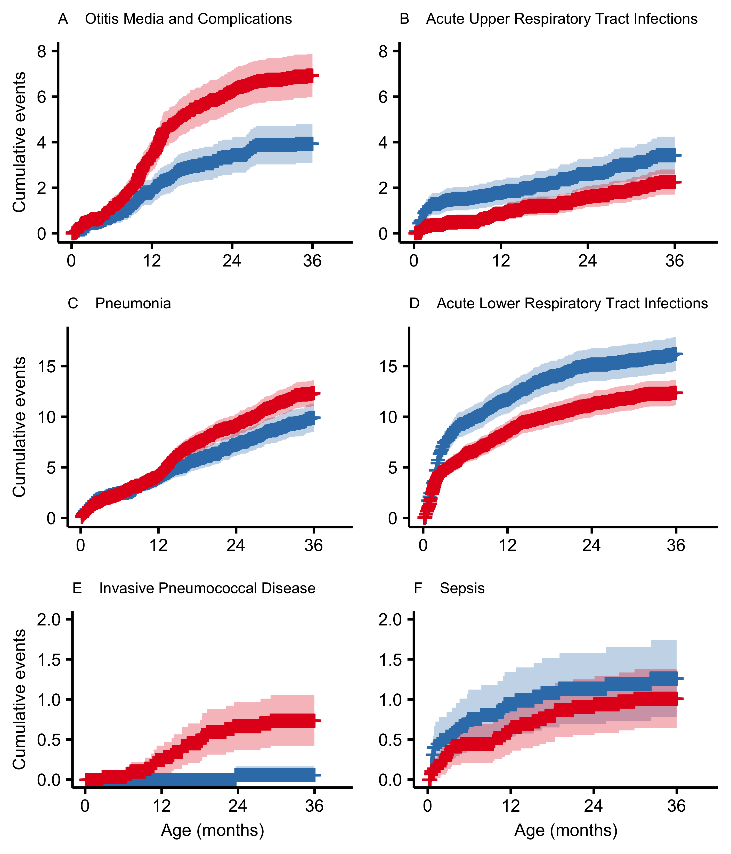

Figure 22 Kaplan-Meier cumulative event curves per 1,000 person-years for each of the diagnostic groups are displayed in panels A-F. The vaccine non-eligible cohorts (VNEC) are illustrated in red and the vaccine eligible cohorts (VEC) in blue. The presence of censored observations is indicated with a cross and the 95% confidence intervals are represented with a shaded area. The Y-axis is scaled independently for each pair of diagnostic groups (A-B, C-D and E-F).

A total of 15 children were admitted to hospital 19 times for meningitis, and 61 children were admitted 63 times for sepsis. The crude incidence rate of meningitis hospitalization was 16.5 and 8.7 per 100,000 person-years in the vaccine non-eligible and vaccine eligible cohorts respectively, and the analogous crude incidence rate for sepsis hospitalizations was 38.8 and 52.3. Culture confirmed invasive pneumococcal disease was diagnosed in 37 children under three years of age in the study birth-cohorts. Of those, 23 (59%) were admitted for inpatient treatment. Of the admitted children, eight children had a primary discharge diagnosis of Sepsis due to Streptococcus pneumoniae (A40.3), eight were diagnosed with Pneumococcal meningitis (G00.1), two with Pneumonia due to Streptococcus pneumoniae (J13), two with Bacterial pneumonia, not elsewhere classified (J15) and the remaining three were diagnosed with Bacterial meningitis, unspecified (G00.9), Pyogenic arthritis, unspecified (M00.9) and Fever, unspecified (R50.9). The crude incidence of invasive pneumococcal disease, regardless of whether the child was admitted to hospital, was 24.7 per 100,000 person-years in the VNEC compared to 1.74 per 100,000 person-years in the VEC. When only considering hospitalized invasive pneumococcal disease, the crude IR was 24.7 and 1.74 per 100,000 person-years. No vaccine-type invasive pneumococcal disease was diagnosed in the VEC. Crude incidence rates of hospitalization by age-group are shown in Figure 21.

Table 35 Hazard ratios between the vaccine eligible and vaccine non-eligible birth-cohorts for each disease-group

|  |  |
| --- | --- |
| Disease group | Hazard ratio (95%CI) |
| Otitis Media and Complications | 0.56 (0.437-0.73) |
| Acute upper respiratory infection | 1.55 (1.103-2.18) |
| Pneumonia | 0.80 (0.671-0.95) |
| Acute Lower Respiratory Tract Infections | 1.32 (1.137-1.53) |
| Sepsis | 1.26 (0.744-2.12) |
| Invasive Pneumococcal Disease | 0.07 (0.009-0.50) |

The mean age of children admitted for meningitis, sepsis and invasive pneumococcal disease was 9.7 months, 8.4 months and 14.4 months respectively. The cumulative incidence rates of hospitalization per 1000 person-years for sepsis and invasive pneumococcal disease are depicted in Figure 22. The hazard ratio of hospitalization for meningitis between the vaccine eligible and non-eligible cohorts was 0.45 (95%CI 0.15-1.41). An E-value was not computed as the hazard ratio was not significant. The hazard ratio for hospital admissions due to invasive pneumococcal disease between the vaccine eligible and vaccine non-eligible cohorts was 0.07 (95%CI:0.01-0.50), with an E-value of 28.06. and a lower bound of 3.41. The hazard ratio of a sepsis hospitalization between the vaccine eligibility cohorts was 1.26 (95%CI:0.75-2.13). No E-value was calculated as the ratio was not significant. Restricted analyses in these three diagnostic groups did not alter results significantly.

# Discussion

## Main findings

* The pediatric pneumococcal vaccination program that was implemented in Iceland in 2011 achieved excellent coverage. Over 90% of all children in the vaccine eligible birth-cohorts received all three doses before 24 months of age. Prior to the introduction of the vaccination program, few children were vaccinated against pneumococcus and even fewer had received two or more doses of a pneumococcal conjugate vaccine.
* An impact of PHiD-CV10 introduction was detected on several different facets of otitis media incidence. Pediatric primary care visits due to acute otitis media decreased by 21% and emergency department visits to Children’s Hospital Iceland decreased by 12-21%. Hospital based treatment of otitis media with parenteral ceftriaxone decreased by 42%.
* The incidence of outpatient antimicrobial prescriptions decreased by 8% following the introduction of PHiD-CV10. The cumulative incidence of antimicrobial prescription among Icelandic children was high. Among children in the vaccine non-eligible cohorts, the incidence of antimicrobial prescriptions was 165 prescriptions per 100 person-years and over 88% of had filled at least one prescription before their fourth birthday.
* The incidence of tympanostomy tube placements did not decrease following the introduction of PHiD-CV10, despite a measurable impact on otitis media visits to primary care and pediatric emergency departments and antimicrobial prescriptions. Approximately one-third of all Icelandic children undergo at least one tympanostomy tube procedure before five years of age.
* Pediatric hospital admissions for pneumonia declined by 20% following PHiD-CV10 introduction. This happened within the context of a large increase in bronchiolitis cases in young children. Pneumonia hospitalizations declined among Icelanders 20-39 years of age, implying a strong herd-effect among adults likely to by the parents of young children.
* Invasive pneumococcal disease requiring hospitalization decreased by 93% in the vaccine eligible cohorts compared to the vaccine non-eligible cohorts. No vaccine-type invasive disease was detected among the vaccinated cohorts.
* The pediatric pneumococcal vaccination program was cost-effective and was associated with a direct net-savings of 2,000,000,000 ISK.

## Data collection and sources

The data used for the papers in this thesis were collected from several population based registries. Each record was associated with a unique study identification number that was created from the individual’s national identification number by staff at the Icelandic Directorate of Health. This allowed the data from the various registries to be reliably linked.

The linkage between several large population based registries overcame a common limitation of epidemiological data. Registries record information about an event that occurred, e.g. an antimicrobial prescription, a primary care visit or a hospital admission. Because of this, they generally lack information about those individuals who did not experience the event. Epidemiological studies are therefore often forced to either restrict their scope to individuals who experienced one or more events, or infer the number of individuals who did not experience an event and the denominator for the total number of individuals at-risk – individual level data on those who did not experience the event is missing.

Our data included the date of birth, date of death, as well as data on immigration and emigration of Icelandic children. Through linkage of the registries, individual level information of those who did not experience an event became available, and accurate time-based at-risk denominators could be constructed. This allowed the study data to be analysed using survival methods, and repeated events within the same individual taken into account. The study contains individual level information on 375,383 Icelandic citizens over a 13 year period from 2005-2017. According to Statistics Iceland, the aggregate number of Icelandic citizens was 293,577 on 1 January 2005, and was 338,349 on 1 January 2017.

Individual level information was available for each pneumococcal vaccine dose that was administered in Iceland. Unlike prior studies, which were forced to infer the the proportion of individuals who were vaccinated using aggregate sales data, we were able to directly check if a specific individual was vaccinated. We were also able to ascertain the low proportion of individuals who were vaccinated prior to the introduction of PHiD-CV10 into the Icelandic pediatric vaccination program. The exception to this was the slight increase in uptake in the 2010 birth-cohort, especially those children born in the later half of 2010. This is likely due to heightened awareness among parents because of the impending introduction of the vaccine. In some sense the result is that a unplanned catch-up occurred, with close to 40% of children born in the later half of 2010 receiving two or more doses of a pneumococcal conjugate vaccine, before two years of age.

## Epidemiology and impact of PHiD-CV10 on otitis media in Iceland (Papers I, II, III, V and VI)

Following the introduction of PHiD-CV10, changes were noted in several facets of otitis media epidemiology. These changes were summarized in papers I, II, III, V and VI.

### Epidemiology of acute otitis media in Iceland (Papers II and V)

The epidemiology of acute otitis media visits to primary care was described in paper II. During the 11 year study period from 2005 to 2015, the overall incidence of AOM episodes among children zero to three years of age was 42 per 100 person-years. Prior to the introduction of PCV into the Icelandic pediatric vaccination program, 59% of children had visited a primary care physician one or more times by their third birthday and each child had experienced 1.6 episodes on average. There were large variations in the incidence rate between both gender, birth-cohort and age. The incidence was consistently higher in males than females, and was highest among children 8-11 and 12-15 months of age.

The pathophysiology and microbiology of AOM are discussed in chapter 2.1.1. The incidence of AOM is highly variable between countries. Published estimates of the incidence prior to the introduction of pneumococcal conjugate vaccines are summarized in Table 2. Generally, the rate of AOM among European children ranges from 15 to 40 episodes per 100 person-years, while the rate among children in the United States ranges from 95 to 200 episodes per 100 person-years. The rate of AOM in Iceland seems to be higher than published estimates from most other European countries, but lower than published estimates from the United States. To our knowledge, only two previous studies have reported the cumulative incidence of AOM in a modern cohort, demonstrating a 74% and 60% cumulative incidence by five and seven years of age respectively (Gribben et al. 2012; Todberg et al. 2014). Compare this to our estimate of 59% by four years of age, and to two studies from the twentieth century showing a 83% cumulative incidence by three years of age and 66% by two years of age (Bjarnason, Friðriksson, and Benediktsson 1991; Teele, Klein, and Rosner 1989).

Care must be taken when comparing incidence rates from different countries, time-periods and age-groups, as variable estimates are not necessarily due to true difference in the rates of clinical disease. Acute otitis media is often a benign, self-limiting condition. The propensity to seek medical care may be influenced by several cultural and socio-economic factors. Access and cost of healthcare may influence whether parents consult a physician and may result in measurable changes in incidence between countries (Fortanier et al. 2015; Hadley 2003; Smolderen 2010). In Iceland, all permanent residents are provided health insurance by the government and there is excellent access to urgent care. Children are provided healthcare free of charge. In Iceland, both parents are typically fully employed and the proportion of children attending daycare is high. These factors may push parents to seek early care for otitis media. The employment rate of Icelandic adults 20-64 years of age is 91% and 84% for males and females respectively, which means that Iceland has the highest employment rate in Europe (Eurostat 2018). Iceland is ranked third in formal daycare attendance by The Organisation for Economic Co-operation and Development (OECD), with up to 60% of children under three years of age attending 38 hours per week or longer. This is compared to the OECD average of 35% attendance for 30 hours (co-operation and development 2013). Both daycare attendance and the number of hours per week are known risk factors for acute otitis media (Ramakrishnan, Sparks, and Berryhill 2007) These factors should result in a higher incidence of AOM in Iceland relative to other countries.

However, certain factors in the study design are likely to decrease the observed incidence. A previous study in Iceland estimated the incidence of acute otitis media using a parental questionnaire and found the incidence rate to be 55-80 episodes per 100 person-years (Gudnason et al. 2013) This suggests that not all otitis media cases are being brought to primary care physicians, and are therefore not counted in our study. Similar observations have been made in other countries (Fortanier et al. 2015). Of those episodes of acute otitis media that present for physician consultation, not all present to a primary care physician. Our study may miss some cases, due to not having access data regarding visits to specialists. Additionally, many of the studies being compared to use the number of acute otitis media visits as the numerator, and therefore count visits for re-evaluations of the same otitis media episode. Our study excludes visits within 30 days of the index visit to better approximate the number of acute otitis media episodes resulting in physician consultation.

### Impact on primary care visits for otitis media (Papers II and VI)

Two separate population based studies estimated the impact of PHiD-CV10 on otitis media visits in primary care. The studies used different methods which complemented each other with regards to underlying assumptions, weaknesses and strengths.

In paper II, the impact of PHiD-CV10 introduction was estimated as 1 - hazard ratio of AOM between children in the last vaccine non-eligible cohort and last vaccine eligible cohort. The hazard ratio was obtained from an Andersen-Gill regression model that incorporated individual level information on AOM episodes. Correlation between successive episodes of the same child were accounted for using sandwich variance estimates. This approach allowed for accurate estimation of an individual child’s hazard of AOM and accounted for differences in follow-up time between the vaccine eligible and non-eligible cohorts. The model accurately corrected for the effect of age, as age was the underlying time frame of the model. Using this model, the estimated impact of PHiD-CV10 was 21%. The vaccine impact was shown to independently protect against a child’s first and second episode, but in the subset of children who had already experienced two episodes of AOM, the vaccine was not shown to decrease the hazard of experiencing a third episode. The study adds to the current literature by providing robust individual level observational evidence of PCV impact on AOM. Randomized controlled trials have shown inconsistent results regarding the efficacy of PCV on all-cause AOM (Black et al. 2000; Dagan et al. 2001; Eskola et al. 2001; Fireman et al. 2003; Kilpi et al. 2003; O’Brien et al. 2008; Palmu et al. 2015; Prymula et al. 2006; Tregnaghi et al. 2014; Vesikari et al. 2016), and no population based study on the impact of PCV on AOM in primary care has previously been reported. To our knowledge, this was the first study to directly account for repeated episodes within the same individual and employ survival methods that accounted for confounding by age and censoring.

One criticism of the methods employed in paper II, is that they do not account for secular trends in the hazard of AOM prior to introduction of the vaccine. Visual inspection of Figure 10 suggests a slight decreasing trend in the hazard of AOM, with each successive vaccine non-eligible cohort. Accounting for this may slightly change the point-estimate. However, the large, abrupt decrease in the hazard ratio between the last vaccine non-eligible cohort and the first vaccine eligible cohort provides strong evidence of a true vaccine impact. Nevertheless, a time-series methodology was used to emphasize correction for secular trends in paper VI. A synthetic control framework was used, in which the relationship between otitis media visits and visits for other indications was estimated in the pre-vaccine period, and this relationship was used to predict the number of otitis media visits which would have occurred in the post-vaccine period, had PHiD-CV10 not been introduced. This approach accurately accounts for secular trends, and gives a robust estimate of the vaccine impact. It also allows estimation of herd-effect in older children who were not vaccine eligible in the post-vaccine period. However, unlike the individual based Andersen-Gill model, it is run on aggregate monthly data and is run separately for each age-group which cannot be more granular than one year intervals. The vaccine impact is estimated as 1 - rate ratio between the observed number of otitis media visits and the predicted number of otitis media visits. The vaccine impact was 18% among children younger than one year of age, 10% among one year olds, 9% among two year olds and 14% among children three to four years of age. Only three previous observational studies evaluating the impact of PCV on otitis media have attempted to correct for secular trends (Grijalva et al. 2006; Lau et al. 2015; Marom et al. 2014). Unlike those, the methods used in paper VI do not depend upon the assumption that pre-vaccine trends can only be linear and lower the risk of bias considerably by introducing controls.

In any vaccine ecology study, one must be careful when interpreting the results, as confounding may have contributed to over- or underestimation of the estimated vaccine impact. The impact of PHiD-CV10 on AOM in Iceland is quantified using two different methods that complement one another. Despite the different methodologies, the results of paper II and paper VI are consistent. The point-estimated in both papers are similar and the diminishing vaccine impact seen in older children with the time-series methodology is mirrored in the incidence rate ratios between the vaccine eligible and vaccine non-eligible birth-cohorts displayed in Figure 9. Both are informed by population based data on all otitis media visits to the primary care system in Iceland. A visit is defined to be associated with otitis media, based on the diagnostic codes that were recorded during the visit. The same diagnostic coding system, ICD-10, has been in use in Iceland during the entire study period and clinical information has been documented in the same electronic health record software, *Saga*. There does not seem to be any reason to suspect that a systematic drift has occurred in the diagnostic classification of children presenting to primary care physicians during the study period that could confound the observed vaccine impact.

To the authors’ knowledge, no change in a child’s access to urgent care within the primary care system has occurred during the study period. However, access to specialist pediatricians at private clinics has increased from 42,916 visits in 2005 to 58,048 visits in 2016 (www.statice.is). These visits were not accessible to the study’s authors and not included in the study’s data. This could be considered a confounder to the observed vaccine impact in paper II, as some of the observed decrease in otitis media cases could hypothetically be explained by children increasingly seeking care outside the primary care system. This is unlikely, as urgent care provided by pediatricians has not increased during the study period, only appointments (personal correspondence with the head of the only private pediatrician clinic in Iceland providing urgent care). Even if urgent care visits had been diverted from primary care to private practice pediatricians, this would not confound the estimates of paper VI, unless children presenting with otitis media were preferentially diverted compared to children presenting with other diagnoses. There is nothing to suggest this.

### Impact on pediatric emergency department visits for acute otitis media (Paper I)

On average, emergency department visits for acute otitis media are likely to represent a subset of more serious cases than those that present to primary care centers. Paper I examined the impact of PHiD-CV10 introduction on the incidence of acute otitis media visits to the emergency department of Children’s Hospital Iceland. Following vaccine introduction, the incidence decreased significantly from 4.7 visits per 100 person-years in the pre-vaccine period to to 4.1 visits per 100 person-years in the post-vaccine period. The estimated vaccine impact was 12%. This study employed a simple pre/post design, and was not able to adjust for secular trends due to the nature of the study data. The design was similar to most previously published observational studies of PCV on AOM (Vojtek, Nordgren, and Hoet 2017). The estimation of the incidence of acute otitis media visits, and impact of the introduction of PHiD-CV10 was a secondary objective of the paper. A robust time-series approach with synthetic controls is warranted to further investigate the impact of PHiD-CV10 on pediatric emergency department visits for acute otitis media, as was done in paper VI for primary care.

### Impact on outpatient antimicrobial prescriptions for otitis media (Paper III)

The impact of the introduction of PHiD-CV10 on outpatient antimicrobial prescriptions for AOM was explored in Paper III, using population based registries. Data was obtained from the Icelandic National Drug Prescription Registry which included all filled outpatient antimicrobial prescriptions during a thirteen year period from 2005 to 2017. This was linked to visits to primary care physicians for AOM which was extracted from the Primary Care Registry. The impact of PHiD-CV10 introduction into the pediatric vaccination program was defined as 1 - hazard ratio of AOM associated antimicrobial prescription between children in the last vaccine non-eligible cohort and last vaccine eligible cohort. The hazard ratio was obtained from an Andersen-Gill model, which corrected for age, gender, censored follow-up time and correlations between successive prescriptions of the same individual child. Using this definition, the estimated impact on AOM associated antimicrobial prescriptions was 22%.

Several randomized controlled trials have estimated the vaccine efficacy of PCV on outpatient antimicrobial consumption, with results ranging from 5% to 15% (Dagan et al. 2001; Fireman et al. 2003; Palmu et al. 2014). Dagan et al. (2001) specifically examined efficacy against otitis media associated antimicrobial days, and reported 20% vaccine efficacy. Our results are within reasonable bounds of these findings. Though blinded randomized controlled trials do provide robust estimates of vaccine efficacy, they do so under artificial conditions. Parents and physicians may behave differently knowing that their actions are being observed and quantified by researchers, and this may reduce the incidence of inappropriate prescribing. In that respect, observational studies provide additional information by demonstrating whether vaccine impact can still be observed in true clinical settings. Only one study has previously assessed the impact of PCV on otitis media associated antimicrobial prescriptions, which demonstrated a 20% vaccine impact (Lau et al. 2015). Two other observational studies on outpatient antimicrobial prescriptions demonstrated an association between PCV introduction and a decline in prescriptions (Gefenaite et al. 2014; Howitz et al. 2017).

Unlike previously published observational studies, we report the results of a cohort study using individual level data. This allows a much sharper delineation between vaccinated and unvaccinated children. When data is aggregated and analysed based on calendar-time, the period from the introduction of the vaccine until the majority of children under observation are vaccinated will span several years. During that time, other secular trends exert their confounding effects on the outcome, and the start of the post-vaccination period is not well defined. Contrast this to our cohort study were children in the 2010 cohort, who were not vaccine eligible, are directly compared to the vaccine eligible children in the 2011 cohort. Though the children in the 2010 birth-cohort are one year older on average, the two cohorts experience the same viral epidemics, are treated by the same physicians and interact with each other daily in daycare centers.

Ecological studies are subject to confounding which must be taken into account when the results are interpreted. A decreasing trend in the hazard of AOM associated antimicrobial prescriptions was noted in the vaccine non-eligible cohorts, such that the hazard was significantly higher in the 2007 compared to the 2010 birth-cohort. Though this may change the point-estimate of the vaccine impact, the large, abrupt and significant hazard decrease in the 2011 compared to the 2010 cohort strongly suggests a true vaccine impact.

### Evidence of herd-effect of PHiD-CV10 on the incidence of otitis media in the unvaccinated population (Papers II and VI)

Vaccination decreases the susceptibility of vaccinated individuals to become infected, and later pass the pathogen to others. Therefore, there is a strong theoretical reason to believe that introducing PHiD-CV10 into the population could confer indirect protection against pneumococcal disease to non-vaccinated members of the population. In vaccine studies, this indirect effect is termed herd-effect, and has been convincingly demonstrated for invasive pneumococcal disease following introduction of pneumococcal conjugate vaccines. There is a paucity of published literature demonstrating herd-effect for acute otitis media following pneumococcal conjugate vaccine introduction (Jennifer D Loo et al. 2014).

In paper II, a large decrease in the incidence of AOM was found among children under four months of age. The incidence rate ratio between children in the vaccine eligible cohorts compared to children in the vaccine non-eligible cohorts was 0.60 (0.51-0.69), which translates to a 40% vaccine impact in this age-group. Children three to four months of age may have already received the first dose of PHiD-CV10, but will not yet have received any direct benefit (Nicholls, Leach, and Morris 2016). Thus the data strongly supports existence of a herd-effect for AOM, and that vaccinating children at three, five and 12 months of age with PHiD-CV10 confers protection to children too young to be themselves directly protected. One previous study reported fewer positive pneumococcal cultures from samples taken from the middle ear of children younger than four months of age, following the introduction of pneumococcal conjugate vaccine in Israel, suggesting a possible herd-effect (Ben-Shimol et al. 2016).

In paper VI, a time-series methodology with synthetic controls was applied to ascertain the PHiD-CV10 impact on otitis media visits in primary care. The study period was 2005-2015, during which none of the vaccine eligible children had reached five years of age. The vaccine impact was estimated separately in children younger than one, one, two, three to four, five to nine, 10-14 and 15-19 years of age. Among children five to nine years of age, the estimated vaccine impact was 11%, and was 17% in children 10-14 years of age. For these estimates the 95% credible intervals did not cross the ratio value of 0.92, which can be interpreted as a 0.975 probability that the true decrease in the risk ratio of outpatient AOM in these age-groups is larger than 0.92. The median posterior probability of vaccine impact among children 15-19 years of age was 15%, however the 95% credible intervals crossed the ratio value of one, which suggests that there is some probability that the risk has increased. The result is consistent with a strong herd-effect of PHiD-CV10 against otitis media in unvaccinated older children.

### Impact on acute otitis media with treatment failure (Paper I)

There is a paucity of published studies that examine the impact of pneumococcal conjugate vaccines on acute otitis media with treatment failure. Treatment failure is defined as the persistence of symptoms despite antimicrobial treatment. There is evidence to suggest that treatment failure occurs more commonly in AOM caused by *Streptococcus pneumoniae* and *Haemophilius influenzae* than in AOM caused by other pathogens (Casey and Pichichero 2004; Pichichero et al. 2008) Otitis media with treatment failure represents an important subset of cases that is associated with a higher burden of disease. In paper I, the impact of PHiD-CV10 on the incidence of AOM episodes treated with parenteral ceftriaxone at Children’s Hospital Iceland was examined. Data regarding the use of ceftriaxone and visits for AOM were extracted from Children’s Hospital Iceland’s patient registry for the period from 2008 to 2015.  
The study demonstrated a statistically significant 52% impact of PHiD-CV10 on ceftriaxone treated AOM episodes among children younger than four years of age.

To our knowledge, this is the first study to show a significant decrease in AOM with treatment failure following PCV introduction. Because AOM with treatment failure is not objectively defined in the literature, a proxy measurement such as ceftriaxone use is needed. Parenteral antimicrobial use is avoided unless absolutely necessary and is not administered at primary care clinics. It is therefore an appropriate and clinically relevant proxy measurement for the worst cases of otitis media with treatment failure. We do however acknowledge that we are not currently in possession of data that proves that a trial of oral antimicrobials was attempted prior to initiation of parenteral ceftriaxone. It is an assumption that is grounded in established clinical norms of pediatric medicine. Unlike the other study data upon which this thesis is based, the data used in paper I was not linkable to population registries, which precludes formal evaluation of this assumption.

No changes in institutional guidelines regarding the use of ceftriaxone or treatment of severe AOM occurred during the study period. Several additional evaluations were performed to examine other possible explanations for the observed decrease. To exclude the possibility that the observed reduction was due to a decrease in AOM cases, the analysis was repeated using the number of AOM visits to Children’s Hospital Iceland as the rate denominator, If this statistic were used, the estimated vaccine impact would be 42%. No changes were observed in ceftriaxone usage among older children, and among children younger than four, ceftriaxone use for indications other than AOM and pneumonia did not change significantly, with an estimated incidence rate ratio 0.96 (95% CI: 0.87-1.06). Though not statistically significant, the observed rate ratio does not prove an absence of effect. The result is consistent with as much as a 13% decrease in the incidence of ceftriaxone treatment for indications other than AOM and pneumonia. This may be partly explained by the inclusion of indications other than AOM and pneumonia that are possibly related to PCV, such as unspecified fever, cough and sepsis. However, when the totality of evidence is considered, it suggests a true independent association between the introduction of PHiD-CV10 into the Icelandic pediatric vaccination program, and the observed decrease in AOM treated with parenteral ceftriaxone. Clinical experience tells us that this may be considered a proxy for AOM with treatment failure.

## Impact of PHiD-CV10 on tympanostomy tube placements (Paper IV)

Tympanostomy tube placements are the most common pediatric surgical procedure requiring general anesthesia (Black 1984; Cullen, Hall, and Golosinskiy 2009). The most common indications for the procedure are recurrent acute otitis media and otitis media with effusion, however evidence of benefit is inconsistent (Venekamp et al. 2018; Browning et al. 2010). In paper IV, we report the impact of PHiD-CV10 introduction into the Icelandic pediatric vaccination program on tympanostomy tube placements. This population based study obtained data on tympanostomy procedures from the reimbursement database of Icelandic Health Insurance and Landspitali University Hospital’s patient registry. Eleven consecutive birth-cohorts were followed from birth until five years of age, or end of the study’s observational period in 2016. A Cox regression model was used to compare the hazard ratio of tympaonstomy tube placement between each birth-cohort and the last vaccine non-eligible birth-cohort, and the vaccine impact was a priori defined as 1 - hazard ratio between the last included vaccine eligible cohort and the last vaccine non-eligible cohort. This definition resulted in an estimated -5% (95%CI -15% to 4%) vaccine impact, indicating a non-significant increase in the hazard of tympanostomy tube placement following vaccine introduction.

The results are neither congruent with the results of other studies included in this thesis, or previously published observational and randomized controlled trials. The study group has shown a clinically meaningful decrease in primary care visits and antimicrobial prescriptions for AOM and all-cause outpatient antimicrobial prescriptions (Eythorsson et al. 2018; Sigurdsson et al. 2018). The results of randomized controlled trials are summarized in Table 4. Black et al. (2000) demonstrated a 20% efficacy of PCV7 for tympanostomy tube procedures. Four other randomized studies reported a non-significant efficacy (Eskola et al. 2001; O’Brien et al. 2008; Prymula et al. 2006; Palmu et al. 2015). An observational study from the United States reported reductions in the risk of tympanostomy procedures following the introduction of PCV7, but did not consider the possibility of secular trends (Poehling et al. 2007). Another study conducted in Australia carefully evaluated secular trends and other confounders, and reported a 23% reduction in the rate of procedures associated with the introduction of PCV7 (Jardine et al. 2009).

We report an incidence of 106 procedures per 1,000 person-years in children zero to five years of age, and a cumulative incidence of 32% by six years of age. This represents both the highest cumulative incidence and incidence rate of tympanostomy procedures that has been published to date (Table 3). We demonstrate that among children who underwent tympanostomy tube placement, the proportion of children who had never visited a primary care physician or filled an antimicrobial prescription prior to the procedure was higher in the vaccine eligible cohorts. The study design does not allow us to estimate the cause of this unexpected increase. We cannot exclude the possibility that an increasing secular trend was occurring in the pre-vaccine period, and that the incidence would have been higher, had the vaccine not been introduced.

### Impact on hospital admissions for otitis media (Paper V)

The impact of PHiD-CV10 on pediatric hospital admissions for otitis media was examined in paper V. The study included eleven consecutive birth-cohorts 2005-2015 and followed children from birth until their third birthday or to the end of the study’s observational period. Hospital admissions for otitis media were compared between the vaccine eligible and non-eligible birth-cohorts using a Cox regression model, resulting in a statistically significant 43% estimated vaccine impact. However, this difference seemed to be largely driven by a sharp decrease in the incidence of otitis media associated hospitalization between the first two vaccine non-eligible cohorts. This decrease occurred before even selective vaccination of high-risk children was common practice, and several years before the introduction of PHiD-CV10.

Four observational studies that estimate the impact of PCV on otitis media associated hospitalizations have previously been published (Durando et al. 2009; Gisselsson-Solen 2017; Marom et al. 2017; Tawfik et al. 2017). A retrospective study in the United States reported a 66% relative risk reduction in hospitalizations in the period following the introduction of PCV13, compared to the period prior to PCV7 introduction – nine years apart (Tawfik et al. 2017). No attempt was made to correct for secular trends and the possibility was not discussed, which is understandable as the study did not include a single observational year prior to the introduction of PCV7 in 2000. The included figures reveal that the entire observed decrease occurred in the first year of the study, between 2000 and 2001 (Tawfik et al. 2017). Gisselsson-Solen (2017) similarly reported a 42% reduction in AOM associated admissions in a period following the introduction of higher valent PCV compared to prior to the introduction of PCV7. The influence of secular trends are not discussed or corrected for, and figures reveal that a large portion of the observed decrease occurs immediately following PCV7 introduction. Durando et al. (2009) implement a pre- and post cohort design, and compare the rates of otitis media hospitalization using a simple comparison of means. They include hospitalizations for urinary tract infections as a control, and report a 36% relative risk reduction. Trends were not considered. Marom et al. (2017) did not observed a decrease in hospitalizations.

A careful examination of our results does not suggest an observable decrease in otitis media associated hospitalizations in Iceland that can be attributed to the introduction of PHiD-CV10 into the pediatric vaccination program. The study underscores the importance of carefully considering the results of vaccine ecology studies.

## Impact of PHiD-CV10 on pneumonia hospitalizations in Iceland (Papers V and VI)

Two separate studies estimated the impact of PHiD-CV10 on pneumonia hospitalizations among children. The studies approached the research question from different angles and complemented each other with regards to weaknesses and strengths.

Children’s Hospital Iceland is the only pediatric hospital in Iceland. It serves as a tertiary hospital for the entire population. Paper V reported the impact of PHiD-CV10 introduction on pneumonia hospitalizations among children younger than three years of age. Eleven consecutive birth-cohorts 2005-2015 were followed from birth to three years of age or end of the study period in 2017. All hospitalizations with discharge diagnoses compatible with pneumonia were extracted from the patient registry. A Cox regression analysis was employed to estimate vaccine impact, which was defined as 1 - hazard ratio of pneumonia hospitalization between children in the vaccine eligible and vaccine non-eligible cohorts. The model accurately corrected for the effect of age, as age was the underlying time frame of the model. Using this model, the estimated impact of PHiD-CV10 was 20%.

The study adds to a growing body of literature by providing population based, individual level observational evidence of PCV impact on pneumonia hospitalizations. Four randomized trials have evaluated the efficacy of PCV for clinical pneumonia and their results are summarized Table 5. (Black et al. 2002; Cutts et al. 2005; Kilpi et al. 2018; Tregnaghi et al. 2014). Only Kilpi et al. (2018) reported efficacy for hospital-diagnosed pneumonia, which was 27%. A systematic review and meta-analysis of observational studies of higher valency PCV on clinical pneumonia concluded that in children aged 24 months and younger, the introduction of PCV resulted in a 17% (95%CI 11% to 22%) reduction in clinical pneumonia (Alicino et al. 2017).

In paper VI, a time-series methodology incorporating synthetic controls was used to estimate the impact of PHiD-CV10 introduction on pneumonia hospitalizations correcting for secular trends in the pre-vaccine period. Data on hospital admissions were extracted from Landspitali University’s Hospital patient registry. The relationship between pneumonia hospitalizations and hospital admissions for other diagnoses was estimated in the pre-vaccine period. On the basis of this relationship, the model predicted the number of pneumonia hospitalizations that would have occurred in the post-vaccine period, had the vaccine not been introduced. The difference between the observed rate of pneumonia hospitalizations and the model estimate was assumed to be due to the vaccine introduction. This approach accurately accounts for secular trends, and gives a robust estimate of the vaccine impact. It also allows for estimation of herd-effect in unvaccinated members of the population.

### Evidence of herd-effect of PHiD-CV10 on pneumonia hospitalization in the unvaccinated population (Papers V and VI)

## Impact of PHiD-CV10 on invasive pneumococcal disease (Papers V and VI)

## Cost-effectiveness of introduction of PHiD-CV10 into the Icelandic pediatric vaccination program (Paper VI)

# Conclusions

Adam, D, and K Fehnle. 2008. “Safety and effectiveness against respiratory tract infections for pneumococcal conjugate vaccine co-administered with routine vaccine combinations.” *Vaccine* 26 (47): 5944–51. doi:[10.1016/j.vaccine.2008.08.058](https://doi.org/10.1016/j.vaccine.2008.08.058).

Ahmed, Sameer, Nina L Shapiro, and Neil Bhattacharyya. 2014. “Incremental health care utilization and costs for acute otitis media in children.” *The Laryngoscope* 124 (1): 301–5. doi:[10.1002/lary.24190](https://doi.org/10.1002/lary.24190).

Alicino, Cristiano, Chiara Paganino, Andrea Orsi, Matteo Astengo, Cecilia Trucchi, Giancarlo Icardi, and Filippo Ansaldi. 2017. “The impact of 10-valent and 13-valent pneumococcal conjugate vaccines on hospitalization for pneumonia in children: A systematic review and meta-analysis.” *Vaccine* 35 (43). The Authors: 5776–85. doi:[10.1016/j.vaccine.2017.09.005](https://doi.org/10.1016/j.vaccine.2017.09.005).

Andersen, P. K., and R. D. Gill. 1982. “Cox’s Regression Model for Counting Processes: A Large Sample Study.” *The Annals of Statistics* 10 (4): 1100–1120. doi:[10.1214/aos/1176345976](https://doi.org/10.1214/aos/1176345976).

Andrade, Luiz Flavio, Grèce Saba, Jean-Damien Ricard, Jonathan Messika, Jacques Gaillat, Pierre Bonnin, Christian Chidiac, et al. 2018. “Health related quality of life in patients with community-acquired pneumococcal pneumonia in France.” *Health and Quality of Life Outcomes* 16 (1). Health; Quality of Life Outcomes: 28. doi:[10.1186/s12955-018-0854-6](https://doi.org/10.1186/s12955-018-0854-6).

Arason, V A, K G Kristinsson, J A Sigurdsson, G Stefánsdóttir, S Mölstad, and S Gudmundsson. 1996. “Do antimicrobials increase the carriage rate of penicillin resistant pneumococci in children? Cross sectional prevalence study.” *BMJ (Clinical Research Ed.)* 313 (7054): 387–91. doi:[10.1136/bmj.313.7054.387](https://doi.org/10.1136/bmj.313.7054.387).

Arason, Vilhjalmur A, Johann A Sigurdsson, Karl G Kristinsson, and Sigurdur Gudmundsson. 2002. “Tympanostomy tube placements, sociodemographic factors and parental expectations for management of acute otitis media in Iceland.” *The Pediatric Infectious Disease Journal* 21 (12): 1110–5. doi:[10.1097/01.inf.0000040702.00373.95](https://doi.org/10.1097/01.inf.0000040702.00373.95).

Arason, Vilhjalmur A., Johann A. Sigurdsson, Karl G. Kristinsson, Linn Getz, and Sigurdur Gudmundsson. 2005. “Otitis media, tympanostomy tube placement, and use of antibiotics.” *Scandinavian Journal of Primary Health Care* 23 (3). Taylor & Francis: 184–91. doi:[10.1080/02813430510031298](https://doi.org/10.1080/02813430510031298).

Arguedas, A., K. Kvaerner, J. Liese, A.G.M. Schilder, and S.I. Pelton. 2010. “Otitis media across nine countries: Disease burden and management.” *International Journal of Pediatric Otorhinolaryngology* 74 (12). Elsevier Ireland Ltd: 1419–24. doi:[10.1016/j.ijporl.2010.09.022](https://doi.org/10.1016/j.ijporl.2010.09.022).

Austin, D J, K G Kristinsson, and R M Anderson. 1999. “The relationship between the volume of antimicrobial consumption in human communities and the frequency of resistance.” *Proceedings of the National Academy of Sciences of the United States of America* 96 (3): 1152–6. [http://www.pubmedcentral.nih.gov/articlerender.fcgi?artid=15366{\&}tool=pmcentrez{\&}rendertype=abstract](http://www.pubmedcentral.nih.gov/articlerender.fcgi?artid=15366%7b\&%7dtool=pmcentrez%7b\&%7drendertype=abstract).

Austrian, R, R M Douglas, G Schiffman, A M Coetzee, H J Koornhof, S Hayden-Smith, and R D Reid. 1976. “Prevention of pneumococcal pneumonia by vaccination.” *Transactions of the Association of American Physicians* 89: 184–94. <http://www.ncbi.nlm.nih.gov/pubmed/14433>.

AUSTRIAN, ROBERT. 1964. “Pneumococcal Bacteremia with Especial Reference to Bacteremic Pneumococcal Pneumonia.” *Annals of Internal Medicine* 60 (5): 759. doi:[10.7326/0003-4819-60-5-759](https://doi.org/10.7326/0003-4819-60-5-759).

Austrian, Robert. 1981. “Pneumococcus: the first one hundred years.” *Reviews of Infectious Diseases* 3 (2): 183–9. doi:[10.1093/clinids/3.2.183](https://doi.org/10.1093/clinids/3.2.183).

———. 1999. “A brief history of pneumococcal vaccines.” *Drugs & Aging* 15 Suppl 1: 1–10. <http://www.ncbi.nlm.nih.gov/pubmed/10690790>.

Backhaus, Erik, Stefan Berg, Rune Andersson, Gunilla Ockborn, Petter Malmström, Mats Dahl, Salmir Nasic, and Birger Trollfors. 2016. “Epidemiology of invasive pneumococcal infections: manifestations, incidence and case fatality rate correlated to age, gender and risk factors.” *BMC Infectious Diseases* 16 (1): 367. doi:[10.1186/s12879-016-1648-2](https://doi.org/10.1186/s12879-016-1648-2).

Ben-Shimol, Shalom, Noga Givon-Lavi, Eugene Leibovitz, Simon Raiz, David Greenberg, and Ron Dagan. 2014. “Near-Elimination of Otitis Media Caused by 13-Valent Pneumococcal Conjugate Vaccine (PCV) Serotypes in Southern Israel Shortly After Sequential Introduction of 7-Valent/13-Valent PCV.” *Clinical Infectious Diseases* 59 (12): 1724–32. doi:[10.1093/cid/ciu683](https://doi.org/10.1093/cid/ciu683).

———. 2016. “Impact of Widespread Introduction of Pneumococcal Conjugate Vaccines on Pneumococcal and Nonpneumococcal Otitis Media.” *Clinical Infectious Diseases : An Official Publication of the Infectious Diseases Society of America* 63 (5): 611–8. doi:[10.1093/cid/ciw347](https://doi.org/10.1093/cid/ciw347).

Bennett, Jonathan E., Walton Sumner, Stephen M. Downs, and David M. Jaffe. 2000. “Parents’ Utilities for Outcomes of Occult Bacteremia.” *Archives of Pediatrics & Adolescent Medicine* 154 (1). American Medical Association: 43–48. doi:[10-1001/pubs.Pediatr Adolesc Med.-ISSN-1072-4710-154-1-poa9043](https://doi.org/10-1001/pubs.Pediatr%20Adolesc%20Med.-ISSN-1072-4710-154-1-poa9043).

Berg, Are Stuwitz, Christopher Stephen Inchley, Audun Aase, Hans Olav Fjaerli, Reidun Bull, Ingeborg Aaberge, Truls Michael Leegaard, and Britt Nakstad. 2016. “Etiology of Pneumonia in a Pediatric Population with High Pneumococcal Vaccine Coverage: A Prospective Study.” *The Pediatric Infectious Disease Journal* 35 (3): e69–75. doi:[10.1097/INF.0000000000001009](https://doi.org/10.1097/INF.0000000000001009).

Bergenfelz, Caroline, and Anders P Hakansson. 2017. “Streptococcus pneumoniae Otitis Media Pathogenesis and How It Informs Our Understanding of Vaccine Strategies.” *Current Otorhinolaryngology Reports* 5 (2): 115–24. doi:[10.1007/s40136-017-0152-6](https://doi.org/10.1007/s40136-017-0152-6).

BEUTELS, P., Z. SHKEDY, M. AERTS, and P. VAN DAMME. 2006. “Social mixing patterns for transmission models of close contact infections: exploring self-evaluation and diary-based data collection through a web-based interface.” *Epidemiology and Infection* 134 (06): 1158. doi:[10.1017/S0950268806006418](https://doi.org/10.1017/S0950268806006418).

Beutels, Philippe, Nancy Thiry, and Pierre Van Damme. 2007. “Convincing or confusing? Economic evaluations of childhood pneumococcal conjugate vaccination–a review (2002-2006).” *Vaccine* 25 (8): 1355–67. doi:[10.1016/j.vaccine.2006.10.034](https://doi.org/10.1016/j.vaccine.2006.10.034).

Birnbaum, Howard G, Melissa Morley, Paul E Greenberg, M Cifaldi, and G L Colice. 2002. “Economic burden of pneumonia in an employed population.” *Archives of Internal Medicine* 161 (2): 2725–31. doi:[10.1001/archinte.161.22.2725](https://doi.org/10.1001/archinte.161.22.2725).

Bjarnason, Agnar, Hilmir Asgeirsson, Olafur Baldursson, Karl G Kristinsson, and Magnus Gottfredsson. 2015. “Mortality in healthcare-associated pneumonia in a low resistance setting: a prospective observational study.” *Infectious Diseases (London, England)* 47 (3): 130–36. doi:[10.3109/00365548.2014.980842](https://doi.org/10.3109/00365548.2014.980842).

Bjarnason, Skúli, Ingþór Friðriksson, and Jón Benediktsson. 1991. “Tíðni bráðrar miðeyrabólgu hjá börnum á svæði heilsugæslustöðvarinnar Borgarnesi.” *Læknablaðið* 77 (4): 137–40. <http://www.hirsla.lsh.is/lsh/bitstream/2336/90415/1/L1991-04-77-F3.pdf>.

Black, Nick. 1984. “SURGERY FOR GLUE EAR —A MODERN EPIDEMIC.” *The Lancet* 323 (8381): 835–37. doi:[10.1016/S0140-6736(84)92280-3](https://doi.org/10.1016/S0140-6736(84)92280-3).

Black, S, H Shinefield, Bruce Fireman, E Lewis, P Ray, J R Hansen, L Elvin, et al. 2000. “Efficacy, safety and immunogenicity of heptavalent pneumococcal conjugate vaccine in children. Northern California Kaiser Permanente Vaccine Study Center Group.” *The Pediatric Infectious Disease Journal* 19 (3): 187–95. <http://www.ncbi.nlm.nih.gov/pubmed/10749457>.

Black, Steven B, and H Shinefield. 2002. “Safety and efficacy of the seven-valent pneumococcal conjugate vaccine: evidence from Northern California.” *Eur J Pediatr* 161 Suppl: S127–31. doi:[10.1007/s00431-002-1064-z](https://doi.org/10.1007/s00431-002-1064-z).

Black, Steven B, H R Shinefield, S Ling, J Hansen, Bruce Fireman, D Spring, J Noyes, et al. 2002. “Effectiveness of heptavalent pneumococcal conjugate vaccine in children younger than five years of age for prevention of pneumonia.” *Pediatr Infect Dis J* 21 (9): 810–15. doi:[10.1097/01.inf.0000027926.99356.4c](https://doi.org/10.1097/01.inf.0000027926.99356.4c).

Blank, Patricia R., and Thomas D. Szucs. 2012. “Cost-effectiveness of 13-valent pneumococcal conjugate vaccine in Switzerland.” *Vaccine* 30 (28): 4267–75. doi:[10.1016/j.vaccine.2012.04.028](https://doi.org/10.1016/j.vaccine.2012.04.028).

Blank, Sarah J, David J Grindler, Kristine A Schulz, David L Witsell, and Judith E C Lieu. 2014. “Caregiver Quality of Life Is Related to Severity of Otitis Media in Children.” *Otolaryngology-Head and Neck Surgery* 151 (2). NIH Public Access: 348–53. doi:[10.1177/0194599814531912](https://doi.org/10.1177/0194599814531912).

Block, Stan L., James Hedrick, Christopher J. Harrison, Ron Tyler, Alan Smith, Rebecca Findlay, and Eileen Keegan. 2004. “Community-Wide Vaccination with the Heptavalent Pneumococcal Conjugate Significantly Alters the Microbiology of Acute Otitis Media.” *The Pediatric Infectious Disease Journal* 23 (9): 829–33. doi:[10.1097/01.inf.0000136868.91756.80](https://doi.org/10.1097/01.inf.0000136868.91756.80).

Bluestone, C D, J S Stephenson, and L M Martin. 1992. “Ten-year review of otitis media pathogens.” *The Pediatric Infectious Disease Journal* 11 (8 Suppl): S7–11. doi:[10.1097/00006454-199208001-00002](https://doi.org/10.1097/00006454-199208001-00002).

Bright, R A, R M Moore, L L Jeng, C M Sharkness, S E Hamburger, and P M Hamilton. 1993. “The prevalence of tympanostomy tubes in children in the United States, 1988.” *American Journal of Public Health* 83 (7): 1026–8. [http://www.ncbi.nlm.nih.gov/pubmed/8328599 http://www.pubmedcentral.nih.gov/articlerender.fcgi?artid=PMC1694786](http://www.ncbi.nlm.nih.gov/pubmed/8328599%20http://www.pubmedcentral.nih.gov/articlerender.fcgi?artid=PMC1694786).

Browning, George G, Maroeska M Rovers, Ian Williamson, Jørgen Lous, and Martin J Burton. 2010. “Grommets (ventilation tubes) for hearing loss associated with otitis media with effusion in children.” *Cochrane Database of Systematic Reviews*, no. 10 (October). doi:[10.1002/14651858.CD001801.pub3](https://doi.org/10.1002/14651858.CD001801.pub3).

Bruhn, Christian A W, Stephen Hetterich, Cynthia Schuck-Paim, Esra Kürüm, Robert J Taylor, Roger Lustig, Eugene D Shapiro, Joshua L Warren, Lone Simonsen, and Daniel M Weinberger. 2017. “Estimating the population-level impact of vaccines using synthetic controls.” *Proceedings of the National Academy of Sciences* 114 (7): 1524–9. doi:[10.1073/pnas.1612833114](https://doi.org/10.1073/pnas.1612833114).

By, Åsa, Patrik Sobocki, Arne Forsgren, and Sven-Arne Silfverdal. 2012. “Comparing Health Outcomes and Costs of General Vaccination with Pneumococcal Conjugate Vaccines in Sweden: A Markov Model.” *Clinical Therapeutics* 34 (1): 177–89. doi:[10.1016/j.clinthera.2011.12.007](https://doi.org/10.1016/j.clinthera.2011.12.007).

Byford, S, and J Raftery. 1998. “Economics notes: Perspectives in economic evaluation.” *BMJ* 316 (7143): 1529–30. doi:[10.1136/bmj.316.7143.1529](https://doi.org/10.1136/bmj.316.7143.1529).

Casey, Janet R, Diana G Adlowitz, and Michael E Pichichero. 2009. “New Patterns in the Otopathogens Causing Acute Otitis Media Six to Eight Years After Introduction of Pneumococcal Conjugate Vaccine.” *The Pediatric Infectious Disease Journal* 29 (November): 1. doi:[10.1097/INF.0b013e3181c1bc48](https://doi.org/10.1097/INF.0b013e3181c1bc48).

Casey, Janet R., and Michael E. Pichichero. 2004. “Changes in frequency and pathogens causing acute otitis media in 1995-2003.” *The Pediatric Infectious Disease Journal* 23 (9): 824–8. doi:[10.1097/01.inf.0000136871.51792.19](https://doi.org/10.1097/01.inf.0000136871.51792.19).

Castiglia, Paolo, Lorenzo Pradelli, Stefano Castagna, Veronica Freguglia, Giorgio Palù, and Susanna Esposito. 2017. “Overall effectiveness of pneumococcal conjugate vaccines: An economic analysis of PHiD-CV and PCV-13 in the immunization of infants in Italy.” *Human Vaccines & Immunotherapeutics* 13 (10). Taylor & Francis: 2307–15. doi:[10.1080/21645515.2017.1343773](https://doi.org/10.1080/21645515.2017.1343773).

Cecil, R. L. 1918. “RESULTS OF PROPHYLACTIC INOCULATION AGAINST PNEUMOCOCCUS IN 12,519 MEN.” *Journal of Experimental Medicine* 28 (1): 19–41. doi:[10.1084/jem.28.1.19](https://doi.org/10.1084/jem.28.1.19).

Chandran, Aruna, Hadley Herbert, Derek Misurski, and Mathuram Santosham. 2011. “Long-term sequelae of childhood bacterial meningitis: an underappreciated problem.” *The Pediatric Infectious Disease Journal* 30 (1): 3–6. doi:[10.1097/INF.0b013e3181ef25f7](https://doi.org/10.1097/INF.0b013e3181ef25f7).

Chen, Yi-Jen, Yu-Chia Hsieh, Yhu-Chering Huang, and Cheng-Hsun Chiu. 2013. “Clinical manifestations and microbiology of acute otitis media with spontaneous otorrhea in children.” *Journal of Microbiology, Immunology and Infection* 46 (5). Elsevier Taiwan LLC: 382–88. doi:[10.1016/j.jmii.2013.04.001](https://doi.org/10.1016/j.jmii.2013.04.001).

Cherian, T, EK Mulholland, JB Carlin, and H Ostensen. 2004. “Standardized Interpretation of Paediatric Chest Radiographs for the Diagnosis of Pneumonia in Epidemiological Studies Variability in the Interpretation of Chest Radiographs ! Standardized Method for Identifying Radiological Pneumonia Would Facilitate Read.” *Bulletin of the World Health Organisation* 83 (5): 353–59.

Chonmaitree, Tasnee, Rocio Trujillo, Kristofer Jennings, Pedro Alvarez-Fernandez, Janak A Patel, Michael J Loeffelholz, Johanna Nokso-Koivisto, et al. 2016. “Acute Otitis Media and Other Complications of Viral Respiratory Infection.” *PEDIATRICS* 137 (4): e20153555–e20153555. doi:[10.1542/peds.2015-3555](https://doi.org/10.1542/peds.2015-3555).

Chuck, Anderson W., Philip Jacobs, Gregory Tyrell, and James D. Kellner. 2010. “Pharmacoeconomic evaluation of 10- and 13-valent pneumococcal conjugate vaccines.” *Vaccine* 28: 5485–90. doi:[10.1016/j.vaccine.2010.05.058](https://doi.org/10.1016/j.vaccine.2010.05.058).

Cilloniz, Catia, Ignacio Martin-Loeches, Carolina Garcia-Vidal, Alicia San Jose, and Antoni Torres. 2016. “Microbial etiology of pneumonia: Epidemiology, diagnosis and resistance patterns.” *International Journal of Molecular Sciences* 17 (12). doi:[10.3390/ijms17122120](https://doi.org/10.3390/ijms17122120).

CLAESSON, BO A., BIRGER TROLLFORS, INGER BROLIN, MARTA GRANSTRÖM, JØRGEN HENRICHSEN, ULF JODAL, PER JUTO, et al. 1989. “Etiology of community-acquired pneumonia in children based on antibody responses to bacterial and viral antigens.” *The Pediatric Infectious Disease Journal* 8 (12): 856–61. doi:[10.1097/00006454-198912000-00006](https://doi.org/10.1097/00006454-198912000-00006).

Claxton, Karl, Mike Paulden, Hugh Gravelle, Werner Brouwer, and Anthony J. Culyer. 2011. “Discounting and decision making in the economic evaluation of health-care technologies.” *Health Economics* 20 (1): 2–15. doi:[10.1002/hec.1612](https://doi.org/10.1002/hec.1612).

co-operation, Organisation for economic, and development. 2013. “PF3 . 2 : Enrolment in childcare and pre-schools.” *Social Policies and Data, OECD Family Database*, 3–8. <http://www.oecd.org/social/soc/oecdfamilydatabase.htm>.

Coker, Tumaini R, Linda S Chan, Sydne J Newberry, Mary Ann Limbos, Marika J Suttorp, Paul G Shekelle, and Glenn S Takata. 2010. “Diagnosis, Microbial Epidemiology, and Antibiotic Treatment of Acute Otitis Media in Children.” *JAMA* 304 (19): 2161. doi:[10.1001/jama.2010.1651](https://doi.org/10.1001/jama.2010.1651).

Cook, Richard J. (Richard John), and Jerald F. Lawless. 2007. *The Statistical Analysis of Recurrent Events*. Edited by M Gail, K Krickeberg, J Sarmet, A Tsiatis, and W Wong. New York: Springer Science + Business Media.

Coyte, P C, Ruth Croxford, C V Asche, T To, W Feldman, and J Friedberg. 2001. “Physician and population determinants of rates of middle-ear surgery in Ontario.” *JAMA* 286 (17): 2128–35. doi:[10.1001/jama.286.17.2128](https://doi.org/10.1001/jama.286.17.2128).

Cullen, Karen A, Margaret J Hall, and Aleksandr Golosinskiy. 2009. “Ambulatory surgery in the United States, 2006.” *National Health Statistics Reports*, no. 11 (January): 1–25. <http://www.ncbi.nlm.nih.gov/pubmed/19294964>.

Cutts, Felicity T, S M Zaman, Godwin C Enwere, S Jaffar, O S Levine, J B Okoko, C Oluwalana, et al. 2005. “Efficacy of nine-valent pneumococcal conjugate vaccine against pneumonia and invasive pneumococcal disease in The Gambia: randomised, double-blind, placebo-controlled trial.” *Lancet* 365 (9465): 1139–46. doi:[10.1016/s0140-6736(05)71876-6](https://doi.org/10.1016/s0140-6736(05)71876-6).

Dagan, Ron, M Sikuler-Cohen, O Zamir, J Janco, Noga Givon-Lavi, and D Fraser. 2001. “Effect of a conjugate pneumococcal vaccine on the occurrence of respiratory infections and antibiotic use in day-care center attendees.” *Pediatr Infect Dis J* 20 (10): 951–58. <http://www.ncbi.nlm.nih.gov/pubmed/11642629>.

Davies, John A. V. 1937. “The Response of Infants to Inoculation with Type I Pneumococcus Carbohydrate.” *The Journal of Immunology*.

De Wals, Philippe, Steven Black, Ray Borrow, and David Pearce. 2009. “Modeling the impact of a new vaccine on pneumococcal and nontypable Haemophilus influenzae diseases: A new simulation model.” *Clinical Therapeutics* 31 (10). Excerpta Medica Inc: 2152–69. doi:[10.1016/j.clinthera.2009.10.014](https://doi.org/10.1016/j.clinthera.2009.10.014).

Deibel, RH, and HW Seeley. 1974. “Family II: Streptococcuceae.” In *Bergey’s Manual of Determinative Bacteriology*, edited by R. E. Buchanan and N. E. Gibbons, 8th ed., 490–517. Baltimore: The William; Wilkins Co.

Delgleize, Emmanuelle, Oscar Leeuwenkamp, Eleni Theodorou, and Nicolas Van de Velde. 2016. “Cost-effectiveness analysis of routine pneumococcal vaccination in the UK: a comparison of the PHiD-CV vaccine and the PCV-13 vaccine using a Markov model.” *BMJ Open* 6 (11): e010776. doi:[10.1136/bmjopen-2015-010776](https://doi.org/10.1136/bmjopen-2015-010776).

Desai, Shalini N, James D Kellner, and Derek Drummond. 2002. “Population-based, age-specific myringotomy with tympanostomy tube insertion rates in Calgary, Canada.” *The Pediatric Infectious Disease Journal* 21 (4): 348–50. <http://www.ncbi.nlm.nih.gov/pubmed/12075770>.

Devine, V. T., J. M. Jefferies, S. C. Clarke, and S. N. Faust. 2015. “Nasopharyngeal Bacterial Carriage in the Conjugate Vaccine Era with a Focus on Pneumococci.” *Journal of Immunology Research* 2015: 1–8. doi:[10.1155/2015/394368](https://doi.org/10.1155/2015/394368).

Díez-Domingo, Javier, Manuel Ridao-López, M Victoria Gutiérrez-Gimeno, Joan Puig-Barberá, Jose a Lluch-Rodrigo, and Eliseo Pastor-Villalba. 2011. “Pharmacoeconomic assessment of implementing a universal PCV-13 vaccination programme in the Valencian public health system (Spain).” *Vaccine* 29 (52). Elsevier Ltd: 9640–8. doi:[10.1016/j.vaccine.2011.10.038](https://doi.org/10.1016/j.vaccine.2011.10.038).

Djurhuus, Bjarki Ditlev Ditlev, Axel Skytthe, Kaare Christensen, and Christian Emil Emil Faber. 2014. “Increasing rate of middle ear ventilation tube insertion in children in Denmark.” *International Journal of Pediatric Otorhinolaryngology* 78 (9): 1541–4. doi:[10.1016/j.ijporl.2014.06.034](https://doi.org/10.1016/j.ijporl.2014.06.034).

Dochez, A Lz, and O T Avery. 1917. “The elaboration of specific soluble substance by pneumococcus during growth.” *The Journal of Experimental Medicine*. doi:[10.1084/jem.26.4.477](https://doi.org/10.1084/jem.26.4.477).

Dowling, John N, Paul R Sheehe, and Harry A Feldman. 1971. “Pharyngeal pneumococcal acquisitions in ‘normal’ families: a longitudinal study.” *The Journal of Infectious Diseases* 124 (1): 9–17. <http://www.ncbi.nlm.nih.gov/pubmed/4401272>.

Drijkoningen, J J C, and G G U Rohde. 2014. “Pneumococcal infection in adults: burden of disease.” *Clinical Microbiology and Infection : The Official Publication of the European Society of Clinical Microbiology and Infectious Diseases* 20 Suppl 5 (May): 45–51. doi:[10.1111/1469-0691.12461](https://doi.org/10.1111/1469-0691.12461).

Durando, Paolo, Pietro Crovari, Filippo Ansaldi, Laura Sticchi, Camilla Sticchi, Valter Turello, Lorenzo Marensi, Raffaella Giacchino, Anna Timitilli, and Roberto Carloni. 2009. “Universal childhood immunisation against Streptococcus pneumoniae: The five-year experience of Liguria Region, Italy.” *Vaccine* 27 (25-26): 3459–62. doi:[10.1016/j.vaccine.2009.01.052](https://doi.org/10.1016/j.vaccine.2009.01.052).

Dvorzak, Michaela, and Helga Wagner. 2016. *Pogit: Bayesian Variable Selection for a Poisson-Logistic Model*. <https://CRAN.R-project.org/package=pogit>.

Earnshaw, Stephanie R, Cheryl L McDade, Giovanni Zanotti, Raymond A Farkouh, and David Strutton. 2012. “Cost-effectiveness of 2 + 1 dosing of 13-valent and 10-valent pneumococcal conjugate vaccines in Canada.” *BMC Infectious Diseases* 12 (1): 101. doi:[10.1186/1471-2334-12-101](https://doi.org/10.1186/1471-2334-12-101).

Ekwurzel, G M, J S Simmons, L I Dublin, and L D Felton. 1938. “Studies on immunizing substances in pneumococci. VIII. Report on field tests to determine the prophylactic value of a pneumococcus antigen.” *Public Health Rep* 53 (42): 1877–93.

Elemraid, Mohamed A., Andrew D. Sails, Gary J.A. Eltringham, John D. Perry, Stephen P. Rushton, David A. Spencer, Matthew F. Thomas, et al. 2013. “Aetiology of paediatric pneumonia after the introduction of pneumococcal conjugate vaccine.” *European Respiratory Journal* 42 (6): 1595–1603. doi:[10.1183/09031936.00199112](https://doi.org/10.1183/09031936.00199112).

Eskola, J, T. Kilpi, A. Palmu, J. Jokinen, J. Haapakoski, E. Herva, A. Takala, et al. 2001. “Efficacy of a pneumococcal conjugate vaccine against acute otitis media.” *N Engl J Med* 344 (6): 403–9. doi:[10.1056/nejm200102083440602](https://doi.org/10.1056/nejm200102083440602).

Esposito, Susanna, Alessandro Lizioli, Annalisa Lastrico, Enrica Begliatti, Alessandro Rognoni, Claudia Tagliabue, Laura Cesati, Vittorio Carreri, and Nicola Principi. 2007. “Impact on respiratory tract infections of heptavalent pneumococcal conjugate vaccine administered at 3, 5 and 11 months of age.” *Respiratory Research* 8 (January): 12. doi:[10.1186/1465-9921-8-12](https://doi.org/10.1186/1465-9921-8-12).

Eurostat. 2018. “Employment statistics.” [https://ec.europa.eu/eurostat/statistics-explained/index.php/Employment{\_}statistics](https://ec.europa.eu/eurostat/statistics-explained/index.php/Employment%7b_%7dstatistics).

Eythorsson, Elias, Samuel Sigurdsson, Birgir Hrafnkelsson, Helga Erlendsdóttir, Ásgeir Haraldsson, and Karl G Kristinsson. 2018. “Impact of the 10-valent pneumococcal conjugate vaccine on antimicrobial prescriptions in young children: a whole population study.” *BMC Infectious Diseases* 18 (1). BMC Infectious Diseases: 505. doi:[10.1186/s12879-018-3416-y](https://doi.org/10.1186/s12879-018-3416-y).

Falster, Kathleen, Deborah Randall, Emily Banks, Sandra Eades, Hasantha Gunasekera, Jennifer Reath, and Louisa Jorm. 2013. “Inequalities in ventilation tube insertion procedures between Aboriginal and non-Aboriginal children in New South Wales, Australia: a data linkage study.” *BMJ Open* 3 (11): e003807. doi:[10.1136/bmjopen-2013-003807](https://doi.org/10.1136/bmjopen-2013-003807).

Feikin, Daniel R, Anne Schuchat, Margarette Kolczak, Nancy L Barrett, Lee H Harrison, Lewis Lefkowitz, Allison McGeer, et al. 2000. “Mortality from invasive pneumococcal pneumonia in the era of antibiotic resistance, 1995-1997.” *American Journal of Public Health* 90 (2): 223–29. doi:[10.1097/00006454-200011000-00030](https://doi.org/10.1097/00006454-200011000-00030).

Feikin, Daniel R., Laura L. Hammitt, David R. Murdoch, Katherine L. O’Brien, and J. Anthony G. Scott. 2017. “The Enduring Challenge of Determining Pneumonia Etiology in Children: Considerations for Future Research Priorities.” *Clinical Infectious Diseases* 64 (suppl_3): S188–S196. doi:[10.1093/cid/cix143](https://doi.org/10.1093/cid/cix143).

Finland, M. 1931. “SPECIFIC CUTANEOUS REACTIONS AND CIRCULATING ANTIBODIES IN THE COURSE OF LOBAR PNEUMONIA: I. CASES RECEIVING NO SERUM THERAPY.” *Journal of Experimental Medicine* 54 (5): 637–52. doi:[10.1084/jem.54.5.637](https://doi.org/10.1084/jem.54.5.637).

Finnbogadóttir, Anna Freyja, Hannes Petersen, Þröstur Laxdal, Fridrik Gudbrandsson, Þórólfur Gudnason, and Ásgeir Haraldsson. 2009. “An increasing incidence of mastoiditis in children in Iceland.” *Scandinavian Journal of Infectious Diseases* 41 (2): 95–98. doi:[10.1080/00365540802593461](https://doi.org/10.1080/00365540802593461).

Fireman, Bruce, Steven B Black, Henry R Shinefield, Janelle Lee, Edwin Lewis, and Paula Ray. 2003. “Impact of the pneumococcal conjugate vaccine on otitis media.” 1. 2003/01/25. Vol. 22. The Pediatric infectious disease journal. doi:[10.1097/00006454-200301000-00006](https://doi.org/10.1097/00006454-200301000-00006).

Florentzson, Rut, and Caterina Finizia. 2012. “Transmyringeal ventilation tube treatment: a 10-year cohort study.” *International Journal of Pediatric Otorhinolaryngology* 76 (8). Elsevier Ireland Ltd: 1117–22. doi:[10.1016/j.ijporl.2012.04.013](https://doi.org/10.1016/j.ijporl.2012.04.013).

Fortanier, Alexandre C, Roderick P Venekamp, Marieke L A de Hoog, Cuno S P M Uiterwaal, Anne C van der Gugten, Cornelis K van der Ent, Arno W Hoes, and Anne G M Schilder. 2015. “Parent-Reported Symptoms of Acute Otitis Media during the First Year of Life: What Is beneath the Surface?” Edited by Herminia de Lencastre. *PLOS ONE* 10 (4). Public Library of Science: e0121572. doi:[10.1371/journal.pone.0121572](https://doi.org/10.1371/journal.pone.0121572).

Francis, T, and W S Tillett. 1930. “Cutaneous reactions in pneumonia. The development of antibodies following the intradermal injection of type-specific polysaccharide.” *The Journal of Experimental Medicine*. doi:[10.1084/jem.52.4.573](https://doi.org/10.1084/jem.52.4.573).

Gefenaite, G, M J Bijlsma, H J Bos, and E Hak. 2014. “Did introduction of pneumococcal vaccines in the Netherlands decrease the need for respiratory antibiotics in children ? Analysis of 2002 to 2013 data.” *Eurosurveillance* 19 (44): 20948. doi:[10.2807/1560-7917.ES2014.19.44.20948](https://doi.org/10.2807/1560-7917.ES2014.19.44.20948).

Gendrel, D., J. Raymond, F. Moulin, J. L. Iniguez, S. Ravilly, F. Habib, P. Lebon, and G. Kalifa. 1997. “Etiology and response to antibiotic therapy of community-acquired pneumonia in French children.” *European Journal of Clinical Microbiology & Infectious Diseases* 16 (5): 388–91. doi:[10.1007/BF01726370](https://doi.org/10.1007/BF01726370).

Geno, K. Aaron, Gwendolyn L. Gilbert, Joon Young Song, Ian C. Skovsted, Keith P. Klugman, Christopher Jones, Helle B. Konradsen, and Moon H. Nahm. 2015. “Pneumococcal Capsules and Their Types: Past, Present, and Future.” *Clinical Microbiology Reviews* 28 (3): 871–99. doi:[10.1128/CMR.00024-15](https://doi.org/10.1128/CMR.00024-15).

Gilani, Zunera, Yuenting D. Kwong, Orin S. Levine, Maria Deloria-Knoll, J. Anthony G Scott, Katherine L. O’Brien, and Daniel R. Feikin. 2012. “A Literature Review and Survey of Childhood Pneumonia Etiology Studies: 2000–2010.” *Clinical Infectious Diseases* 54 (suppl_2): S102–S108. doi:[10.1093/cid/cir1053](https://doi.org/10.1093/cid/cir1053).

Gisselsson-Solen, Marie. 2017. “Trends in Otitis Media Incidence After Conjugate Pneumococcal Vaccination; A National Observational Study.” *The Pediatric Infectious Disease Journal* 36 (11): 1. doi:[10.1097/INF.0000000000001654](https://doi.org/10.1097/INF.0000000000001654).

Glezen, W. Paul, and Floyd W. Denny. 1973. “Epidemiology of Acute Lower Respiratory Disease in Children.” *New England Journal of Medicine* 288 (10): 498–505. doi:[10.1056/NEJM197303082881005](https://doi.org/10.1056/NEJM197303082881005).

Gouveia, Miguel, Francesca Fiorentino, Gonçalo Jesus, João Costa, and Margarida Borges. 2017. “Cost-effectiveness of the 13-valent Pneumococcal Conjugate Vaccine in Children in Portugal.” *The Pediatric Infectious Disease Journal* 36 (8): 782–87. doi:[10.1097/INF.0000000000001587](https://doi.org/10.1097/INF.0000000000001587).

Gram, Christian. 1884. “Ueber die isolierte Fabung der Schizomyceten in Schnitt und Trockenpraparaten.” *Fortschritte Der Medicin* 2: 185–89.

Gray, Alastair M, Philip M Clarke, Jane L Wolstenholme, and Sarah Wordsworth. 2011. *Applied Methods of Cost-effectiveness Analysis in Health Care*. New York: Oxford University Press.

Gribben, Barry, Lesley J Salkeld, Simon Hoare, and Hannah F Jones. 2012. “The incidence of acute otitis media in New Zealand children under five years of age in the primary care setting.” *Journal of Primary Health Care* 4 (3): 205–12. <http://www.ncbi.nlm.nih.gov/pubmed/22946068>.

Grijalva, C. G., K. A. Poehling, J. P. Nuorti, Y. Zhu, S. W. Martin, K. M. Edwards, and M. R. Griffin. 2006. “National Impact of Universal Childhood Immunization With Pneumococcal Conjugate Vaccine on Outpatient Medical Care Visits in the United States.” *PEDIATRICS* 118 (3): 865–73. doi:[10.1542/peds.2006-0492](https://doi.org/10.1542/peds.2006-0492).

Grijalva, Carlos G, J Pekka Nuorti, and Marie R Griffin. 2009. “Antibiotic prescription rates for acute respiratory tract infections in US ambulatory settings.” *JAMA : The Journal of the American Medical Association* 302 (7): 758–66. doi:[10.1001/jama.2009.1163](https://doi.org/10.1001/jama.2009.1163).

Groth, Anita, Frida Enoksson, Ann Hermansson, Malou Hultcrantz, Joacim Stalfors, and Karin Stenfeldt. 2011. “Acute mastoiditis in children in Sweden 1993-2007-No increase after new guidelines.” *International Journal of Pediatric Otorhinolaryngology* 75 (12): 1496–1501. doi:[10.1016/j.ijporl.2011.08.015](https://doi.org/10.1016/j.ijporl.2011.08.015).

Groth, Christina, Reimar W Thomsen, and Therese Ovesen. 2015. “Association of pneumococcal conjugate vaccination with rates of ventilation tube insertion in Denmark: population-based register study.” *BMJ Open* 5 (6). BMJ Group: e007151. doi:[10.1136/bmjopen-2014-007151](https://doi.org/10.1136/bmjopen-2014-007151).

Gudnason, Thorolfur, Birgir Hrafnkelsson, Brynja Laxdal, and Karl G. Kristinsson. 2013. “Does hygiene intervention at day care centres reduce infectious illnesses in children? An intervention cohort study.” *Scandinavian Journal of Infectious Diseases* 45 (5): 397–403. doi:[10.3109/00365548.2012.749424](https://doi.org/10.3109/00365548.2012.749424).

Haapkylä, Johanna, Gunnhild Karevold, Kari Jorunn Kværner, and Anne Pitkäranta. 2008. “Trends in otitis media surgery: A decrease in adenoidectomy.” *International Journal of Pediatric Otorhinolaryngology* 72 (8): 1207–13. doi:[10.1016/j.ijporl.2008.04.012](https://doi.org/10.1016/j.ijporl.2008.04.012).

Habib, Maha, Barbara D. Porter, and Catherine Satzke. 2014. “Capsular Serotyping of <em>Streptococcus pneumoniae</em> Using the Quellung Reaction.” *Journal of Visualized Experiments*, no. 84 (February). doi:[10.3791/51208](https://doi.org/10.3791/51208).

Hadley, Jack. 2003. “Sicker and Poorer—The Consequences of Being Uninsured: A Review of the Research on the Relationship between Health Insurance, Medical Care Use, Health, Work, and Income.” *Medical Care Research and Review* 60 (2_suppl): 3S–75S. doi:[10.1177/1077558703254101](https://doi.org/10.1177/1077558703254101).

Halloran, M. Elizabeth, Ira M. Longini, and Claudio J. Struchiner. 2010. *Design and Analysis of Vaccine Studies*. Statistics for Biology and Health. New York, NY: Springer New York. doi:[10.1007/978-0-387-68636-3](https://doi.org/10.1007/978-0-387-68636-3).

Hansen, John, Steven Black, Henry Shinefield, Thomas Cherian, Jane Benson, Bruce Fireman, Edwin Lewis, Paula Ray, and Janelle Lee. 2006. “Effectiveness of Heptavalent Pneumococcal Conjugate Vaccine in Children Younger Than 5 Years of Age for Prevention of Pneumonia.” *The Pediatric Infectious Disease Journal* 25 (9): 779–81. doi:[10.1097/01.inf.0000232706.35674.2f](https://doi.org/10.1097/01.inf.0000232706.35674.2f).

Harboe, Zitta B, Reimar W Thomsen, Anders Riis, Palle Valentiner-Branth, Jens Jørgen Christensen, Lotte Lambertsen, Karen A Krogfelt, Helle B Konradsen, and Thomas Benfield. 2009. “Pneumococcal serotypes and mortality following invasive pneumococcal disease: a population-based cohort study.” *PLoS Medicine* 6 (5). Public Library of Science: e1000081. doi:[10.1371/journal.pmed.1000081](https://doi.org/10.1371/journal.pmed.1000081).

Harboe, Zitta B, Palle Valentiner-Branth, Thomas Benfield, Jens Jørgen Christensen, Peter H Andersen, Michael Howitz, Karen A Krogfelt, Lotte Lambertsen, and Helle B Konradsen. 2010. “Early effectiveness of heptavalent conjugate pneumococcal vaccination on invasive pneumococcal disease after the introduction in the Danish Childhood Immunization Programme.” *Vaccine* 28 (14): 2642–7. doi:[10.1016/j.vaccine.2010.01.017](https://doi.org/10.1016/j.vaccine.2010.01.017).

Harrell, Jr., Frank E. 2018. *Rms: Regression Modeling Strategies*. <https://CRAN.R-project.org/package=rms>.

Heidelberger, M, and O T Avery. 1923. “THE SOLUBLE SPECIFIC SUBSTANCE OF PNEUMOCOCCUS.” *The Journal of Experimental Medicine*. doi:[10.1084/jem.40.3.301](https://doi.org/10.1084/jem.40.3.301).

Heikkinen, T, and T Chonmaitree. 2003. “Importance of respiratory viruses in acute otitis media.” *Clin Microbiol Rev* 16 (2): 230–41.

Herdman, Michael, Amanda Cole, Christopher K Hoyle, Victoria Coles, Stuart Carroll, and Nancy Devlin. 2016. “Sources and Characteristics of Utility Weights for Economic Evaluation of Pediatric Vaccines: A Systematic Review.” *Value in Health : The Journal of the International Society for Pharmacoeconomics and Outcomes Research* 19 (2): 255–66. doi:[10.1016/j.jval.2015.11.003](https://doi.org/10.1016/j.jval.2015.11.003).

Hoek, Albert Jan van, Nick Andrews, Pauline a. Waight, Robert George, and Elizabeth Miller. 2012. “Effect of serotype on focus and mortality of invasive pneumococcal disease: Coverage of different vaccines and insight into non-vaccine serotypes.” *PLoS ONE* 7 (7). doi:[10.1371/journal.pone.0039150](https://doi.org/10.1371/journal.pone.0039150).

Hoek, Albert Jan van, Yoon Hong Choi, Caroline Trotter, Elizabeth Miller, and Mark Jit. 2012. “The cost-effectiveness of a 13-valent pneumococcal conjugate vaccination for infants in England.” *Vaccine* 30 (50). Elsevier Ltd: 7205–13. doi:[10.1016/j.vaccine.2012.10.017](https://doi.org/10.1016/j.vaccine.2012.10.017).

Holubar, Marisa, Maria Christina Stavroulakis, Yvonne Maldonado, John P A Ioannidis, and Despina Contopoulos-Ioannidis. 2017. “Impact of vaccine herd-protection effects in cost-effectiveness analyses of childhood vaccinations. A quantitative comparative analysis.” *PLoS ONE* 12 (3): 1–22. doi:[10.1371/journal.pone.0172414](https://doi.org/10.1371/journal.pone.0172414).

Hoshino, Kazuhiko, Hiroshi Watanabe, Rinya Sugita, Norichika Asoh, Simon Angelo Ntabaguzi, Kiwao Watanabe, Kazunori Oishi, and Tsuyoshi Nagatake. 2002. “High rate of transmission of penicillin-resistant Streptococcus pneumoniae between parents and children.” *Journal of Clinical Microbiology* 40 (11): 4357–9. doi:[10.1128/JCM.40.11.4357](https://doi.org/10.1128/JCM.40.11.4357).

Howitz, Michael Frantz, Zitta Barrella Harboe, Helene Ingels, Palle Valentiner-Branth, Kåre Mølbak, and Bjarki Ditlev Djurhuus. 2017. “A nationwide study on the impact of pneumococcal conjugate vaccination on antibiotic use and ventilation tube insertion in Denmark 2000-2014.” *Vaccine* 35 (43). Elsevier Ltd: 5858–63. doi:[10.1016/j.vaccine.2017.09.006](https://doi.org/10.1016/j.vaccine.2017.09.006).

Hsu, Heather E, Kathleen A Shutt, Matthew R Moore, Bernard W Beall, Nancy M Bennett, Allen S Craig, Monica M Farley, et al. 2009. “Effect of pneumococcal conjugate vaccine on pneumococcal meningitis.” *The New England Journal of Medicine* 360 (3): 244–56. doi:[10.1056/NEJMoa0800836](https://doi.org/10.1056/NEJMoa0800836).

HUSSAIN, M., A. MELEGARO, R. G. PEBODY, R. GEORGE, W. J. EDMUNDS, R. TALUKDAR, S. A. MARTIN, A. EFSTRATIOU, and E. MILLER. 2005. “A longitudinal household study of Streptococcus pneumoniae nasopharyngeal carriage in a UK setting.” *Epidemiology and Infection* 133 (05): 891. doi:[10.1017/S0950268805004012](https://doi.org/10.1017/S0950268805004012).

Isaacman, Daniel J, David R Strutton, Edward a Kalpas, Nathalie Horowicz-Mehler, Lee S Stern, Roman Casciano, and Vincent Ciuryla. 2008. “The impact of indirect (herd) protection on the cost-effectiveness of pneumococcal conjugate vaccine.” *Clinical Therapeutics* 30 (2): 341–57. doi:[10.1016/j.clinthera.2008.02.003](https://doi.org/10.1016/j.clinthera.2008.02.003).

Jain, Seema, Derek J. Williams, Sandra R. Arnold, Krow Ampofo, Anna M. Bramley, Carrie Reed, Chris Stockmann, et al. 2015. “Community-Acquired Pneumonia Requiring Hospitalization among U.S. Children.” *New England Journal of Medicine* 372 (9): 835–45. doi:[10.1056/NEJMoa1405870](https://doi.org/10.1056/NEJMoa1405870).

Jandoc, Racquel, Andrea M. Burden, Muhammad Mamdani, Linda E. Lévesque, and Suzanne M. Cadarette. 2015. “Interrupted time series analysis in drug utilization research is increasing: Systematic review and recommendations.” In *Journal of Clinical Epidemiology*, 68:950–56. 8. doi:[10.1016/j.jclinepi.2014.12.018](https://doi.org/10.1016/j.jclinepi.2014.12.018).

Jardine, Andrew, Robert I. Menzies, Shelley L. Deeks, Mahomed S. Patel, and Peter B. McIntyre. 2009. “The impact of pneumococcal conjugate vaccine on rates of myringotomy with ventilation tube insertion in Australia.” *The Pediatric Infectious Disease Journal* 28 (9): 761–5. doi:[10.1097/INF.0b013e31819e9bc5](https://doi.org/10.1097/INF.0b013e31819e9bc5).

Kastenbauer, S., and H.-W. Pfister. 2003. “Pneumococcal meningitis in adults: Spectrum of complications and prognostic factors in a series of 87 cases.” *Brain* 126 (5): 1015–25. doi:[10.1093/brain/awg113](https://doi.org/10.1093/brain/awg113).

Kaur, Ravinder, Matthew Morris, and Michael E. Pichichero. 2017. “Epidemiology of Acute Otitis Media in the Postpneumococcal Conjugate Vaccine Era.” *Pediatrics* 140 (3): e20170181. doi:[10.1542/peds.2017-0181](https://doi.org/10.1542/peds.2017-0181).

Keitel, K, G Alcoba, L Lacroix, S Manzano, a Galetto-Lacour, and a Gervaix. 2014. “Observed costs and health care use of children in a prospective cohort study on community-acquired pneumonia in Geneva, Switzerland.” *Swiss Medical Weekly* 144 (April): w13925. doi:[10.4414/smw.2014.13925](https://doi.org/10.4414/smw.2014.13925).

Keyhani, Salomeh, Lawrence C Kleinman, Michael Rothschild, Joseph M Bernstein, Rebecca Anderson, and Mark Chassin. 2008. “Overuse of tympanostomy tubes in New York metropolitan area: evidence from five hospital cohort.” *BMJ (Clinical Research Ed.)* 337 (5). British Medical Journal Publishing Group: a1607. doi:[10.1136/bmj.a1607](https://doi.org/10.1136/bmj.a1607).

Kilpi, T, Heidi Ahman, J Jokinen, K S Lankinen, A Palmu, H Savolainen, M Gronholm, et al. 2003. “Protective efficacy of a second pneumococcal conjugate vaccine against pneumococcal acute otitis media in infants and children: randomized, controlled trial of a 7-valent pneumococcal polysaccharide-meningococcal outer membrane protein complex conjugate v.” *Clin Infect Dis* 37 (9): 1155–64. doi:[10.1086/378744](https://doi.org/10.1086/378744).

Kilpi, T.M., J. Jokinen, T. Puumalainen, H. Nieminen, E. Ruokokoski, H. Rinta-Kokko, M. Traskine, et al. 2018. “Effectiveness of pneumococcal Haemophilus influenzae protein D conjugate vaccine against pneumonia in children: A cluster-randomised trial.” *Vaccine* 36 (39). The Authors: 5891–5901. doi:[10.1016/j.vaccine.2018.08.020](https://doi.org/10.1016/j.vaccine.2018.08.020).

Kim, Su Jin, Ji Hyun Chung, Ho Min Kang, and Seung Geun Yeo. 2013. “Clinical bacteriology of recurrent otitis media with effusion.” *Acta Oto-Laryngologica* 133 (11). Taylor & Francis: 1133–41. doi:[10.3109/00016489.2013.816442](https://doi.org/10.3109/00016489.2013.816442).

Kim, Sun-young, and Sue J Goldie. 2008. “Cost-effectiveness analyses of vaccination programmes : a focused review of modelling approaches.” *PharmacoEconomics* 26 (3): 191–215. doi:[2634 [pii]](https://doi.org/2634%20%5bpii%5d).

Kirkwood, BR, and JAC Sterne. 2003. *Essential medical statistics*. Edited by Fiona Goodgame. 2nd ed. Oxford: Blackwell Science. doi:[10.1002/sim.1961](https://doi.org/10.1002/sim.1961).

Klok, Rogier M, Rose-Marie Lindkvist, Mats Ekelund, Raymond a Farkouh, and David R Strutton. 2013. “Cost-Effectiveness of a 10- Versus 13-Valent Pneumococcal Conjugate Vaccine in Denmark and Sweden.” *Clinical Therapeutics* 35 (2). Elsevier Inc.: 119–34. doi:[10.1016/j.clinthera.2012.12.006](https://doi.org/10.1016/j.clinthera.2012.12.006).

Knerer, Gerhart, Afisi Ismaila, and David Pearce. 2012. “Health and economic impact of PHiD-CV in Canada and the UK: a Markov modelling exercise.” *Journal of Medical Economics* 15 (1): 61–76. doi:[10.3111/13696998.2011.622323](https://doi.org/10.3111/13696998.2011.622323).

Kogan, M D, M D Overpeck, H J Hoffman, and M L Casselbrant. 2000. “Factors associated with tympanostomy tube insertion among preschool-aged children in the United States.” *American Journal of Public Health* 90 (2): 245–50. [http://search.ebscohost.com/login.aspx?direct=true{\%}7B{\&}{\%}7Ddb=rzh{\%}7B{\&}{\%}7DAN=107110611{\%}7B{\&}{\%}7Dsite=ehost-live{\%}7B{\&}{\%}7Dscope=site http://www.ncbi.nlm.nih.gov/pubmed/10667186 http://www.pubmedcentral.nih.gov/articlerender.fcgi?artid=PMC1446140 http://search.ebscoh](http://search.ebscohost.com/login.aspx?direct=true%7b\%25%7d7B%7b\&%7d%7b\%25%7d7Ddb=rzh%7b\%25%7d7B%7b\&%7d%7b\%25%7d7DAN=107110611%7b\%25%7d7B%7b\&%7d%7b\%25%7d7Dsite=ehost-live%7b\%25%7d7B%7b\&%7d%7b\%25%7d7Dscope=site%20http://www.ncbi.nlm.nih.gov/pubmed/10667186%20http://www.pubmedcentral.nih.gov/articlerender.fcgi?artid=PMC1446140%20http://search.ebscoh).

Kuhlmann, Alexander, and J-Matthias Graf von der Schulenburg. 2017. “Modeling the cost-effectiveness of infant vaccination with pneumococcal conjugate vaccines in Germany.” *The European Journal of Health Economics* 18 (3). Springer Berlin Heidelberg: 273–92. doi:[10.1007/s10198-016-0770-9](https://doi.org/10.1007/s10198-016-0770-9).

Kvaerner, Kari J, Per Nafstad, and Jouni J K Jaakkola. 2002. “Otolaryngological surgery and upper respiratory tract infections in children: an epidemiological study.” *The Annals of Otology, Rhinology, and Laryngology* 111 (11): 1034–9. doi:[10.1177/000348940211101115](https://doi.org/10.1177/000348940211101115).

Ladhani, Shamez N., Mary P E Slack, Nick Andrews, Pauline a. Waight, Ray Borrow, and Elizabeth Miller. 2013. “Invasive pneumococcal disease after routine pneumococcal conjugate vaccination in children, England and Wales.” *Emerging Infectious Diseases* 19 (1): 61–68. doi:[10.3201/eid1901.120741](https://doi.org/10.3201/eid1901.120741).

Lau, Wallis C Y, Macey Murray, Aisha El-Turki, Sonia Saxena, Shamez Ladhani, Paul Long, Mike Sharland, Ian C K Wong, and Yingfen Hsia. 2015. “Impact of pneumococcal conjugate vaccines on childhood otitis media in the United Kingdom.” *Vaccine* 33 (39): 5072–9. doi:[10.1016/j.vaccine.2015.08.022](https://doi.org/10.1016/j.vaccine.2015.08.022).

Le Polain de Waroux, Olivier, Stefan Flasche, David Prieto-Merino, and W John Edmunds. 2014. “Age-Dependent Prevalence of Nasopharyngeal Carriage of Streptococcus pneumoniae before Conjugate Vaccine Introduction: A Prediction Model Based on a Meta-Analysis.” Edited by Hiroshi Nishiura. *PLoS ONE* 9 (1): e86136. doi:[10.1371/journal.pone.0086136](https://doi.org/10.1371/journal.pone.0086136).

Legood, Rosa, Pietro G Coen, Kyle Knox, Russell M Viner, Haitham El Bashir, Deborah Christie, Bharat C Patel, and Robert Booy. 2009. “Health related quality of life in survivors of pneumococcal meningitis.” *Acta Paediatrica* 98 (3): 543–47. doi:[10.1111/j.1651-2227.2008.01136.x](https://doi.org/10.1111/j.1651-2227.2008.01136.x).

Leino, Tuija, Kari Auranen, Jukka Jokinen, Maija Leinonen, Päivi Tervonen, and Aino K. Takala. 2001. “Pneumococcal carriage in children during their first two years: important role of family exposure.” *The Pediatric Infectious Disease Journal* 20 (11): 1022–7. doi:[10.1097/00006454-200111000-00004](https://doi.org/10.1097/00006454-200111000-00004).

Levine, Orin S., Katherine L. O’Brien, Maria Deloria-Knoll, David R. Murdoch, Daniel R. Feikin, A. N. DeLuca, Amanda J. Driscoll, et al. 2012. “The Pneumonia Etiology Research for Child Health Project: A 21st Century Childhood Pneumonia Etiology Study.” *Clinical Infectious Diseases* 54 (suppl 2): S93–S101. doi:[10.1093/cid/cir1052](https://doi.org/10.1093/cid/cir1052).

Lieberthal, A. S., A. E. Carroll, T. Chonmaitree, T. G. Ganiats, A. Hoberman, M. A. Jackson, M. D. Joffe, et al. 2013. “The Diagnosis and Management of Acute Otitis Media.” *PEDIATRICS* 131 (3): e964–e999. doi:[10.1542/peds.2012-3488](https://doi.org/10.1542/peds.2012-3488).

Liese, J. G., S. A. Silfverdal, C. Giaquinto, A. Carmona, J. H. Larcombe, J. Garcia-Sicilia, A. Fuat, et al. 2014. “Incidence and clinical presentation of acute otitis media in children aged <6 years in European medical practices.” *Epidemiology and Infection* 142 (8). Cambridge University Press: 1778–88. doi:[10.1017/S0950268813002744](https://doi.org/10.1017/S0950268813002744).

Lin, D. Y., and L. J. Wei. 1989. “The Robust Inference for the Cox Proportional Hazards Model.” *Journal of the American Statistical Association* 84 (408): 1074–8. doi:[10.1080/01621459.1989.10478874](https://doi.org/10.1080/01621459.1989.10478874).

Lister, Frederick Spencer. 1916. “An experimental study of prophylactic inoculation against pneumococcal infection in the rabbit and in man.” *Publication of the South African Institute of Medical Research* 8: 231–87.

Lister, Frederick Spencer, and D Ordman. 1936. “The Epidemiology of Pneumonia on the Witwatersrand Goldfields and the Prevention of Pneumonia and Other Allied Acute Respiratory Diseases in Native Labourers in South Africa by Means of Vaccine.” *Journal of the American Medical Association* 106 (9): 733. doi:[10.1001/jama.1936.02770090069032](https://doi.org/10.1001/jama.1936.02770090069032).

Loo, Jennifer D, Laura Conklin, Katherine E Fleming-Dutra, Maria Deloria Knoll, Daniel E Park, Jennifer Kirk, David Goldblatt, Katherine L O’Brien, and Cynthia G Whitney. 2014. “Systematic review of the indirect effect of pneumococcal conjugate vaccine dosing schedules on pneumococcal disease and colonization.” *The Pediatric Infectious Disease Journal* 33 Suppl 2 (1). Wolters Kluwer Health: S161–71. doi:[10.1097/INF.0000000000000084](https://doi.org/10.1097/INF.0000000000000084).

Loo, Jennifer D., Laura Conklin, Katherine E. Fleming-Dutra, Maria Deloria Knoll, Daniel E. Park, Jennifer Kirk, David Goldblatt, et al. 2014. “Systematic review of the effect of pneumococcal conjugate vaccine dosing schedules on prevention of pneumonia.” *The Pediatric Infectious Disease Journal* 33 Suppl 2 (1): S140–51. doi:[10.1097/INF.0000000000000082](https://doi.org/10.1097/INF.0000000000000082).

Mackenzie, Grant. 2016. “The definition and classification of pneumonia.” *Pneumonia* 8 (1). Pneumonia: 14. doi:[10.1186/s41479-016-0012-z](https://doi.org/10.1186/s41479-016-0012-z).

Macleod, C M, Richard G Hodges, Michael Heidelberger, and W G Bernhard. 1945. “PREVENTION OF PNEUMOCOCCAL PNEUMONIA BY IMMUNIZATION WITH SPECIFIC CAPSULAR POLYSACCHARIDES.” *The Journal of Experimental Medicine* 82 (6): 445–65. [http://www.ncbi.nlm.nih.gov/pubmed/19871511 http://www.pubmedcentral.nih.gov/articlerender.fcgi?artid=PMC2135567](http://www.ncbi.nlm.nih.gov/pubmed/19871511%20http://www.pubmedcentral.nih.gov/articlerender.fcgi?artid=PMC2135567).

Maddigan, Sheri L., David H. Feeny, and Jeffrey A. Johnson. 2005. “Health-related quality of life deficits associated with diabetes and comorbidities in a Canadian National Population Health Survey.” *Quality of Life Research* 14 (5): 1311–20. doi:[10.1007/s11136-004-6640-4](https://doi.org/10.1007/s11136-004-6640-4).

Madhi, Shabir a, Philippe De Wals, Carlos G Grijalva, Keith Grimwood, Ronald Grossman, Naruhiko Ishiwada, Ping-Ing Lee, et al. 2012. “The Burden of Childhood Pneumonia in the Developed World.” *The Pediatric Infectious Disease Journal* 32 (3): 1. doi:[10.1097/INF.0b013e3182784b26](https://doi.org/10.1097/INF.0b013e3182784b26).

Magnus, Maria C, Didrik F Vestrheim, Wenche Nystad, Siri Eldevik Håberg, Hein Stigum, Stephanie J London, Marianne R A R Bergsaker, Dominique A Caugant, Ingeborg S Aaberge, and Per Nafstad. 2012. “Decline in early childhood respiratory tract infections in the Norwegian mother and child cohort study after introduction of pneumococcal conjugate vaccination.” *The Pediatric Infectious Disease Journal* 31 (9): 951–5. doi:[10.1097/INF.0b013e31825d2f76](https://doi.org/10.1097/INF.0b013e31825d2f76).

Mangen, Marie-Josée J, Susanne M. Huijts, Marc J M Bonten, and G. Ardine de Wit. 2017. “The impact of community-acquired pneumonia on the health-related quality-of-life in elderly.” *BMC Infectious Diseases* 17 (1). BMC Infectious Diseases: 208. doi:[10.1186/s12879-017-2302-3](https://doi.org/10.1186/s12879-017-2302-3).

Marchisio, Paola, Luigi Cantarutti, Miriam Sturkenboom, Silvia Girotto, Gino Picelli, Daniele Dona, Antonio Scamarcia, Marco Villa, Carlo Giaquinto, and Pedianet. 2012. “Burden of acute otitis media in primary care pediatrics in Italy: a secondary data analysis from the Pedianet database.” *BMC Pediatrics* 12 (1). BMC Pediatrics: 185. doi:[10.1186/1471-2431-12-185](https://doi.org/10.1186/1471-2431-12-185).

Marom, Tal, Ofer Israel, Haim Gavriel, Jacob Pitaro, Ali Abo Baker, and Ephraim Eviatar. 2017. “Comparison of first year of life acute otitis media admissions before and after the 13-valent pneumococcal conjugate vaccine.” *International Journal of Pediatric Otorhinolaryngology* 97 (June). Elsevier: 251–56. doi:[10.1016/j.ijporl.2017.04.023](https://doi.org/10.1016/j.ijporl.2017.04.023).

Marom, Tal, Alai Tan, Gregg S. Wilkinson, Karen S. Pierson, Jean L. Freeman, and Tasnee Chonmaitree. 2014. “Trends in otitis media-related health care use in the United States, 2001-2011.” *JAMA Pediatrics* 168 (1). American Medical Association: 68–75. doi:[10.1001/jamapediatrics.2013.3924](https://doi.org/10.1001/jamapediatrics.2013.3924).

Mauskopf, Josephine, Baudouin Standaert, Mark P. Connolly, Anthony J. Culyer, Louis P. Garrison, Raymond Hutubessy, Mark Jit, Richard Pitman, Paul Revill, and Johan L. Severens. 2018. “Economic Analysis of Vaccination Programs: An ISPOR Good Practices for Outcomes Research Task Force Report.” *Value in Health* 21 (10). Elsevier Inc.: 1133–49. doi:[10.1016/j.jval.2018.08.005](https://doi.org/10.1016/j.jval.2018.08.005).

Maynard, G D. 1913. “An enquiry into the etiology, manifestations and prevention of pneumonia amongst natives on the Rand recruited from tropical areas.” *Public South Afr Inst Med Res* 1 (0): 1–101.

Mäkelä, P H, M Leinonen, J Pukander, and P Karma. 1981. “A study of the pneumococcal vaccine in prevention of clinically acute atttacks of recurrent otitis media.” *Reviews of Infectious Diseases* 3 Suppl: S124–32. <http://www.ncbi.nlm.nih.gov/pubmed/6974386>.

Melegaro, A, and W.J. Edmunds. 2004. “Cost-effectiveness analysis of pneumococcal conjugate vaccination in England and Wales.” *Vaccine* 22 (31-32): 4203–14. doi:[10.1016/j.vaccine.2004.05.003](https://doi.org/10.1016/j.vaccine.2004.05.003).

MELEGARO, A., N. J. GAY, and G. F. MEDLEY. 2004. “Estimating the transmission parameters of pneumococcal carriage in households.” *Epidemiology and Infection* 132 (3): 433–41. doi:[10.1017/S0950268804001980](https://doi.org/10.1017/S0950268804001980).

Monasta, Lorenzo, Luca Ronfani, Federico Marchetti, Marcella Montico, Liza Vecchi Brumatti, Alessandro Bavcar, Domenico Grasso, et al. 2012. “Burden of disease caused by otitis media: Systematic review and global estimates.” *PLoS ONE* 7 (4): e36226. doi:[10.1371/journal.pone.0036226](https://doi.org/10.1371/journal.pone.0036226).

Morrow, Adrienne, Philippe De Wals, Geneviève Petit, Maryse Guay, and Lonny James Erickson. 2007. “The Burden of Pneumococcal Disease in the Canadian Population Before Routine Use of the Seven-Valent Pneumococcal Conjugate Vaccine.” *Canadian Journal of Infectious Diseases and Medical Microbiology* 18 (2): 121–27. doi:[10.1155/2007/713576](https://doi.org/10.1155/2007/713576).

Mosser, Jonathan F., Lindsay R. Grant, Eugene V. Millar, Robert C. Weatherholtz, Delois M. Jackson, Bernard Beall, Mariddie J. Craig, Raymond Reid, Mathuram Santosham, and Katherine L. O’Brien. 2014. “Nasopharyngeal carriage and transmission of Streptococcus pneumoniae in American Indian households after a decade of pneumococcal conjugate vaccine use.” *PLoS ONE* 9 (1): 3–10. doi:[10.1371/journal.pone.0079578](https://doi.org/10.1371/journal.pone.0079578).

Mufson, M A, and R J Stanek. 1999. “Bacteremic pneumococcal pneumonia in one American City: a 20-year longitudinal study, 1978-1997.” *The American Journal of Medicine* 107 (1A): 34S–43S. <http://www.ncbi.nlm.nih.gov/pubmed/10451007>.

Myint, Tin Tin Htar, Harish Madhava, Paul Balmer, Dina Christopoulou, Sepideh Attal, Damianos Menegas, Ralf Sprenger, and Eric Bonnet. 2013. “The impact of 7-valent pneumococcal conjugate vaccine on invasive pneumococcal disease: a literature review.” *Advances in Therapy* 30 (2): 127–51. doi:[10.1007/s12325-013-0007-6](https://doi.org/10.1007/s12325-013-0007-6).

Newall, A.T., J.F. Reyes, P. McIntyre, R. Menzies, P. Beutels, and J.G. Wood. 2016. “Retrospective economic evaluation of childhood 7-valent pneumococcal conjugate vaccination in Australia: Uncertain herd impact on pneumonia critical.” *Vaccine* 34 (3). Elsevier Ltd: 320–27. doi:[10.1016/j.vaccine.2015.11.053](https://doi.org/10.1016/j.vaccine.2015.11.053).

Newall, Anthony T., Prudence Creighton, David J. Philp, James G. Wood, and C. Raina MacIntyre. 2011. “The potential cost-effectiveness of infant pneumococcal vaccines in Australia.” *Vaccine* 29: 8077–85. doi:[10.1016/j.vaccine.2011.08.050](https://doi.org/10.1016/j.vaccine.2011.08.050).

Ngo, Chinh C., Helen M. Massa, Ruth B. Thornton, and Allan W. Cripps. 2016. “Predominant Bacteria Detected from the Middle Ear Fluid of Children Experiencing Otitis Media: A Systematic Review.” Edited by Sean Reid. *PloS One* 11 (3): e0150949. doi:[10.1371/journal.pone.0150949](https://doi.org/10.1371/journal.pone.0150949).

Nicholls, Thomas Rodger, Amanda Jane Leach, and Peter Stanley Morris. 2016. “The short-term impact of each primary dose of pneumococcal conjugate vaccine on nasopharyngeal carriage: Systematic review and meta-analyses of randomised controlled trials.” *Vaccine* 34 (6). Elsevier Ltd: 703–13. doi:[10.1016/j.vaccine.2015.12.048](https://doi.org/10.1016/j.vaccine.2015.12.048).

Oostenbrink, Rianne, Henriëtte A Moll, and Marie-Louise Essink-Bot. 2002. “The EQ-5D and the Health Utilities Index for permanent sequelae after meningitis.” *Journal of Clinical Epidemiology* 55 (8): 791–99. doi:[10.1016/S0895-4356(02)00448-1](https://doi.org/10.1016/S0895-4356(02)00448-1).

O’Brien, Katherine L, Lawrence H Moulton, Raymond Reid, Robert Weatherholtz, Jane Oski, Laura Brown, Gaurav Kumar, et al. 2003. “Efficacy and safety of seven-valent conjugate pneumococcal vaccine in American Indian children: group randomised trial.” *Lancet* 362 (9381): 355–61. doi:[10.1016/S0140-6736(03)14022-6](https://doi.org/10.1016/S0140-6736(03)14022-6).

O’Brien, Katherine L., Angeline B David, Aruna Chandran, Lawrence H Moulton, Raymond Reid, Robert Weatherholtz, and Mathuram Santosham. 2008. “RANDOMIZED, CONTROLLED TRIAL EFFICACY OF PNEUMOCOCCAL CONJUGATE VACCINE AGAINST OTITIS MEDIA AMONG NAVAJO AND WHITE MOUNTAIN APACHE INFANTS.” *The Pediatric Infectious Disease Journal* 27 (1): 71–73. doi:[10.1097/INF.0b013e318159228f](https://doi.org/10.1097/INF.0b013e318159228f).

O’Brien, Katherine L., Lara J. Wolfson, James P. Watt, Emily Henkle, Maria Deloria-Knoll, Natalie McCall, Ellen Lee, et al. 2009. “Burden of disease caused by Streptococcus pneumoniae in children younger than 5 years: global estimates.” *The Lancet* 374 (9693). Elsevier Ltd: 893–902. doi:[10.1016/S0140-6736(09)61204-6](https://doi.org/10.1016/S0140-6736(09)61204-6).

O’Brien, Megan A, Lisa A Prosser, Jack L Paradise, G Thomas Ray, Martin Kulldorff, Marcia Kurs-Lasky, Virginia L Hinrichsen, Jyotsna Mehta, D Kathleen Colborn, and Tracy A Lieu. 2009. “New vaccines against otitis media: projected benefits and cost-effectiveness.” *Pediatrics* 123 (6): 1452–63. doi:[10.1542/peds.2008-1482](https://doi.org/10.1542/peds.2008-1482).

PAISLEY, JOHN W., BRIAN A. LAUER, KENNETH MCINTOSH, MARY P. GLODE, JULIUS SCHACHTER, and ACAROL RUMACK. 1984. “Pathogens associated with acute lower respiratory tract infection in young children.” *The Pediatric Infectious Disease Journal* 3 (1): 14–19. doi:[10.1097/00006454-198401000-00005](https://doi.org/10.1097/00006454-198401000-00005).

Palmu, Arto A I, Jouko Verho, Jukka Jokinen, Pekka Karma, and Terhi M Kilpi. 2004. “The seven-valent pneumococcal conjugate vaccine reduces tympanostomy tube placement in children.” *The Pediatric Infectious Disease Journal* 23 (8): 732–38. doi:[10.1097/01.inf.0000133049.30299.5d](https://doi.org/10.1097/01.inf.0000133049.30299.5d).

Palmu, Arto A, Jukka Jokinen, Dorota Borys, Heta Nieminen, Esa Ruokokoski, Lotta Siira, Taneli Puumalainen, et al. 2013. “Effectiveness of the ten-valent pneumococcal Haemophilus influenzae protein D conjugate vaccine (PHiD-CV10) against invasive pneumococcal disease: a cluster randomised trial.” *Lancet* 381 (9862): 214–22. doi:[10.1016/s0140-6736(12)61854-6](https://doi.org/10.1016/s0140-6736(12)61854-6).

Palmu, Arto A, Jukka Jokinen, Heta Nieminen, Hanna Rinta-Kokko, Esa Ruokokoski, Taneli Puumalainen, Dorota Borys, et al. 2014. “Effect of pneumococcal Haemophilus influenzae protein D conjugate vaccine (PHiD-CV10) on outpatient antimicrobial purchases: a double-blind, cluster randomised phase 3-4 trial.” *The Lancet Infectious Diseases* 14 (3). British Medical Journal Publishing Group: 205–12. doi:[10.1016/S1473-3099(13)70338-4](https://doi.org/10.1016/S1473-3099(13)70338-4).

Palmu, Arto A, Hanna Rinta-Kokko, Hanna Nohynek, J Pekka Nuorti, and Jukka Jokinen. 2017. “Impact of National Ten-Valent Pneumococcal Conjugate Vaccine Programme on Reducing Antimicrobial Use and Tympanostomy Tube Placements in Finland.” *The Pediatric Infectious Disease Journal* 37 (1): 1. doi:[10.1097/INF.0000000000001810](https://doi.org/10.1097/INF.0000000000001810).

Palmu, Arto, Jukka Jokinen, Heta Nieminen, Hanna Rinta-Kokko, Esa Ruokokoski, Taneli Puumalainen, Magali Traskine, et al. 2015. “Effectiveness of the 10-Valent Pneumococcal Conjugate Vaccine Against Tympanostomy Tube Placements in a Cluster-Randomized Trial.” *The Pediatric Infectious Disease Journal* 34 (11): 1230–5. doi:[http://dx.doi.org/10.1097/INF.0000000000000857](https://doi.org/http://dx.doi.org/10.1097/INF.0000000000000857).

Pasteur, Louis. 1881. “Note sur la maladie nouvelle provoquee par la salive d’un enfant mort de la rage.” 10. Vol. 2. Paris: I’Academie de Medicine. <https://gallica.bnf.fr/ark:/12148/bpt6k408671n>.

Pedersen, Tine Marie, Anna-Rosa Cecilie Mora-Jensen, Johannes Waage, Hans Bisgaard, and Jakob Stokholm. 2016. “Incidence and Determinants of Ventilation Tubes in Denmark.” *PloS One* 11 (11): e0165657. doi:[10.1371/journal.pone.0165657](https://doi.org/10.1371/journal.pone.0165657).

Penfold, Robert B, and Fang Zhang. 2013. “Use of interrupted time series analysis in evaluating health care quality improvements.” *Academic Pediatrics* 13 (6 Suppl): S38–44. doi:[10.1016/j.acap.2013.08.002](https://doi.org/10.1016/j.acap.2013.08.002).

Petrou, Stavros, and Emil Kupek. 2009. “Estimating preference-based health utilities index mark 3 utility scores for childhood conditions in England and Scotland.” *Medical Decision Making : An International Journal of the Society for Medical Decision Making* 29 (3): 291–303. doi:[10.1177/0272989X08327398](https://doi.org/10.1177/0272989X08327398).

Pichichero, Michael E., Janet R. Casey, Alejandro Hoberman, and Richard Schwartz. 2008. “Pathogens causing recurrent and difficult-to-treat acute otitis media, 2003-2006.” *Clinical Pediatrics* 47 (9): 901–6. doi:[10.1177/0009922808319966](https://doi.org/10.1177/0009922808319966).

Pitman, Richard, David Fisman, Gregory S. Zaric, Maarten Postma, Mirjam Kretzschmar, John Edmunds, and Marc Brisson. 2012. “Dynamic Transmission Modeling.” *Medical Decision Making* 32 (5): 712–21. doi:[10.1177/0272989X12454578](https://doi.org/10.1177/0272989X12454578).

Poehling, K. A. 2004. “Population-Based Impact of Pneumococcal Conjugate Vaccine in Young Children.” *PEDIATRICS* 114 (3): 755–61. doi:[10.1542/peds.2003-0592-F](https://doi.org/10.1542/peds.2003-0592-F).

Poehling, Katherine A, Peter G Szilagyi, Carlos G Grijalva, Stacey W Martin, Bonnie LaFleur, Ed Mitchel, Richard D Barth, J Pekka Nuorti, and Marie R Griffin. 2007. “Reduction of Frequent Otitis Media and Pressure-Equalizing Tube Insertions in Children After Introduction of Pneumococcal Conjugate Vaccine.” *PEDIATRICS* 119 (4): 707–15. doi:[10.1542/peds.2006-2138](https://doi.org/10.1542/peds.2006-2138).

Prosser, Lisa A, G Thomas Ray, M. O’Brien, Ken Kleinman, Jeanne Santoli, and Tracy A Lieu. 2004. “Preferences and Willingness to Pay for Health States Prevented by Pneumococcal Conjugate Vaccine.” *PEDIATRICS* 113 (2): 283–90. doi:[10.1542/peds.113.2.283](https://doi.org/10.1542/peds.113.2.283).

Prymula, Roman, Pascal Peeters, Viktor Chrobok, Pavla Kriz, Elena Novakova, Eva Kaliskova, Igor Kohl, et al. 2006. “Pneumococcal capsular polysaccharides conjugated to protein D for prevention of acute otitis media caused by both Streptococcus pneumoniae and non-typable Haemophilus influenzae: A randomised double-blind efficacy study.” *Lancet* 367 (9512): 740–48. doi:[10.1016/S0140-6736(06)68304-9](https://doi.org/10.1016/S0140-6736(06)68304-9).

Pulido, Marifi, and Frank Sorvillo. 2010. “Declining invasive pneumococcal disease mortality in the United States, 1990-2005.” *Vaccine* 28 (4): 889–92. doi:[10.1016/j.vaccine.2009.10.121](https://doi.org/10.1016/j.vaccine.2009.10.121).

Pumarola, Felix, Josep Marès, Isabel Losada, Isabel Minguella, Fernando Moraga, David Tarragó, Ulla Aguilera, et al. 2013. “Microbiology of bacteria causing recurrent acute otitis media (AOM) and AOM treatment failure in young children in Spain: Shifting pathogens in the post-pneumococcal conjugate vaccination era.” *International Journal of Pediatric Otorhinolaryngology* 77 (8): 1231–6. doi:[10.1016/j.ijporl.2013.04.002](https://doi.org/10.1016/j.ijporl.2013.04.002).

R Core Team. 2018. *R: A Language and Environment for Statistical Computing*. Vienna, Austria: R Foundation for Statistical Computing. <https://www.R-project.org/>.

Ramakrishnan, Kalyanakrishnan, Rhonda A Sparks, and Wayne E Berryhill. 2007. “Diagnosis and treatment of otitis media.” *American Family Physician* 76 (11): 1650–8. <http://www.ncbi.nlm.nih.gov/pubmed/18092706>.

Ricketson, Leah J, Alberto Nettel-Aguirre, Otto G Vanderkooi, Kevin B Laupland, and James D Kellner. 2013. “Factors Influencing Early and Late Mortality in Adults with Invasive Pneumococcal Disease in Calgary, Canada: A Prospective Surveillance Study.” *PloS One* 8 (10): e71924. doi:[10.1371/journal.pone.0071924](https://doi.org/10.1371/journal.pone.0071924).

Robberstad, Bjarne, Carl R. Frostad, Per E. Akselsen, Kari J. Kværner, and Aud K H Berstad. 2011. “Economic evaluation of second generation pneumococcal conjugate vaccines in Norway.” *Vaccine* 29: 8564–74. doi:[10.1016/j.vaccine.2011.09.025](https://doi.org/10.1016/j.vaccine.2011.09.025).

Rodrigues, C. M. C., and H. Groves. 2017. “Community-Acquired Pneumonia in Children: the Challenges of Microbiological Diagnosis.” Edited by Colleen Suzanne Kraft. *Journal of Clinical Microbiology* 56 (3): JCM.01318–17. doi:[10.1128/JCM.01318-17](https://doi.org/10.1128/JCM.01318-17).

Rosenfeld, Richard M., Jennifer J. Shin, Seth R. Schwartz, Robyn Coggins, Lisa Gagnon, Jesse M. Hackell, David Hoelting, et al. 2016. “Clinical Practice Guideline: Otitis Media with Effusion (Update).” *Otolaryngology–head and Neck Surgery : Official Journal of American Academy of Otolaryngology-Head and Neck Surgery* 154 (1 Suppl): S1–S41. doi:[10.1177/0194599815623467](https://doi.org/10.1177/0194599815623467).

Rozenbaum, M. H., P. Pechlivanoglou, T. S. Werf, J. R. Lo-Ten-Foe, M. J. Postma, and E. Hak. 2013. “The role of Streptococcus pneumoniae in community-acquired pneumonia among adults in Europe: a meta-analysis.” *European Journal of Clinical Microbiology & Infectious Diseases* 32 (3): 305–16. doi:[10.1007/s10096-012-1778-4](https://doi.org/10.1007/s10096-012-1778-4).

Rozenbaum, Mark H, Elisabeth a M Sanders, Albert Jan van Hoek, Angelique G S C Jansen, Arie van der Ende, Germie van den Dobbelsteen, Gerwin D Rodenburg, Eelko Hak, and Maarten J Postma. 2010. “Cost effectiveness of pneumococcal vaccination among Dutch infants: economic analysis of the seven valent pneumococcal conjugated vaccine and forecast for the 10 valent and 13 valent vaccines.” *BMJ* 340 (jun02 1): c2509–c2509. doi:[10.1136/bmj.c2509](https://doi.org/10.1136/bmj.c2509).

Rubin, Jaime L., Lisa J. McGarry, David R. Strutton, Keith P. Klugman, Stephen I. Pelton, Kristen E. Gilmore, and Milton C. Weinstein. 2010. “Public health and economic impact of the 13-valent pneumococcal conjugate vaccine (PCV13) in the United States.” *Vaccine* 28 (48). Elsevier Ltd: 7634–43. doi:[10.1016/j.vaccine.2010.09.049](https://doi.org/10.1016/j.vaccine.2010.09.049).

Rudan, Igor, Katherine L O’Brien, Harish Nair, Li Liu, Evropi Theodoratou, Shamim Qazi, Ivana Lukšić, Christa L Fischer Walker, Robert E Black, and Harry Campbell. 2013. “Epidemiology and etiology of childhood pneumonia in 2010: estimates of incidence, severe morbidity, mortality, underlying risk factors and causative pathogens for 192 countries.” *Journal of Global Health* 3 (1): 010401. doi:[10.7189/jogh.03.010401](https://doi.org/10.7189/jogh.03.010401).

Ruuskanen, O., H. Nohynek, T. Ziegler, R. Capeding, H. Rikalainen, P. Huovinen, and M. Leinonen. 1992. “Pneumonia in childhood: Etiology and response to antimicrobial therapy.” *European Journal of Clinical Microbiology & Infectious Diseases* 11 (3): 217–23. doi:[10.1007/BF02098083](https://doi.org/10.1007/BF02098083).

Said, Maria a., Hope L. Johnson, Bareng a S Nonyane, Maria Deloria-Knoll, and Katherine L. O′Brien. 2013. “Estimating the Burden of Pneumococcal Pneumonia among Adults: A Systematic Review and Meta-Analysis of Diagnostic Techniques.” Edited by Philip C. Hill. *PLoS ONE* 8 (4): e60273. doi:[10.1371/journal.pone.0060273](https://doi.org/10.1371/journal.pone.0060273).

Sanders, Gillian D., Peter J. Neumann, Anirban Basu, Dan W. Brock, David Feeny, Murray Krahn, Karen M. Kuntz, et al. 2016. “Recommendations for Conduct, Methodological Practices, and Reporting of Cost-effectiveness Analyses.” *JAMA* 316 (10): 1093. doi:[10.1001/jama.2016.12195](https://doi.org/10.1001/jama.2016.12195).

Saokaew, Surasak, Ajaree Rayanakorn, David Bin-Chia Wu, and Nathorn Chaiyakunapruk. 2016. “Cost Effectiveness of Pneumococcal Vaccination in Children in Low- and Middle-Income Countries: A Systematic Review.” *PharmacoEconomics* 34 (12). Springer International Publishing: 1211–25. doi:[10.1007/s40273-016-0439-3](https://doi.org/10.1007/s40273-016-0439-3).

Sarasoja, Ilona, Jukka Jokinen, Mika Lahdenkari, Terhi Kilpi, and Arto A. Palmu. 2013. “Long-term effect of pneumococcal conjugate vaccines on tympanostomy tube placements.” *The Pediatric Infectious Disease Journal* 32 (5): 517–20. doi:[10.1097/INF.0b013e31827c9bcc](https://doi.org/10.1097/INF.0b013e31827c9bcc).

Schiemann, O., and W. Casper. 1927. “Sind die spezifisch pracipitablen Substanzen der 3 Pneumokokkentypen Haptene?” *Zeitschrift Fur Hygiene Und Infektionskrankheiten*. doi:[10.1007/BF02176583](https://doi.org/10.1007/BF02176583).

Severens, Johan L., and Richard J. Milne. 2004. “Discounting health outcomes in economic evaluation: the ongoing debate.” *Value in Health : The Journal of the International Society for Pharmacoeconomics and Outcomes Research* 7 (4): 397–401. doi:[10.1111/j.1524-4733.2004.74002.x](https://doi.org/10.1111/j.1524-4733.2004.74002.x).

Shioda, Kayoko, Cynthia Schuck-Paim, Robert J. Taylor, Roger Lustig, Lone Simonsen, Joshua L Warren, and Daniel M Weinberger. 2018. “Challenges in estimating the impact of vaccination with sparse data.” *Epidemiology (Cambridge, Mass.)* 4 (5): 1. doi:[10.1097/EDE.0000000000000938](https://doi.org/10.1097/EDE.0000000000000938).

Shiri, Tinevimbo, Samik Datta, Jason Madan, Alexander Tsertsvadze, Pamela Royle, Matt J. Keeling, Noel D. McCarthy, and Stavros Petrou. 2017. “Indirect effects of childhood pneumococcal conjugate vaccination on invasive pneumococcal disease: a systematic review and meta-analysis.” *The Lancet Global Health* 5 (1). The Author(s). Published by Elsevier Ltd. This is an Open Access article under the CC BY license: e51–e59. doi:[10.1016/S2214-109X(16)30306-0](https://doi.org/10.1016/S2214-109X(16)30306-0).

Sigurdsson, Samuel, Elias Eythorsson, Birgir Hrafnkelsson, Helga Erlendsdóttir, Karl G Kristinsson, and Ásgeir Haraldsson. 2018. “Reduction in All-Cause Acute Otitis Media in Children <3 Years of Age in Primary Care Following Vaccination With 10-Valent Pneumococcal Haemophilus influenzae Protein-D Conjugate Vaccine: A Whole-Population Study.” *Clinical Infectious Diseases* 67 (8): 1213–9. doi:[10.1093/cid/ciy233](https://doi.org/10.1093/cid/ciy233).

Singleton, Rosalyn J., Robert C. Holman, Randall Plant, Krista L. Yorita, Steve Holve, Edna L. Paisano, and James E. Cheek. 2009. “Trends in otitis media and myringtomy with tube placement among American Indian/Alaska native children and the US general population of children.” *The Pediatric Infectious Disease Journal* 28 (2): 102–7. doi:[http://dx.doi.org/10.1097/INF.0b013e318188d079](https://doi.org/http://dx.doi.org/10.1097/INF.0b013e318188d079).

Sloyer, John L, John H Ploussard, and Virgil M Howie. 1981. “Efficacy of pneumococcal polysaccharide vaccine in preventing acute otitis media in infants in Huntsville, Alabama.” *Reviews of Infectious Diseases* 3 Suppl: S119–23. <http://www.ncbi.nlm.nih.gov/pubmed/7280444>.

Smit, Pieter. 1977. “Protective Efficacy of Pneumococcal Polysaccharide Vaccines.” *JAMA: The Journal of the American Medical Association* 238 (24): 2613. doi:[10.1001/jama.1977.03280250039019](https://doi.org/10.1001/jama.1977.03280250039019).

Smolderen, Kim G. 2010. “Health Care Insurance, Financial Concerns in Accessing Care, and Delays to Hospital Presentation in Acute Myocardial Infarction.” *JAMA* 303 (14). American Medical Association: 1392. doi:[10.1001/jama.2010.409](https://doi.org/10.1001/jama.2010.409).

Snaebjarnardóttir, Kolfinna, Helga Erlendsdóttir, Ingi Karl Reynisson, Karl Kristinsson, Sandra Halldórsdóttir, Hjördís Hardardóttir, Thórólfur Gudnason, Magnús Gottfredsson, and Ásgeir Haraldsson. 2013. “Bacterial meningitis in children in Iceland, 1975-2010: a nationwide epidemiological study.” *Scandinavian Journal of Infectious Diseases* 45 (11): 819–24. doi:[10.3109/00365548.2013.817680](https://doi.org/10.3109/00365548.2013.817680).

Song, Joon Young, Moon H. Nahm, and M. Allen Moseley. 2013. “Clinical Implications of Pneumococcal Serotypes: Invasive Disease Potential, Clinical Presentations, and Antibiotic Resistance.” *Journal of Korean Medical Science* 28 (1): 4. doi:[10.3346/jkms.2013.28.1.4](https://doi.org/10.3346/jkms.2013.28.1.4).

Sonsuwan, Nuntigar, Patcharin Watcharinyanon, and Kittisak Sawanyawisuth. 2016. “What are the leading causative pathogens in acute otitis media with tympanic membrane perforation?” *International Journal of Pediatric Otorhinolaryngology* 90 (November). Elsevier Ltd: 20–22. doi:[10.1016/j.ijporl.2016.08.021](https://doi.org/10.1016/j.ijporl.2016.08.021).

Spilsbury, Katrina, Abdul Latif Kadhim, James B Semmens, Francis J Lannigan, Spilsbury K., Kadhim A.L., Semmens J.B., et al. 2006. “Decreasing rates of middle ear surgery in Western Australian children.” *Archives of Otolaryngology - Head and Neck Surgery* 132 (11): 1216–20. doi:[10.1001/archotol.132.11.1216](https://doi.org/10.1001/archotol.132.11.1216).

Sternberg, G M. 1882. “A fatal form of septicemia in the rabbit produced by subcutaneous injection of human saliva.” Washington: National Board of Health; U.S. Government Printing Office. [https://books.google.is/books?id=YojXubzmx3sC{\&}printsec=frontcover{\&}hl=is{\#}v=onepage{\&}q{\&}f=false](https://books.google.is/books?id=YojXubzmx3sC%7b\&%7dprintsec=frontcover%7b\&%7dhl=is%7b\#}v=onepage{\&}q{\&}f=false).

Stevenson, Mark, Telmo Nunes, Cord Heuer, Jonathon Marshall, Javier Sanchez, Ron Thornton, Jeno Reiczigel, Jim Robison-Cox, Paola Sebastiani, and Peter Solymos. 2017. *EpiR: Tools for the Analysis of Epidemiological Data*. <https://CRAN.R-project.org/package=epiR>.

Strutton, David R, Raymond a Farkouh, Stephanie R Earnshaw, Sharon Hwang, Ulrike Theidel, Stathis Kontodimas, Rogier Klok, and Sotiria Papanicolaou. 2012. “Cost-effectiveness of 13-valent pneumococcal conjugate vaccine: Germany, Greece, and The Netherlands.” *Journal of Infection* 64 (1). Elsevier Ltd: 54–67. doi:[10.1016/j.jinf.2011.10.015](https://doi.org/10.1016/j.jinf.2011.10.015).

Syrjänen, Ritva K, Kari Auranen, Tuija M Leino, Terhi M Kilpi, and P Helena Mäkelä. 2005. “Pneumococcal acute otitis media in relation to pneumococcal nasopharyngeal carriage.” *The Pediatric Infectious Disease Journal* 24 (9): 801–6. doi:[10.1097/01.inf.0000178072.83531.4f](https://doi.org/10.1097/01.inf.0000178072.83531.4f).

Talbird, Sandra E, Thomas N Taylor, Stefanie Knoll, Carl Richard Frostad, and Sebastián García Martí. 2010. “Outcomes and costs associated with PHiD-CV, a new protein D conjugate pneumococcal vaccine, in four countries.” *Vaccine* 28 Suppl 6 (November). Elsevier Ltd: G23–9. doi:[10.1016/j.vaccine.2010.06.016](https://doi.org/10.1016/j.vaccine.2010.06.016).

Tawfik, Kareem O., Stacey L. Ishman, Mekibib Altaye, Jareen Meinzen-Derr, and Daniel I. Choo. 2017. “Pediatric Acute Otitis Media in the Era of Pneumococcal Vaccination.” *Otolaryngology-Head and Neck Surgery* 156 (5). SAGE PublicationsSage CA: Los Angeles, CA: 938–45. doi:[10.1177/0194599817699599](https://doi.org/10.1177/0194599817699599).

Taylor, Sylvia, Paola Marchisio, Anne Vergison, Julie Harriague, William P. Hausdorff, and Mark Haggard. 2012. “Impact of pneumococcal conjugate vaccination on otitis media: A systematic review.” *Clinical Infectious Diseases* 54 (12): 1765–73. doi:[10.1093/cid/cis292](https://doi.org/10.1093/cid/cis292).

Teele, D W, J O Klein, and B Rosner. 1989. “Epidemiology of otitis media during the first seven years of life in children in greater Boston: a prospective, cohort study.” *The Journal of Infectious Diseases* 160 (1): 83–94. <http://www.ncbi.nlm.nih.gov/pubmed/2732519>.

Therneau, Terry M. 2018. *Survival: Survival Analysis*. <https://CRAN.R-project.org/package=survival>.

Thornton, Ruth B, Paul J Rigby, Selma P Wiertsema, Pierre Filion, Jennifer Langlands, Harvey L Coates, Shyan Vijayasekaran, Anthony D Keil, and Peter C Richmond. 2011. “Multi-species bacterial biofilm and intracellular infection in otitis media.” *BMC Pediatrics* 11 (1): 94. doi:[10.1186/1471-2431-11-94](https://doi.org/10.1186/1471-2431-11-94).

Tillett, W S, M J Cambier, and J E McCormack. 1944. “The Treatment of Lobar Pneumonia and Pneumococcal Empyema with Penicillin.” *Bulletin of the New York Academy of Medicine* 20 (3): 142–78. doi:[10.7326/0003-4819-60-5-759](https://doi.org/10.7326/0003-4819-60-5-759).

Todberg, Tanja, Anders Koch, Mikael Andersson, Sjurdur F. SF F Olsen, Jørgen Lous, Preben Homøe, W Nystad, et al. 2014. “Incidence of otitis media in a contemporary danish national birth cohort.” Edited by C M Schooling. *PloS One* 9 (12). Public Library of Science: e111732. doi:[10.1371/journal.pone.0111732](https://doi.org/10.1371/journal.pone.0111732).

Torné, Adoración Navarro, Joana Gomes Dias, Chantal Quinten, Frantiska Hruba, Marta Cecilia Busana, Pier Luigi Lopalco, Andrew J Amato Gauci, and Lucia Pastore-Celentano. 2014. “European enhanced surveillance of invasive pneumococcal disease in 2010: Data from 26 European countries in the post-heptavalent conjugate vaccine era.” *Vaccine* 32 (29): 3644–50. doi:[10.1016/j.vaccine.2014.04.066](https://doi.org/10.1016/j.vaccine.2014.04.066).

Tregnaghi, Miguel W. Marcelo, Xavier Sáez-Llorens, Pio López, Hector Abate, Enrique Smith, Adriana Pósleman, Arlene Calvo, et al. 2014. “Efficacy of pneumococcal nontypable Haemophilus influenzae protein D conjugate vaccine (PHiD-CV) in young Latin American children: A double-blind randomized controlled trial.” Edited by Elizabeth Miller. *PLoS Medicine* 11 (6). Public Library of Science: e1001657. doi:[10.1371/journal.pmed.1001657](https://doi.org/10.1371/journal.pmed.1001657).

Troeger, Christopher, Brigette F Blacker, Ibrahim A Khalil, Puja C Rao, Shujin Cao, Stephanie RM Zimsen, Samuel B Albertson, et al. 2018. “Estimates of the global, regional, and national morbidity, mortality, and aetiologies of diarrhoea in 195 countries: a systematic analysis for the Global Burden of Disease Study 2016.” *The Lancet Infectious Diseases* 3099 (18): 1–20. doi:[10.1016/S1473-3099(18)30362-1](https://doi.org/10.1016/S1473-3099(18)30362-1).

Troeger, Christopher, Mohammad Forouzanfar, Puja C Rao, Ibrahim Khalil, Alexandria Brown, Scott Swartz, Nancy Fullman, et al. 2017. “Estimates of the global, regional, and national morbidity, mortality, and aetiologies of lower respiratory tract infections in 195 countries: a systematic analysis for the Global Burden of Disease Study 2015.” *The Lancet Infectious Diseases* 17 (11). Elsevier: 1133–61. doi:[10.1016/S1473-3099(17)30396-1](https://doi.org/10.1016/S1473-3099(17)30396-1).

Tsaban, Gal, and Shalom Ben-Shimol. 2017. “Indirect (herd) protection, following pneumococcal conjugated vaccines introduction: A systematic review of the literature.” *Vaccine* 35 (22): 2882–91. doi:[10.1016/j.vaccine.2017.04.032](https://doi.org/10.1016/j.vaccine.2017.04.032).

Tsigrelis, Constantine, Imad M. Tleyjeh, Brian D. Lahr, Lisa M. Nyre, Abinash Virk, and Larry M. Baddour. 2008. “Decreases in Case‐Fatality and Mortality Rates for Invasive Pneumococcal Disease in Olmsted County, Minnesota, during 1995–2007: A Population‐Based Study.” *Clinical Infectious Diseases* 47 (11): 1367–71. doi:[10.1086/592970](https://doi.org/10.1086/592970).

Tuomanen, Elaine I., Robert Austrian, and H. Robert Masure. 1995. “Pathogenesis of Pneumococcal Infection.” Edited by Franklin H. Epstein. *New England Journal of Medicine* 332 (19): 1280–4. doi:[10.1056/NEJM199505113321907](https://doi.org/10.1056/NEJM199505113321907).

Usonis, Vytautas, Teresa Jackowska, Sigita Petraitiene, Alicja Sapala, Andrea Neculau, Izabella Stryjewska, Raghavendra Devadiga, Monica Tafalla, and Katsiaryna Holl. 2016. “Incidence of acute otitis media in children below 6 years of age seen in medical practices in five East European countries.” *BMC Pediatrics* 16 (1). BioMed Central: 108. doi:[10.1186/s12887-016-0638-2](https://doi.org/10.1186/s12887-016-0638-2).

Van Dyke, Melissa K., Jean-Yves Pirçon, Robert Cohen, Shabir A. Madhi, Andrés Rosenblüt, Mercedes Macias Parra, Khalid Al-Mazrou, et al. 2017. “Etiology of Acute Otitis Media in Children Less Than 5 Years of Age.” *The Pediatric Infectious Disease Journal* 36 (3): 274–81. doi:[10.1097/INF.0000000000001420](https://doi.org/10.1097/INF.0000000000001420).

VanderWeele, Tyler J., and Peng Ding. 2017. “Sensitivity Analysis in Observational Research: Introducing the E-Value.” *Annals of Internal Medicine* 167 (4): 268–74. doi:[10.7326/M16-2607](https://doi.org/10.7326/M16-2607).

Venekamp, Roderick P, Paul Mick, Anne GM Schilder, and Desmond A Nunez. 2018. “Grommets (ventilation tubes) for recurrent acute otitis media in children.” *Cochrane Database of Systematic Reviews* (4):CD0047 (4): CD004741. doi:[10.1002/14651858.CD012017.pub2](https://doi.org/10.1002/14651858.CD012017.pub2).

Vergison, Anne, Ron Dagan, Adriano Arguedas, Jan Bonhoeffer, Robert Cohen, Ingeborg DHooge, Alejandro Hoberman, et al. 2010. “Otitis media and its consequences: beyond the earache.” *The Lancet Infectious Diseases* 10 (3): 195–203. doi:[10.1016/S1473-3099(10)70012-8](https://doi.org/10.1016/S1473-3099(10)70012-8).

Vesikari, Timo, Aino Forsten, Ilkka Seppa, Tarja Kaijalainen, Taneli Puumalainen, Anu Soininen, Magali Traskine, et al. 2016. “Effectiveness of the 10-valent pneumococcal nontypeable Haemophilus influenzae protein D-conjugated vaccine (PHiD-CV) against carriage and acute otitis media-a double-blind randomized clinical trial in Finland.” *Journal of the Pediatric Infectious Diseases Society* 5 (3). doi:[10.1093/jpids/piw010](https://doi.org/10.1093/jpids/piw010).

Vlastarakos, Petros V., Thomas P. Nikolopoulos, Stavros Korres, Evangelia Tavoulari, Antonios Tzagaroulakis, and Eleftherios Ferekidis. 2007. “Grommets in otitis media with effusion: the most frequent operation in children. But is it associated with significant complications?” *European Journal of Pediatrics* 166 (5): 385–91. doi:[10.1007/s00431-006-0367-x](https://doi.org/10.1007/s00431-006-0367-x).

Vojtek, Ivo, Marcus Nordgren, and Bernard Hoet. 2017. “Impact of pneumococcal conjugate vaccines on otitis media: A review of measurement and interpretation challenges.” *International Journal of Pediatric Otorhinolaryngology* 100 (September). Elsevier Ltd: 174–82. doi:[10.1016/j.ijporl.2017.07.009](https://doi.org/10.1016/j.ijporl.2017.07.009).

Vooren, K van de, S Duranti, A Curto, and L Garattini. 2014. “Cost effectiveness of the new pneumococcal vaccines: a systematic review of European studies.” *Pharmacoeconomics* 32: 29–45. doi:[10.1007/s40273-013-0113-y](https://doi.org/10.1007/s40273-013-0113-y).

Wagner, A K, S B Soumerai, F Zhang, and D Ross-Degnan. 2002. “Segmented regression analysis of interrupted time series studies in medication use research.” *Journal of Clinical Pharmacy and Therapeutics* 27 (4): 299–309. <http://www.ncbi.nlm.nih.gov/pubmed/12174032>.

Waight, Pauline A., Nicholas J. Andrews, Shamez N. Ladhani, Carmen L. Sheppard, Mary P.E. E Slack, and Elizabeth Miller. 2015. “Effect of the 13-valent pneumococcal conjugate vaccine on invasive pneumococcal disease in England and Wales 4 years after its introduction: An observational cohort study.” *The Lancet Infectious Diseases* 15 (5): 535–43. doi:[10.1016/S1473-3099(15)70044-7](https://doi.org/10.1016/S1473-3099(15)70044-7).

Walker, Damian G, Raymond Hutubessy, and Philippe Beutels. 2010. “WHO Guide for standardisation of economic evaluations of immunization programmes.” *Vaccine* 28 (11). Elsevier Ltd: 2356–9. doi:[10.1016/j.vaccine.2009.06.035](https://doi.org/10.1016/j.vaccine.2009.06.035).

Wasserman, Matt, Heather L. Sings, Dylan Jones, Sarah Pugh, Margaret Moffatt, and Raymond Farkouh. 2018. “Review of vaccine effectiveness assumptions used in economic evaluations of infant pneumococcal conjugate vaccine.” *Expert Review of Vaccines* 17 (1). Taylor & Francis: 71–78. doi:[10.1080/14760584.2018.1409116](https://doi.org/10.1080/14760584.2018.1409116).

Watson, David A, Daniel M Musher, James W Jacobson, and Jan Verhoef. 1993. “A Brief History of the Pneumococcus in Biomedical Research: A Panoply of Scientific Discovery Description of the Organism and Demonstration of Its Virulence.” *Clinical Infectious Diseases* 17: 913–24. doi:[10.1093/clinids/17.5.913](https://doi.org/10.1093/clinids/17.5.913).

Weichselbaum, A. 1886. “Ueber die Aetiologie der acuten Lungen-und Rippenfellentzundungen.” *Medizinische Jahrbücher.*, 483–554.

Weinberger, Daniel M, Zitta B Harboe, Cécile Viboud, Tyra G Krause, Mark Miller, Kåre Mølbak, and Helle B Konradsen. 2013. “Pneumococcal disease seasonality: incidence, severity, and the role of influenza activity.” *The European Respiratory Journal*, September, 1–19. doi:[10.1183/09031936.00056813](https://doi.org/10.1183/09031936.00056813).

Weinberger, Daniel M, Richard Malley, and Marc Lipsitch. 2011. “Serotype replacement in disease after pneumococcal vaccination.” *Lancet* 378 (9807): 1962–73. doi:[10.1016/S0140-6736(10)62225-8](https://doi.org/10.1016/S0140-6736(10)62225-8).

Weinberger, Daniel M., Zitta B. Harboe, Elisabeth A. M. Sanders, Moses Ndiritu, Keith P. Klugman, Simon Rückinger, Ron Dagan, et al. 2010. “Association of Serotype with Risk of Death Due to Pneumococcal Pneumonia: A Meta‐Analysis.” *Clinical Infectious Diseases* 51 (6): 692–99. doi:[10.1086/655828](https://doi.org/10.1086/655828).

Weisfelt, Martijn, Diederik van de Beek, Lodewijk Spanjaard, Johannes B Reitsma, and Jan de Gans. 2006. “Clinical features, complications, and outcome in adults with pneumococcal meningitis: a prospective case series.” *The Lancet. Neurology* 5 (2): 123–9. doi:[10.1016/S1474-4422(05)70288-X](https://doi.org/10.1016/S1474-4422(05)70288-X).

Whitney, C G, T Pilishvili, Monica M Farley, W Schaffner, Allen S Craig, R Lynfield, A C Nyquist, et al. 2006. “Effectiveness of seven-valent pneumococcal conjugate vaccine against invasive pneumococcal disease: a matched case-control study.” *Lancet* 368: 1495–1502. doi:[S0140-6736(06)69637-2 [pii]\r10.1016/S0140-6736(06)69637-2](https://doi.org/S0140-6736(06)69637-2%20%5bpii%5d\r10.1016/S0140-6736(06)69637-2).

Wilkinson, Thomas, Mark J. Sculpher, Karl Claxton, Paul Revill, Andrew Briggs, John A. Cairns, Yot Teerawattananon, et al. 2016. “The International Decision Support Initiative Reference Case for Economic Evaluation: An Aid to Thought.” *Value in Health* 19 (8). Elsevier: 921–28. doi:[10.1016/j.jval.2016.04.015](https://doi.org/10.1016/j.jval.2016.04.015).

Winslow, C.-E. E, Jean Broadhurst, R. E. Buchanan, C Krumwiede, L. A. Rogers, and G. H Smith. 1920. “The Families and Genera of the Bacteria: Final Report of the Committee of the Society of American Bacteriologists on Characterization and Classification of Bacterial Types.” *Journal of Bacteriology* 5 (3): 191–229. doi:[10.1086/278854](https://doi.org/10.1086/278854).

World Health Organization Pneumonia Vaccine Trial Investigators’ Group. 2001. “Standardization of interpretation of chest radiographs for the diagnosis of pneumonia in children.” Geneva: World Health Organization. <http://www.who.int/iris/handle/10665/66956>.

Wright, AlmrothE., W. Parry Morgan, L Colebrook, and R.W. Dodgson. 1914. “Observations ON PROPHYLACTIC INOCULATION AGAINST PNEUMOCOCCUS INFECTIONS. AND ON THE RESULTS WHICH HAVE BEEN ACHIEVED BY IT.” *The Lancet* 183 (4715): 87–95. doi:[10.1016/S0140-6736(01)56449-1](https://doi.org/10.1016/S0140-6736(01)56449-1).

Wu, David Bin-Chia, Nathorn Chaiyakunapruk, Huey-Yi Chong, and Philippe Beutels. 2015. “Choosing between 7-, 10- and 13-valent pneumococcal conjugate vaccines in childhood: A review of economic evaluations (2006–2014).” *Vaccine* 33 (14). Elsevier Ltd: 1633–58. doi:[10.1016/j.vaccine.2015.01.081](https://doi.org/10.1016/j.vaccine.2015.01.081).

Yagupsky, P, N Porat, D Fraser, F Prajgrod, M Merires, L McGee, K P Klugman, and R Dagan. 1998. “Acquisition, Carriage, and Transmission of Pneumococci with Decreased Antibiotic Susceptibility in Young Children Attending a Day Care Facility in Southern Israel.” *Journal of Infectious Diseases* 177 (4): 1003–12. doi:[10.1086/515239](https://doi.org/10.1086/515239).

Youngster, Ilan, Jerry Avorn, Valeria Belleudi, Anna Cantarutti, Javier Díez-Domingo, Ursula Kirchmayer, Byung-Joo Park, et al. 2017. “Antibiotic Use in Children – A Cross-National Analysis of 6 Countries.” *The Journal of Pediatrics* 182 (March). Elsevier Inc.: 239–244.e1. doi:[10.1016/j.jpeds.2016.11.027](https://doi.org/10.1016/j.jpeds.2016.11.027).

Zhou, F., Abigail Shefer, J. Wenger, M. Messonnier, L. Y. Wang, A. Lopez, M. Moore, T. V. Murphy, M. Cortese, and L. Rodewald. 2014. “Economic Evaluation of the Routine Childhood Immunization Program in the United States, 2009.” *PEDIATRICS* 133 (4): 577–85. doi:[10.1542/peds.2013-0698](https://doi.org/10.1542/peds.2013-0698).

Zhou, Fangjun, Abigail Shefer, Yuan Kong, and J Pekka Nuorti. 2008. “Trends in acute otitis media-related health care utilization by privately insured young children in the United States, 1997-2004.” *Pediatrics* 121 (2): 253–60. doi:[10.1542/peds.2007-0619](https://doi.org/10.1542/peds.2007-0619).

Þórðardóttir, Ásgerður, Helga Erlendsdóttir, Bryndís Sigurðardóttir, Hjördís Harðardóttir, Ingi Karl Reynisson, Magnús Gottfreðsson, and Sigurður Guðmundsson. 2014. “Bacterial meningitis in adults in Iceland, 1995–2010.” *Scandinavian Journal of Infectious Diseases* 46 (5): 354–60. doi:[10.3109/00365548.2014.880184](https://doi.org/10.3109/00365548.2014.880184).